Irena SAS modeling macros manual

Jan Ilavsky and Peter R. Jemian, *“Irena: tool suite for modeling and analysis of small-angle scattering”*, Journal of Applied Crystallography, vol. 42 (2009). Please e-mail me, if you need copy.

Version 2.51   
(for Igor 6.22 and higher)

***Jan Ilavsky***

**Included Methods – authors:**

Least Squares Modeling & other methods – Jan Ilavsky

Size distribution – Pete R. Jemian (Maximum entropy/regularization)

Unified model – Greg Beaucage

Gunier-Porod model Bualem Hammouda

Pair Distance Dist. Function – Jan Ilavsky, Pete Jemian (regularization)

Fractals model – Andrew J. Allen

Reflectivity (aka Parrat’s code) – Andrew Nelson

Desmearing – Pete R. Jemian

Ciccariello-Benedetti model S. Ciccariello

Monday, April 01, 2013

Disclaimer:

These macros represent a collaborative work in progress and it is very likely that not all features are finished at any given time. Therefore, some features may not work fully or at all. Please note, while I try my best to verify the results, no guarantees can be made as to the reliability of these results. Please, verify results in some other way. Please report any bugs to me, I will do my best to remove them ASAP. I provide limited support for users of these macros. Limited means that my time available for this support is limited. If you need help, e-mail Igor file to me with data so I can work on your data.

[ilavsky@aps.anl.gov](mailto:ilavsky@aps.anl.gov)

**Content**

Introduction 5

Instructions on installation 7

Please read these comments: 8

Important Information 8

Kill all Irena panels and graphs 9

Open Irena pdf manual 9

Open Form factor description 9

Location of items in SAS menu. 10

0. GUI controls and common controls 11

0.1 Manual, Manuscript, Mailing list, About... 11

0.2 Configure default fonts and names 11

0.3 Data selection 12

0.4 Use of XOP 15

0.5 Genetic optimization 15

1. Loading data – ASCII & XML (CanSAS) 16

1.1 Description 16

1.2 Importing test file: 19

2.1 Introduction 23

3. Data manipulation tools 26

3.1 Data manipulation I – one or two data sets 26

3.1.1 Panel description 26

3.1.2 Various uses of this tool 28

3.2 Data manipulation II – many data sets 29

3.2.1 Introduction 29

3.2.2 GUI and controls 31

4. Plotting tool I and II 37

4.1 Introduction 37

4.2 Plotting tool I Description 37

Creating user style 38

Import & Export of styles 39

Modifying the data 39

Fitting 41

Storing graphs for future use, exporting figures 42

Modifying the data in the graphing tool 43

Scripting 43

Waterfall 3D graph 44

Movie making 45

Gizmo 3D graph 45

4.3 Plotting tool II 47

5. Scattering contrast calculator 48

5.1 Introduction 48

5.2 Running Scattering contrast calculator 48

5.3 Use of matrix 49

5.4 Saving data 50

5.5 Anomalous calculator 50

6. Unified Fit 53

6.2 Running Unified fit 55

6.3 Correlations 65

6.4 RgCO again – main warning 66

6.5 Output from Unified 67

Copy to Data folder 67

6.6. UNCERTAINITY EVALUATION 68

Export ASCII 69

Results to graph 69

Export to XLS file panel 70

6.7 Analyze results 71

Invariant 72

Porods law 72

Branched mass fractal 73

Size distribution 74

Two Phase media (aka: Porous system): 76

7. Gunier-Porod 82

7.1 Introduction 82

Simple description of Unified-Guinier-Porod differences 82

7.2 How to use Guinier-Porod model 83

8. Modeling II 84

8.1 Use of this tool 84

8.2 Theory behind this tool 85

8.2.1 What is size distribution 85

8.2.2 Structure factors 86

8.2.3 Important Information 86

8.2.4 Distribution Ψ(r) and V(r)* Ψ(r) and distribution of r. 86

8.2.5 F(Q,r) problem – applicable ONLY to integrated spheroid 87

8.3 Use of this tool for SINGLE input data set - size distribution. 88

GUI description 88

Data controls 89

Model controls 91

Last few buttons 94

8.4 "Unified level" and "Diffraction peak" 94

8.5 Fitting data with one input data set 103

8.6. Uncertainity evaluation 109

8.7 Fitting data with multiple input data set 111

Changes in Data controls 111

Changes in Model controls 111

General comment 112

9. Size Distribution 113

9.1 Basic description of methods 113

Maximum entropy method by Pete Jemian 113

Regularization method by Pete Jemian 114

Total non-negative least square method 114

9.2 Using the tool 115

Fitting parameters: 116

Error handling: 116

Particle shape: 118

Method: 118

Buttons part 119

Getting fit. 119

Resulting waves: 123

9.3 Uncertainity analysis of Size distribution: 125

10. Pair distance distribution function (PDDF, p(r)) 127

10.1 Model description 127

10.2 Use of the tool 127

10.3 Semi-GNOM file and other output data methods 131

11. Fractal model 135

11.1 Model description 135

11.2 Use 137

12. Analytical models 140

12.1 Debye-Bueche model for gels 140

12.2 Treubner-Strey for small-angle diffraction 146

12.3 Ciccariello – Benedetti model for coated smooth surfaces 147

13. Small-angle diffraction tool 151

Function of controls: 152

14. Reflectivity 158

14.1 Running the reflectivity 158

Important comments 160

14.2 Use 161

15. Data export tool 163

16. Evaluate size distributions tool 166

16.1 Description 166

16.2 Example 168

16.3 New data created 169

17 Scripting tool 171

17.1 What this tool does: 171

17.2 Use of the Scripting tool 171

18. Desmearing 174

18.1 Theory behind the Desmearing Procedure 174

18.2 Example of the Desmearing Procedure 174

18.3 Final comment 174

19. Modeling I (standard models) 181

19.1 Details on Standard models mathematics: 181

19.2 Interference 182

19.3 Important Information 182

Distribution Ψ(r) and V(r)* Ψ(r) and distribution of r. 182

F(Q,r) problem – applicable ONLY to integrated spheroid 183

Saving results 189

Modeling only 190

19.4 Fitting 190

General comments 190

20 Logging feature 192

21. Final Comments 193

# Introduction

The “*Irena*” package is a suite of Igor Pro (Wavemetrics, version 6) macros for the evaluation of small-angle scattering data. It has been designed to use seamlessly data from APS USAXS instrument (currently beamline 15ID, Advanced Photon Source, Argonne, IL; reduced using “Indra” package). Further it can work easily with d any SAS data, which use “qrs” naming system. It easily integrates with “Nika” which uses the qrs naming system. Its use for most other data is made easy by a customized import tool, which should be able to handle most “column-type” ASCII data from various SAS instruments.

The package contains following parts:

1. **Size distribution** – using Maximum Entropy, Total Non-negative least square (TNNLS) & Regularization methods for evaluation of small-angle scattering from scatterers represented by number of different form factors.
2. **Modeling** (II) of SAS from up to 10 model "populations" (either Size distribution, Unified level, or diffraction peaks each) to up to 10 different data sets… VERY powerful tool. Number of form factors and structure factors.
3. **Unified fit model** for fitting SAS data using up to 5 levels of combinations of Guinier and power law dependencies.
4. **Gunier-Porod model** for fitting of SAS data using up to 5 "levels"
5. **Pair distance distribution function** (PDDF, p(r)).
6. **Fractal model** – combination of 2 mass and 2 surface fractals.
7. **Analytical models –** tool with option for:

* **Debye-Bueche model** for scattering from gels
* **Treubner_Strey model** for small-angle diffraction
* **Cicarriello-Benedetti model** for layer on smooth surfaces

1. **X-ray & neutron reflectivity** calculations using Parrat’s recursive method
2. **Scattering contrast calculator** including anomalous effects
3. **Data import tools**. Allows importing multiple ASCII or XML files, where SAS data are written in columns, separated by white space, tab or other separators. Allows creating user friendly logical folder structure within Igor experiment.
4. **Deprecated - do not use if possible... Modeling** (I) of scattering from up to 5 populations of various-shape scatterers, with least-square fitting optimization of model parameters
5. **Desmearing** for finite-slit length smeared data
6. **Data manipulation tool**. Allows merging, smoothing, adding together and subtracting of SAS data sets. These data sets do not have to necessarily use the same naming convention.
7. **Two plotting tools**. This tool allows to generate various SAS plots (Porod, Guinier, Kratky, Zimm…) and do some basic fitting. Further the tool allows to save plot styles with various formatting parameters and then fast reapply these on other data sets, generating exactly same plots useable for publications. Plotting tool I can generate two types of 3D graphs - wire graph and "Gizmo" graph. It can also generate movies from the data.
8. **Data “mining” tool** – allows searching for results (variables/strings/waves …) in the folders of Igor experiment with flexible output options.
9. **Data export tool** – exports into ASCII various types of data.
10. **Scripting tool**.Tool to run (Size distribution and Unified fit for now) tools on multiple data sets at once.
11. Tool to create folder structure for unstructured QRS data. And few other tools…

Methods use as similar as reasonably possible. This should simplify learning curve for the users…

Name “*Irena”* of this package, for those really interested, is the name of my wife. All my packages have female names, for example “*Nika*” is the nickname of my daughter (Veronika), etc. As choice of names is more or less arbitrary, I felt that selecting the name of my wife for this large and important package will be one way to give her credit for all the time I spent working on this package and not with my family.

## Instructions on installation

To install the macros, please install first Igor Pro, version 6 and update to latest release (6.22a at this time).

There are two ways to install the macros:

**0. The best way using Java instaler.**

Download Java installer from my web site and use the installer. Install packages you need AND xop support. You can use "Check Packages versions" to see, if you need to update to latest version.

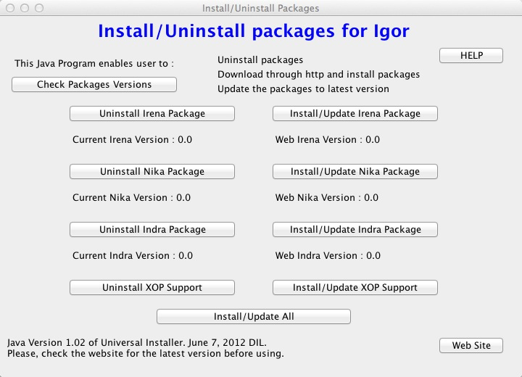

Note, this works only on Windows or Mac OSX which are in English language. Seems to fail in non-English versions of OS since it cannot find users home folder. It may also fail in exotic setups, so if it fails, use Igor Installer.

**II. Easy way using Igor 6.20 and higher (including user with limited privileges)**

Download the “Universal installer 1.19.pxp” (or latest version) file from my web site. Optionally, if you have firewall issues or just want to have easier life, download ALSO the whole depository of my packages as one zip file. Then use this Igor experiment and install using the buttons provided. Note, that if you have local copy (unzip the downloaded (large) zip file, then select “Use local copy” checkbox. Instructions are in the file itself. It usually works just fine, but sometimes ftp communication is either bad due to network issues or even prevented due to firewall, so then local copy is your only choice. Install the xop support!

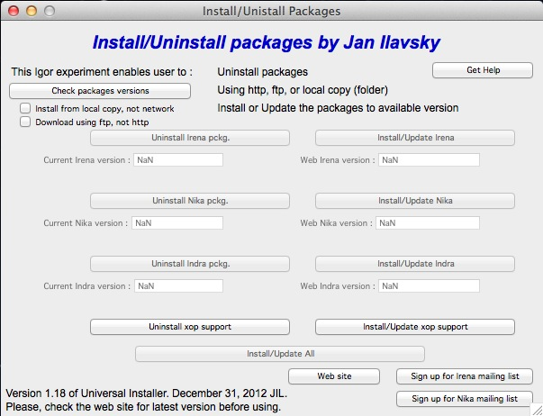

**III. The hard way, when the other methods fail... Zip files.**

Get zip file for Irena package AND xops, appropriate for your platform. Place the files in the zip file, following the folders in the appropriate places in the Igor Pro Folder in User area. This location is easiest found by using in Igor Pro in help menu the item "Show Igor Pro User Files". Note that some of the files belong to Igor Procedures and some in User procedures, keep folder structure as is in the zip file, please...

**NOTE: If you had prior installation (before 6.10 version of Igor) : Update Igor Pro (free from any 6.xx version) to latest version and check for presence of obsolete version :**

Locate Igor Pro Files (again: Help menu in Igor, Show Igor Files) and remove any files related to Irena, Nika, and Indra from Igor Procedures and from User Procedures. This should be done automatically by the installers, but may not be possible if you are running, as lower privilege user installers may not be able to do this.

To load macros, **select “Load Irena SAS macros” from “Macros” menu** after starting Igor Pro. Whichever method you choose, the macros should work the same.

Please, learn more about full capabilities of the Igor Pro. It is very powerful graphing and data evaluation package. It may be necessary for you to handle data import and handling, data export and some graphing. Further, the macros heavily rely on the data folder structure, so it is important to learn enough to realize the use of this feature…

## Please read these comments:

Few suggestions first:

1. Learn enough Igor, that Igor problems do not prevent you from getting results. Igor tour and 1-2 hours playing with it should be sufficient
2. Read this manual full or in pieces and test what is shown on your own computer
3. Use folder structure, or things will become way too messy for these tools to be useful
4. Read supporting literature (especially papers about Unified fit, Reflectivity and other methods) if you want to use these methods.

**Comment on ending the macros:**

At any time user can end working with the macros by closing associated graphs and panels. There is also command which closes all open windows and panels of this package.

#### Getting help

There are no "Igor help files" written yet for this code. However, most of the panel items do have help associated with them and if you move cursor the help text should be visible in the bar at the bottom of the screen (on Windows) or in the balloon help (on Mac, if you switch the balloon help on). Please, use it; I tried to be descriptive there.

## Important Information

The code uses for all size related parameters Angstroems (10-10 m) or for Q vector (A-1). In the case of scattering contrast, number distribution and any other volume contents centimeters (10-2 m).

Output of the size is *usually* in particle diameters, but Modeling II is using radii, but read the graphs, the output may not be always the same. Output graph legend or panel text should be always correct.

## Kill all Irena panels and graphs

This menu item allows to close all Irena related windows – panels and graphs – to be closed at once. Very convenient…

## Open Irena pdf manual

In most cases this should open Irena manual in default pdf reader. If you are reading this, you probably managed.

## Open Form factor description

This should open pdf file with form factors description – including simplified code and graphs. These are form factors in the “central bank” of the Irena, available for use in packages, which use them.

# Location of items in SAS menu.

The location of items in SAS menu keeps changing. Here is current (version 2.50) location to help you find what you need…:

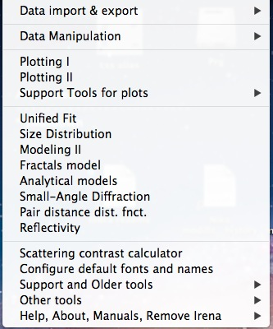

Submenus:

Data Import & Export:

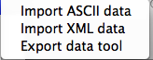

Support tools for plots:

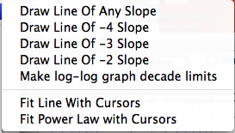

Support tools:

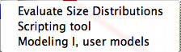

Other tools:

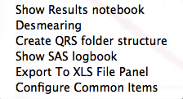

About, Manuals, Remove Irena, help

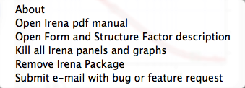

# 0. GUI controls and common controls

## 0.1 Manual, Manuscript, Mailing list, About...

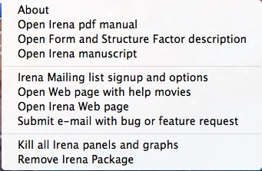

From the Last menu Item you can get "About" :

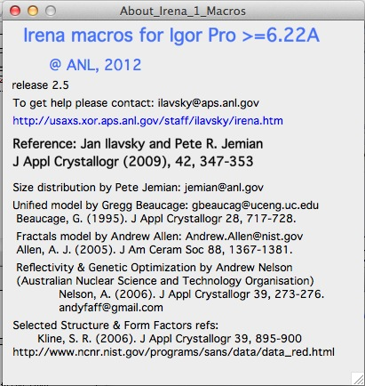

Download and open Manual, request manuscript, sign up for mailing list and do few other operations you may find useful. Including "offloading" Irena package from the experiment, so it does not slow down the operations when you want to do something else. Or when you want to send file to someone who may not have Irena installed, remove Irena package so he/she does not get errors on load when Igor tries to load Irena unsuccessfully.

## 0.2 Configure default fonts and names

“Configure default fonts and names” in the SAS menu will create panel with some controls common for all tools, like font type & size and how legend names are handled. NOTE: Panel controls are applied immediately to all existing panels, graph controls are applied ONLY to the newly created graphs (and only those which were upgraded to this behavior).

**Panels font and font sizes**

These controls enable user to customize font used on control panels therefore this enables customization for a given platform. This is necessary as more and more control is provided on each platform to user and therefore default fonts and font sizes may not be appropriate any more for the panels I design. These settings are actually saved on a given machine as well as the experiment. This has some interesting features, so please, read carefully:

When these controls are run (and user is forced to run them if the Irena is loaded and preferences are not found), they save preferences in special folder Igor maintains for users. At the same time, the settings are applied to the current experiment.

When this experiment is opened on another computer, the preferences from that computer are not reloaded, so the experiment will use preferences from the original computer. When the “Configure GUI and Graph defaults” is run, it will reload the computer defaults and apply them to the given experiment. Then user can change the fonts and font sizes as they wish. The new settings are saved on the computer – and within the experiment.

*Note*, that Panel font and font size are platform specific, so same experiment may present differently looking panels on Mac and PC.

*Note*, not all controls actually follow these settings, I have been changing some buttons to specific font and font size and those are not affected by these settings.

If there are any issues with the behavior, please, let me know and I’ll see if I can make it more logical.

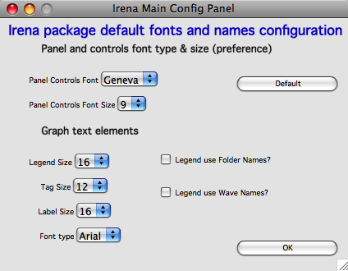 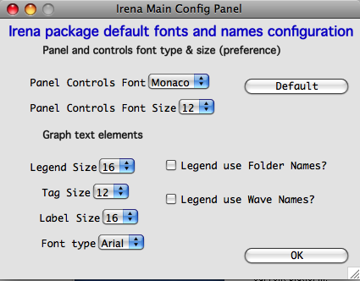

Note the difference in Configure GUI and Graph defaults panels when different fonts are used. Left is using Geneva font size 9, right is using Monaco size 12, both on Mac platform. You can mess up the panels really well by wrong choices!

Defaults button returns the panel font choices to platform specific default state (Mac: Geneva size 9 and PC Tahoma size 12). Note, that there is no guarantee that these were your choices before. But these should be reasonable choices for most setups.

**Graph controls**

I am slowly adding in various parts of the whole package calls to these commonly stored values. This allows user to configure fonts for various screen sizes. This seems necessary to allow use of Mac/Win platforms with vastly different screen sizes and resolutions.

Not all packages follow these controls yet, if you see issues in package of your choice, let me know and I will try to address them ASAP. Time is limited resource.

## 0.3 Data selection

Data selection part of the panels is served by common package (mostly) and has more or less similar behavior – with modifications appropriate for each package. The purpose of these controls is to provide as much help to user to select appropriate data as possible. This is not easy task… Sometimes even it is not clear what the right help is.

There are few checkboxes for data types, up to 4 popups with Data Folder, Wave with X, Y and error data. If Model input is appropriate, Qmin, Qmax, number of points and log/lin binning inputs are displayed.

***How the control works:***

**Type of data:**

**Indra 2 data** data from Indra package (DSM_Int, etc.). Assumes data are in root:USAXS folder (or any subfolder) only.

**QRS data** data with q_name, r_name (intensity) and optionally s_name (error).

**Model** No data, tool will create q data using user input and intensity/error data will be set to 0. Then passed intot he tool so one can model with no measured data present. Available ONLY when appropriate

Irena results should know results from Irena package (all different types). When appropriate will be available. Note, that in any folder may be number of different results available.

**User type** currently not used, but allows definition of any other naming structure to be used in the future. Note this can be named differently at any time and can provide access to any doublet or triplet of wave types, if it can be defined.

**No type of data selected** In this case the tool will present choice of all folder in the experiment and for data waves all of the wave in the particular folder. This method will work always, but may be quite challenging to use.

**Basic control logic**

When particular type of data is selected, the tool should go and find all of the folders containing at least one of the type of data.

**Indra 2 data** at least one of M_DSM_Int (M_DSM_Qvec, M_DSM_Error), DSM_Int, M_SMR_Int, SMR_Int triplets.

**QRS data** triplet of waves starting with q, r, s with the rest of name the same. Note, this is the most cpu challenging data type, so it will take the longest.

**Irena results** any of the results from Irena package. If any is missing, let me know, please…

**Model** no input data, input data will be created.

**User** not used at this time. Can be used in the future for any data types, which can be defined.

**Nothing** all folders, all waves available

These folders are presented in the “Data folder” for user selection. When user selects the folder, rest of Wave popups will be populated by first valid set, which is in the order prescribed by internal logic.

If other data set is needed, select different data in the “Wave with X axis data” popup. This will attempt to fill the next ones with appropriate data. This may not be unique, so the first match will be filled in.

Then if still necessary, fill in the other two popups.

Note, that it is possible, that depending on tool you can select only two data waves (X and Y), some tools may require also error wave.

**Folder/Wave name masking :**

Starting with *Irena* 2.39 I have added option to mask Folder name and/or Wave name with grep stringa to make smaller selection in the popups. There are two new fields now – and yes, it is possible the new string fields get hidden below controls for Folder and Q wave selection. There is not enough space, select “---“ in that popup to get to these new controls.

These controls allow user to use “Grep” - "RegEx" syntax to select folder/waves to be displayed. The function varies a bit among different types of naming structure and there may be some specific cases when the logic fails. Send me example and I’ll fix it.

Here is how to use it:

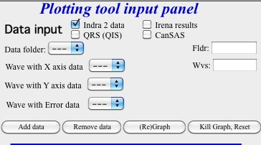

This is how the default sate looks – empty field for “Fldr” and “Wvs”. If there is empty string, all folders and waves of that specific type will be presented.

See here, we have 4 samples measured and we have now 4 folders available.

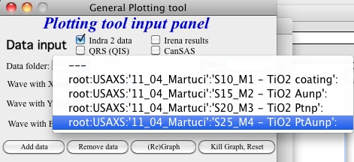

Here is setting when I want to match Aunp string to be in each of the names:

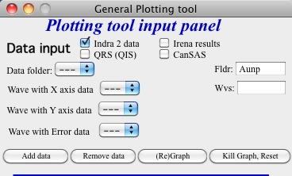

and here is what is presented as result of the above choice:

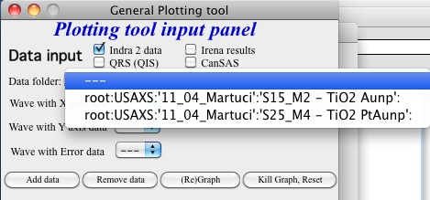

Those, who know how to use RegEx (do not ask me!) can setup relatively complicated masks here, internally he list of folders/waves is simply, item by item, compared by Grep to the mask provided by user.

Little help:

Typical use is to show only data with specific match string, to display only selections, which contain "abcd" in the name just put the abcd letters in the field. No * are necessary, they have special meaning in RegEx. By default the match is case specific. Prepending the match string by (?i) makes it case independent, so (?i)aunp would match the above case. Read about regex on line helps, it is ***very*** powerful.

Match strings are tool-specific, so each tool has its own specific set of match strings.

## 0.4 Use of XOP

Igor Pro enables use of external C-code to speed up some high cpu intensive operations. Currently various optional xop program are available:

1. Two by Andrew Nelson <http://motofit.sourceforge.net/wiki/index.php/Main_Page> – one for calculation of reflectivity (abeles.xop) and one for genetic optimization (GenOpt.xop). Both are compulsory (for functionality of Reflectivity and Genetic optimization) and need to be placed in “Igor extensions” folder. Both speed up the calculations by factor of up to 40 compared to now removed Igor code. They need to be kept updated, so please, update with every new Irena update as they do not have version numbers.
2. XML loader (also by Andrew Nelson) necessary to load XML (CanSAS) file formats. You can download this general use XML xop from : <http://www.igorexchange.com/project/XMLutils>
3. In the future, Form factor will be provided by xop library maintained by NIST reactor. Once that is available, the link to download place will be provided here.

## 0.5 Genetic optimization

Genetic optimization method is form of fitting from SAS data. It has been developed for optimization of reflectivity data but is very useful for cases where least square fitting may not find global minimum. It has been programmed for Igor by Andrew Nelson, who is also author of internal code for reflectivity tool.

Note that this code uses some version of Monte Carlo method. Therefore limits are _very_ important. When Genetic optimization method is used user will be presented with dialog to check the limits. For this method is really important that the calculations do not fail for any combination of parameters and that the range of probed parameters is sensible.

# 1. Loading data – ASCII & XML (CanSAS)

Users of Indra 2 or Nika produced data can skip this chapter.

I have included ASCII set of data from our USAXS experiment as example on which user can play and test capabilities.

***Comments:***

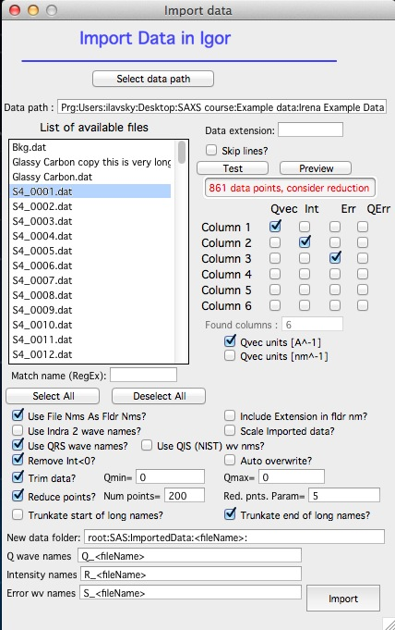When loading data for use with Irena macros, the user needs to decide ahead on naming system, which will be used. Indra 2 (USAXS) data use somehow specific naming structure: folder names for sample names and within the folders the waves with names such as: DSM_Int for intensity wave, DSM_Qvec for Q vector wave and DSM_Error for error wave. This may not be the first choice of most users from other instruments. Therefore the Irena handles well also “qrs” naming convention, where the wave with q vector starts with q_*andTheDataName*, intensity wave is named r_*andTheDataName*, and error wave s_*andTheDataName*. This allows placing multiple data sets in one Igor folder, **which I strongly discourage**. Note, that when Irena macros save results within Igor experiment, they **ASSUME**, that they can write simply solution into folder where the SAS data came from. Irena macros **WILL NOT** overwrite old results, but it may be impossible to figure out, which data the particular result belongs to…. To make best use of these macros, please use folder structure with folder names being the sample name.

YOU WERE WARNED!!!!

## 1.1 Description

In “Data import & export” from “SAS” menu select either “Import ASCII data” or “Import XML data”. Following screens appears:

**1. ASCII**

Explanation of control available here:

“*Select data path”* browse to the folder on the computer drive where the data to be imported reside.

“*Data path”* this shows the path selected above. Cannot be edited in this window, use button *Select data path*.

“*List of available files”* lists all files in the current folder on the computer, unless masked by *Data extension*. One or more files here can be selected for import. Use shift - click to select multiple files (on Windows) or cmd – click on Macs (to pick one file at time), shift-click to pick range of files. Double click on file runs "Test" and "Preview" commands on that file.

*"Match name"* enables to use regEx to select subset of files.

“*Data extension”* if extension is put in this filed (e.g., “dat”) only files with the “dat” extension will be shown in the *List of available files*.

*“Skip lines”* if there are known number of lines, which need to be skipped. Note, Igor will automatically read file structure and skip usually any text header which needs to be skipped. Therefore this “skip lines” should not be usually necessary.

*“Test”* Test import of first selected file. Not really necessary, but very useful. Sets checkboxes for Column 1 to 6, how many columns were found in the file, etc.

*Red text indicating too many data points* - lot of data from SAXS instruments contains very high number of data points which are really useless for SAXS data analysis. Actually, they are bad, as they force code to fit too many noisy points. This warning comes when too many points are found. See below the controls for reduction of data points.

*“Preview”* Opens the first selected file in Igor notebook for preview. Kill notebook after use, it is not needed for anything else…

*“column 1 – 6”* and *Qvec Int err*” This is checkbox area, in which user needs to select which column of data contains which SAS data. Assumption is, that SAS data are in the first 6 columns in the ASCII file. These checkboxes appear when “*Found columns”* number gets set. User can set it or it gets set during “*test*”.

”*Select all”* or “*Deselect all”* modifies which files are selected in “*List of available files”*.

*“Qvec units”* select proper checkbox. Units will be converted to A-1 if nm-1 data are imported. Irena uses A-1.

“*Create errors”* if the data imported do not contain error bars, this will generate sqrt(Intensity) error bars. These can be further modified (multiplied) in Data manipulation tool.

*“Scale imported data?”* if the data need to be scaled by some calibration factor… New input variable appears, if necessary.

“*Use file name as folder name”* **Strongly suggested to use**. Will cause the import tool to create for each imported data set new folder with name by the file name.

“*Use Indra 2 wave names”,* ”*Use qrs wave names”, "Use QIS (NIST) wv nms"* selects which naming structure is used during import of data. One of these selections is more or less necessary for multiple file import.

*"Remove Int<0"* removes any negative intensities during import.

*"Auto overwrite"* Overwrites existing folders in same named data are imported second time.

*"Trim data"* opens two new input variables and enables to trim Q range of data being imported. 0 means no trimming in that "direction". Otherwise, input Qmin or Qmax as needed.

*"Reduce data points"* reduces number of points by averaging on log-scale. Suggested for data with large number of points at high Q (if more than 250 points is found, warning appears below "test" and "Preview" buttons. Note, this step creates new Q resolution wave - even though currently Irena is not using Q resolution data for anything.

*"Truncate start/end of long names"* - allows users to choose how to truncate long names (current limit is 26 characters which user can use). Important if the "important" part of the name is at the end...

Single file import can be done by manually filling the following controls.

“*Select data folder”* and “*New data folder”* Using pull-down menu in *Select data folder* user can select existing data folder where to put the imported data. Using *New data folder* user can create folder in Igor for the data. Note, that “<filename>” will be replaced with the file name of the imported data file during import. This allows for creating data structure which uses folders during multiple file import.

“*Intensity wv name”*, “*Q wave name”*, and “*Error wave name”* – these can be filled with the names for data waves. Note, that “<filename>” will be replaced with the file name of the imported data file during import.

“***Import”*** imports the selected data.

Some of the controls (checkboxes) do change some of the setting in other controls. Generally the proper order, how to select and modify control is from top to bottom.

2. XML data file:

NOTE: XML data tool requires xop for XML data file interface. See chapter 0.4 above for the link to this file.

Similar controls, except CanSAS XML file does not need some of the controls. Therefore, the GUI can be easier. On the other hand there may be more data columns (meaningful) in this data file and while Irena does not use any of these, they can be loaded to be useful for user code or other tools, which may be able to use them (like NIST macros).

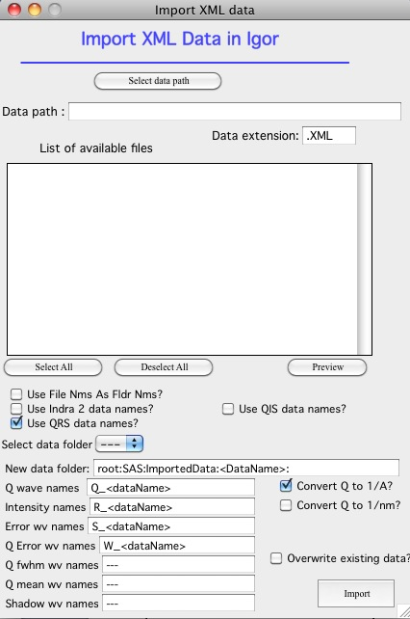

## 1.2 Importing test file:

Using *Select data path* button select folder on the computer, where Irena data are installed, for example:

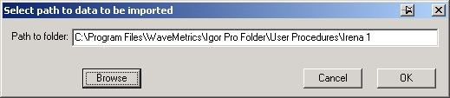

and in *Data extension* input “dat”. The following should be the panel:

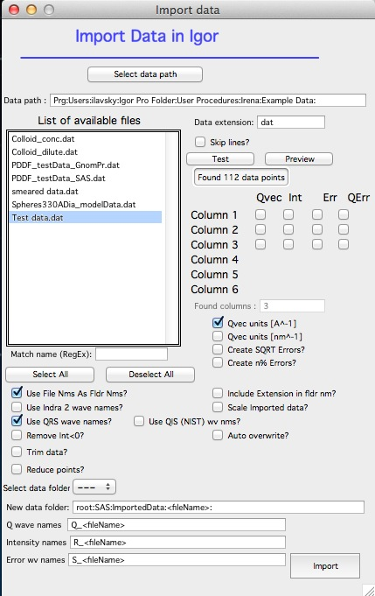

Select the “Test data.dat” file and double click - or push *Test* and *Preview* buttons.

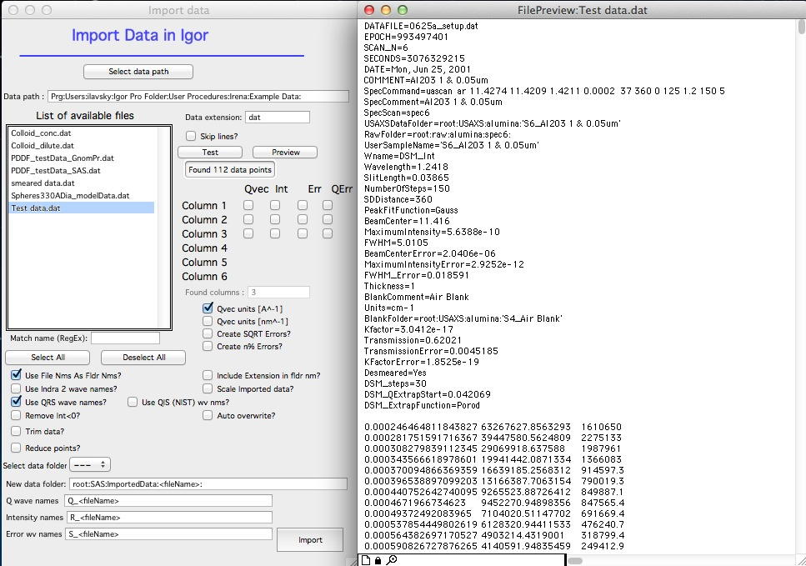

Igor found 3 columns of data so 3 rows of checkboxes appeared. The *Preview* has created notebook on right, where user can preview the file and check, which columns contain which data. Note, that Igor skipped the block of text in the beginning of the data file automatically.

Check cheboxes according to following screen and noticed, that *Create errors* checkbox becomes unavailable when any checkbox in the Err column is selected. Notice, that when checkboxes *Use file nms as Fldr Nms* and *Use QRS wave names* are checked, the names for folder and data wave names are filled in with default.

Note: from version 2.51 I have added another row of checkboxes to include in the wave note of the Intensity Units. Currently three options are possible: Arbitrary, cm2/cm3 (most common volume calibration) and cm2/g (weight calibration). In the future this will be used by other Irena code.

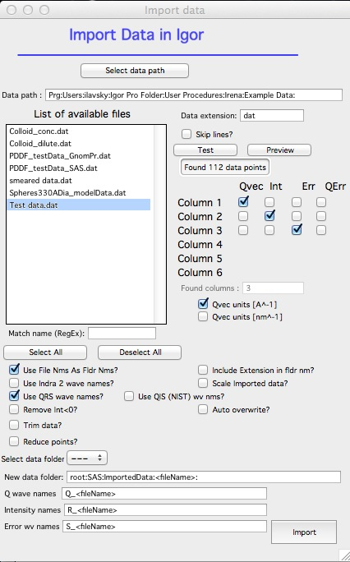

Now push *Import* and the data are imported. Kill the Import data panel and see in Data browser:

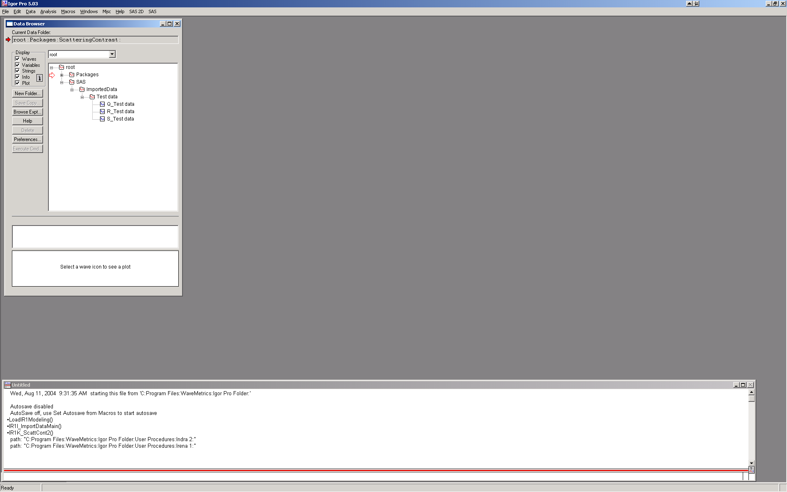

Here is bit more complicated example:

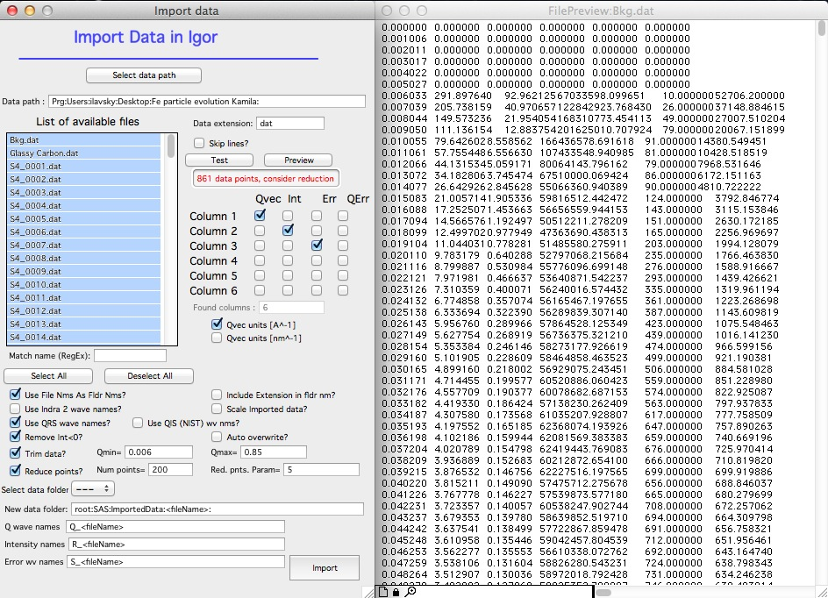

Note: I have selected may be 136 data sets here, I have decided to trim data (note in the notebook that there are no data bellow Q of 0.006) I have also reduced number of points to 200 from 861, limited high q range (no data found above Q of 0.85) and removed negative intensities. This load creates much more easy to handle data with q scale logarithmic and not linear with less noise at high q, which is much easier to plot and analyze. 2. QRS data folder creation tool

## 2.1 Introduction

Many users may have QRS named data in unstructured way – that is all data placed in one folder, very often “root” folder. This is not very convenient place for the data, since the Irena macros make heavy use of the folder structure. To help the users, I made little simple tool, which should in most cases create successfully folder structure for this type of data.

Start the tool from “SAS” “Create QRS folder structure”.

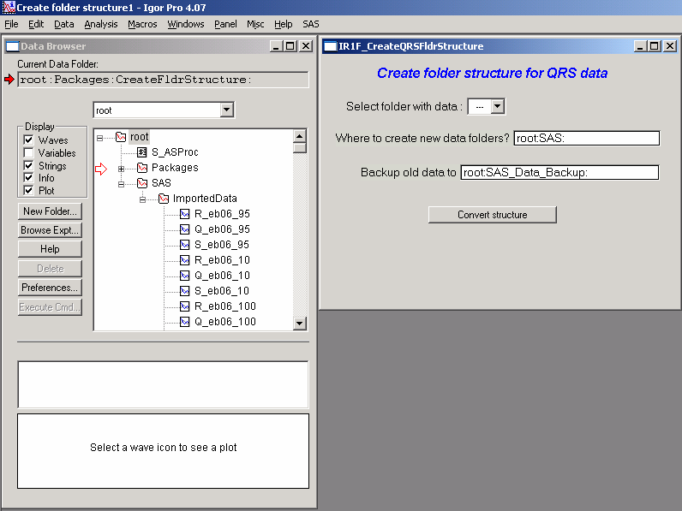

Note that all my imported data are in “root:SAS:ImportedData:” folder. They can be in any folder in the Igor experiment. Note few controls in the panel just created.

“*Select folder with data”* this popup will list ONLY folders containing triplets of QRS named data. Select folder, which contains data you want to convert. In case of this example the “root:SAS:ImportedData:” folder

*“Where to create new data folder?”* Input full folder name to folder, in which you want to create new folders with the separated data

*“Backup old data to”* input full folder name where you want to put backup copy of old data. If empty, backup will not be created.

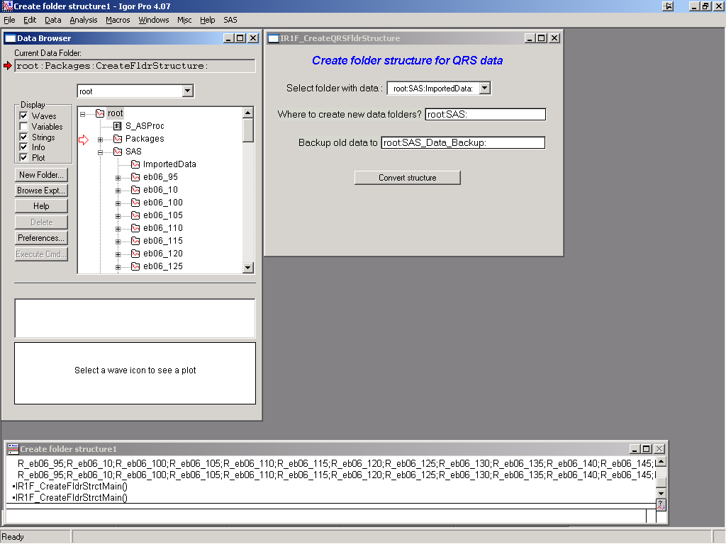

Select appropriate folder with data and push button “Convert structure”. Result can be seen above – folder “Imported data” is now empty and new folders which are named by sample names (using the name from QRS naming structure) were created. Each contains QRS named triplet of waves.

Note, that copy of original data is now in root:SAS_Data_Backup folder:

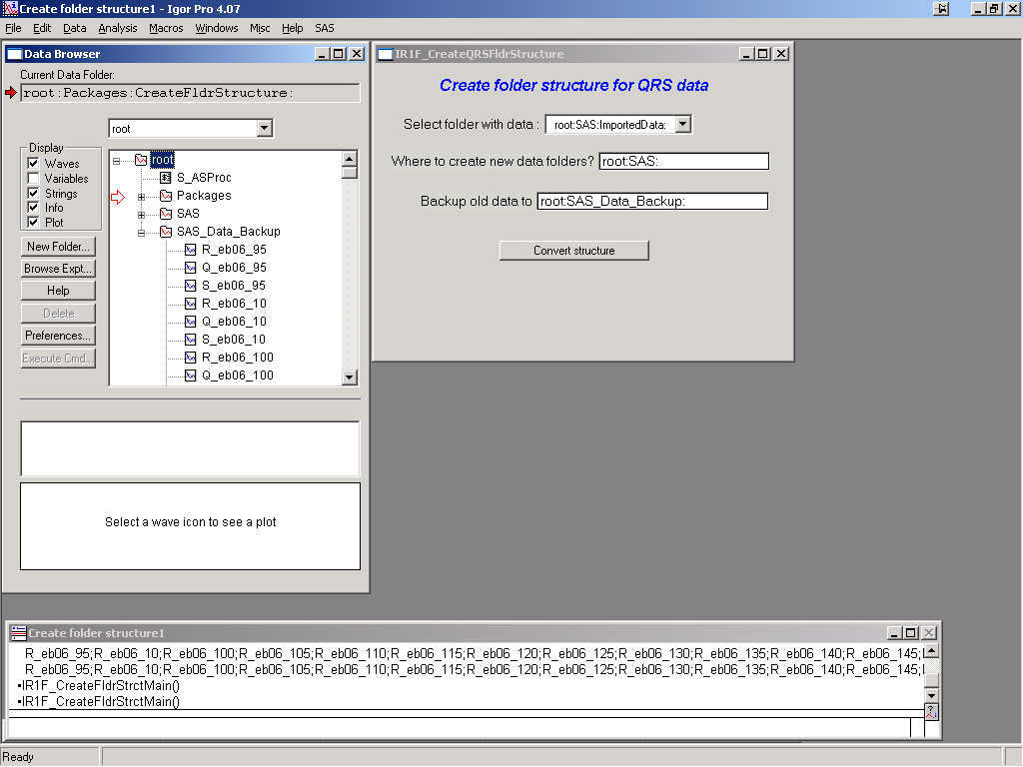

Few comments.

This tool is relatively simple and does not do much checking. It will not be able to remove waves, which are part of any graph (or for other reasons Igor refuses to remove them). It will create new copies of these data, it just cannot remove the waves in use.

The folders with data are never overwritten, if folder of the particular name exists, index starting from 0 will be attached to the name.

Do not backup into the same place where the data are coming from. Make separate backup into separate folder.

Data, for which the code does not find properly named QRS triplet of waves are not touched.

There is no checking for wave length or other validity, all what is used is the names of the waves.

The code does not know about any “name extensions”, so data named “R_myName_BkgSub” are treated as separate data from original data “R_myName”…

I assume, that your names are legal and valid. The code may fail on liberal names (names with spaces and other weird characters). I need to test that later. This should not be a problem, since most users with the data needing this treatment should have standard (non-liberal) names, or the code used to create these should not work..

# 3. Data manipulation tools

## 3.1 Data manipulation I – one or two data sets

This tool allows the user to modify data in many ways. It can work on one or two data sets at the same time. The data sets may or may not contain errors.

The tool allows the following data manipulations:

1. Modify data – multiply the intensity and errors by constant, subtract background, and shift in Q
2. Merge data sets - attach data sets together as when attaching sectors from different camera lengths on pinhole cameras. The data can be scaled together manually or automatically by using area under the curves in range selected by cursors
3. Sum together data
4. Subtract data set one from another
5. Re-bin intensity and errors to new Q
6. Smooth data in linear or logarithmic scales or using spline smoothing with variable smoothing constant.

### 3.1.1 Panel description

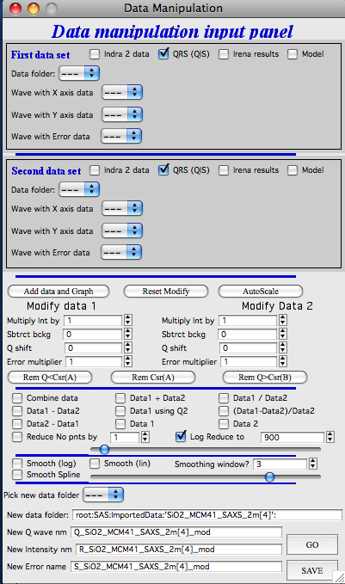In the top part user can select *First set data input* and S*econd set data input*. The behavior of these controls is always the same in all Irena macros system.

Select data naming convention used – Indra 2 (Folder names for sample names and then DSM_Int, DSM_Qvec, and DSM_Error), “qrs” (suggested use of folder names for sample names [but not necessary], q_sampleName for q vector, r_sampleName for intensity and s_sampleName for error. Or do not check any checkbox and all folders and waves will be listed (allows for ANY naming convention to be used).

The pick *Data folder*. Subset of folder will be listed in specific naming conventions.

*Waves with data* may or may not be automatically selected, depending on naming convention.

You do not have to select error wave, but it is strongly suggested to create one during data import, if better error wave does not exist!!!

*Add data and graph* after selecting one or two data sets (use data set 1 as single set, please) click this button – data are recorded for use by the tool and graph is created.

*Reset Modify* resets the tool

*Autoscale* When two data sets are used and range of data (overlapping data) is selected using cursors, this will calculate area under both curves and use the ratio of these areas to scale data set 2 to data set 1. Will write the result into the *Modify data 2*, *Multiply int by*. There it can be later modified by user.

*Modify data* areas. Scaling factors, background subtraction, etc.

*Rem Q<Csr(A)* remove data with Qs smaller than Q for the data point on which is cursor A (rounded cursor) set. Note, this gets the data set name from the wave on which the cursor is positioned. Place cursor on right data set you want to modify.

*Rem Csr(A)* removes ONE point, on which the cursor resides at this moment.

*Rem Q>Csr(B)* removes points with Qs larger than Q of the point with cursor B (squared) for the data set on which the cursor B is. Note, this may not be the same data set as where the cursor A is!

*Combine data* joins data by simply writing two data sets into one data set and arranging them from smallest Q to largest Q. No rebinning for Qs is done. Therefore it is likely in overlap region may be more points than appropriate. Suggestions for use are below in the section titled "Various uses for this tool.".

*Data1 – Data2 ; Data2 – Data1 ; Data1 + Data2 ; Data1 / Data2; (Data1 – Data2)/Data2*  These do the math described here on the intensity data (and properly propagate the errors). This is done after rebinning data 2 to Q points of Data 1. This is done by interpolation of logarithm of intensity and then conversion back to intensity.

*Data 1 using Qvec2* Does ONLY rebinning of Data set 1 to Q vector of data set 2 (and propagates errors, if available).

*Data 1 ; Data 2* Passes data 1 or 2 only to allow use of smoothing on data without any math being done.

*“Reduce No of points by”* Takes Data 1 and reduces number of points by number selected (2 = ½ points left).

*“Log Reduce to”* Takes Data 1 and reduces number of points using approximately logarithmic reduction. Generally, at low-q more points are left while at high q more points are summed. Note, this reduction is by averaging points on log-scale and assigning them new, average, q, intensity, and error (all simple averages). This is done by first creating new log-Q scaling and then going through data and summing in each newly created q bin (borders being linear half distance between preceding and subsequent points) all of the Q, intensity and errors (if exist)… Bins with no values in them are then dropped… This has side effects: you cannot create more points then exists, you cannot increase point density (no interpolation is done) and the new Q scale may not be exactly logarithmic. Also, you are not guarantee to have the right number of points you requested, as some may have been dropped, if locally the density of new points was higher than density of old points…

Slider below the checkbox controls the weighing of the log scale – how many points are created at low and high Q values. You need to push the button “go” first time when using the “*Log reduce to*” – after that the slider updates the graph every time the value is changed and mouse is released.

This tool can be very useful, when large number of points exists at high Q with very little information content. Especially when input data have very high number of points, some of the tools will run very slow or not run at all for memory limitations. This data reduction may be the right choice…

Results of above mathematical functions can be also smoothed by checking *Smooth* checkboxes and selecting appropriate *Smoothing window*.

*Smooth (log)* smooth logarithm of intensity and then converts back to intensity

*Smooth (lin)* smooth directly intensity

*Smooth window* number of points accounted in “running average” smoothing used here…

*Smooth spline* uses spline interpolation (with slider on right setting the spline smooth parameter). Use carefully – and test right setting of the slider. You need to push “go” first time, after that (when smoothing parameter is changed and mouse is let go) the data are redrawn automatically.

**Output area**

*Pick new data folder* pull down menu allows selection of existing folder in Igor experiment

*New data folder* modify, write in data folder name (fullname, staring from root:…., use the above pull down to preselect). If the folder does not exist, it will be created

*New intensity name, New Q wave name, New Error wave name* names for output waves. Please fill in appropriately for your naming convention**.**

### 3.1.2 Various uses of this tool

1. Merging segments from various sources. Import segments and then load in as Data set 1 the set which is calibrated, as set 2 next one and using automated method (select data overlap by cursors) scale them together. Remove extra points, reduce number of points in overlap area (if necessary) and subtract backgrounds, if necessary. The *Combine data*. Smooth if desired.
2. Subtraction of one data set from another. Load the data sets in, scale and modify if necessary. Do the proper math. Smooth if necessary.
3. Smoothing data. Select only data set 1 data, pas it through math part (modify, if necessary) and select smoothing method desired.

Please, make sure you fill in properly the names of waves for output data. There is nothing I can do here to catch typos and mistakes…

## 3.2 Data manipulation II – many data sets

This tool serves for modification of many data sets at once. In can average waves (all selected or every N waves), Normalize data, Subtract dataset from all selected waves, and - possibly combined with the other tools also scale the data. But this tool can be modified to do other things. If you have any ideas, let me know.

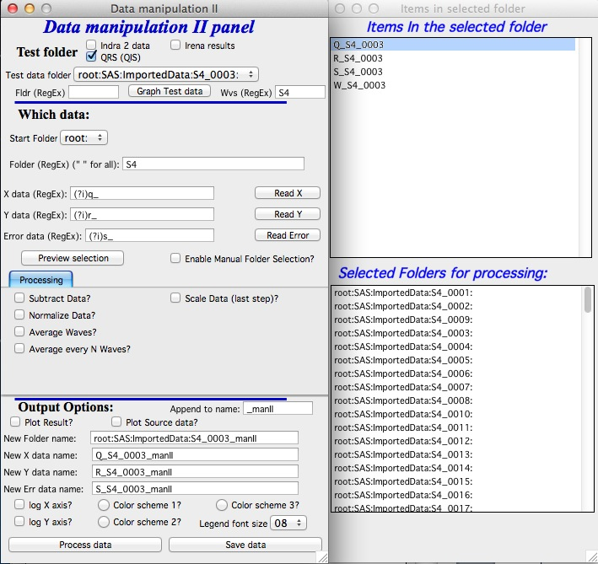

### 3.2.1 Introduction

This tool is combination of data selection method used in Data Mining tool, which enables user to select folders with data. These data can be processed (averaged all or in "chunks" of N at a time for now), plotted and saved. Further one can use this subtract one data set from all selected data sets.

It is relatively simple tool at this moment… User selects by one of few methods number of data sets and these then are processed.

**Averaging** – first data set found during processing X (Q for SAS data) values are used for result X vales. At this time there is not way of reordering the data, so this is kind of random which X wave is picked. Then for all data sets the Y is linearly interpolated for each X value and average and standard deviation (or standard error of mean) are calculated. It is not necessary to have the same number of points – and it is even not necessary to have same X (Q) range, but if the X range is different, Igor will extrapolate the closes existing values as fixed number. That is likely going to make such situation really bad. But anyway, the code will not fail.

What is not done yet: As written now, the code simply dumps any errors provided and uses only the standard deviation on the Y values. If I get smarter, I can try to propagate the errors also.

**Average every N waves** -same as average above, but averages first N waves, names the output folder by taking the wave name of the first data set and saves the data there. The continues with next N waves etc. If the last set has less than N data sets, it will average that smaller number. Saves automatically and uses name of the first folder of data in the set, attaches the "Append to name" ending.

2. **Subtract data** – subtract one data set (may be background data?) from selected other data. Check “Subtract data” checkbox and select what data type etc. in the usual data selection controls which appear. You do not need error wave for this, but you can have it. In order to save the data new folders must be created and to make sure the names are unique, there is “Append to name” field. Add string (may be “_sub” is good choice?) and then select other controls (like plotting options) and process the data. No scaling is available at this time, you need to scale the data to be subtracted first in Data manipulation 1, if needed…
3. **Normalize data** – normalize data sets to fixed value of area under the Intensity vs Q. Used mostly in BioSAXS when normalization of data sets is critical and in specific Q range the assumption can be made that the intensity should be same for all samples.
4. **Scale data** – this step can be combined with the others and enables scaling by fixed number, for example by scaling factor to put on absolute scale.

### 3.2.2 GUI and controls

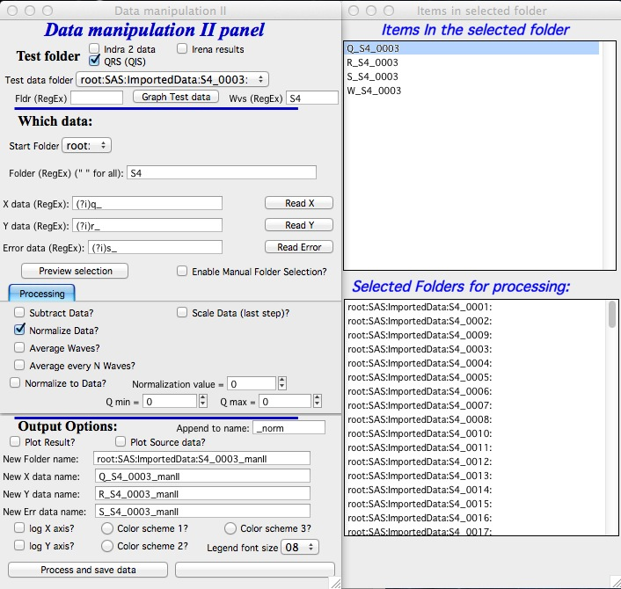

The control panel is on right, Panel with two list boxes for user controls on the left.

At the top of the control panel is standard suite of data selection control. User should select folder in which are waves which user may want to do something with. In my case I selected a folder containing some Indra (USAXS) data I want to sum together.

Please note, that for lack of better choice, this “Test Folder” name will be used as template for output suggestion – basically, I will add “_manII” to its name. You can modify later.

**Which data**

In this area user should try to select as best as possible the data to be used.

*Start folder* – Lists folders in the current experiment, any folder below this one in the folder hierarchy will be searched. Therefore, user can select only part of the data to be searched and considered.

*Folder (RegEx)* – Regular expression string which can be used to match to folder names. Uses more or less standard system, basically I suggest considering this: "" matches any folder name, K matches any folder containing K in the name (Regex is case sensitive). In the example, I wanted to match all folders which contained S4 in the name. Note, do not add “” to this string.

*X data, Y data, Error data* – you can use either full name (like the Indra data “SMR_Int”, etc.) or you can use RegEx to create more complicated matches part of the name. For QRS data, for example, you can use (?i)q, (?i)r, and (?i)s. While this does not guarantee the right triplet is used if more than one proper triplet is found in the folder. Things get messy if many qrs waves are in the same folder. This tool just cannot manage that. If you have weird system, send me example and I can try to fix it.

*Preview selection* – runs data checking code and finds the folders with data. Just the folders. They are listed in the bottom listbox in the panel on right.

*Enable Manual selection* – if selected, user can manually select only subset of folders in the listbox on right (bottom). Use buttons *Select All* and *Deselect All*  - as well ctrl and shift – left mouse button to select ranges of data.

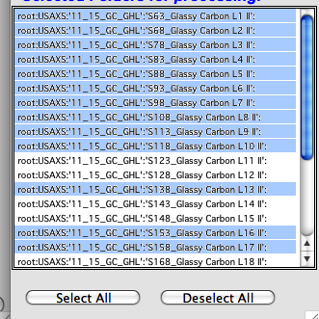

Now the Processing controls:

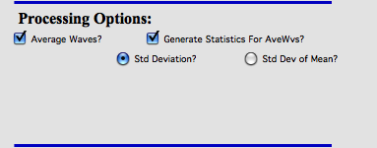

Above example is for *Average Waves*, and you can choose to create statistics (either standard deviation for each point or standard deviation of mean). As noted above, at this moment this is purely statistics on Y values, Errors are not considered.

Here is example for Subtract data:

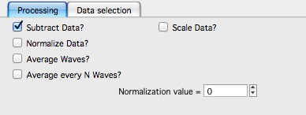

with the second tab:

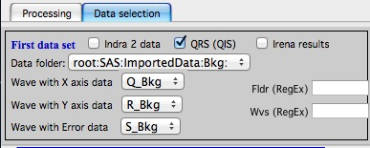

**Output options**

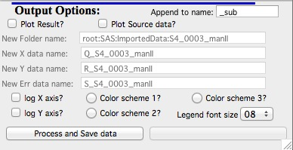

Note the "Append to name" varies based on tool used. When the folder and data names are inaccessible to users it means that output is multiple data sets and therefore the names will be created on fly using the "Append to name" string. You can modify as needed.

***Display result?* And “*Display Source data?***

Will cause that a graph with results and source data will be presented when *Process data is pushed.*

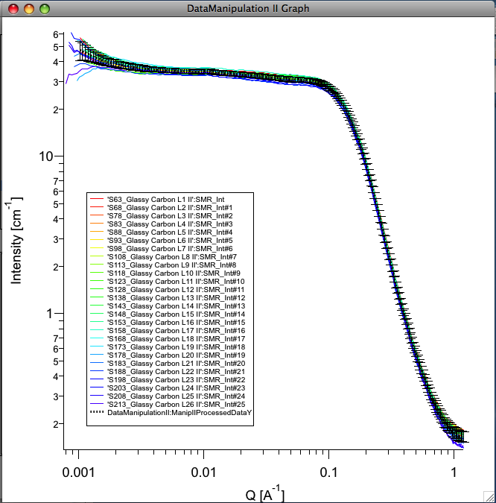

Example of plot with data with average.

*New Folder name and X, Y, Err names*  - folder needs to be with path (keep it short), separated by :. No need to add ‘ ‘ to names with spaces, the code will fix it. If a name is too long (more than 30 characters) it will be cut short. Wave names are simple strings, can contain spaces, but no special characters. No +, -, and other weird symbols.

Other controls below control how the output graph looks like.

If the results look good and you like them, use *Save data* button, which will store the data in the folder and under names in the above controls.

**Average every N waves controls   
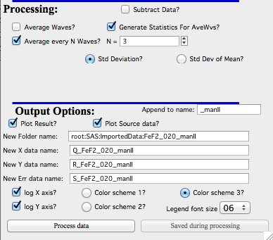**

Here are specifics... Save button is disabled, as the data must be saved automatically, control names of the data by changing the "Append to name" field.

Data can be processed all or manually selected.

Note that plotting is bit challenging in this case, so do not expect perfect results of the plots. Basically seems like logic to plot both Source data and results is failing as the code cannot distinguish between them and format them differently.

**Subtract data controls**

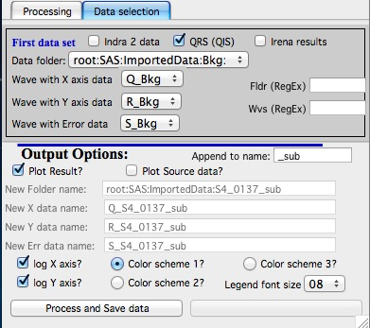

Select “*Subtract data”* checkbox to get the data selection controls.

Use of other controls is same as listed above.

Set “*Append to name*” string to something meaningful (and not too long).

# 4. Plotting tool I and II

## 4.1 Introduction

This plotting tool is designed to be able to produce publication ready plots of SAS data and simple fits.

The tool creates usual 2D plot, but can also create two types of 3D plots - Waterfall plot and Gizmo plot. It can also create movies of either 2D plot and 3D plots.

The tool allows creation of plot user styles, which can be applied quickly and reproducibly to numerous sets of data. New data types can be automatically created. Please note, that the formatting is saved ONLY if it is done through my custom made panels designed for this purpose.

The tasks, which can be done:

1. Load data and plot them, new data types (e.g., Y * X^4) are automatically created if necessary.
2. Modify data (Multiply Intensity, remove points, subtract background,…)
3. Do simple fitting (Porod, Guinier,…)
4. Create plot user styles, import and export them from current Igor experiment for future use

Note, that this tool also allows displaying “results” – size distributions, Unified fits etc. The capabilities are still little bit limited in this area… I plan to improve on this.

## 4.2 Plotting tool I Description

Select “Plotting I” from SAS menu.

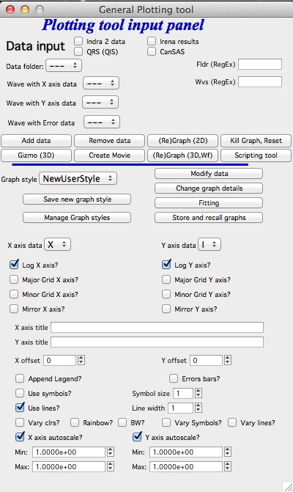

Select data in usual way and push button “Add data”. You can add multiple data sets (most formatting in this tool is set for up to 8 different data sets). You cannot have the same data set twice, code will complain and refuse to do so. You can add data anytime later also.

Apply Graph style available in the popup “Graph style” or select the data type to plot on both axes. The needed data are created, if they do not exist.

Use checkboxes and more controls in “Change graph details” (opens new panel with more space) to modify graph as needed.

Example: Selected data and applied included log-log style:

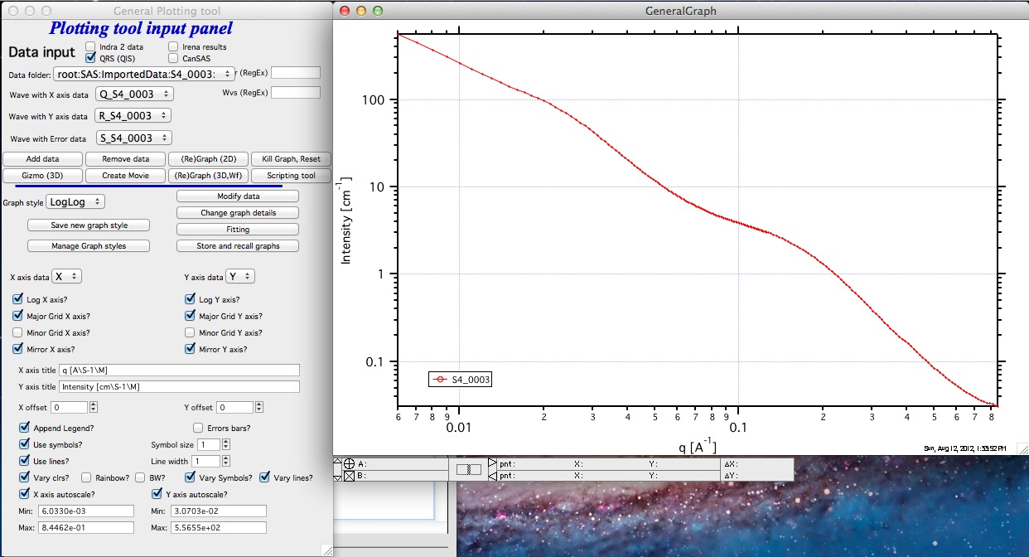

Note few items: In the axes names you need to use Igor formatting for subscripts, superscripts, Greek letters etc.

Setting limits on the axis can be done manually or using function which can be called using zoom function in Igor. Select area of the graph you want to zoom to and right-click. Select “ZoomAndSetLimits” from the menu. This will zoom the graph as well as set limits in this tool.

### Creating user style

When you have graph which you like to use many times, click button “Save new graph style”. The new style will be created after user provides name. The name is checked for uniqueness and for name appropriateness, so the new name may be slight modification of the name provided. You can rename the style using “Manage Graph details” button.

NOTE: from version 2.38 I have added predefined common styles (Guinier, Porod, Zimm,…) into the menu. These could have been defined by any user if needed. Note, that at this moment it is difficult to do those linearized fits which call for fitting in log scale (fitting log or ln of Intensity vs log or ln of Q for example) because the tool displays data on log scale when the plot calls for it. That is kind of problem, as in order to use line fitting in Igor I would have to create log or ln of the Intensity (or Q). This is mess logically (display Intensity on log/ln scale or create log/ln of intensity and display on linear scale?). I am trying to figure out how to do this so it is easy to use for users and logical. I may actually do separate tool for these fits, as adding this into Plotting Tool I seems to make it much more cumbersome to use. User input would be really welcome here!

### Import & Export of styles

Use “Manage Graph details” button.

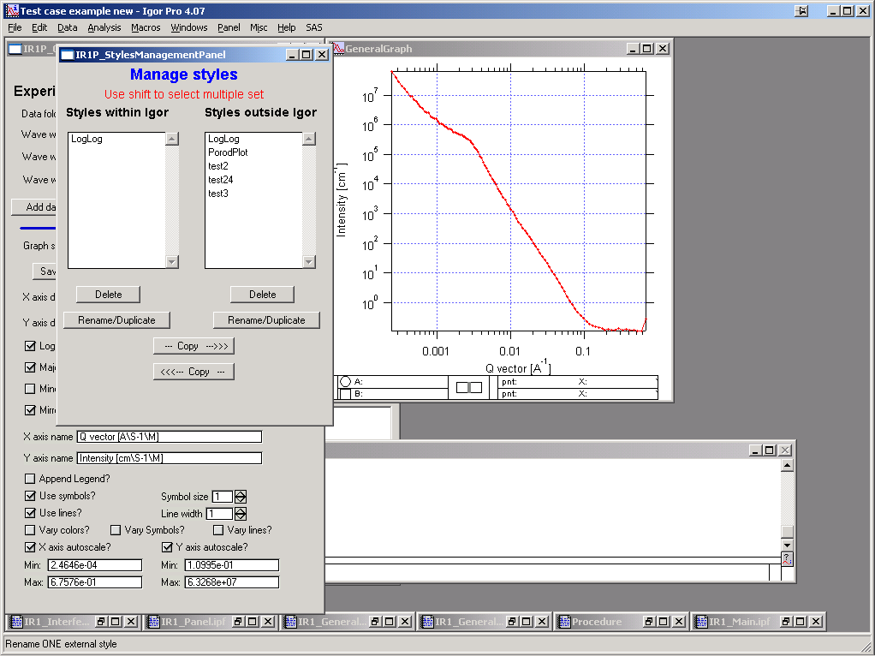

The panel shows two main lists. Left shows user styles available in Igor and right shows styles outside Igor. Buttons under each window allow manipulation with the styles, the buttons “ --- Copy -→” or “←-Copy ---“ can be used to copy styles between the Igor experiment and hard drive storage space.

When done, kill the panel.

### Modifying the data

Click button “Modify data” and new panel will show up.

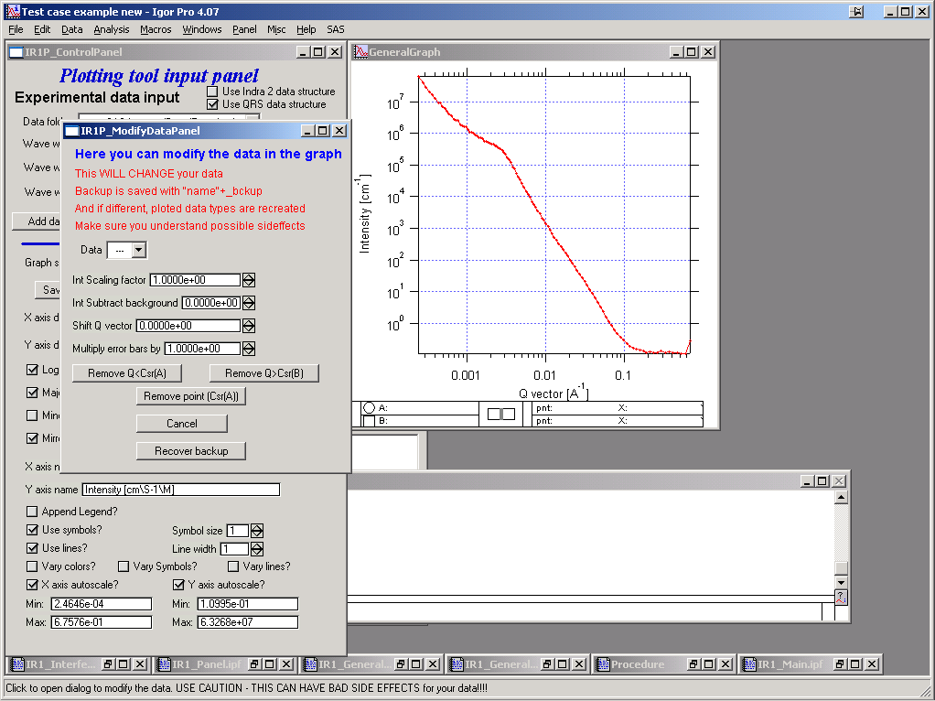

**Important information:**

When this tool is used **FIRST** time on a data set, it creates a backup copy of the data. Anytime later, this can be recovered. If that is done, **ALL** changes done to the data will be removed.

Select data to modify, modify using buttons and numbers. For removing data smaller than particular Q or removing just one data point, user rounded cursor (called A in Igor) and for removing data larger than particular Q use cursor B (squared).

Use button Cancel to reset the corrections to default values seen above. Note, that this resets instance of running this tool, to reset data to original data you may have to recover backup of the data…

Note, that the length of the name of wave is limited to 30 characters, including the "q_" etc. at the beginning.

### Fitting

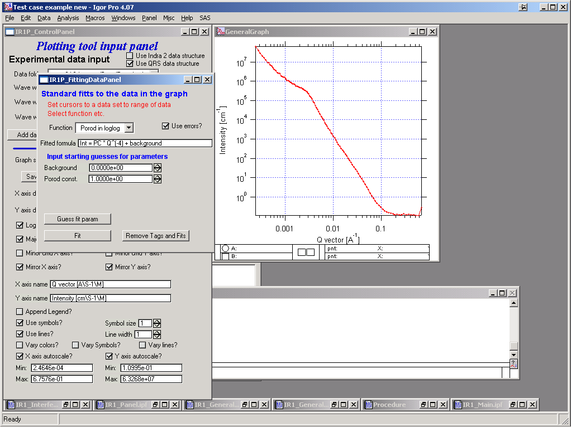

Use button “Fitting” to pull up panel with fitting range, checkbox “Use errors” if these are available. Select function to fit. Use cursors to select range of data to fit.

Note, that various number of parameters appears below for starting guesses for parameters. You can try to push button “Guess fit parameters”. This will try to guess starting parameters for fitting, since these are necessary for various fits. It may or may not work well. Good guess is VERY important for least square fitting. Example:

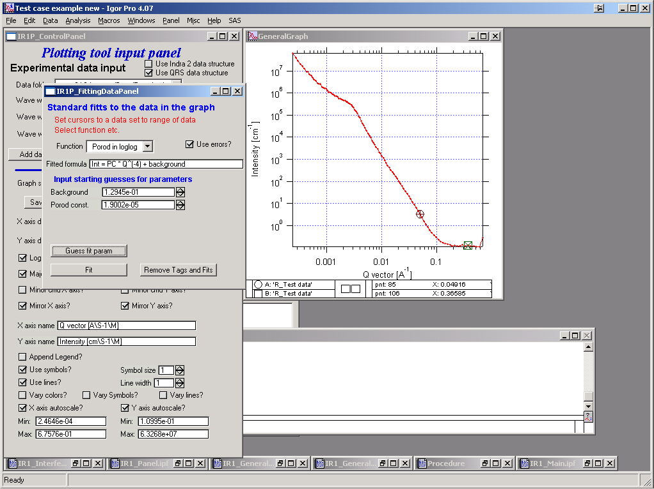

The try to fitting:

Results are printed in graph:

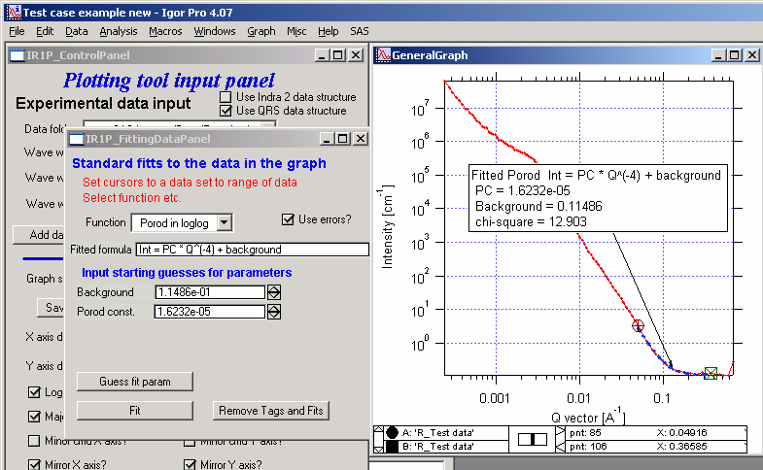

To remove the results from the graph and clean it up, use button “Remove Tags and Fits”.

### Storing graphs for future use, exporting figures

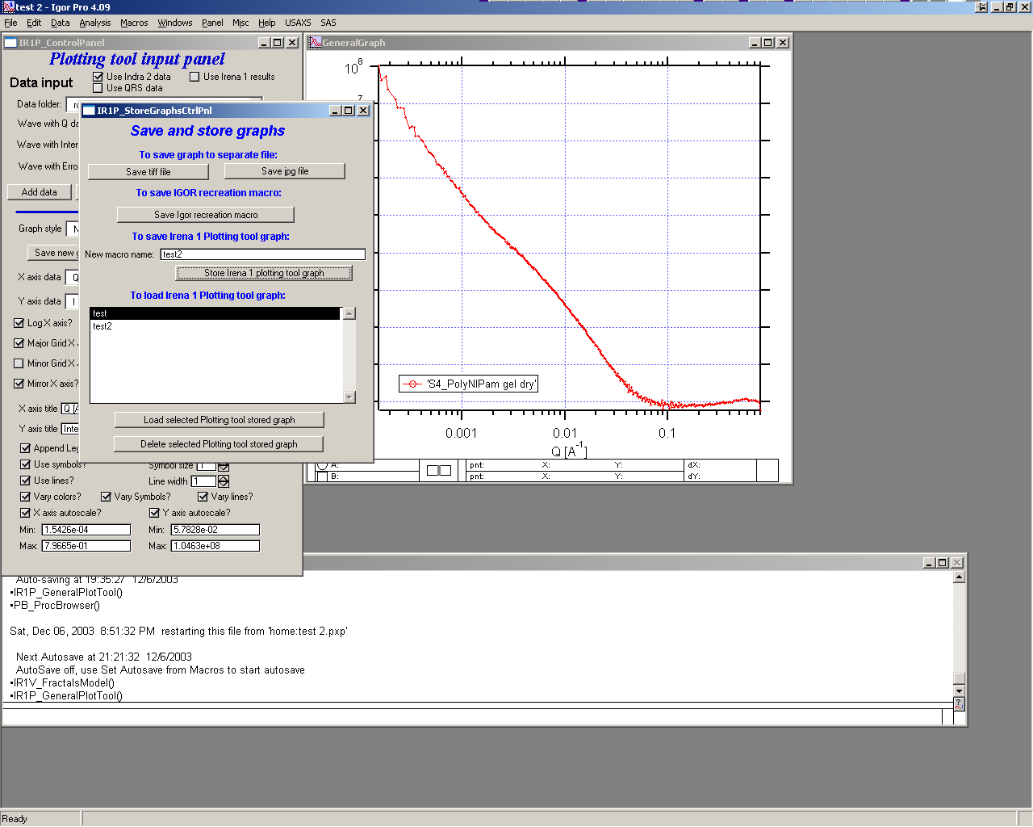

To get a control panel controlling the features for storing graph, exporting graph and recalling stored graph, push button on main screen “Store and recall graph”. This pulls up the above control graph.

Controls description:

The two top buttons allow user to save current graph as tiff or jpg files. The dialog for naming them is provided after pushing the button.

To save Igor recreation macro, push the next button. It does not work yet… I need to figure out how to do this.

Next is name for Irena own recreation macro, which you can store. This macro is in form of string and stored in “root:Packages:StoredGraphs:".

The advantage of using this macro compared to Igor Pro recreation macros is the fact, that after recovery of graph through this macro the Plotting tool can still control all features. That is not true for Igor recreation macros.

“Store Irena plotting tool graph” button will store the current graph in the above-mentioned place as a string. The strings are listed in the listBox below.

Selected stored graph in the listBox can be either restored – or deleted, using the buttons below.

### Modifying the data in the graphing tool

To restart the tool and cleanup the data from graph push button “Kill graph, reset”, to remove one data set at a time from the tool, use button “Remove data”.

### Scripting

It is possible to script the Plotting tool I to add multiple data sets into the tool without doing it manually:

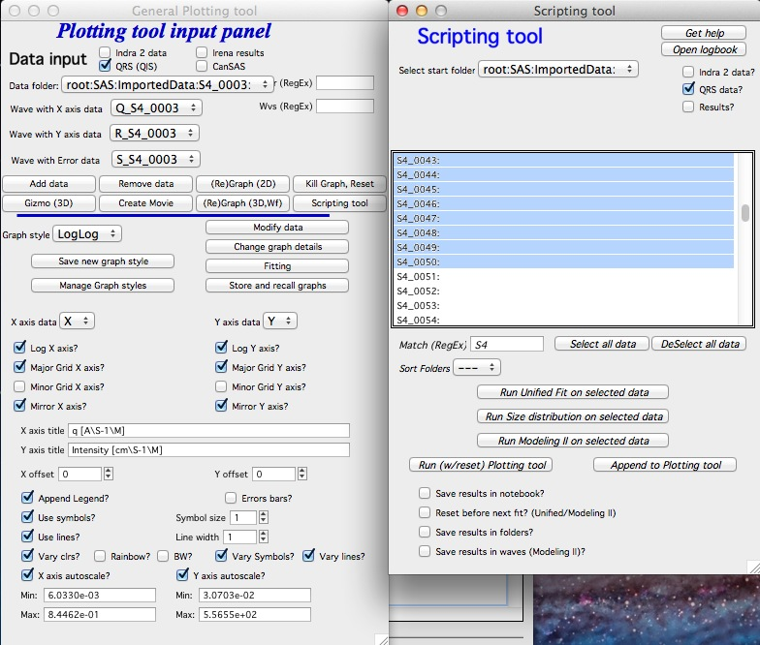

You can use the scripting tool to either rest Plotting tool and add the files or just add files to existing files already in the plotting tool using one of the two buttons:  
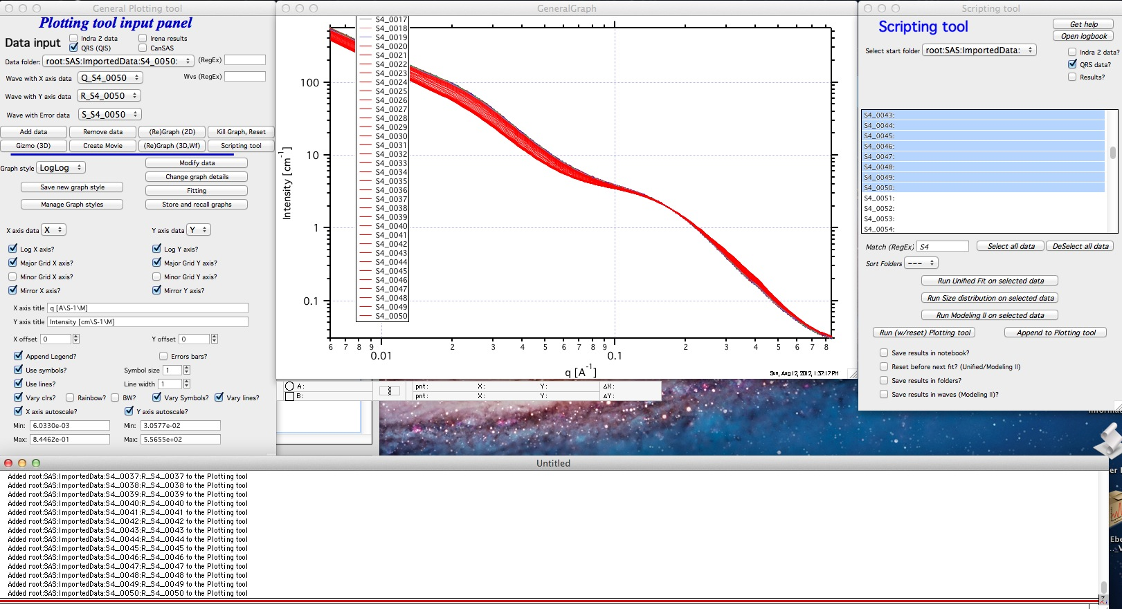

The plot of these data (time series of SAXS data) is not very informative in any presentation... Therefore now we have two 3D options...

### Waterfall 3D graph

Using the button "(Re)Graph (3D, Wf)" you can create Waterfall graph. It is fast and kind of very simplistic.

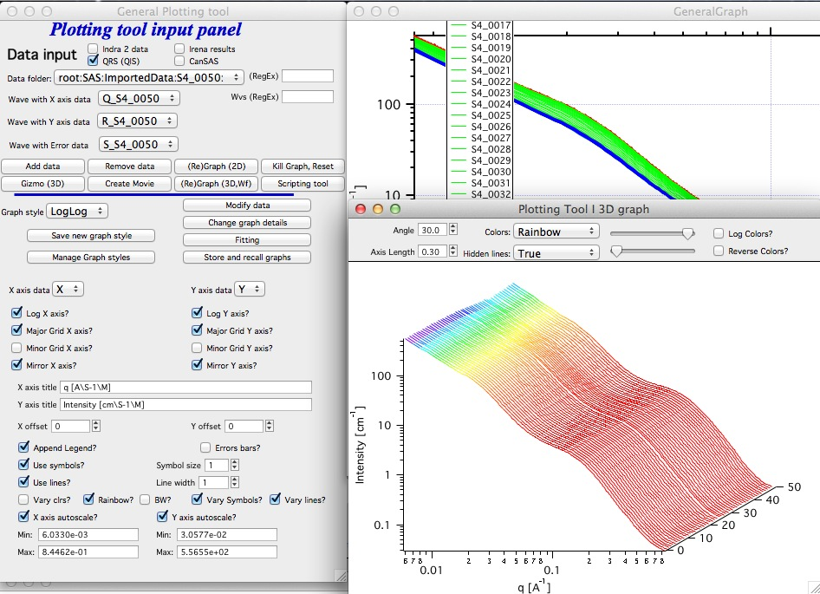

There are some controls at the top which enable small changes to presentation of this graph...

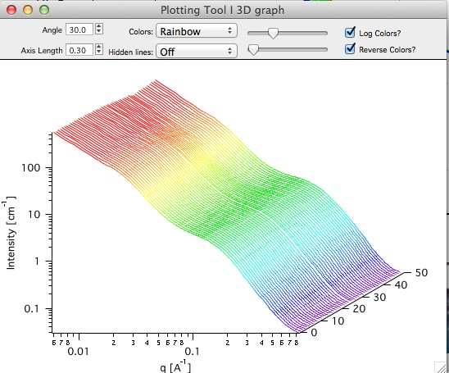

But not that much...

### Movie making

To present time series of data version 2.48 can create movies. Use button "Create movie" and ne panel is created:

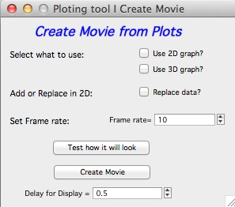You can create sequence of 2D graphs or 3D graphs, in 2d graphs you can either add the data in between the frames or replace the data in between the frames. Few other controls allow you to control how the movie is going to look like. The 3D graph here is the Waterfall graph described above, Gizmo has its own movie creation tool provided by Wavemetrics.

### Gizmo 3D graph

Using Gizmo in Igor is much more advanced and this tool is under development in version 2.48. More functionality is likely going to be added.

To start, push button "Gizmo (3D)", at least 3 data sets are necessary...

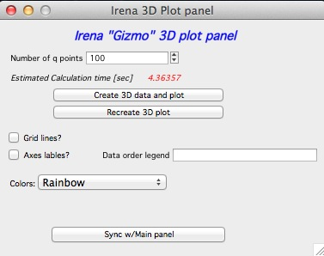To use Gizmo one needs to resample the data to create smooth plane data on grid pattern. Therefore we need to resample q scale. Note that if the main panel has "Log X" selected, log(q) will be used for this tool. Also if the main tool has "Log Y axis" selected, log of Intensity will be used. This may be correct for SAXS data, but not for Size distribution for example. If main tool has these Log choices unselected, straight data will be used.

Note that this calculation may take a lot of time, especially when input data have a lot of points. Therefore there is Estimated Calculation time - which is kind of approximate for my Macbook Pro, your times will vary. But it tells you if it takes short time or lot of time. Better feedback ("get coffee" may be provided in the future.

The button "Create 3D data set and plot" will - as indicated - create the 3D data and plot them. The button "Recreate 3D plot" will use existing data (it exist) to recreate the 3D plot. It will be much faster, but the data may be stale.

Choices of Grid lines and Axes labels = legend are left to user. Note, that the x axis and z axis are taken from the main plot panel while the "data order" legend is in this panel. Color scale is common with Waterfall 3D graph. Other controls may appear in the future.

Since this tool does not know about the main panel, if there are changes to the main panel you need to push button "Sycn w/main panel" to update the Gizmo plot:

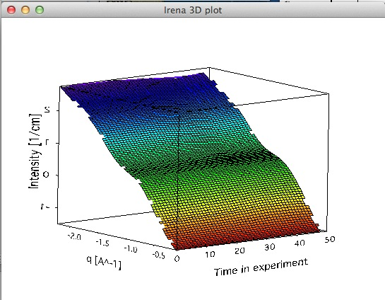

Note, that Gizmo has manytools associated with it in the menu as the controls for it are kind of awkward at this time. Major upgrade is planned for Igor 7.

You can create movies of rotation of the Gizmo plot, control its visual look, etc. More controls is likely to appear in the future, but final version of this tool is likely for Igor 7.

## 4.3 Plotting tool II

This is modification of plotting tool developed by Dale Schaefer. This tool control ANY top graph. It can, therefore, be used more flexibly – but has some limitations… This tool is likely to be developed more in the future.

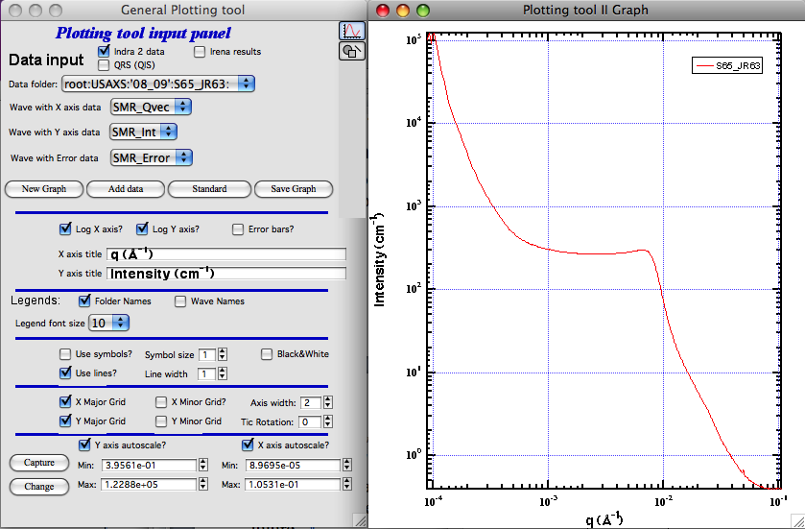

The GUI contains selected controls and any change in this GUI is applied to the top graph. Note, that compared to Plotting tool I, which at each modification reapplies all formatting to the graph it controls, this tool applies only the control which has been changed. Therefore, this tool is basically ONLY different GUI to Igor controls – combined with convenient Irena data selection tools.

# 

# 5. Scattering contrast calculator

## 5.1 Introduction

Calculating scattering contrast for various compounds is annoying “monkey” work, which can be easily left to computers. The tool in “Irena” at this time allows one to calculate the X-ray and neutron scattering contrast for compounds with up to 24 atoms, with known density, with known atomic fractions and **with no energy dependence**. Energy-dependent anomalous scattering effects (for X-rays) may also be considered by an additional level of this tool (see button marked "Anomalous calculator" in lower right corner).

## 5.2 Running Scattering contrast calculator

Select from menu “SAS” item “Scattering contrast calculator”:

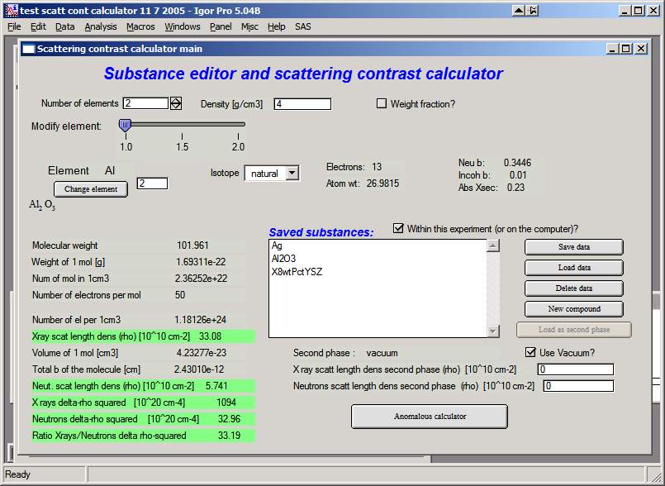

This is the interface. At the top, select number of atoms in the material, set its density and check the check box if you want neutron data displayed. Let’s select 2 atoms, may be Al2O3 (Corundum) with density of 4 and see neutron results. This is the picture after this selection

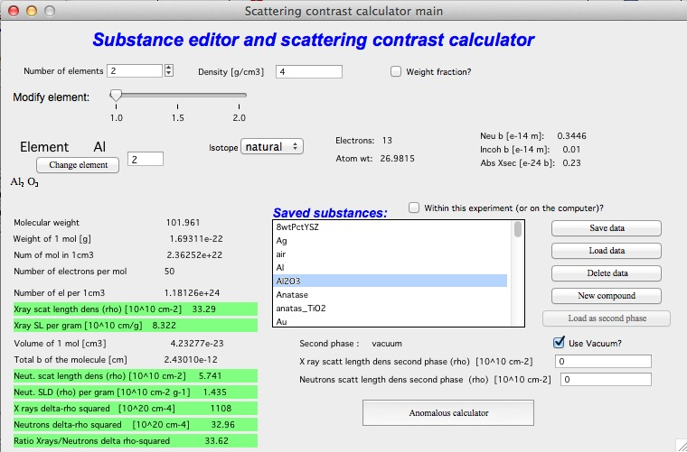

Use slider to select each element and check it’s properties – amount in molecule, Isotope etc. Input is done through Periodic system table (push Change element button). To continue, close the table…

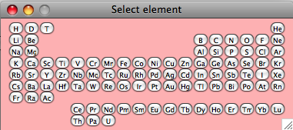

Most of the fields is filled automatically with data from internal databases of this tool. In the lowest part of the tool are results and intermediate calculations of this tool – so one can obtain various numbers, which needed to be calculated.

## 5.3 Use of matrix

To calculate delta-rho squared … (matrixscatterer)2 ... we need to set scattering length density of matrix. This can be done in numerous ways:

* 1. Write the numbers directly in the fields provided
  2. Calculate the matrix scattering length densities and use “Set as matrix” button
  3. Save matrix data using “Save data” button and then load them as matrix “Load matrix data”

In each case the values for “delta-rho squared” should be recalculated. Note, that if checkbox “Use vacuum as matrix” is checked, vacuum is used as matrix and no selection for matrix is available…

## 5.4 Saving data

This tool has “saving” feature, which allows to save the compound parameters in such way, that it can be used in the future. The data **can be saved either INSIDE the current Igor experiment or OUTSIDE Igor experiment**. Compounds saved outside ***are available to any Igor experiment on that particular computer***. But experiment moved to another computer will not have these compounds saved…

To select where compounds are saved, use checkbox “Within this experiment(or on the computer)?

Use buttons “Save data” to save current compound, modify name as necessary – keep in mind to keep the “” around the name and use characters allowed as file names. Limit name to 27 characters or so (Mac name limitation).

Use buttons “Load data” to load data in the tool and “Load matrix data” to load data as matrix ONLY…

Comment: Due to rounding related to saving the data in ASCII file, there will be rounding error when using “Load matrix data” in the “delta-rho squared” calculations…

Button “New compound” will clear all settings in the tool to start creation of the new compound.

**New comments on saving the data:**  From this release the compound data are saved with in the same place where the Irena macros are stored. This is to allow users of limited privileges to run and operate. See above comments on macros installation.

## 5.5 Anomalous calculator

The package includes Cromer-Liberman code for calculating energy-dependent (anomaouls) effects. The button “Anomalous calculator” on the “Substance editor and Scattering contrast calculator” calls up new window…

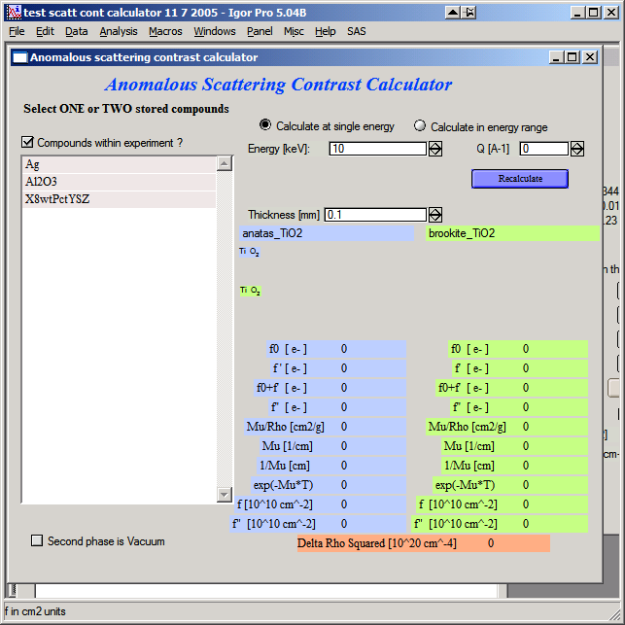

Use of this tool:

Select one or two compounds created and SAVED in previous (regular scattering contrast calculator). If you select only one, use vacuum as second phase (checkbox below the selection of compounds). Then select, if you want to calculate values at one energy or in energy range. Note, that calculating values for large number of points may take quite a long time.

To select two compounds hold shift. Then input right thickness and click “Recalculate”. Fill in the Q if you need values at higher Q values (for small-angle scattering assume Q=0)…

**For single energy following appears:**

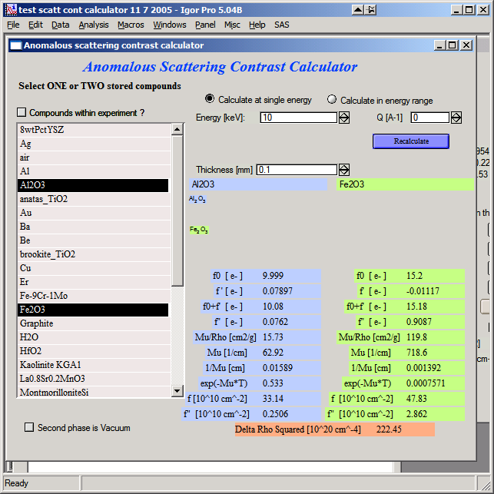

Note, that table on right got filled with all relevant numbers – f`’, f’’, , and related values for each compound separately. Note, that f’ and f” are here with two different units as output – in electrons per molecule unit and in 1010 cm-2. Lowest number is delta-rho squared between the two compounds at this energy…

**For range of energies:**

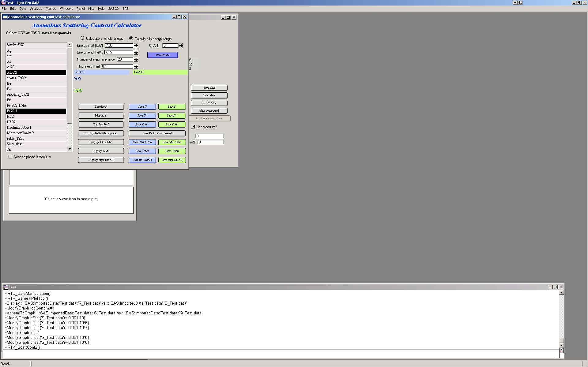

Fill in the range of energies, number of steps you want to calculate (equidistantly spaced between min and max energies) and other parameters. The push “Recalculate”.

The buttons “Display” create graphs of appropriate parameter, see for example below:

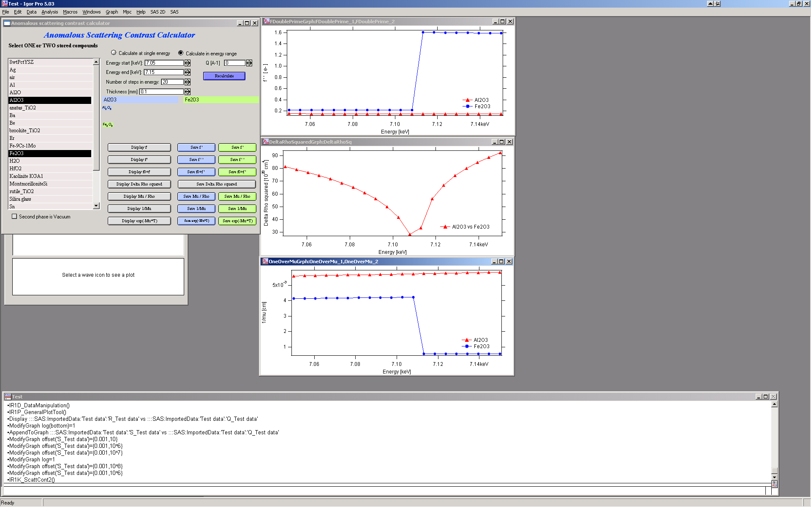

Buttons “Save …” save the wave with the data into Igor folder of users choice. The dialog should be easy to use and allows user to create new folder, select name for new data etc. Note, the data are saved as waves with so called “x-scaling”. To learn more read Igor manual.

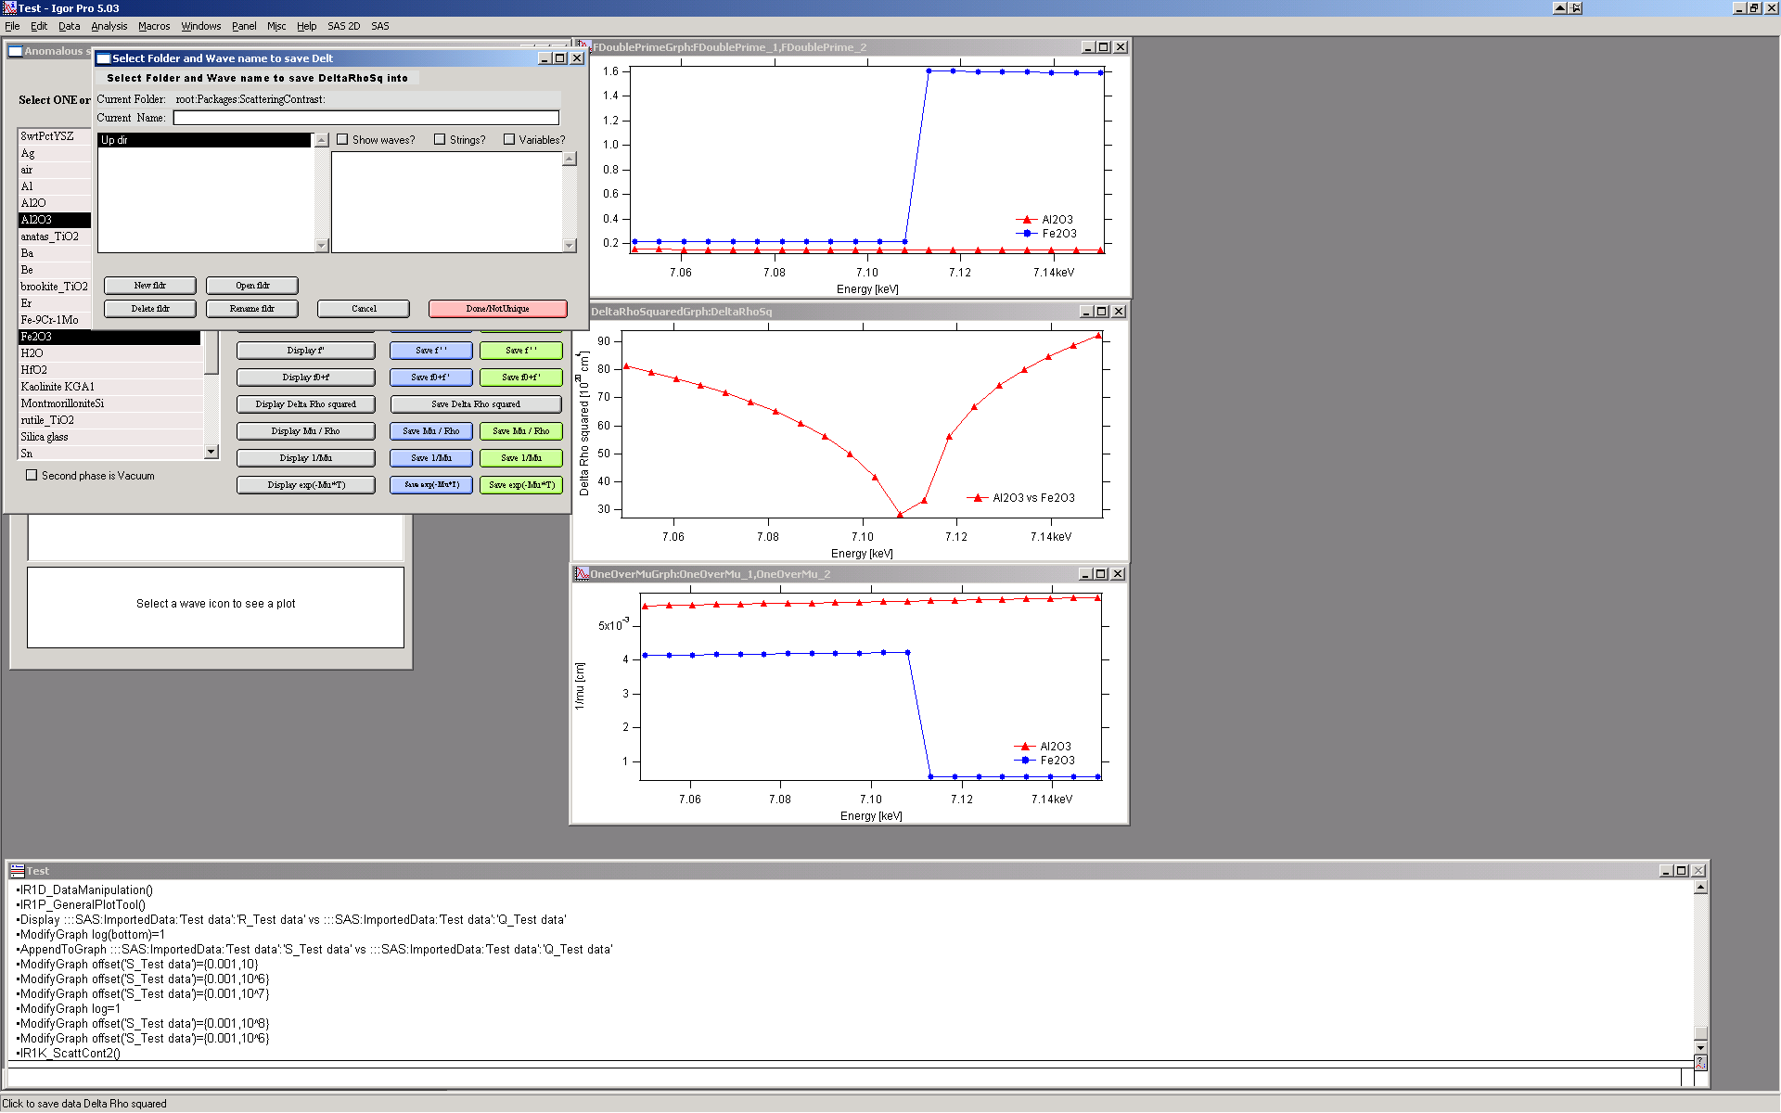

# 

# 6. Unified Fit

#### 6.1 Introduction

The Unified fit uses code developed by Greg Beuacage to fit SAS data with levels composed of a Guinier part and a power law tail. The code handles various data for which the development of an exact scatterer model is difficult or impossible. The fitting code can handle some interparticle interference, fractal scatterers *etc*. For details, please see papers written by Greg Beuacage or, hopefully, in the future an included description.

**This is introduction written by Greg for this code**:

*This fit uses the function described in*

*http://www.eng.uc.edu/~gbeaucag/PDFPapers/Beaucage2.pdf*

*http://www.eng.uc.edu/~gbeaucag/PDFPapers/Beaucage1.pdf*

*http://www.eng.uc.edu/~gbeaucag/PDFPapers/ma970373t.pdf*

*The basic function is composed of a series of structural levels, each with the possibility to be*

*a) associated with the previous smaller size level (Rcutoff2 = Rg1 in I2highq=B2q^(-p2)exp(-q^2Rg1^2/3) for the power-law region of 2)*

*b) to follow mass fractal restrictions (calculate B for the mass fractal power law I = B q^(-p)*

*c) to display spherical Correlations (Interference) as described by I(q) = I(q)/(1+p f(q etai)) where p is a packing factor 8*vH/vO for vH = hard sphere volume and vO is occupied volume and f(q eta) is the sphere amplitude function for spherical Correlations (Interference)*

*The intensity from each level is summed and the intensity from one level, i, is given by:*

Ii(q) = Gi exp(-q^2Rgi^2/3) + exp(-q^2Rg(i-1)^2/3)Bi {[erf(q Rgi/sqrt(6))]^3/q}^Pi

$$I_{i}\left(q\right)=G_{i}e^{-\frac{q^{2}R_{g}^{2}}{3}}+e^{-\frac{q^{2}R_{gco}^{2}}{3}}B_{i}{\left\{{{(\operatorname{erf}\left(\frac{qR_{g}}{\sqrt{6}}\right))}^{3}}/q\right\}}^{P_{i}}$$

This equation includes a) above if Rgco = Rg(i-1) is the previous smaller Rg e.g. the primary particles from a mass fractal level. If there is no such dependence Rgco = Rg(i-1) is set to 0 or it could be set to an independent size under unusual circumstances

This equation can include b) if Bi is calculated using Bi = (G df/Rg^df) GammaFun(df/2) and the erf argument includes kqRgi/sqrt(6) where k is 1.06. The latter can be included or ignored for high dimension mass fractals but becomes more important for dimensions less than 2.

The equation can include c) by multiplying the entire level Ii(q) by a function that follows the Born-Green approximation for Correlations (multiple particle Correlations) and this works well for weak Correlations of any type but becomes more restricted to spherical Correlations as the Correlations become stronger. The measure of the strength of the Correlations is the packing factor p = 8 vH/vO as described above and for spherical particles this value can be 0 (no Correlations) to about 5.92 (calculated for FCC or HCP packing).

*The packing factor for FCC is p=8*Vh/Vo = 8*(pi*sqrt(2)/6)=5.92 - this is basically the total volume of lattice points in FCC divided by the volume of the lattice (provided to me by one nice Irena user)*.

If particles are asymmetric, *e.g.,* rods or sheets the packing the number can be much higher and the spherical function becomes less appropriate although it can be used in a pinch for weak Correlations. The interpretation of p and eta become complicated in these cases. As a general rule has to be larger than Rgi as common sense would dictate. The correlation function follows closely the development of Fournet in Guinier and Fournet and in Fournet's PhD dissertation where it is better described but is in French...



So the Unified needs to accommodate multiple levels each of which can potentially have 8 parameters (including spherical Correlations):

Rgi,

Gi,

Pi,

Bi,

etai,

packi,

RgCOi, k where RCOi is usually Rg(i-1), as shown above, for hierarchical structures (k is 1.06 for mass fractals and 1 for others)

Each level must also have the answer to at least three questions:

Are there Correlations: qCori.

Is this a Mass Fractal: qMFi.

Does this level terminate at high-q in the next lower level Rg: qPL (PowerLimit) That is, is this a hierarchical structure build from the previous smaller level. A third option is to let the power law limit float as a free parameter although this is rarely appropriate.

As Gregg wrote me:

“We have several options for coding the unified function.

a) Write a dedicated code for a specific morphological model where all of the parameters are defined in terms of the model. We have done this for correlated lamellae, rods, mass-fractals, spheres, correlated spheres, RPA based polymer blends of arbitrary fractal dimension, polymer gels among others.

b) Write a generic unified code that allows a high degree of flexibility but which is naturally complex.

For cases where you deal with a fairly complex and limited structural model option a) is most appropriate and is easiest to understand. We can't however write such code for each and every case. Several of our publications indicate how to go about calculating the unified parameters, for instance for a sheet structure 8 parameters in the unified equation (for 2 levels) reduce to 3 free parameters, the contrast, thickness and diameter of the sheets. Similarly rods can be described by 3 parameters the length, diameter and contrast. Correlations in both systems add 2 other parameters although the spherical correlation function can not be rigorously used except at extremely weak levels of correlation.”

This code deals with approach b) where only spherical correlations are dealt with but including an optional mass fractal limitation (strictly limited to linear chains but useful for branched structures in application).

#### Helpful hint on use of Invariant:

The invariant INV is:

INV = 2*pi2*(1-)*

To use correctly, one needs to convert the Unified provided invariant to cm-4 by multiplying by 1024   
(from cm-1A-3 to cm-4)….

#### Helpful hint on use of Porods law:

The specific surface area Sv is:

Sv = B / 2*pi*

Where B is Porods constant – it is the value you get from Unified fit when P=4. To use correctly, one needs to convert the Unified provided B to cm-5 by multiplying by 1032   
(from cm-1A-4 to cm-5)….

NOTE: from version 1.37 Unified has “Analyze results” tool, which can analyze also Invariant, Porod’s law and some other specific cases.

## 6.2 Running Unified fit

Select “SAS” – “Unified fit”. Following is the screen you should see after initialization:

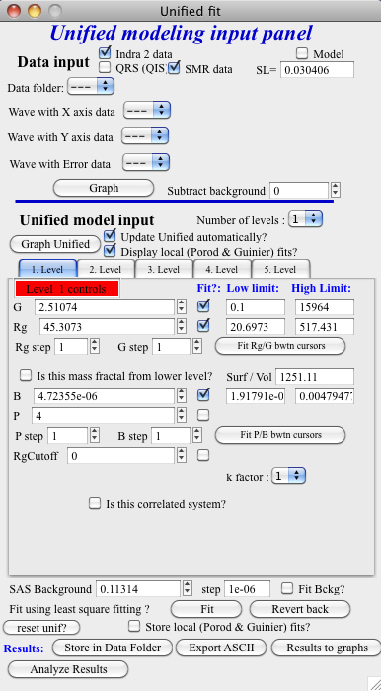

In the top part again deselect “Use Indra 2 data”, or “Use QRS data” or none checkbox and then select data as seen below and push button graph:

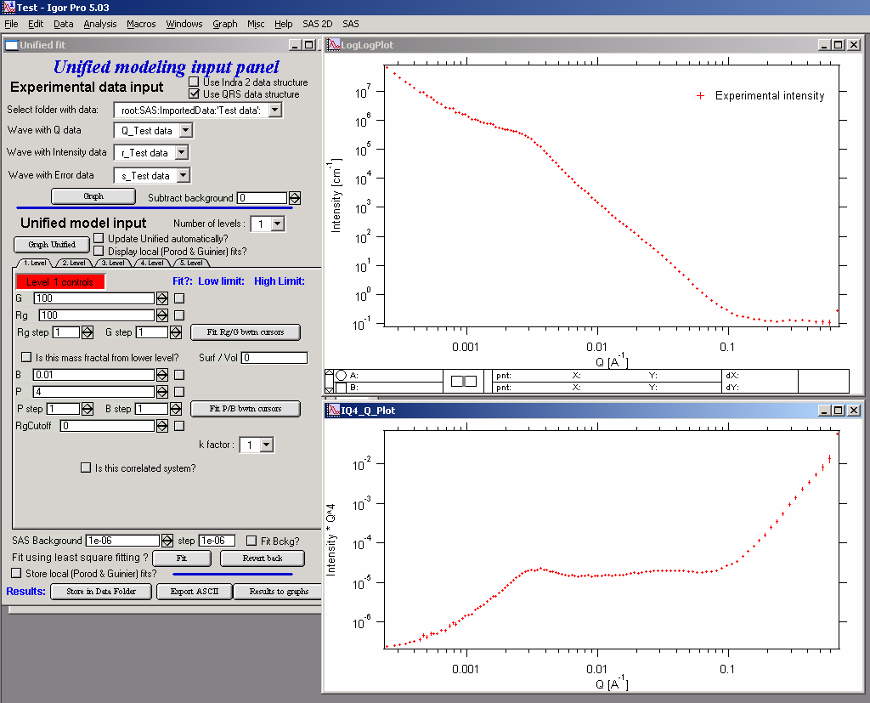

The two graphs which appear show selected data in two different views – top graph is log-log Intensity vs Q vector, bottom part is Intensity * Q^4 vs Q vector, this represents S(Q) as known from scattering theories.

**ALL USER INPUT IS IN THE TOP WINDOW (log-log plot)**

Controls above the tabs:

Graph Unified button recalculates model and puts it into the graphs

Update automatically checkbox if any change to model parameters is made, automatically recalculates (i.e., automatically pushes the button Graph Unified). Uncheck on slow computers.

Display local fits displays local Guinier and Porod fits in the graphs for active tab level

Number of levels selects number of levels displayed. Note, that at no time parameters for not displayed levels are reset, so user can switch between number of displayed (=used) levels freely…

Now, when we have the data we will start building the structures from large Qs…

Select the number of level 1, check Update Unified automatically (if used computer is fast enough, else push the button Graph Unified)…Click on the Tab “1. level”. What appears is the screen shot:

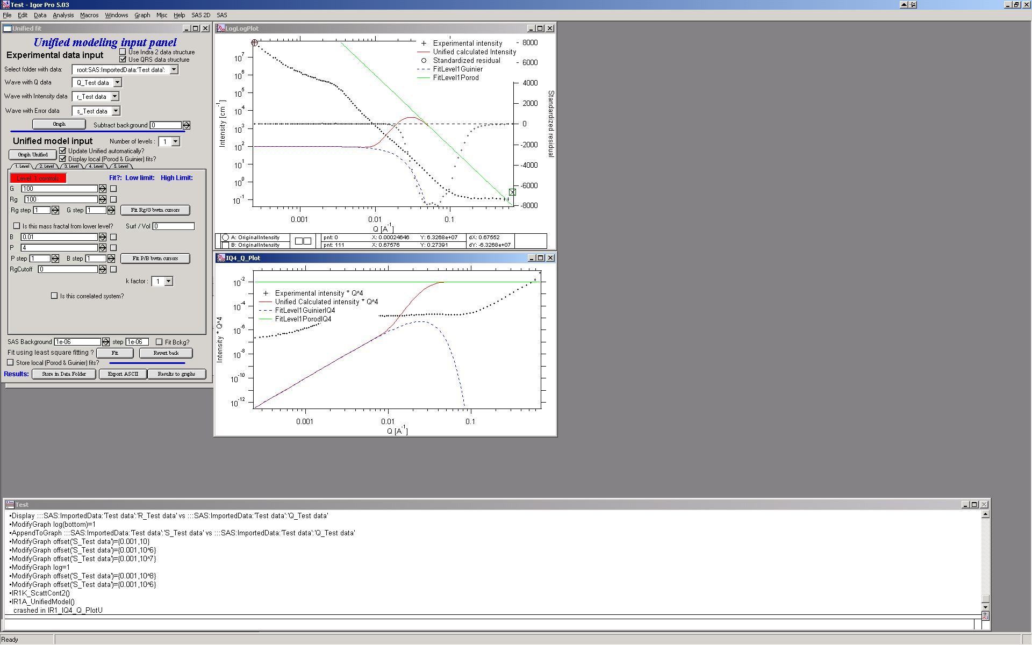

Description of the Tab area in the panel:

This area changes according to parameter selection etc. I have tried to put in this as much “smarts” as possible to help user make right choices, so parameters, which are not applicable at any given time should be invisible… Anyway, each parameter has most controls grouped on one line – that is current parameter value, checkbox “Fit” and (if Fit is selected) limits – low and high fitting limits. Further more underneath the parameters is the parameter step variable. This allows the user to select the magnitude that a parameters changes by pushing the arrows at the end of it’s field. This allows user to “walk” the parameters into their starting condition as best as possible. There are also buttons for local fits. If the checkbox “Is it correlated system” is selected, new parameters appear. Also the screen changes, if the checkbox “Is it mass fractal from lower level” is selected….

The new red line in the graphs represents the results f the model for default values of level 1. Now, we need to make this level fit the smaller particles Guinier and Power at Q ~ 0.025 A-1. This shoulder is better visible in the bottom graph. Also we need to include appropriate background…

Change background (under the tabs field) into the 0.1

Select point 76 –87 on the top graph using cursors and check “Fit” checkboxes next to G and Rg. These parameters will be fitted in between the cursors. Push button “Fit Rg/G bwtn cursors”. The following should be result:

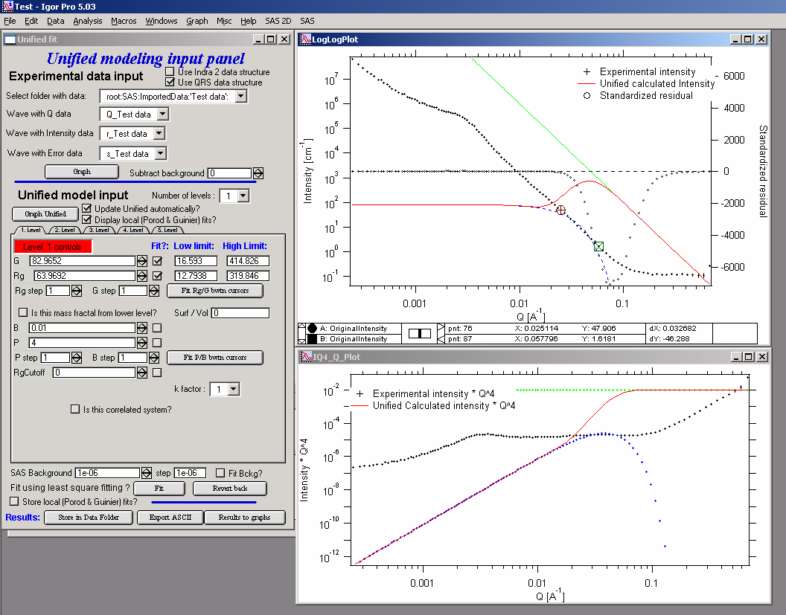

The blue line in the graphs now is the Guinier fit. Next select points 84 to 92 with cursors, check boxes “Fit” next to B and P and push button “Fit P/B btwn cursors”. Now we get the power-law fit on this area:

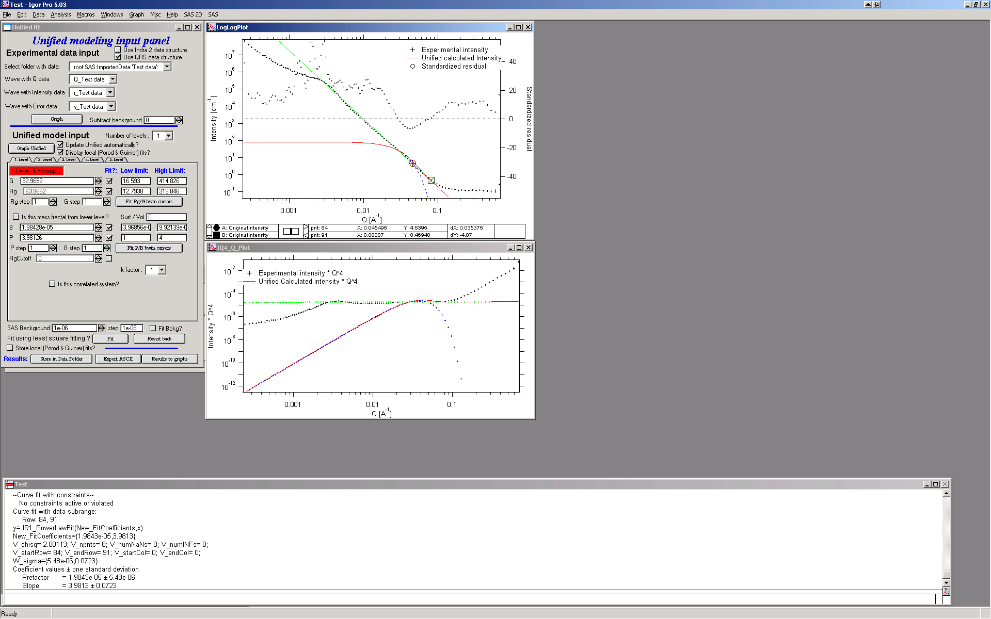

The green line is local fit for the power law dependence. Notice, that the fit to the data in the modeled q range is now reasonably good, including our background estimate.

You can also guess flat background, or check the checkbox “Fit Bckg?” and let the least square fitting (next below) to estimate the best guess for the flat background.

Now we can fit the whole Level 1 dependence. Select large range of data (points 77 – 109) and check “Fit” next to background parameter. Then push the fit button. This runs least square fitting on the data.

Comment:

If the least square fit fails, it should automatically return all values where they were before fitting. If the fit “walks away” to a solution, which is not right, the user can push the “Revert Fit” button and the parameters are returned back to where they were before fitting.

Only parameters selected to fit (checkbox “Fit” next to them) are fitted – **BUT FROM ALL ACTIVE TABS**. Therefore if using more than one level make sure you have selected only the appropriate parameters from all levels that you want to vary in this fit. ***These fits can be highly unstable, if starting conditions are not right***….

Ok, level 1 looks fine and the background also. Uncheck all fit boxes in the panel and then select Number of levels as 2. Click on tab with “2. level”.

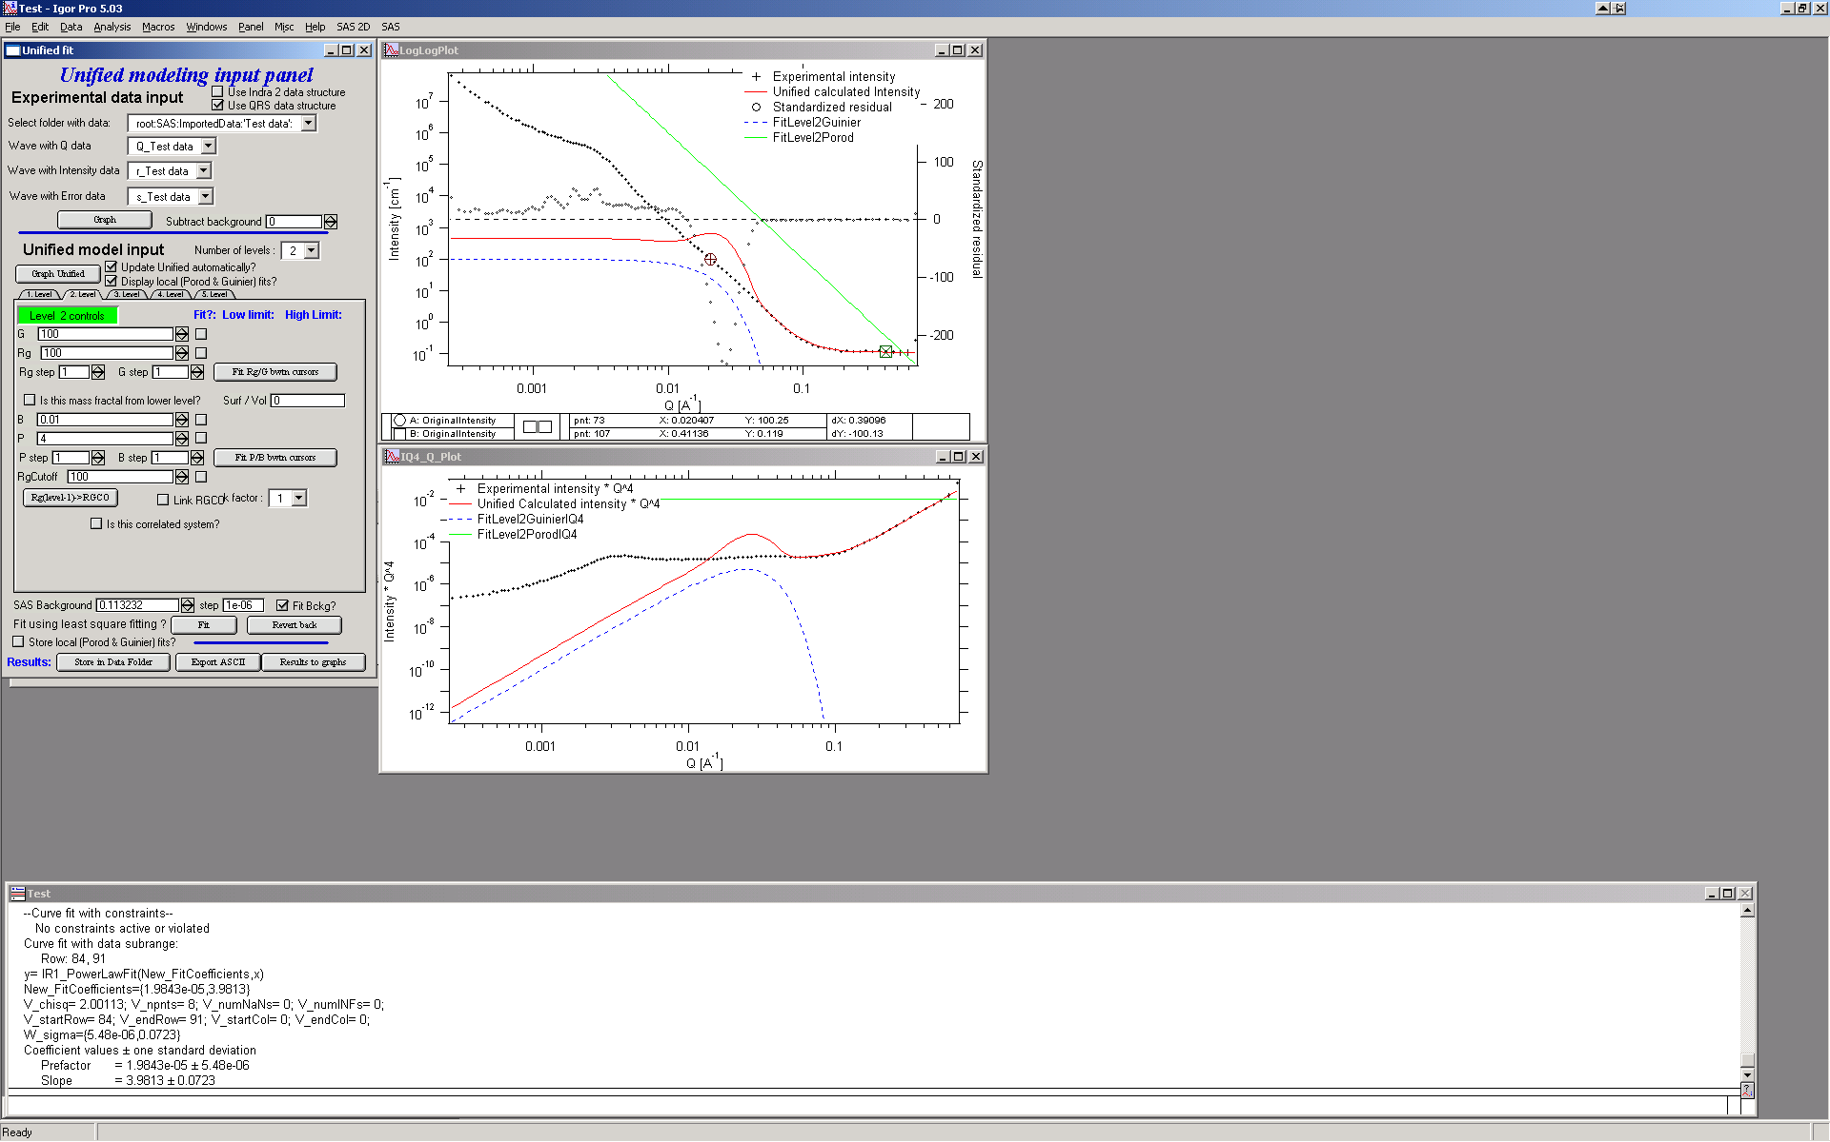

The green and blue lines in at this time represent default values for level 2. If you click now on tab of 1. level, the blue and green lines will be set for local fits for level 1, if on tab with level 2, they represent local fits for level2., etc…

Let’s do local fits for level 2. Set cursors between points 31 and 48. The default values for the parameters are way too far from the expected values and the fit may not converge starting from them. Therefore change the G significantly higher (just add few 0 to make it may be 100 000 or more) and increase the Rg to some higher number (500 or so) also. Note, that the blue fit line moves closer to the measured data. Next push “Fit Rg/G bwtn cursors” button. Fit should converge to following solution:

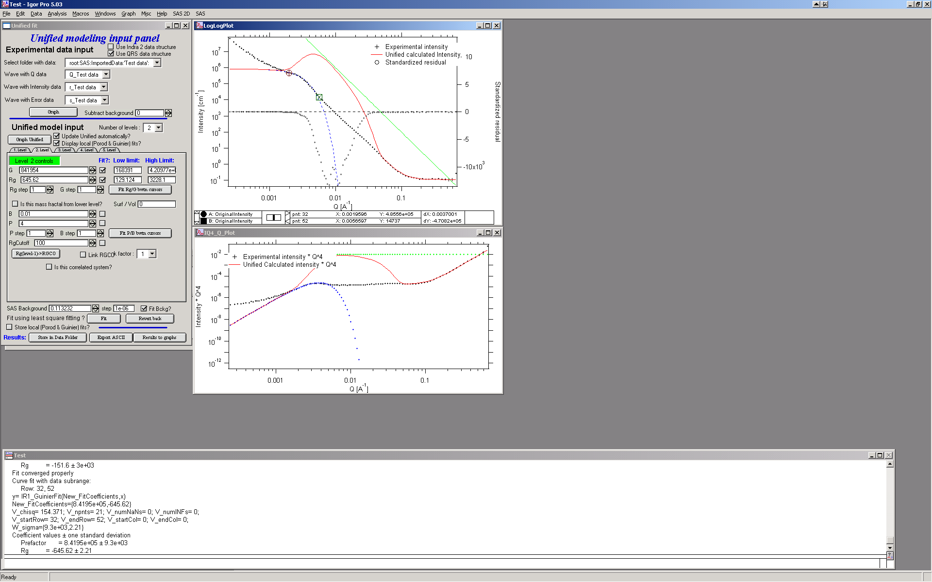

Now we need to do something similar for power law dependence. Select points 47 to 63, reduce B to about 0.00001, select “fit” checkboxes there and do local fit. Following should be the result:

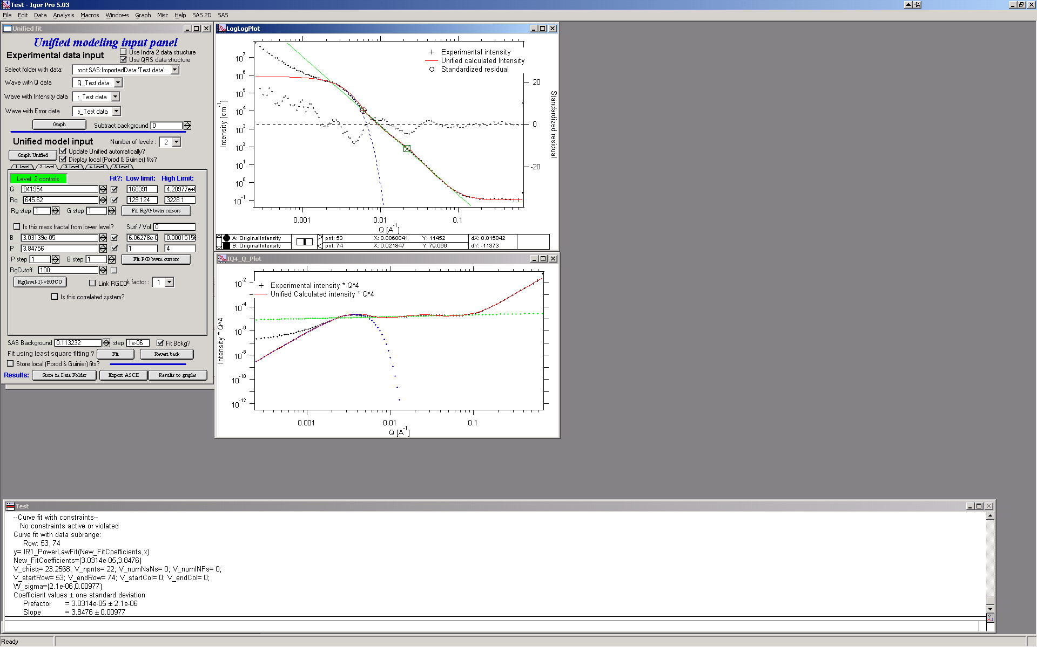

Now we can select area with this level only and optimize the parameters of Both Guinier part and Power law part together:

Select point 31 to 63, make sure that other levels (in th3 current case the level 1) parameters have deselected checkboxes Fit, and push fit button. If you get error message that limits are incorrectly selected, check, that starting conditions for that parameter are between the limits. This is very important…

In this case the reason for error message is the fact, that power law slope starting value is 4.2, which is not physical. Change that to 4 and fix it by deselecting the Fit checkbox. The do the fit:

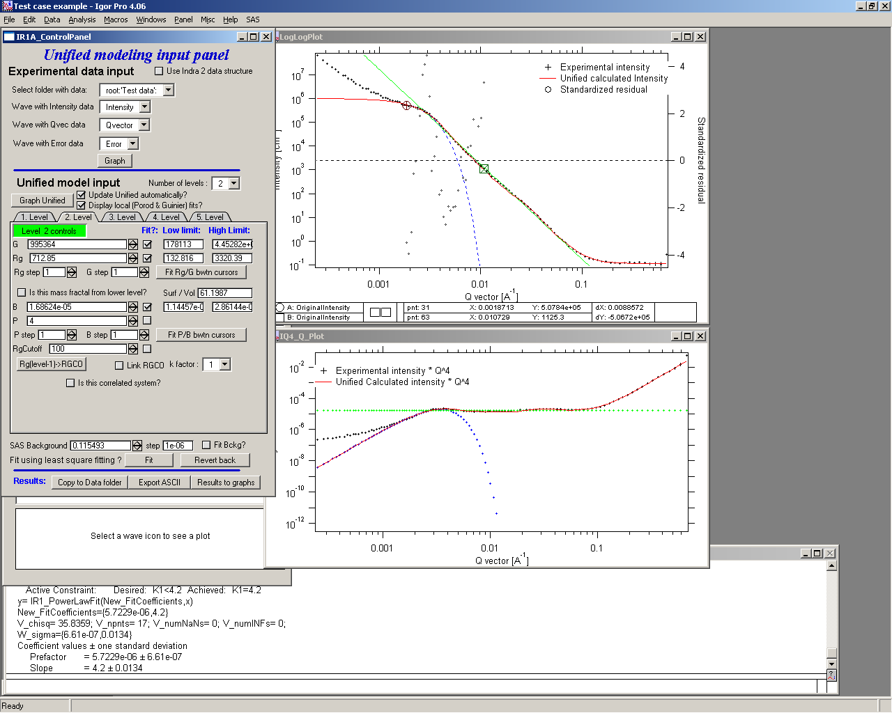

And now is the time to broaden the data range and fit both levels together. It is not necessary to fit background, but should not hurt… Select points 31 to 103, check all parameters for level 1 and level 2 to fit and then fit.

Note, that in this case (this was mixture of two powders) the right setting for the Level 2 (large particles) RgCutoff (RGCO) parameter is 0, since the scattering from these large particles extends to even largest qs. Therefore, to get good fit one needs to set RGCO to 0 and rerun the fit. Some modification of starting conditions may be necessary (I had to set B for level 2 to lower number to get stable solution). But one can get really good solution:

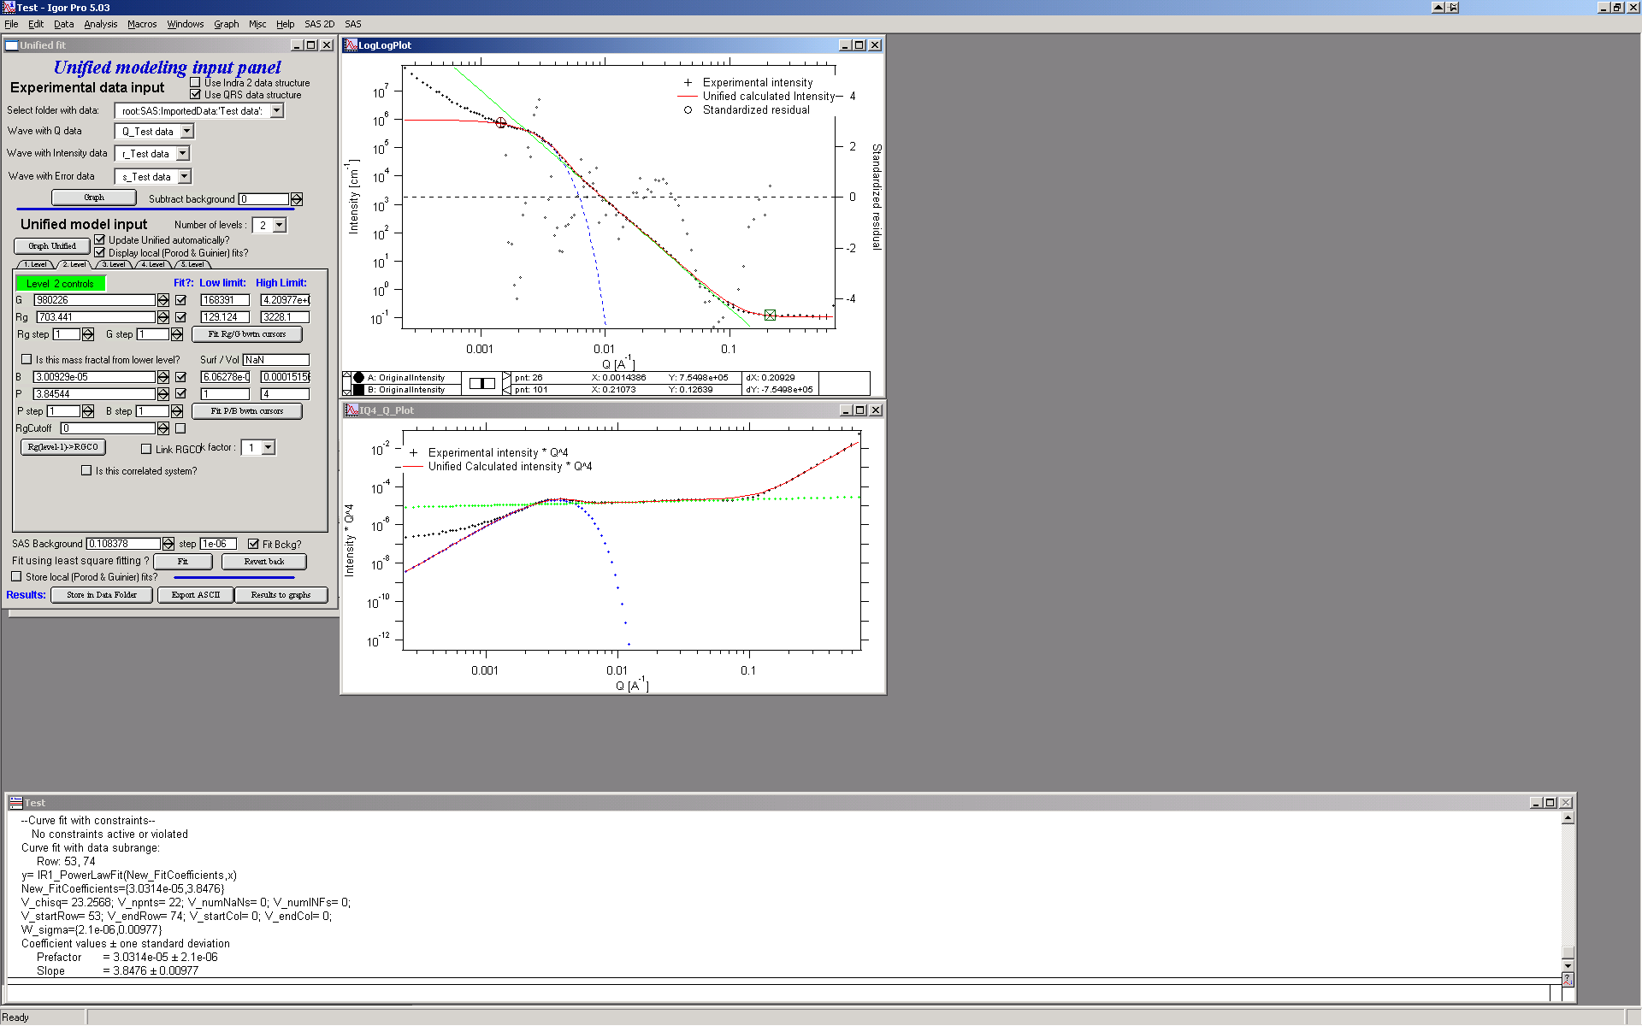

Last part, which may need to be solved, is the power law tail at smallest Qs from something large. To do so, we can use trick of this method – create level, which has really large Rg, but G is 0, This removes effectively Guinier area from the calculations. Then we are left with power-law only. To do so, create level 3 and select the tab with level 3. Set G to 0 and Rg is automatically set to 1010. Now we need to fix only the power-law part. Modifying the B and P manually is the best method in this case… A good guess clearly is about 3*10-7 for B and P roughly 4.

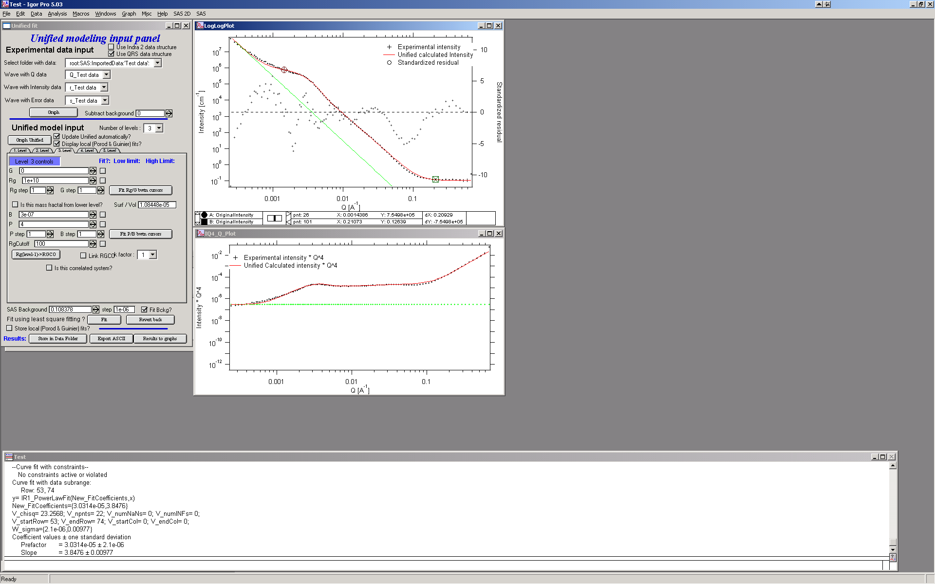

Now select wide range of Q’s – points 103, select parameters to fit (possibly all, but that will take longer) and make sure the limits (especially for level 3!!!) are set correctly. Note, that Level 3 Guinier parameters should not be fitted! Then push button fit.

And we receive nice solution:

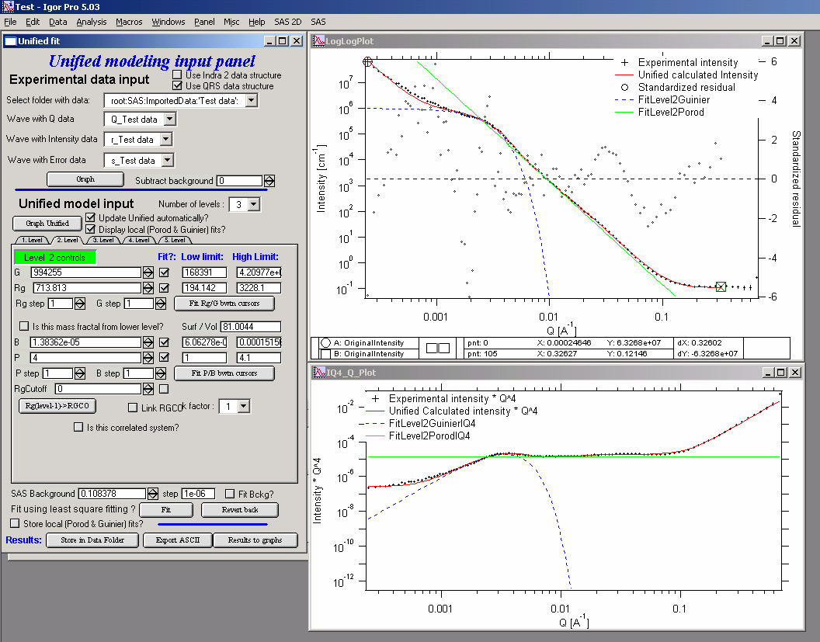

Notice the standardized residuals in the top graphs are reasonable for all Q’s suggesting that we have right number of levels. It may be possible to improve the fit by including some correlations – the powder could have been compacted quite a bit, but I leave that to user to figure out more…

## 6.3 Correlations

If inter-particle interference is not negligible, then for reasonably weak interferences the code has built in simple model for modeling those. This is simple model, which is realistically valid only for gasses and is only approximation. For details see publications by Beaucage.

**User should be aware of the crudeness of these calculations.**

The code used for calculations involves correcting intensity from a level using this formula:

Intensitywith interfernce(Q, R) =Intensitywithout interference * (1+*pack*\* SphereAmplitude(Q, *Eta*))

Where the *pack* and *Eta* are the two parameters of this model.

Note, that this is supposed to be valid for spheres. I am working on adding other methods for other arrangements of particles.

**Remember**: this method accounts in very crude way ONLY for interaction for particles in the particular population. If there are interactions among particles from different populations – which is very likely – these calculations have NO WAY to account for it.

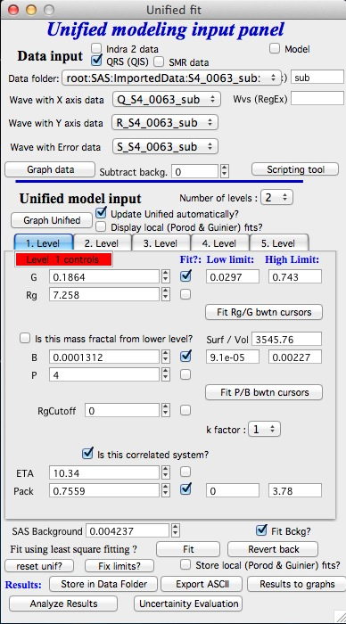When checkbox is selected for correlations, new windows appear – ETA (distance between the layers) and Pack (fill of the first layer). Smaller the Pack, less interference. The ETA should not ever bee smaller than size of particles, and actually should be larger…

## 6.4 RgCO again – main warning

My experience has shown, that one of the least understood parameters of the whole Unified fit seems to be RgCO parameter. Here is more details on this parameter:

If you look in the formulas and what this parameter actually does, you will see, that it terminates very steeply scattering form given population by the time the one reaches Q ~ Rgco. Therefore the level becomes unimportant at q higher than equivalent of Rgco.

There are two cases when one needs this parameter and both relate to case when higher level and next lower level represent scattering from the same volume of materials.

1. Scattering from particles having two main dimensions – such as rods, disks etc. In this case the form factor (see the pdf list of form factors) exhibits two Guinier regions connected by relatively shallow power law slope. After the higher-q Guinier are the terminal slope is Q-4. In order to be able to describe this type of behavior the higher level power law scattering MUST be terminated by the time we reach the lower level Rg.
2. Scattering from fractals which exhibit more than one characteristic dimension in the measured Q range. The argument here is VERY similar. Imagine fractal measured over such q range, that one can see the fractal behavior (higher level) but also time when you can see the primary particles. This very much resembles the case 1, except it is less clear.

My general simplistic rule is, that if the two levels represent scattering **FROM ONE POPULATION (VOLUME) OF PARTICLES** then the RgCO must be set, if these are different populations (having their own volumes) then the scattering is additive and RgCO should be set to 0 for both of the levels.

## 6.5 Output from Unified

Result scan be either copied back to folder where the data came from, exported as ASCII, or little macro will include for each level text box in both of the graphs. User than can modify fonts/size etc and print. I need to make this later more user friendly to give more flexibility…

Further the data can be exported into Excel table using “Export to XLS file panel”. This macro was written by Greg Beaucage and I need to learn myself little bit better what it does. But it allows output results into spreadsheet for publication.

Use the buttons at the bottom of the panel.

### Copy to Data folder

If checkbox “Store Local (Porod & Guinier) fits?” is selected, then saved are not only final fits but also all local fits too.. This creates large number of waves, but provides separated outputs for various levels – allowing to use these data for further separate analysis…

After pushing the button user gets input dialog:

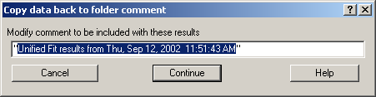

In which any useful comment can be inserted (modify default). Note the quotes. They have to be there…

Then program saves following waves in the folder with original data:

UnifiedFitIntensity_0

UnifiedFitQvector_0

The _0 is generation number. User can save large number of solutions, with increasing _XX where XX is number. When Unified is run on data in folder, where Unified solution exists, user can recover any present solution – all parameters are put back in the panel, this allows user to quickly return back to previously saved solution, whit out need for recording the results.

All Unified fit parameters are saved in the wave notes of the above listed waves. This list is quite extensive and hopefully the names are descriptive enough. User can interrogate them either in data browser or using Igor built in tools (read functions “note”, and “StringByKey” resp “NumberByKey” manual)…

This is the example of the list in this case:

IgorExperimentName=Test case example;DataFolderinIgor=root:'Test data':;DistributionTypeModelled=Number distribution;NumberOfModelledDistributions=2;SASBackground=0.12257;Dist1ShapeModel=sphere;Dist1ScatShapeParam1=1;Dist1ScatShapeParam2=1;Dist1ScatShapeParam3=1;Dist1DistributionType=LogNormal;Dist1Formula=P(x)=(1/((x-loc)*scale*sqrt(2*pi)) * exp(-ln((x-loc)/scale)^2/(2*shape^2));Dist1NegligibleFraction=0.01;Dist1VolFraction=0.0024333;Dist1Location=21.79;Dist1Scale=87.731;Dist1Shape=0.5;Dist1VolFractionError=8.698e-05;Dist1LocationError=16.734;Dist1ScaleError=5.8733;Dist1ShapeError=0;Dist2ShapeModel=sphere;Dist2ScatShapeParam1=1;Dist2ScatShapeParam2=1;Dist2ScatShapeParam3=1;Dist2DistributionType=LogNormal;Dist2Formula=P(x)=(1/((x-loc)*scale*sqrt(2*pi)) * exp(-ln((x-loc)/scale)^2/(2*shape^2));Dist2NegligibleFraction=0.01;Dist2VolFraction=0.047415;Dist2Location=608.88;Dist2Scale=538.71;Dist2Shape=0.5;Dist2VolFractionError=0.00026279;Dist2LocationError=13.656;Dist2ScaleError=7.249;Dist2ShapeError=0;UsersComment=Result from Modeling Thu, Sep 12, 2002 1:20:06 PM;Wname=ModelingQvector_0;Units=A-1;

## 6.6. UNCERTAINITY EVALUATION

This script enables to analyze uncertainties of parameters of the Unified fit model. There are two different types of analysis one can imagine:

1. Effect of input data uncertainties on the results. This analysis is done by running same fitting analysis (with all parameters fitted) on variations of data. These variations are created by adding Gaussian noise on input data. The Gaussian noise is scaled to have same standard deviation as input data uncertainties ("errors"). Analysis on these randomly modified data is run multiple times and statistical analysis on the results for each parameter is performed.

2. Stability of each parameter separately. This is bit more complicated - analyzed parameter is fixed, step wise, in range of values user specifies. Other user-selected parameters are fitted and chi-square values are recorded. After the analysis, this dependence is analyzed and based on statistical analysis (number of fitted points and free parameters) the uncertainty of the parameter is estimated.

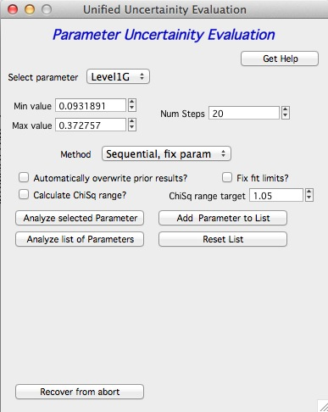

Here is example of results:

**********

Unified fit evaluation of parameter Level2Rg

Method used to evaluate parameter stability: Sequential, fix param

Minimum chi-squared found = 18.723 for Level2Rg = 81.189

Range of Level2Rg in which the chi-squared < 1.05*18.723 is from 78.446 to 82.62

**************************************************

"Simplistic presentation" for publications: >>>> Level2Rg = 81.2 +/- 2.1

**************************************************



NOTE: you need to make sure the fitting limits are set widely enough as the fit may abruptly stop when these are violated. The Help in the panel provides many more details.

### Export ASCII

This exports ASCII file with all the fitting parameters from Unified model (whole wave note from the results waves) and Q and Measured intensity, Error estimates and Unified fit intensity.

### Results to graph

This includes results in the graphs in text boxes:

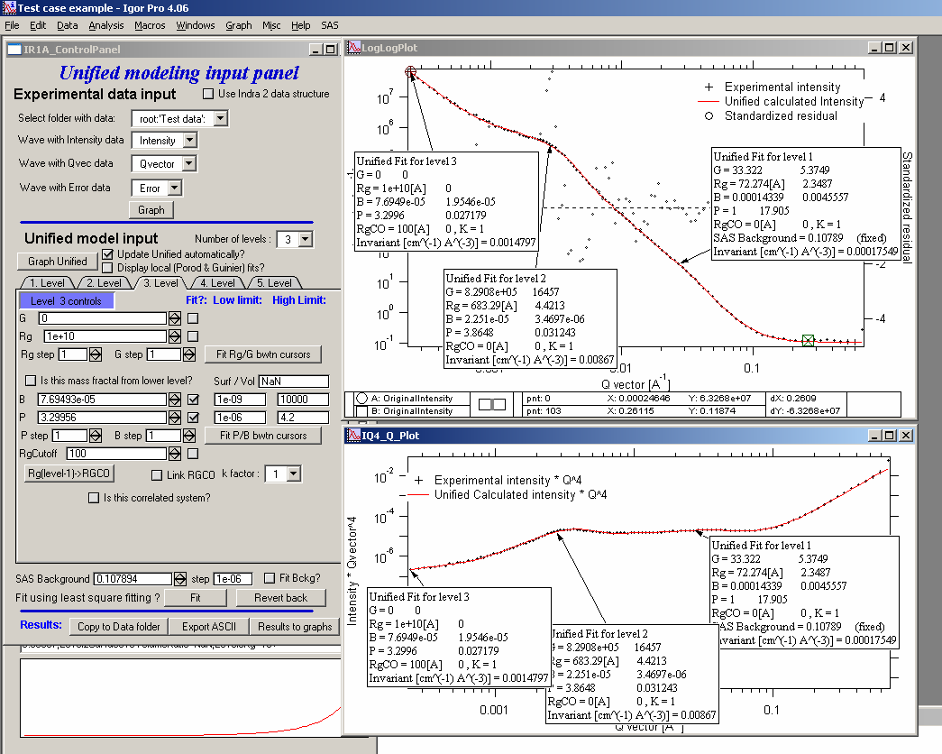

Note, that only selected, applicable parameters for each level are included in the text boxes… The text boxes can be formatted (double click on the text box) to suit user output. But note, that the text boxes get redrawn (and therefore reset to default) next time user pushes the “Results to graph” button.

### Export to XLS file panel

This macro should output data in the table which can be loaded by spread sheet type program (Excel). Macro creates panel with buttons and walks user through steps needed to add data to the notebook in Igor, which then can be saves as text file and imported to other programs.

## 6.7 Analyze results

Some specific cases can be analyzed further using Unified method. These are:

**Invariant**

**Porod’s law**

Special cases published by Greg Beaucage : **Size distribution and Branched polymers**.

**Two Phase system** using methods published by Dale Schaefer (Naiping Hu, Neha Borkar, Doug Kohls and Dale W. Schaefer, “Characterization of Porous Materials Using Combined Small-Angle X-ray and Neutron Scattering Techniques”, J Appl Cryst 2011.

All of these can be analyzed by using “Analyze results” tool. It can be called from the bottom of the Unified main panel.

**Usage:**

Open the tool from the Unified panel (at the bottom):

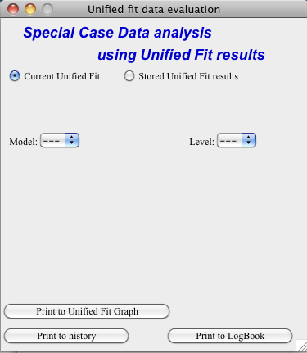 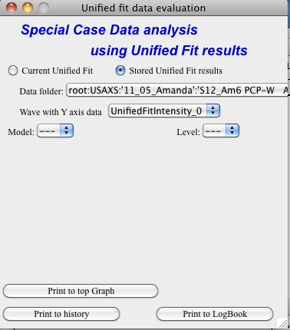

There are two options which data can be analyzed…

Current Unified data in the Unified fit tool. This is selected in the left figure above.

Unified results saved to any folder in the Igor experiment. This is selected in the right figure above. Note, that in this case user needs to select folder which contains unified results as well as UnifiedFitIntensity_X, where X is number of the Unified results “generation” (remember, there may be many generations of results there). Note that this can be quite messy, if you do not know which generation to pick… The data for analysis are picked from the wave note of the selected wave.

Then one can pick models:

### Invariant

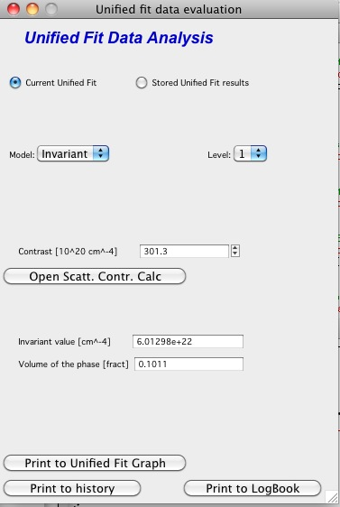

You need to pick also level for which to calculate the invariant. The invariant value is in the top field, user can input contrast value (if known) and if the data were absolutely calibrated and the contrast is known, the tool calculates the volume fraction of the phase.

### Porods law

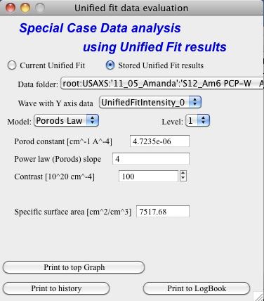

This will provide results ONLY, if the P for selected level is close to 4 (3.96 – 4.04). In that case, the tool provides Porod constant, P and calculates specific surface area – if the scattering contrast is provided. You need to have data absolutely calibrated.

### Branched mass fractal

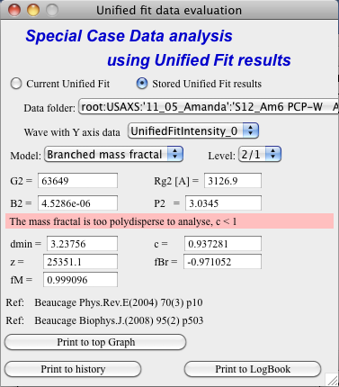

Ok, this tool requires users to read the references. The code was provided by Greg Beaucage and provides results as expected. But I am not clear on what these numbers really mean. Any way, the references are on the panel itself.

Note, that when the calculations fail, the tool beeps and prints error message in the red box.

Note, to calculate all of the parameters, you need two levels – so there are choices like 2/1 (1 would be primary particles, 2 would be the mass fractal). But you can also calculate some parameters from only one level (dmin and c) and if you select only one level, parameters, which cannot be calculated, will be set to NaN.

### Size distribution

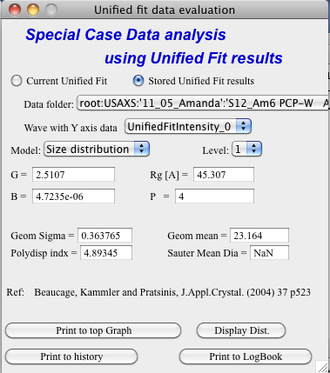

In this case, parameters from one level can be used to calculate log-normal size distribution for the particles – which assumes the P is close to 4 (Porods law). The details are in the manuscript referenced on the panel. Please, read it.

**Outputs of this tool:**

User can get following outputs, using the buttons:

*Print results to history area in Igor experiment*. For example here is the results from the above Size distribution tool:

****************** Results for Size dsitribution analysis from Unified fit ***************************

User Data Name : 'S12_Am6 PCP-W A'

Date/time : Analyzed using Unified Fit results from Sun, Feb 21, 2010 7:19:12 PM

Folder name : root:USAXS:'11_05_Amanda':'S12_Am6 PCP-W A':

Intensity name : UnifiedFitIntensity_0

Q vector name : UnifiedFitQvector_0

Error name : ---

Selected level : 1

G/Rg/B/P 2.5107 45.307 4.7235e-06 4

Geom. sigma : 0.36376

Geom mean : 23.164

Polydispersity index : 4.8935

Sauter mean diameter : NaN

Reference : Beaucage, Kammler and Pratsinis, J.Appl.Crystal. (2004) 37 p523

******************************************************************************************************

*Print the same results into the Irena log*. Remember, this is the log book (Igor “notebook” which manuy Irena tools save record of what is happening to.

*Print textbox with the results to top (or Unified) graph*. This is example of record for the Size distribution:

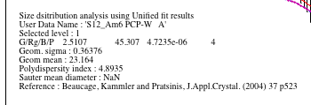

And for size distribution ONLY… Display distribution. This will calculate the log normal distribution for the parameters obtained.

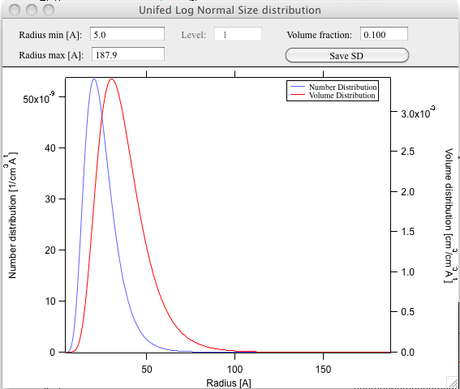

User may need to change the Radius min and Max values (my code to guess these seems to fail miserably in some cases). The graphs shows which level was analyzed and enables user input of volume of the total volume of the particles in this size distribution. This is basically absolute scaling, as it looks like Greg Beaucage never worked out details of using absolute calibration of the data themselves. If this becomes important, I may be able to develop the math myself. You can use for now for example value from invariant (which would be my choice for code anyway).

You can also save size distribution as waves for future euse (these waves are recognized as “results” in irena package now. You will get report in history area:

******

Saved Unified size analysis data to : root:USAXS:'11_05_Amanda':'S12_Am6 PCP-W A':

waves :

UnifSizeDistRadius_1

UnifSizeDistVolumeDist_1

UnifSizeDistNumberDist_1

### Two Phase media (aka: Porous system):

This is copied from the manuscript by Dale Schaefer … For details, please, check the manuscript… It is applicable for two-phase systems which at high-Q satisfy Porod’s law (power law slope = -4, Porod’s law is valid).

Before I start with the methods… Here is some more description of input:

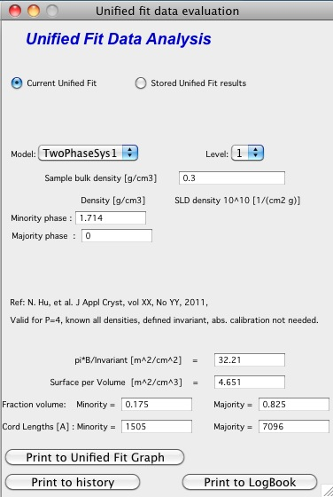

Top part (above lines with reference and Comments on validity) is for input. All numbers here should be known and provided by user. Anything below the two text lines are fields with calculated values. Note, that the results vary depending on what can be calculated from the input data provided. Make sure that assumptions about validity of data (calibration, quality of G and Rg, Power law slope = - 4 (Porod’s law valid) when needed) are satisfied.

Note, these models can be evaluated also for combination of Unified levels… Only single level or “All” is allowed. If “All” is used, Porod constant from level 1 is used, but invariant is calculated from all levels together…

**IMPORTANT**: this tool uses scattering length density per gram of materials. This is kind of unique, I have extended the Scattering contrast calculator to calculate these values. Please, NOTE this…

#### TwoPhaseSys1: *ρs, ρsam* and *B/Q* known. *φp* calculated

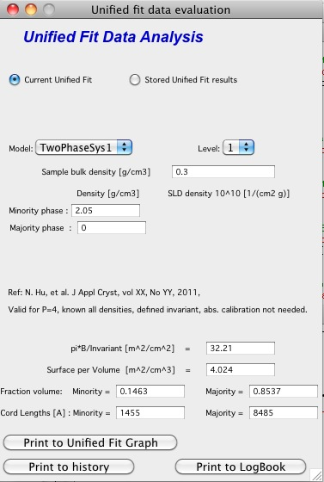

This approach can be applied when the data are not measured on an absolute scale, but sample densities are known and the data cover a sufficient *q* range to determine the ratio *B/Q*. In this case, the porosity is calculated from : , and *Sv* is calculated from . In our realization of this approach *B* and *Q* used are obtained from a unified fit (see above) to the scattering data. Normally the relevant *Q* is for level-1 only. The chord lengths are calculated from:



#### TwoPhaseSys2. : *ρs, ρsam, Δr* and *Bv* known*. φp* calculated

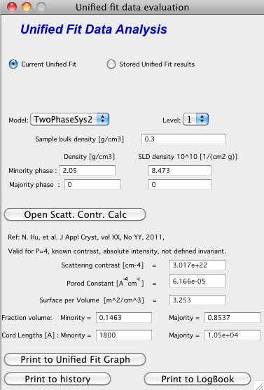

This approach applies where the data are on an absolute intensity but the low *q* data are lacking so *Q* is not known. The sample density must be known so that *φp* can be calculated by. is used to compute *Sv*. *Δr* is calculated from using known chemical composition of the struts.



#### TwoPhaseSys3. : *ρsam, Δr*, *Bv*and *Qv,* known*. ρs* is calculated

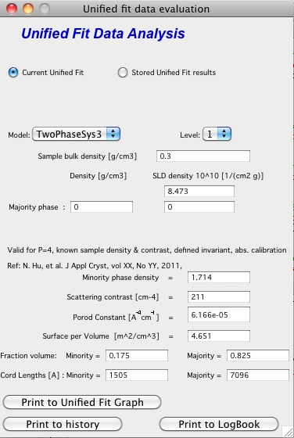

This approach is similar to approach 2 but the data cover a sufficient *q* range to calculate *Qv*. For porous materials where one of the two phases is air, *ρs* is calculated from and



If the SLD of the pore material is not zero, an iterative process is applied to calculate *ρs* by forcing *φp* in to equal *φp* calculated from *Qv* in . The calculated *ρs* is then plugged in to calculate *Sv*.



#### TwoPhaseSys4. *ρs,Δr*, *Bv* and *Qv* known

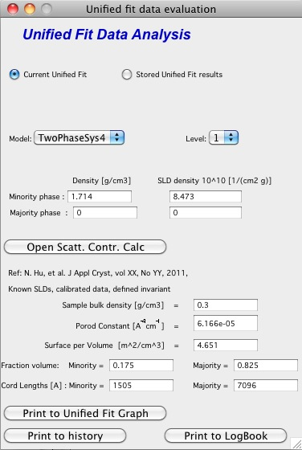

This approach requires valid scattering data on absolute scale. By equating and , *φp* is solved using *Bv* and *Qv* obtained from the scattering data. The scattering data must be valid over a sufficient *q* range to assure that *Qv* is accurate. After solving for *φp, Sv* can be calculated using . This approach does not require the sample density, but the chemical composition of the struts (Δ*r*) must be known. In addition this approach does require the complete scattering profile on an absolute scale.



#### TwoPhaseSys4.

Particulate analysis, not published in manuscript.

There are two more methods provided to me by Dale Schaefer, which are not published in the manuscript. They assume we can model the material as systems of particles and take two different methods to calculate particle density.

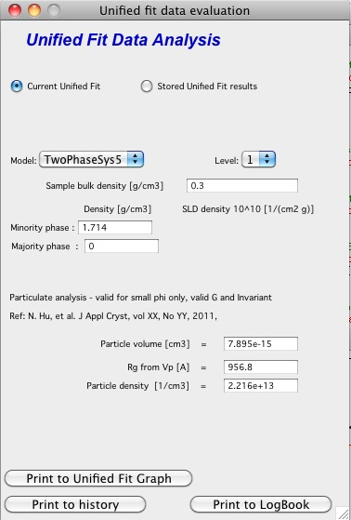 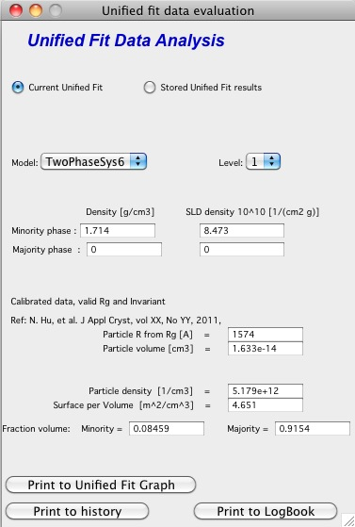

Note, that there are differences in what needs to be known. Method 6 requires knowledge of contrast, while the method 5 does not, while method 5 requires knowledge of sample bulk density…

# 7. Gunier-Porod

## 7.1 Introduction

This model was developed by Boualem Hammouda (NIST) and published in "A new Guinier–Porod model", J. Appl. Cryst. (2010). 43, 716–719. In some way it is similar to Unified fit model, but there are important differences. I strongly encourage users to read the basic papers on the theory - if you have difficulties getting the manuscripts, let me know and I'll pass you the pdf copies.

Next text is dumbed down version of explanation of differences, more or less ... for dummies version. It is imperative to read and understand the theories behind these theories - they are not simple for sure. Do not complain you get different results form Unified vs Guinier-Porod. It shows lack of understanding of the theories.

## Simple description of Unified-Guinier-Porod differences

Unified fit models scattering as system, of "levels" composed of Guinier and power law (Porod) areas (in simple case).

Guinier-Porod models scattering as system of levels composed of Guinier and Porod (power law) areas (in simple case).

They are NOT same, though.

In Guinier-Porod model each level represent ONLY one particulate system. For particle with one dimension we have one Guinier area and one power law area. By assuming this is one system of particles adhering to Guinier and Porod law some relationships between volume and surface area are known. This reduces number of parameters. For particles with more dimensions (e.g., rod with two major dimensions) we can have two Guniier areas and two power law slopes, for particles with three different dimensions, the code has only two Guinier areas (assumes the third cannot be seen which is acceptable assumption usually) and three power law slopes. There is ONLY one parameter related to "volume" of these particles.

See pictures copied from the Hammouda manuscript for particle with one dimension (sphere) and two major dimensions (cylinder).:

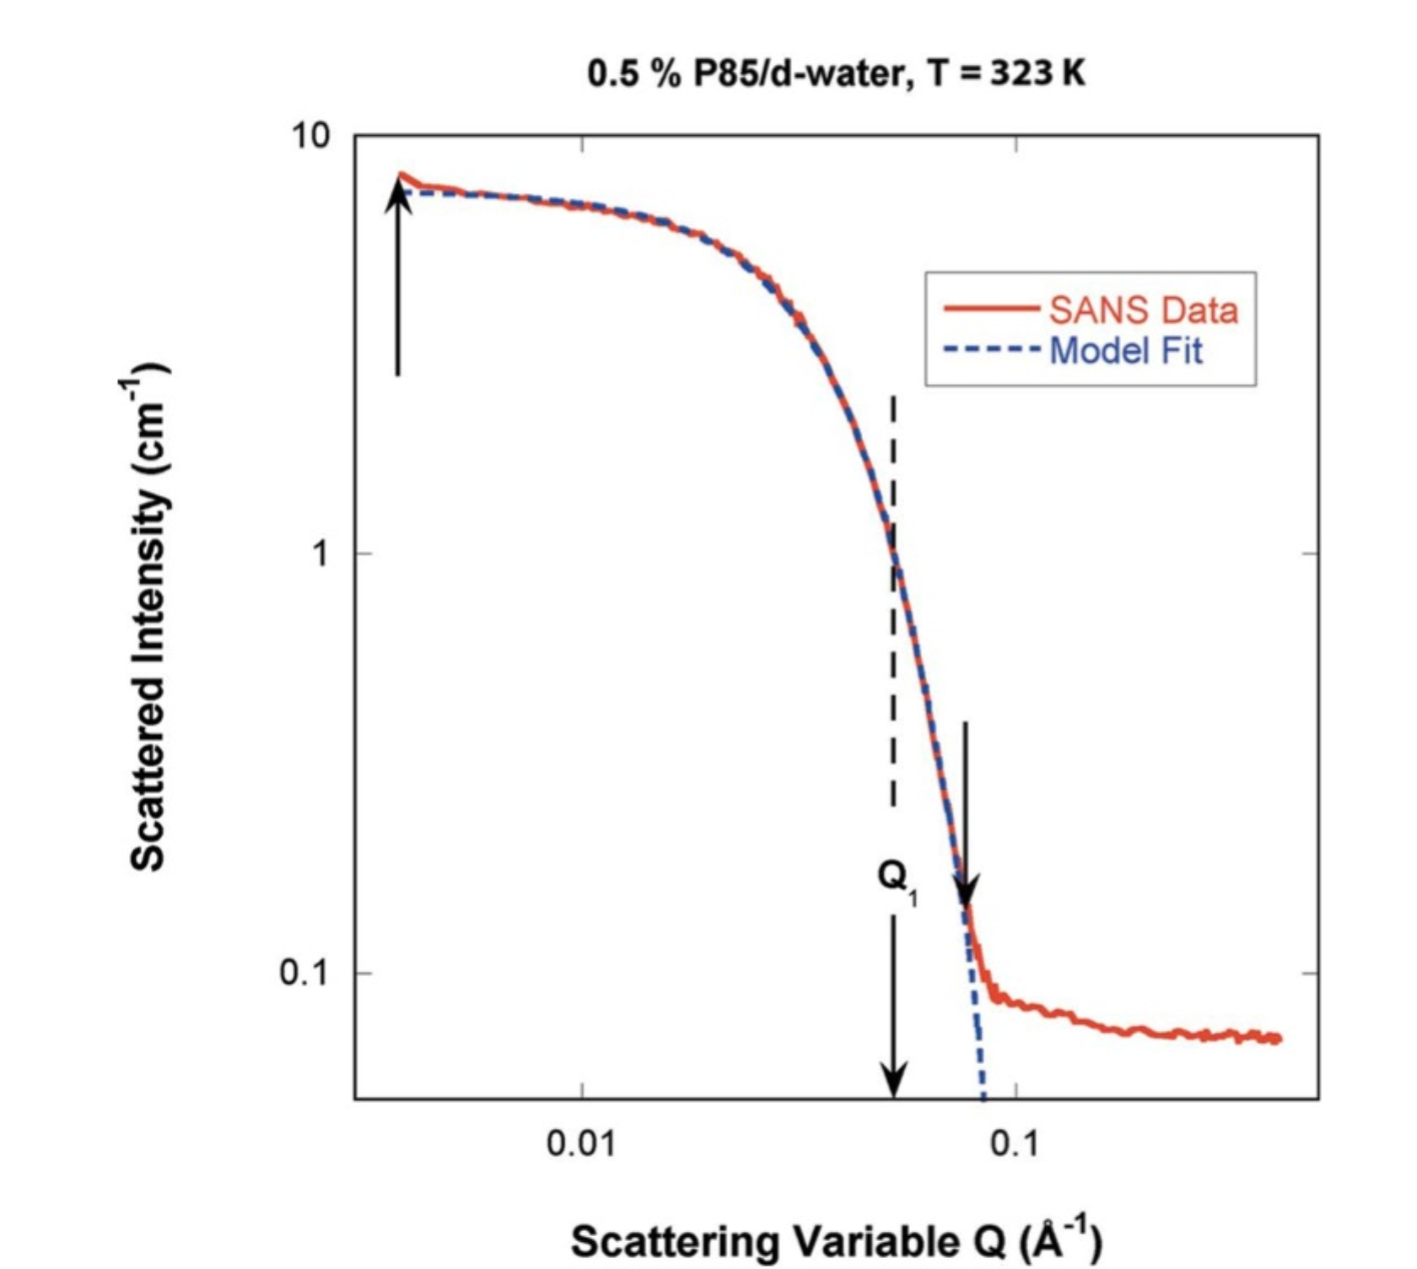 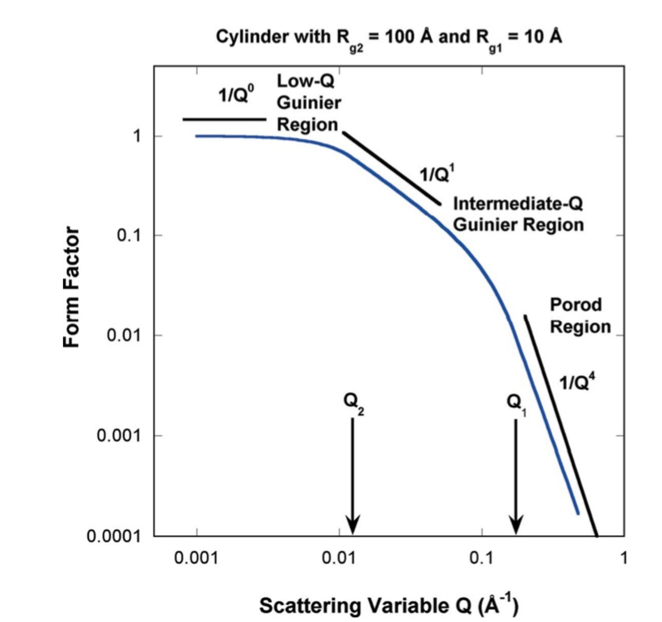

The important to note here is, that one "level" in Gunier-Porod model can describe particle with multiple main dimensions. Basically each "Level" in Guinier-Porod model can be described as form factor for particulate system. To describe similar scattering in Unified fit one may need multiple levels, connected with proper use of Rgcuttoff. In Unified fit one need many more parameters to describe such system - which means that chances getting physically unreasonable solution is much higher.

From above it seems the Guniier-Porod model is better - less parameters, more compact description...

However, there is a problem here. For systems, which do not adhere to Guinier-Porod, assumptions cannot be modeled by the Guinier-Porod model at all. For example, these would be hierarchical fractal systems, particulate systems with broad size distribution, etc.. For example, it is possible to use Unified fit and from Gunier/Porod areas mismatch calculate log-normal size distribution - this is impossible in Guinier-Porod model.

Another words, as far as I can say, Guinier-Porod model is superior in limited number of cases where the scattering system satisfies the basic assumptions - such as relatively monodispersed particulate systems. In other cases Unified fit may be the more generally applicable model.

## 7.2 How to use Guinier-Porod model

This part of the manual will be changed later.

In summary, this tool follows as much as possible the Unified fit. It is imperative to do local fits in order described on the panel or else the results go crazy. I am trying to fix some background issues here to make this more user friendly. It works when system is applicable and one follows the procedures, but I need more testing to make it robust.

Another words, the tool is in beta at this time.

# 8. Modeling II

This tool is replacement of Modeling I package and is being maintained and improved.

## 8.1 Use of this tool

This tool is : ***advanced; complicated; challenging to use – but really powerful***.

The use of this tool is recommended to everyone who is trying to model small angle scattering and would consider Modeling I tool. While it is more challenging, it is much more capable.

This tool will do all the Modeling I does and much more. There is penalty for the much more…

**Features**:

1. **Multiple input data sets at the same time**. Up to 10 input data sets can be loaded at the same time and fitting/modeling can be done to one or more data sets at any time.
2. **Up to 10 populations of scatterers** can be combined. Any population can be arbitrarily “switched on and off”. Any population also can be one of : **"Size distribution", “Unified level”, or "Diffraction peak"**; allowing to model really complex small-angle scattering data.
3. Each population can have **different contrast** for each data set. Note, that this means up to 60 contrasts potentially.
4. **Form factor parameters can be fitted**. That does not mean the data must allow them to be fitted, but the tool will allow any form factor parameter to be fitted.
5. **Structure Factors – library of 5 structure factors** to be used. See Structure factor description in the “Form factor and Structure factor description” pdf file.
6. **Optimized for speed** - much faster fitting when “semi-auto” R distribution is selected for complicated form factors.
7. **Input of “model” data** when no real data are loaded, but only q-data are created to model SAS from microstructure without the need for measured data.

**Logging during use of this tool** – This tool similarly to other Irena tools logs state of the parameters before and after each fitting. The purpose is to enable at least some recovery, if fitting goes to never-never land and user accidentally looses the “recovery” option by using revert fit (by hitting the fit button second time etc…). The notebook can be pulled up by using menu SAS -> Other tools -> Show SAS Logbook. This logbook is mess of information, but all necessary information to recover should be there. It is not formatted in any particularly meaningful way, though. As output use the “Save in notebook” option discussed later in this chapter.

## 8.2 Theory behind this tool

Actually, theory is the same as for Modeling I from chapter 7 – up to 10 "populations" or models can be used : each can be either "Size Distribution of scatterers", "Unified level", or "Diffraction peak"; For teh Size distribution and Unified level the SAS from them can be calculated in dilute limit or after applying one of 5 available structure factors. For comments on used size distribution shapes (log-normal, LSW) please refer to chapter 7.3. It is important and useful to understand.

As of *Irena* version 2.40 this tool can also use “Unified level” for any population. **NOTE:** this is kind of simplified Unified level and the tool will complain (once every 24 hours) if you try to use more than one Unified level. It is not impossible, but it is strongly discouraged. If you need more Unified levels, you need “Unified fit” tool. There are various rules and relationships, which can be enforced in that tool. The reason for Unified level here is to enable one combine scattering from particulate system with the scattering from fractal system formed by these particles. Typical use is to describe low-q power law slope, which is mass fractal of primary particles, which then can be modeled correctly.

As of *Irena* version 2.43 this tool enables also use of "Diffraction peak" for any population. **NOTE:**  this is simplified version of Diffraction tool and for now there is no way to include relationships between the peaks (to provide for specific structures) as the Diffraction tool allows. Fort more details on the terms, peak profilesetc. read the Diffraction tool chapter.

### 8.2.1 What is size distribution

The size distribution is modeled as small angle scattering (SAS) using basic SAS formula:

,



where  is contrast, F(Q,r) is scattering form factor, V(r) is the particle volume, N is the total number of scattering particles, (r) is the probability of occurrence of scatterer at size of r. This formula is, of course, replaced by summation formula with limited number of bins in radii. Therefore the formula coded in is following:



This formula has been coded very many times… Following are comments, which address specific parts of this formula.

Three different distribution models are available – Gauss (Normal), Log-Normal, and LSW (Lifshitz-Slyozov-Wagner used in precipitation theory involving Ostwald Ripening).

Automatic selection of radius distributions – ranges needed, bin widths etc. – with user selectable precision and number of steps. For details seem Irena manuscript which goes to details on this subject.

Number of form and structure factors are available. Note, that it is relatively easy to add other shapes in the code, so if anyone needs (really needs) another shape, let me know… Note, that calculation speed of different form factors varies significantly depending on calculations needed to calculate involved integrals.

### 8.2.2 Structure factors

The code includes number of Structure factors to account for interaction among the particles for non-dilute systems, which can be independently switched on or off for each population of the scatterers. **User should be aware of the crudeness of any of these calculations.**

The code used for calculations involves correcting intensity from a population of scatterers using this formula:

Intensitywith interfernce(Q, R) =Intensitywithout interference * Structure factor

Description and details on the structure factors (5 at this time I believe) are in the pdf file "Form and Structure description" which can be opened from the Irena menu.

**Remember**: these method accounts in very crude way ONLY for interaction for particles in the particular population. If there are interactions among particles from different populations – which is very likely – these calculations have NO WAY to account for it.

### 8.2.3 Important Information

The code uses for all size related parameters Angstroems (10-10 m) or for Q vector (A-1). In the case of scattering contrast, number distribution and any other volume contents centimeters (10-2 m).

This code uses everywhere **Diameter** for scatterer size.

### 8.2.4 Distribution Ψ(r) and V(r)* Ψ(r) and distribution of r.

The code can work with distribution defined as for number distribution N*Ψ(r), where integral over Ψ(r) for all r is 1 and N is total number of scatterers or for volume distribution Vtot*Ψ(r), where integral over this term is equal total volume of scatterers. Internally, the code actually always works with number distributions (N*Ψ(r)), which, in the second case is calculated from the total volume of scatterers.

There are currently 3 different distributions built in the code, which can be used independently for any of up to 5 scatterers populations: Gauss (normal), Log-Normal, LSW.

Gauss and Log-Normal distribution definitions were adopted from NIST engineering statistics handbook, [www.itl.nist.gov/div898/handbook/eda](http://www.itl.nist.gov/div898/handbook/eda) . See <http://www.itl.nist.gov/div898/handbook/eda/section3/eda366.htm>

Standard complicated log-normal distribution is defined as follows (Allen, A.J., Krueger, S., Skandan, G., Long, G.G., Hahn, H., Kerch, H.M., Parker, J.C. and Ali, M.N. (1996). *J. Am. Ceram. Soc.* **79**, 1201-1212., Filliben, J.J. (2006). *Exploratory Data Analysis*, in *NIST/SEMATECH e-Handbook of Statistical Methods*, edited by C. Croarkin and P. Tobias, p. 1.3.6.6.9, available online at *http://www.itl.nist.gov/div898/handbook/*. Gaithersburg, MD: NIST.):

The NIST definition is modified to be more elegant and parameters used by Irena package are as follows:

"Min" = Dmin

"Mean" = (Dmed - Dmin)

"Sdev" = sigma = ln((Dmed-Dmin)/(Dmode-Dmin))

The LSW distribution has been accepted from a source by J. Nasser, A. K. Kuruvilla, and J. E. Smith Jr. These authors in their manuscript on the web (www.space.gc.ca/science/space_science/paper_reports/spacebound97/materials_sciece/….) refer to distribution by Lifshitz, Slyozlov, and Wagner:



This is the particle size distribution predicted by LSW in their theory of Ostwald Ripening.

Each distribution in this type of problems needs an appropriate selection of radial bins. Appropriate selection is actually problem – too many bins cause too long calculation times, narrow range of radii causes some significant volume of scatterers to be neglected, etc. In this code I take a different approach, which is important to explain properly:

For each distribution I create cumulative distribution (if exists using formula, if not numerically). Using user input value I select range of radii in which the value for cumulative distribution is between this value and (1-this value). This causes, that only the tails, for which the cumulative probability is below the user selected value are neglected, giving user full control of the precision in which we/she wants to model the data. Then radial bins are calculated, so their spacing for cumulative probability is the same. This causes that the bins have varying width – are narrowest around the areas, where probability function changes fast and wider in the tails. This should provide the best possible method for using the binning method, I hope…

All of the code handles bins of varying width…

### 8.2.5 F(Q,r) problem – applicable ONLY to integrated spheroid

For the case of **integrated spheroids ONLY** - *rarely addressed problem is related to usual method of calculation of F(Q,r), independent of selected particle shape. In usual method of modeling – using bins this problem is usually neglected. Standard method is to take for radius the center point of the bin, and calculate F(Q,r) for this point. However, this may be very incorrect - the F(Q,r) is a strong function of Q*r (with period of pi). Through the Q range and size range studied, the number of periods in pi within the bin width * Q varies strongly. Taking just center of the bin for calculating F(Q,r) results in nearly random selection of the r for this calculation and can result in significant error. Calculated value may be very far from average F(Q,r) value, which we should properly used.*

*In case of data from USAXS instrument we at least have no problem with definition of Q – the Q resolution is very high, otherwise we would have to worry about the Q variation within the Q point - smearing…*

*Anyway, to avoid problems with the oscillatory behavior of the F(Qr) the code takes at least 3 – and maximum 61 F(Qr) values within the bin in radius (at least start, middle and end of the radius bin point), linearly distributed in the bin, multiply them by appropriate V(r) and then average the result. The number of points within the bin is obtained as floor(3+abs((10*(QRMax-QRMin)/pi))), with maximum being 61.*

*This causes significant increase in the calculation time… Keep this in mind*.

--- end of part valid ONLY for spheroids

The above does not apply for other shapes – globs by definition do not exhibit this problem and I have not included this complication for other shapes. The standard spheroids also do not have this included – if you want to use this integration method, use even for spheres “integrated spheroid” and aspect ratio 1.

## 8.3 Use of this tool for SINGLE input data set - size distribution.

NOTE: This part of the manual is from pre-2.43 version of Irena. It relates ONLY to Size distribution type of "population" in Modeling II. Please, use this to learn about the specific related to size distribution use and the types of parameters. Next chapter will describe use of Unified fit and Diffraction peaks. It is not easy to find nice case example data to produce one chapter together. Also, it may be really confusing to mix and match these models.

Start tool from SAS menu. At this time it is titled “Modeling II”.

### GUI description

Note in following image, that the tool has somehow different GUI. The lower 2/3 of panel change depending on selection of radio-buttons “Data controls” and “Model controls”. See figure below. Also, if only one data set will be used, make sure the checkbox below “Data controls” is unchecked (only one tab “Input Data” is visible).

Note, that there are few buttons just under the Data input popup controls: “**Remove all**”, “**unUseAll**” “**Config Graph**” and “**Graph(reGraph)**”. These are tools to control global behavior or resent the tool.

“**Remove all**” button removes all input data from the tool.

“**unUseAll**” button sets all of the input data sets to not to be used. (useful only with multiple data input)

“**Config Graph**” opens control screen for graph controls (font size etc.). These values are common for all tools (once I propagate them through whole package).

“**Graph (reGraph)**” button creates the graph or forces redraw of the graph.

Note one more checkbox which is worth mentioning here… It is little bit lower, on the right hand side and is called “Auto recalc?”. If checked the model will be recalculated with every change of any parameter (except Form factor parameters, which cannot trigger this). Use only on fast computers and simple enough model, or it can be tedious..

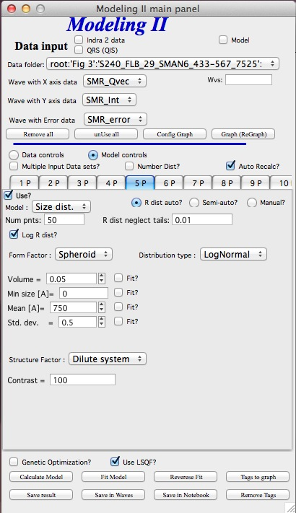 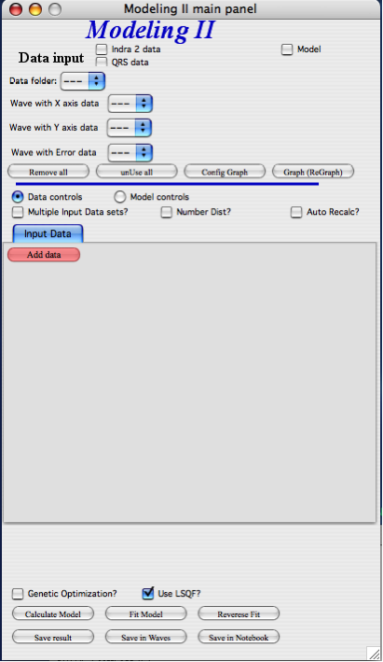

### Data controls

The data available in the test.pxp file distributed with the Irena package are in *qrs* structure, so select “QRS data” and pick the ‘Test data”.

To load data into the tool use the red button “Add data” on the left top corner of the Input Data tab.

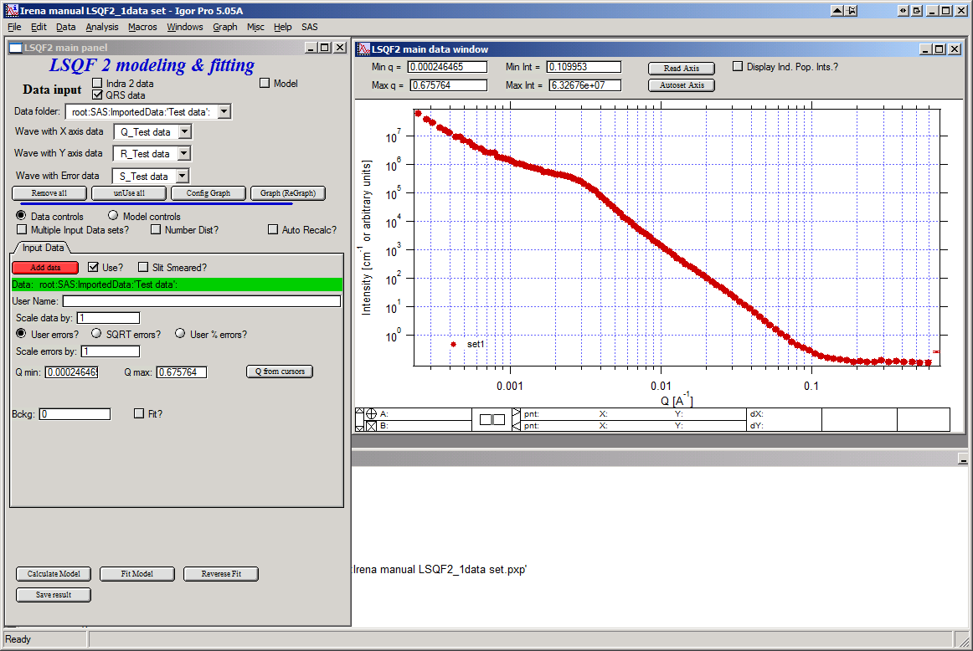

Description of parameters on the Input data tab:

Checkbox “**Use?”** allows to select if this data set is used in the tool. This is really useful when multiple data sets are used.

Checkbox “**Slit smeared**” if slit smeared data re used, select. Note, that if checked field for slit length will appear.

**“Data”** field. This field contains path to data within Igor experiment. Cannot be edited.

**“User name”** user editable name for the data. Will be used in the graph – needed to make sense in case of use of multiple input data. If empty, default name will be used (not very informative).

**“Scale data by”** field – user can scale data here. For example some data may need to recalibrated, converted to 1/cm or whatever. Ideally should not need to be used.

Radio buttons “**User errors”**, “**SQRT errors”**, and “**User % errors”** – what type of errors to use for this particular data set? User errors are provided by wave with error data, SQRt errors are square root of intensity and when % error is used, the error is set to 1 % of intensity.

**Scale errors by:”** allows scaling errors by factor. Errors are produced using method selected above and then scaled by the factor user provides here.

“**Qmin**” and “**Qmax**” – selection on fitting interval of data – can be typed in or using the button “**Q from cursors”** can be read from cursor position. Only data within this interval will be used for fitting.

**“Bckg”** Background for this data set. Can be fitted (“**Fit?**” checkbox will open fields for Min and Max limits for fitting…

Further controls are likely going to appear…

### Model controls

Model controls become available by selecting “**Model controls”** radio button above the tabs.

Note the checkbox “**Number Dist?”** – if checked the distribution will be considered to be number distribution, if unchecked (default) the distribution is volume distribution.

Controls for any population appear when “**Use?**” checkbox is selected… see below:

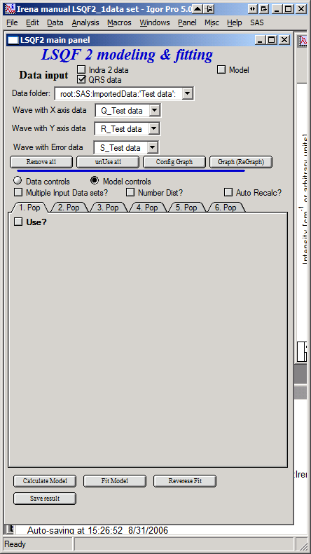 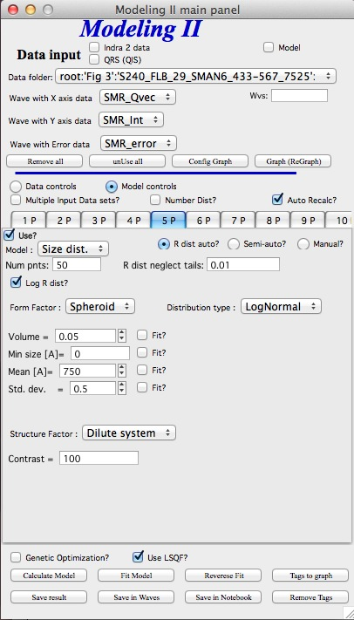

Description of controls:

"**Model :**" Select what model to use for this population. "Size dist." chooses size distribution, other options are "Unified Level" or "Diffraction peak". These two are described in next chapter.

“**R dist auto?**” distribution of radii selected automatically for given distribution. As in the older LSQF (chapter 9) the R distribution here is selected in such way, that densest points in R are at the middle of the distribution (around maximum) and then they spread with large and larger steps.

“**R dist semi-auto**” same as above, except the R distribution is not being changed during fitting. Therefore one needs to be close to final solution when starting fitting. But this way the fitting can be MUCH faster for complicated form factors. Since the R points and q-points do not change during fitting, G matrix (which is cashed internally for each population and data set) is calculated ONLY once. Major time saver…

“**R dist manual?**” Manually input min/max R for each distribution. Opens control fields needed for input.

“**Num pnts”** Number of points in R distribution. Use sensible numbers. Large numbers will take a lot of time.

“**R dist neglect tails”** same meaning as in LSQF (chapter 9). Basically what fraction of volume of size distribution can be neglected. Allows truncation at small/large sizes - defines Rmin and Rmax for automatic/semi-automatic R distribution method.

“**Log R dist?”** – select to have R points logarithmically distributed. If unchecked, linearly distributed bins in R will be created.

“**Form Factor”** – select form factor from list of available form factors. May open another control screen for parameters of the form factors. To get this controls screen again, re-select the form factor and the screen will pop up.

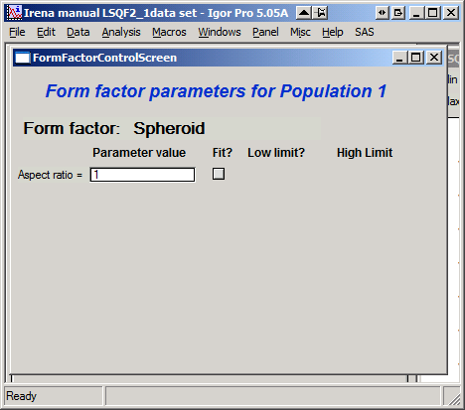

This is example of screen for Spheroid. Note, that there is one parameter for this Form factor (aspect ratio). This parameter can be fitted in this tool. By selecting “**Fit?**” checkbox, low an high limits fields will appear.

“**Distribution type**” select “lognormal”, “Gauss” or “LSW”. Definitions are in LSQF (chapter 9). Parameters for these distributions are now separate, so one can go among them and the parameters will not be reused/lost from previous use of that particular distribution type…

**“Volume”** – volume of scatterers in this population. “**Fit?”** checkbox allows fitting. Fields for min/maxc values will appear. When volume is changed manually by typing in this field, min and max are automatically set to 1/5 and 5x the typed value. Therefore, it is important to first set the value and then, if necessary change the limits. Not the other way around!!!

**LogNormal parameters**

See details in the chapter 9.3 for details… Formula:

P (x) = exp(-1*( ln( (x-MinSize) / meanSize) )^2 / (2*SDeviation^2) ) / (SDeviation*sqrt(2*pi)*(x-MinSize))

“**Min size”,** “**Mean”** , “**Std Dev.”**

**Gauss**

Has just two parameters: “**Mean size”** and “**Width”**.

**LSW**

Just one parameter: “**Position”**. For details see chapter 9.3.

**Schulz-Zimm**

Schulz-Zimm distribution was added by modifying code from Scatter 3, see reference: Stephan Furster and Christian Burger, Scattering Functions of Polymeric Core-Shell Structures and Excluded Volume Chains, Macromolecules 1998, 31 (879-881). Here is the code. Irena presents user with parameters ***width*** and ***MeanPos***:

b = 1/(*width*/(2\**MeanPos*))^2

a = b / *MeanPos*

if(b<70)

y=( (a^(b+1))/gamma(b+1) * x^b / exp(a*x) )

else //do it in logs to avoid large numbers

y=exp( (b+1)*ln(a)- gammln(b+1) + B*ln(x) - (a*x) )

endif

**“Structure factor”** Popup allows selection of one of included structure factors (see pdf file with description). The structure factors have their own screens and parameters can be fitted. See below for case example:

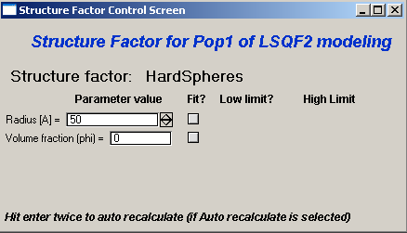

Note, that due to quirk in Igor way of controlling updates you need to hit enter twice to automatically recalculate the curve (when checkbox on main panel is selected)…

**“Contrast”** field – input contrast. Only one contrast in case of single input data set.

### Last few buttons

Under the tab area there are few more control buttons.

“**Calculate model”** calculates Intensity for current model.

“**Fit model”** Runs fitting with currently selected parameters to fit.

“**Reverse fit”** recover parameters stored before the current fit run.

**“Save result”**  Saves result into the folder. It feature is not fully finished yet. This is difficult to know what is expected in case of multiple data input…

“**Save in Waves”** Saves results into new folder in form meant for creating tables with results. In this case new folder (user is presented with dialog to create new name) is created and for each internal variable/string is created new wave. This creates large number of waves – most useless… But user then can create table of selected waves with important results – for example sample name, volume of pop1, mean diameter of pop1 etc.

“**Save in notebook”** Creates Igor Notebook (formatted) and pastes in this notebook summary of current state of the tool in more or less human readable form. This includes copy of the graphs and somehow reasonably formatted listing of parameters.

Comment: If user decides to do NOLY modeling with no real input data - by using “model” checkbox when adding data in the tool – there is no real “output” place where to put the modeled data for future use. Starting from release 2.41 dialog is presented to user and user can input name of new folder, which will be created, and the model data will be saved there.

## 8.4 "Unified level" and "Diffraction peak"

Select Model: “Unified level” or "Diffraction peak". Note, that different controls appear in the panel.

***NOTE:***

Both these implementations of "Unified level" and "Diffraction peak" have contrast in it, so Unified parameters G and B and Diffraction peak parameter "Prefactor" are multiplied by contrast when used in calculations. This is different from Unified fit and Small-angle Diffraction tools, which do not know about any contrasts. This is important for modeling of data where user has multiple input data sets and each has different contrast for the population represented by the Unified level. Such as Anomalous data or combined X-ray and neutron data etc. Be aware, that B, G, and Prefactor will be different for modeling by Modeling II and Unified fit or Small-angle Diffraction tools. Also, note, that the Unified fit data analysis tools DO NOT work with Unified fit results from Modeling II.

Note also, that "Peak Intg. intensity" in "Diffraction peak" model is calculated WITHOUT contrast included.

While the choices above are open for discussion, logically these are the only and right choice as for fitting for multiple data sets only one G, B, and "Peak Intg. Intensity" can be calculated.

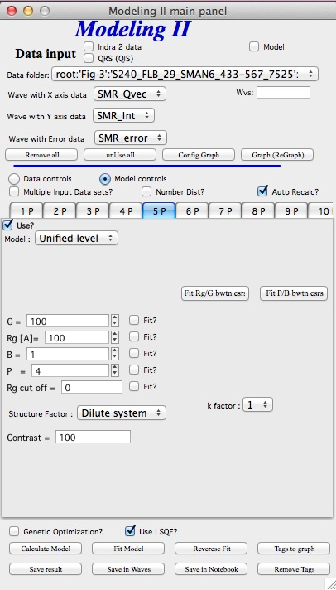 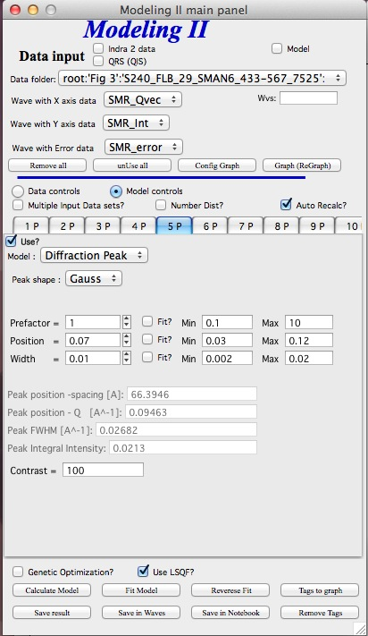

Here is fitting example when complicated data set is fitted with two Unified levels and two peaks. This is complicated system and data are not attached. Also, these data are slit smeared so the fitting is bit more complicated. This case is used mainly as example of GUI and tool capabilities.

Bellow are data, the data were identified to be composed of two types of components :

1. Low Q scattering of some size distribution of highly asymmetric particles with two Guinier areas ~ 0.0003 and 0.004 A-1 connected by power law slope. This system may be fitable by size distribution but it was found easier to fit by two-levels Unified fit.

2. Two diffraction peaks Q ~ 0.025 and 0.07 A-1

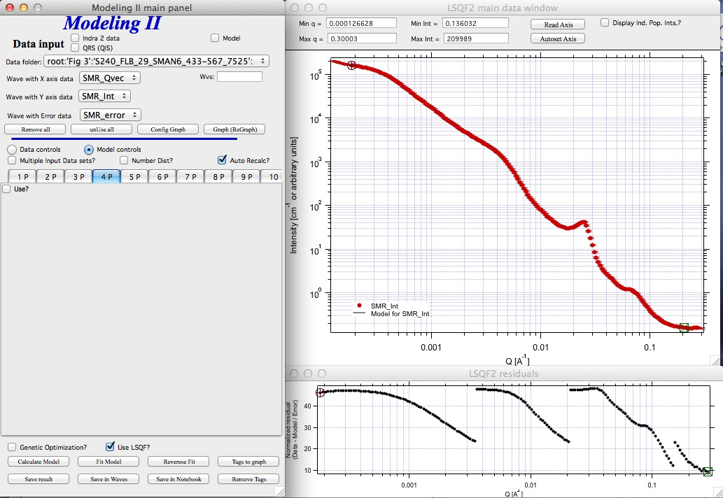

Unified fit with two levels

Selecting in 1P Modle as "Unified level" we get appropriate controls:

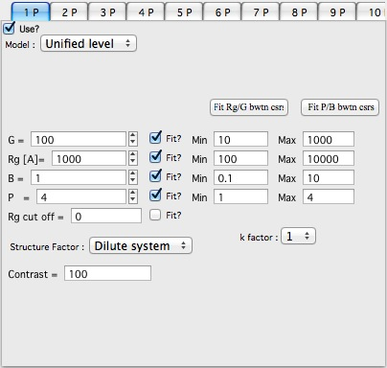

Next we can select with cursors the are where Guinier dominates in graph and use button "Fit Rg/G btwn csrs" to fit Rg and G: Here is the result:

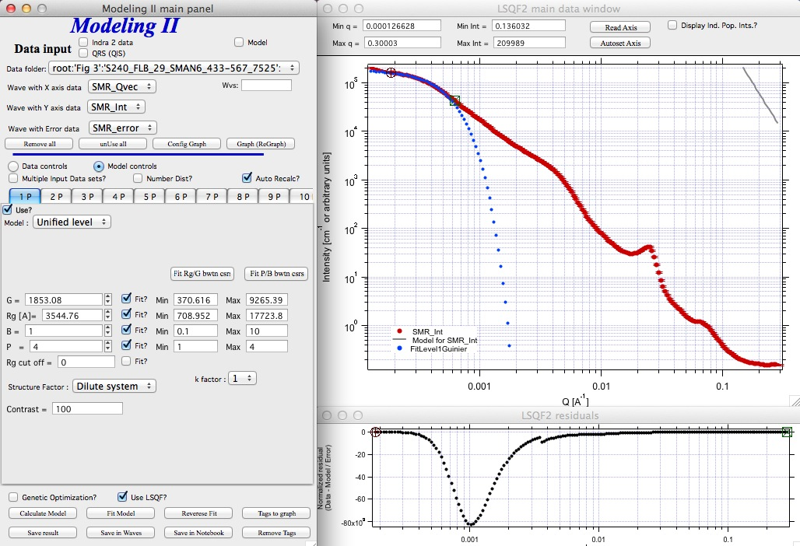

Note the blue curve that is the Guiner fit to the data. Next we select power law area at higher Q and fit the P/B:

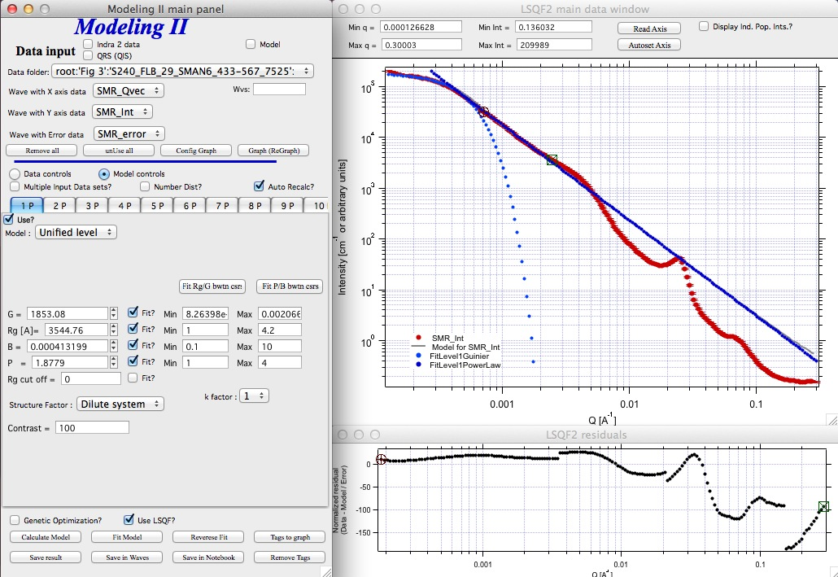

Note that the slope P is close to 2 so this looks like plane-like object and that the scattering needs to be terminated at Rg of the next (smaller) Guinier area. Select 2P as Unified level and fit the Guinier area there also:

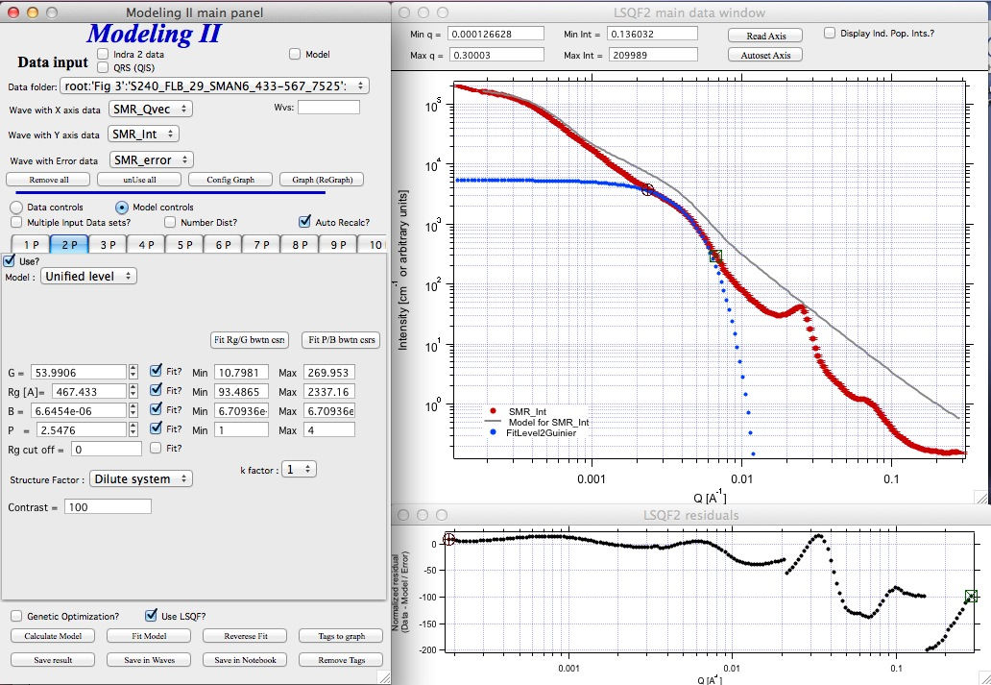

The Rg of the 2P is about 467A, so we can now transfer this number to RgCO of the 1P and then we can also fit the B/P to higher Q values power law slope:

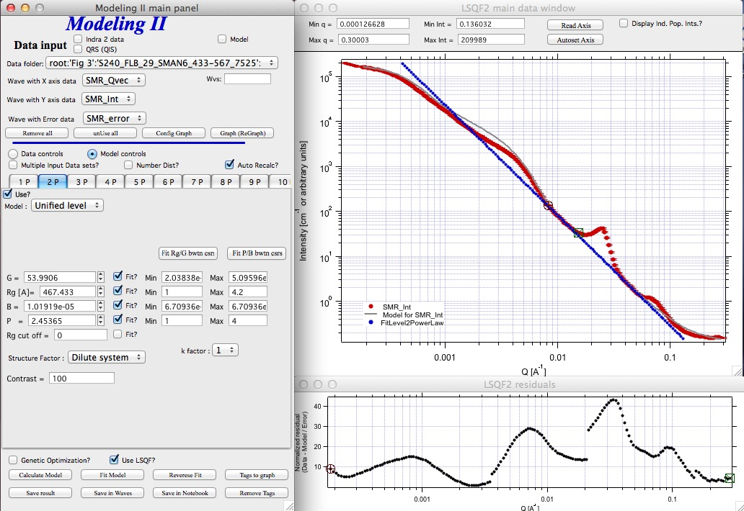

Note, that on the "Data controls" set of tabs in the "Data 1" tab I have already set the background to about 0.12 and also checked "Fit?" checkbox there.

Next we need to add the diffraction peaks, 3P will be the first peak:

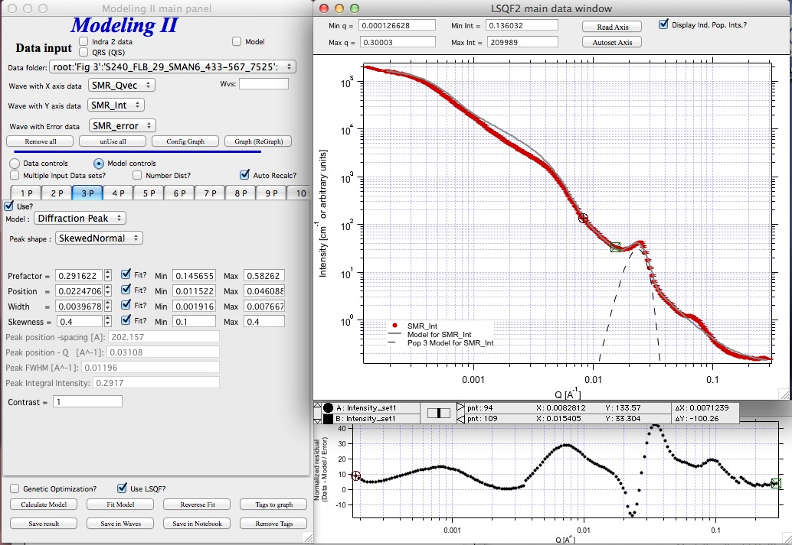

Note, I have played with these data already and found "SkewedNormal" shape to be the best. I checked here the "Display Ind. Pop. Ints?" at the top of the main graph here as that helps for you to see the peak.

And next we will set the 4P as diffraction peak:

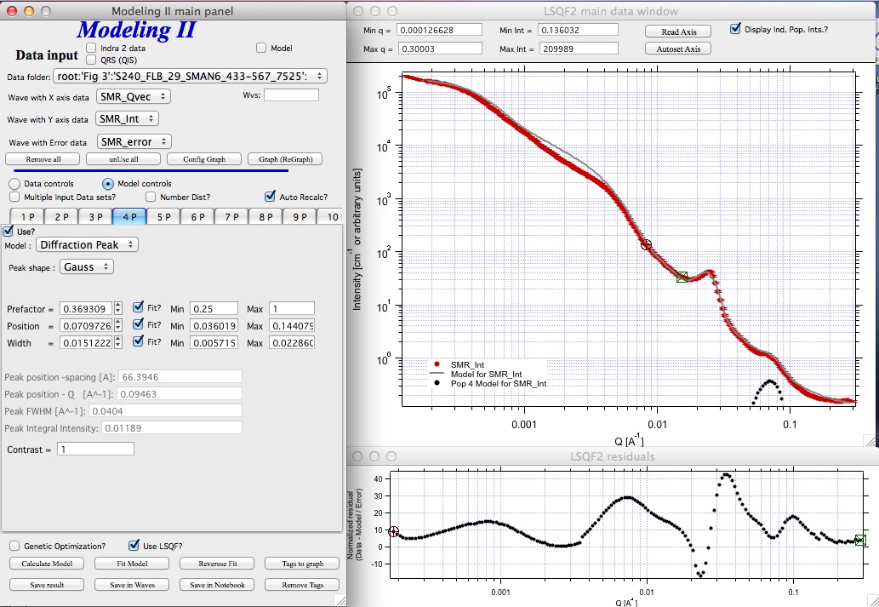

Note the changes in the bottom window, which displays "normalized residuals".

Next we can fit the parameters and then push the "Tags to graph" button :

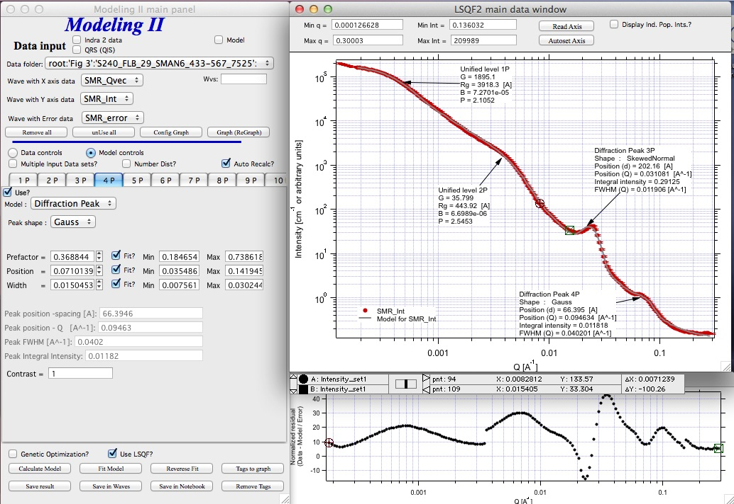

This is the best result with this model I was able to get.

You can also now store the results in Notebook for export to Word processor or as record of yoru results. Of course you should save your results in folder with "Save results".

Here is the Notebook record of these results

************************************************

Results saved on Fri, Dec 30, 2011 4:24:57 PM

Single data set used:

FolderName_set1 = root:'Fig 3':'S240_FLB_29_SMAN6_433-567_7525':

IntensityDataName_set1 = SMR_Int

QvecDataName_set1 = SMR_Qvec

ErrorDataName_set1 = SMR_error

UserDataSetName_set1 = SMR_Int

DataScalingFactor_set1 = 1

ErrorScalingFactor_set1 = 1

Qmin_set1 = 0.00018493

Qmax_set1 = 0.28792

Background_set1 = 0.11996



LSQF2 main data window



Normalized residuals



Size distributions

**Model data for 4 population(s) used to obtain above results**

**Summary results for population 1**

This population was Unified level

Contrast = 100

Unified level Rg = 3918.3

Unified level G = 1895.1

Unified level B = 7.2701e-05

Unified level P = 2.1052

Unified level RGCo = 467

Unified level K = 1

Structure factor description and parameters

StructureFactor = Dilute system

**Summary results for population 2**

This population was Unified level

Contrast = 100

Unified level Rg = 443.92

Unified level G = 35.799

Unified level B = 6.6989e-06

Unified level P = 2.5453

Unified level RGCo = 0

Unified level K = 1

Structure factor description and parameters

StructureFactor = Dilute system

**Summary results for population 3**

This population was Diffraction Peak

Contrast = 1

Peak profile shape = SkewedNormal

Peak D position [A] = 202.16

Peak Q position [A^-1] = 0.031081

Peak FWHM (Q) = 0.011906

Peak Integral Intensity = 0.29125

Prefactor = 0.29117

Position = 0.021975

Width 0.0041395

**Summary results for population 4**

This population was Diffraction Peak

Contrast = 1

Peak profile shape = Gauss

Peak D position [A] = 66.395

Peak Q position [A^-1] = 0.094634

Peak FWHM (Q) = 0.040201

Peak Integral Intensity = 0.011818

Prefactor = 0.36884

Position = 0.071014

Width = 0.015045

*************************************************

## 8.5 Fitting data with one input data set

Select “data controls” radio button. Select data (‘Test Data’) and push red button “Add data”

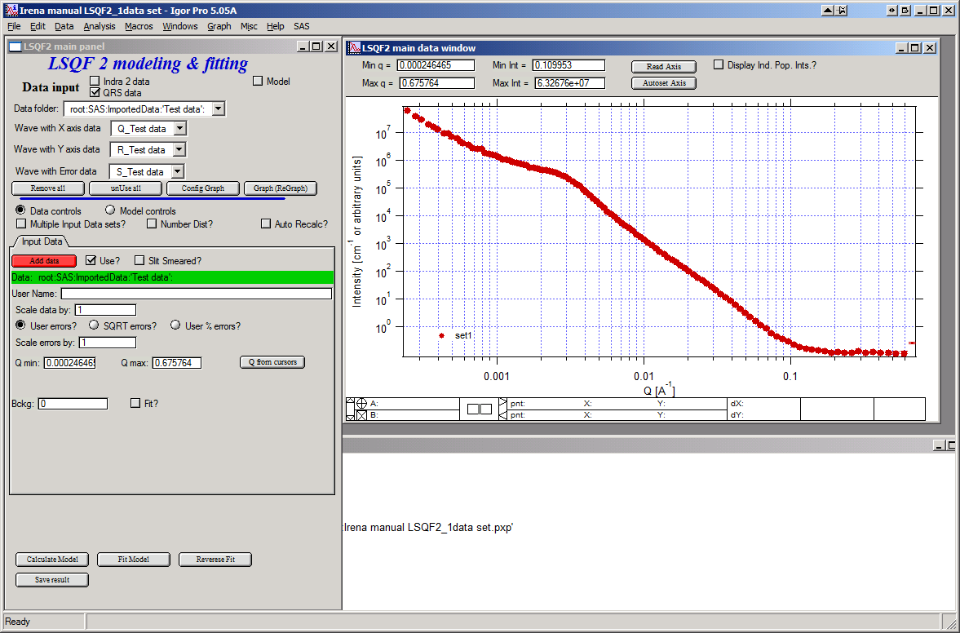

Name the data “Alumina powder” in the “User name” field.

Let’s also select the background immediately here. Set cursor (square) to area of flat background (around point 100) and read value of intensity there from the reader below the graph. It should be around 0.12 or so. Type 0.11 into the “Bckg” field and check the “Fit?” checkbox. Note that the Min and max fields appeared and are set to 0.1 and 10x the value of our estimate. Uncheck the “Fit?” checkbox so the background is NOT fitted, when we run this next time…

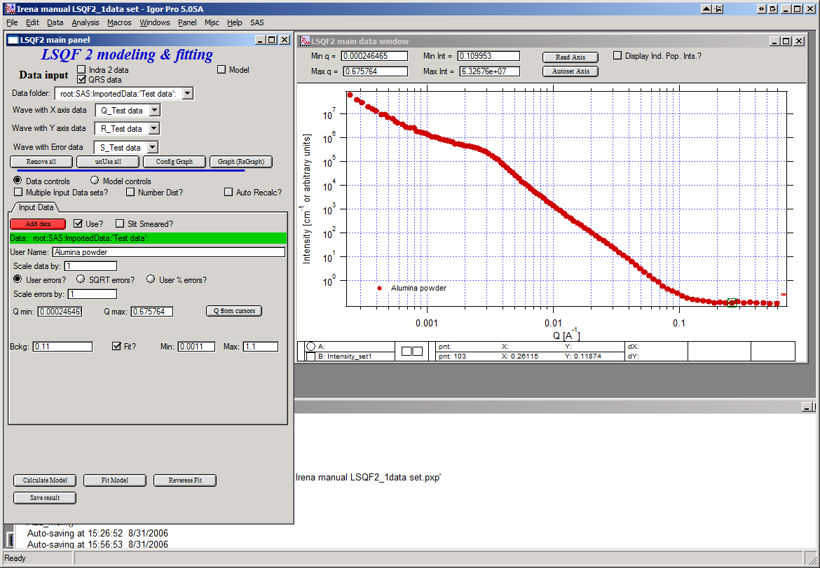

Now, let’s go to “Model controls”. Check the radio button “Model controls”. Check the checkbox “Auto recalc”. Make sure the “Interferences” checkbox is unchecked. Make sure that “Use?” checkbox for Pop 1 is checked and for all the others is unchecked.

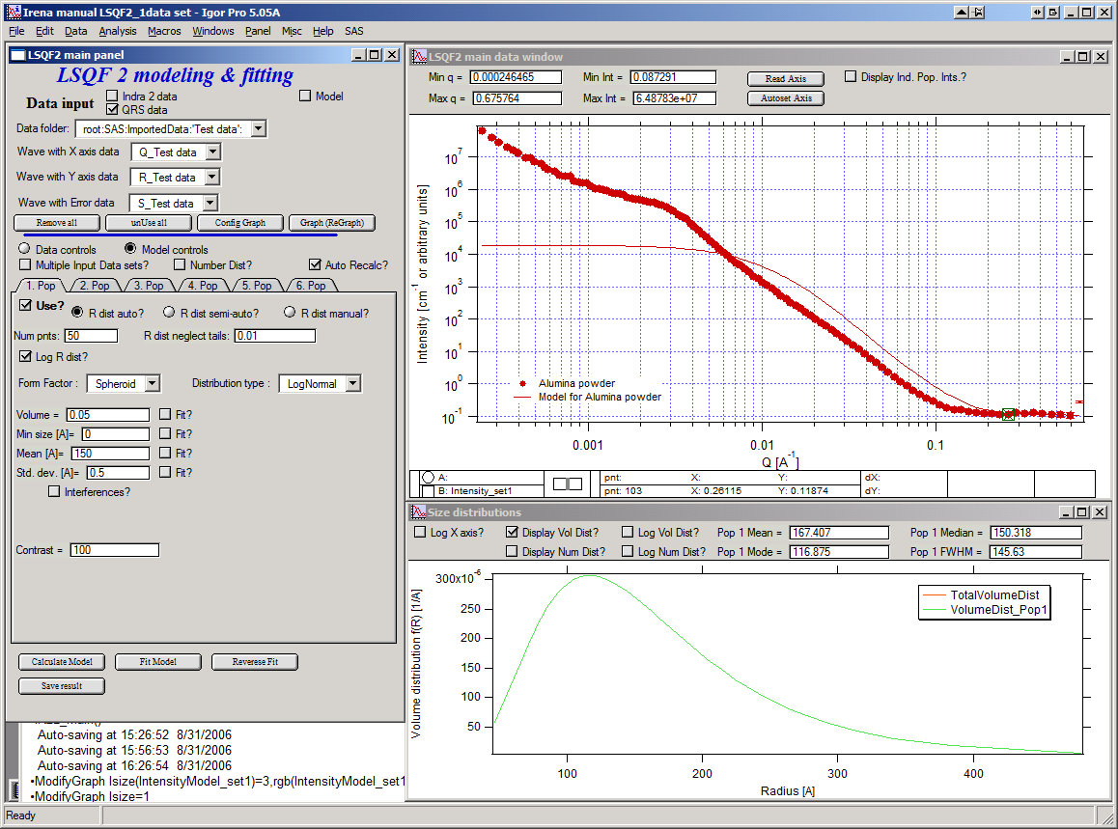

The model (default values) is going to be calculated.

Let’s decide, that this population will be the larger stuff, dominating the data. This means the Guinier knee at around 0.003 A-1. Also, since these data are not calibrated (powder sample), we can leave contrast to default value of 100. But if data would be meaningfully calibrated, correct contrast needs to be used here…

Let’s change values little bit to get better estimate of parameters… Reasonable starting point is may be with Min size ~ 100, Mean ~ 450, and Std. dev ~ 0.5 :

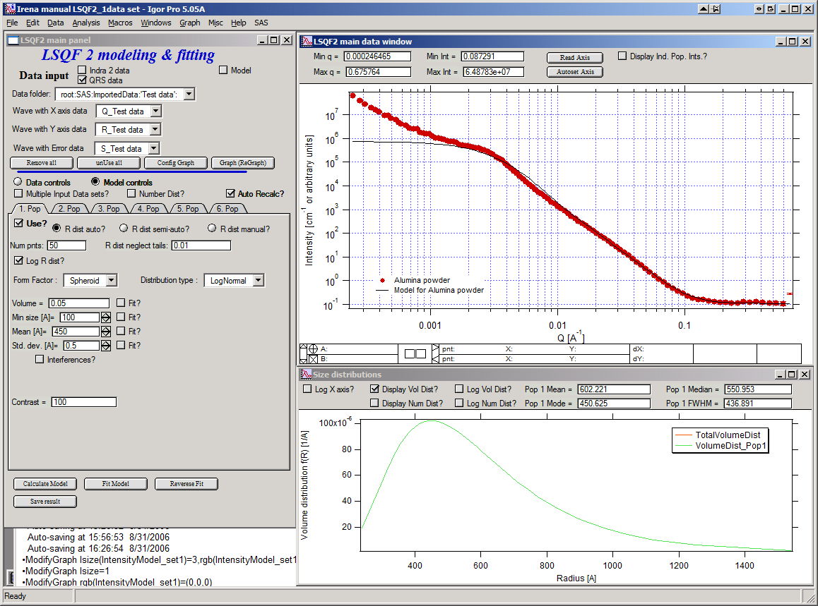

Now we need to select fitting range for this population… Check the “Data controls” Use cursors to select in the graph input data between point 30 and 73 and push button “Q from cursors”. This will set the Q min and Q max values.

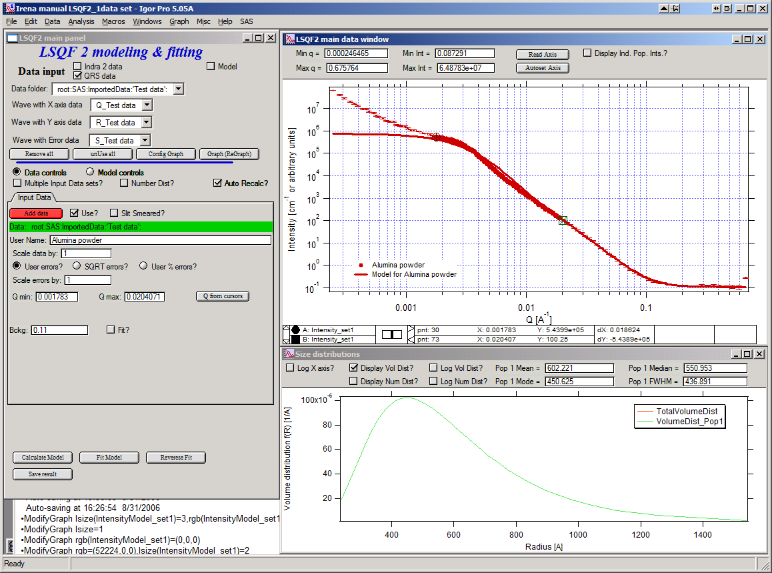

Make sure the background “Fit?” checkbox is unchecked here…

Now, let’s select parameters to fit. Background is not appropriate for this subset of data. Select “Model controls” again. Check “Fit?” for Volume, Min size, Mean and Std Dev. Values for fitting limits should be set to relatively wide range.

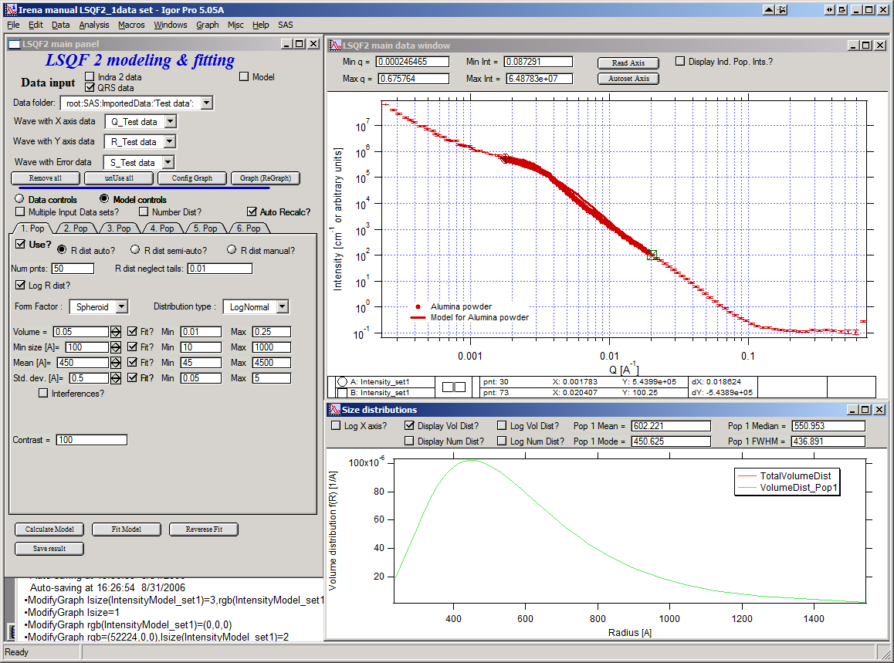

Now push button “Fit model” at the bottom of the panel. The model should fit after few iterations…

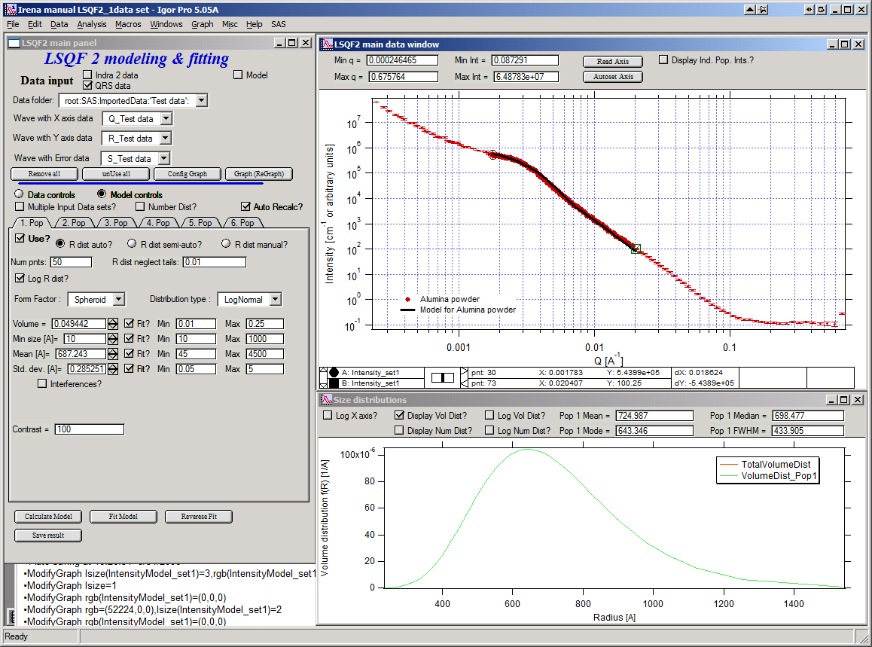

Now we will add other population (smaller particles). Uncheck all “Fit?” checkboxes on this Pop tab.

Select Pop 2. tab. Check “Use?” checkbox here. To see whole q-range, go back to “Data controls” and change Qmin and Q max to smaller/larger values (0.0015 and 0.5). Now come back to “Data controls” and let’s see, where the population 2 should be. Easiest achieved by unchecking “Use?” for population 1 and then the model in the graph is only for population 2. We want to use this population to describe data at around 0.05. So we need to move the mean to smaller sizes… This can be achieved by setting Mean to around 80 and reducing volume to about 0.01. Now check again “Use?” for population 1.

Check “Fit?” for Population 2 volume and Mean and fit the data by “FitModel” button.

Now we need to do final fitting of all meaningful parameters at once… There are now 3 places, where we need to select what will be fitted – but potentially could be even more… So let me review where the fitting parameters can be:

1. Data Controls – fitting of background
2. Model controls - Population tabs – fitting of distribution parameters (and volume, potentially interference parameters) – here we have two of these to check.
3. Model controls – Form factor panels - Potentially we could have for each population form factor parameters fitted, these need to be selected by reselecting again on each Population tab the form factor, which brings up (if appropriate) the appropriate panel..

**Good luck finding all of the parameters… You need it.**

Anyway, select background, Volume for each f the populations, Mean size, and Std deviation. Try to fit to the data from 0.0015A-1 to 0.5 A-1… With little bit of luck (and a lot of calculations) you should get result similar to one below:

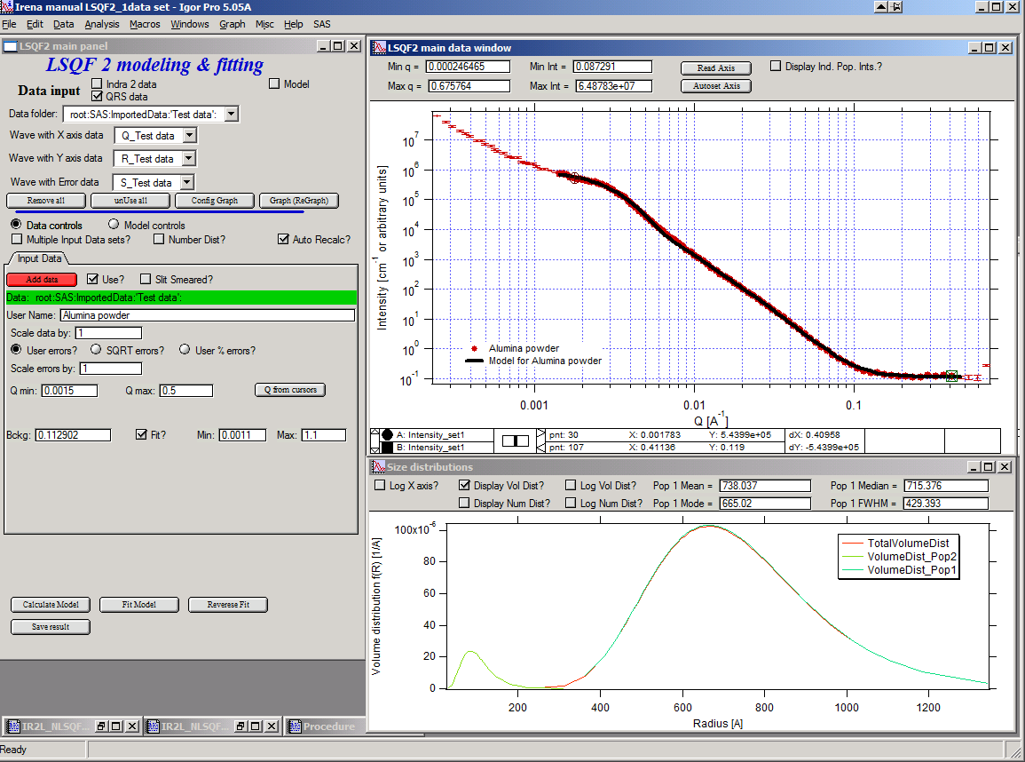

## 8.6. Uncertainity evaluation

This script enables to analyze uncertainties of parameters of the Modeling II, same method as Unified fit (chapter 6.6). There are two different types of analysis one can imagine:

1. Effect of input data uncertainties on the results. This analysis is done by running same fitting analysis (with all parameters fitted) on variations of data. These variations are created by adding Gaussian noise on input data. The Gaussian noise is scaled to have same standard deviation as input data uncertainties ("errors"). Analysis on these randomly modified data is run multiple times and statistical analysis on the results for each parameter is performed.

2. Stability of each parameter separately. This is bit more complicated - analyzed parameter is fixed, step wise, in range of values user specifies. Other user-selected parameters are fitted and chi-square values are recorded. After the analysis, this dependence is analyzed and based on statistical analysis (number of fitted points and free parameters) the uncertainty of the parameter is estimated.

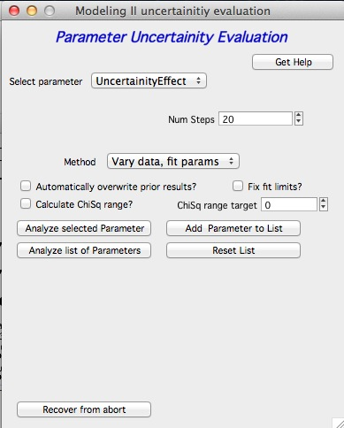

Here is example of results:

**********

Effect of data uncertainties on variability of parameters

root:SAS:ImportedData:S4_0055_sub:

Run 20 fittings using data modified by random Gauss noise within "Errors". Note, that adding noise on data increases chi-square significnatly.

To get following statistical results

Chi-square values : average +/- st. dev. = 180 +/- 19

Volume_pop1 : average +/- st. dev. = 0.114 +/- 0.006

Volume_pop2 : average +/- st. dev. = 0.0862 +/- 0.0019

GMeanSize_pop1 : average +/- st. dev. = 6.9 +/- 0.5

GMeanSize_pop2 : average +/- st. dev. = 26.0 +/- 6.9

GWidth_pop2 : average +/- st. dev. = 51.8 +/- 3.9

StructureParam1_pop1 : average +/- st. dev. = 9.6 +/- 0.4

StructureParam2_pop1 : average +/- st. dev. = 0.212 +/- 0.018

Background_set1 : average +/- st. dev. = 0.00267 +/- 0.00064

************

Moldeling II Evaluation of parameter GMeanSize_pop2

Method used to evaluate parameter stability: Sequential, fix param

Minimum chi-squared found = 2.6829 for GMeanSize_pop2 = 28.363

Range of GMeanSize_pop2 in which the chi-squared < 1.2623*2.6829 is from 22.704 to 33.271

**************************************************

"Simplistic presentation" for publications : >>>> GMeanSize_pop2 = 28.4 +/- 5.3

**************************************************



NOTE: you need to make sure the fitting limits are set widely enough as the fit may abruptly stop when these are violated. The Help in the panel provides many more details.

## 8.7 Fitting data with multiple input data set

Assumption of this chapter is, that you can already fit data with one data set (10.4). Only differences caused by adding other data sets are pointed out here. Not everything can work easily though - scripting does not work and analysis of the parameters uncertainties has not been tested yet.

### Changes in Data controls

When “**Data controls**” AND “**Multiple Input Data Sets?**” are selected, up to 10 input data sets can be loaded at the same time in the tool. Each Data set has all of the controls as the first one, including separate background. Note, that if the background is to be fitted, checkbox needs to be selected on its tab.

If “**Different contrasts for data sets**” is selected, separate contrast needs to be input for every population and every population. This can be excessive number of contrasts. It is typically suitable for anomalous SAXS data evaluation.

Note, that the selection of number/volume distribution is used for all of the populations at the same type. You cannot mix number and volume distributions at the same time.

Note, that you can use one or more of the input data sets at the same time. If you unselect the “**Use?**” checkbox on any data tab, all parameters stay in the tab. Therefore you can mix-and-match data any time from any of the 10 populations.

### Changes in Model controls

All controls stay the same. Contrast field will change reflecting selections: if “**Different contrast for data sets**” is not selected only one Contrast will appear, if it is selected, “**Contrast data X**” will appear, if Data X are set to be used. This appears on EVERY population tab. You need to go and check the contrasts for every population.

### General comment

*Please, remember, that with more data sets, this will be much slower. Setting up parameters for this complicated fitting space can be intimidating and very much complicated. You need to go through all of the used tabs in both Data controls and Model controls.*

# 9. Size Distribution

**Using maximum entropy, total-non negative least squares method and regularization**

## 9.1 Basic description of methods

### Maximum entropy method by Pete Jemian

Maximum entropy (MaxEnt) and regularization (maximizes smoothness) are two separate methods for obtaining size distributions from small-angle scattering data. Yet, we describe them together here since they share many common components. Both are versions of a constrained optimization of parameters which solve the scattering equation.

(9.1) $I\left(Q\right)={\left|Δϱ\right|}^{2}Σ{\left|F\left(Q,r\right)\right|}^{2}V\left(r\right)NP\left(r\right)dr$

The difference in these two methods is in the applied constraint and it is this constraint which most heavily influences the differences between the two methods in the form of the result.

The maximum entropy method was developed by Jennifer Potton et al., and supplied in the code package MAXE.FOR. Pete Jemian (jemian@anl.gov) has had his hands all over this code and in a few places, made some rather significant additions, resulting in the code package sizes.c. Most significant is the addition of the regularization method which is likely to succeed an finding a solution in many cases when the MaxEnt method fails to converge upon a solution. Please contact him with any questions regarding the implementation of these methods. (Point of fact, *both* are actually regularization methods.)

J.A. Potton, G.J. Daniell, and B.D. Rainford; ***Inst Phys Conf Ser*** **#81, Chap. 3** (1986) 81-86

--- ***J Appl Cryst*** **21** (1988) 663-668

--- ***J Appl Cryst*** **21** (1988) 891-897.

J. Skilling and R.K. Bryan; ***Mon Not R Astr Soc*** **211** (1984) 111-124.

Ian D. Culverwell and G.P. Clarke; ***Inst Phys Conf Ser*** **#81, Chap. 3** (1986) 87-96.

Literature citation for Maximum Entropy code in Irena macros bvy Pete Jemian

Pete R. Jemian, Julia R. Weertman, Gabrielle G. Long, and Richard D. Spal; Characterization of 9Cr-1MoVNb Steel by Anomalous Small-Angle X-ray Scattering, **Acta Metall Mater 39** (1991) 2477-2487.

Here *N(r)* is described as a histogram size distribution where a fixed number of bins are defined over a given range of diameter with either constant diameter bins or constant proportional diameter bins. Solution of the histogram size distribution to the scattering equation 9.1 above is obtained by fitting the scattering calculated from trial distributions to the measured data and then revising the amplitudes of the trial histogram distribution based upon the applied constraints. The trial histogram size distribution is not forced to adhere to a particular functional form, such as Gaussian or log-normal. However, in the current formulation, all sizes of the scatterer are expected to have the same scattering contrast and morphology (shape, degree of interaction, aspect ratio, orientation, etc.).

In both MaxEnt and regularization methods, the measured data must be represented by the calculated data so that the goodness of fit criteria (sum of squared standardized residuals) is close to the number of measured data points used in the analysis, subject to an additional constraint. This imposes a high standard for the reported errors on the scattering intensity. The reported errors are expected to be estimates which are comparable to one standard deviation of the true intensity and that the difference between the measured intensity and the true intensity is within one standard deviation of 67% of the time and randomly distributed such that a summation over these differences has zero mean and unit RMS. If these conditions are not met, it is likely that artifacts in the derived size distribution will result. Often it is necessary to scale the reported errors by a factor to achieve converge of the MaxEnt method.

As a point of fact, both MaxEnt and regularization are regularized methods of solution to the scattering equation (9.1). They both seek solutions of the functional,,

(9.2)

where ** describes the goodness of fit, *S* is the applied constraint, and  is a Lagrange mutiplier used to ensure that the solution fits the measured data to some extent.

For MaxEnt, the additional contraint is that the configurational entropy of the size distribution must be maximized. Rather than be bothered by what this means when compared with the thermodynamic entropy, you are asked to consider that this constraint enforces the principle that all histograms in the size distribution must have a positive amplitude. To make the calculation of the entropy, an additional reference level must be defined. Typically, this reference level (a.k.a., Sky Background, starting guess, *a priori* information) is about 0.01 of the maximum level of the final size distribution. One does not need to fine-tune this parameter and should never be concerned with adjustments less than one order of magnitude. Too high and this parameter will cause the solution to have upward tails at both low and high ends of the distribution. Too low and additional scatter will appear in the distribution. The MaxEnt constraint imposes no correlation on the amplitudes of adjacent bins in the calculated histogram size distribution.

### Regularization method by Pete Jemian

The regularization method implemented here maximizes the smoothness of the calculated histogram size distribution by minimizing the sum of the squared curvature deviations. The particular mathematics used here do not prevent the use of negative values for the amplitudes of the histogram size distribution and this is a noted behavior which must be considered to avoid. Often, it is possible to avoid the negative bins in the size distribution by adjusting the fitting range, the bins in the histogram size distribution, or the background.

NOTE: since version 1.50 I modified the code to provide ONLY positive solutions. It is heavy-handed code change and likely not really mathematically correct. It may change a bit in the future.

### Total non-negative least square method

This is implementation of the “Interior point method for totally nonnegative least square method”. I have found reference and method description for this method on line: Michael Merrit and Yin Zhang, Technical report TR04-08, Department of Computational and Applied Mathematics, Rice University, Houston, Texas, 77005, USA. This publication was from May 2004, I have found it on the web posted in December 2004, <http://www.caam.rice.edu/caam/trs/2004/TR04-08.pdf>

Basically, this is very interesting method, in which one starts with reliably positive solution, calculates gradients using least square method to better solution and makes step towards this solution. The size of the step is limited in such manner, that the solution (histogram bin content) cannot be made negative. If the step would make it negative, the size of the step is limited in such manner, that the non-negativity is guaranteed.

The problem of this method is, that there does not seem to be any simple way of incorporating errors in the calculation. Generic method which was suggested to me resulted in instability of the code. So, contrary to MaxEnt method (which inherently uses errors), in this method the errors are used only to identify sufficiently good solution.

Also this method seems to have major problem with the poor conditioning of the SAS problem – natural log-q and log-I behavior of the SAS data. Therefore, it basically requires, that fitting is done in different “weighing” of the data – for example I*Q4 vs Q etc…

Uncertainties - since version 2.50 I have added code, which can generate uncertainties, by running multiple fits to data modified by adding Gaussian noise scaled to have standard deviation equal to the data uncertainties.

## 9.2 Using the tool

This program uses one complex interface – a complex graph and panel for data input and manipulation. To start, select “Size distribution” from “SAS” menu…

On the panel, which gets created, starting from top:

1. select the “Use QRS checkbox” (assuming you are using QRS named data as explained above).
2. Select data folder with data (see figure below)
3. Select wave with Q vector, other should be selected automatically (if not select right waves). Note, that it is now not necessary to input error wave. See below…
4. “Graph”

New graph gets created.

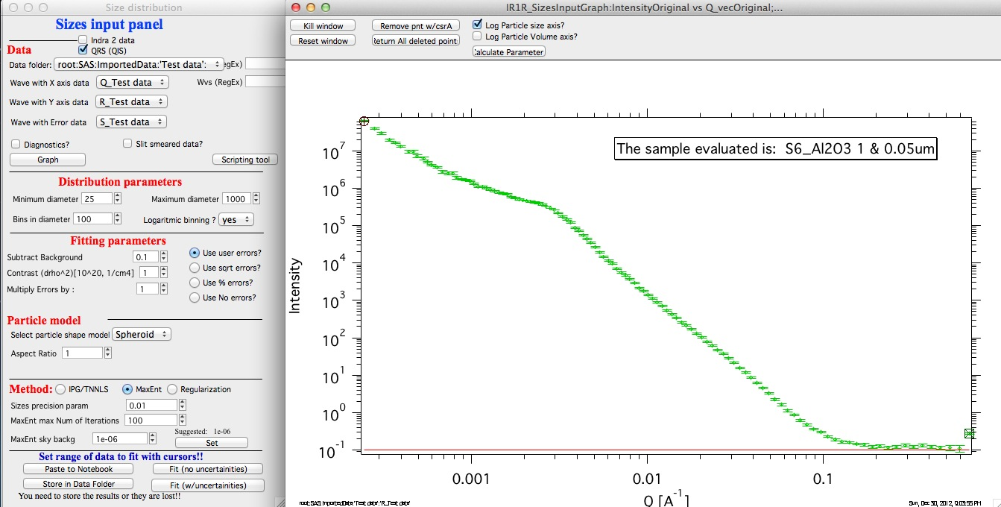

Leave the “Slit smeared data” set to no and “Slit length” set to NaN. If using the Indra data structure (UNICAT USAXS data reduction), these fields are preselected in the proper form and should not have to be changed. If the data are from different instrument (as here) and are slit smeared the macro can be still used. Providing user selects correctly slit smeared data and inputs slit length in units of Q. I expect this case to be highly unlikely…

Next we need to setup some parameters.

**Distribution parameters**:

Minimum diameter & Maximum diameter – both are in A. These are limits of fitted distribution. Set minimum to 25 and maximum to 10000

Bins in diameter – into how many bins you want to divide the range of diameters. 100 is a good number – more points may be really slow on slower computers.

Logaritmic binning – if yes, the bins are binned logarithmically – i.e., the bins at small sizes are smaller and at large sizes are larger, giving save width bins when plotted on axis logarithmically. This is very useful setting for the wide ranges of sizes measured using USAXS instrument. If no is selected here, the bins are all same width. Leave in yes for now…

### Fitting parameters:

Background this is flat background to be subtracted from data. The red line in the graph shows current value. Set correctly for this case to 0.1 or so

Contrast (delta rho squared) – if this is properly inserted, the data are calibrated… Leave to 1 since the contrast is not known.

### Error handling:

There are four ways to handle now errors in this tool. The method is selected by four checkboxes lined vertically next to the “Background and Contrast” fields…

1. “Use user errors” use erros input as wave. In this case the field: “Multiply errors by”is available and errors can be scaled as needed. Start with high multiplier and reduce as necessary to reach solution, which is both close to the data but not too noisy.

2. “Use sqrt errors” – will create errors equal to square root of intensity (standard Poission error estimate). You can multiply these errors by error multiplier. Errors are smoothed.

3. “Use % errors” – will create errors equal to n% of intensity. Field where to input the n appears. Errors are smoothed.

4. “Use No errors” – use no errors – the weight of all points is the same. This is unlikely to be correct, but this case allows to use fitting in “scaled” space – Intensity * Qm vs Q, where m = 0 to 4. This helps to mathematically better condition problem (similarly to using errors) and can yield sometimes good solution.

**NOTE : at this time you cannot use this method (no errors) with MaxEnt or Regularization.**

**Comments:**

MaxEnt works best with user errors or % errors.

IPG/TNNLS seems to work best with no errors and m = 2 -4. Reason is unclear.

The errors displayed in the graph will change as different methods are selected:

User errors, multiplied by 10:

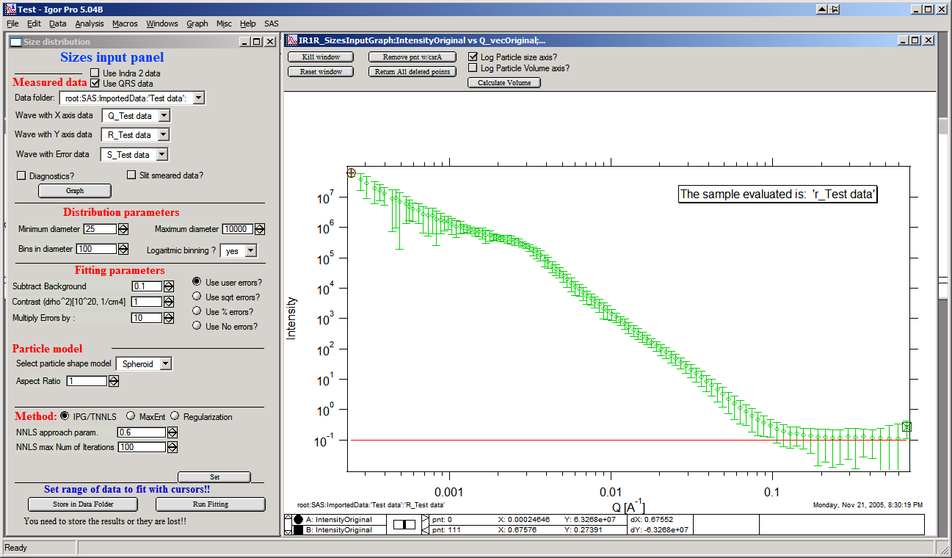

SQRT errors, multiplied by 10:

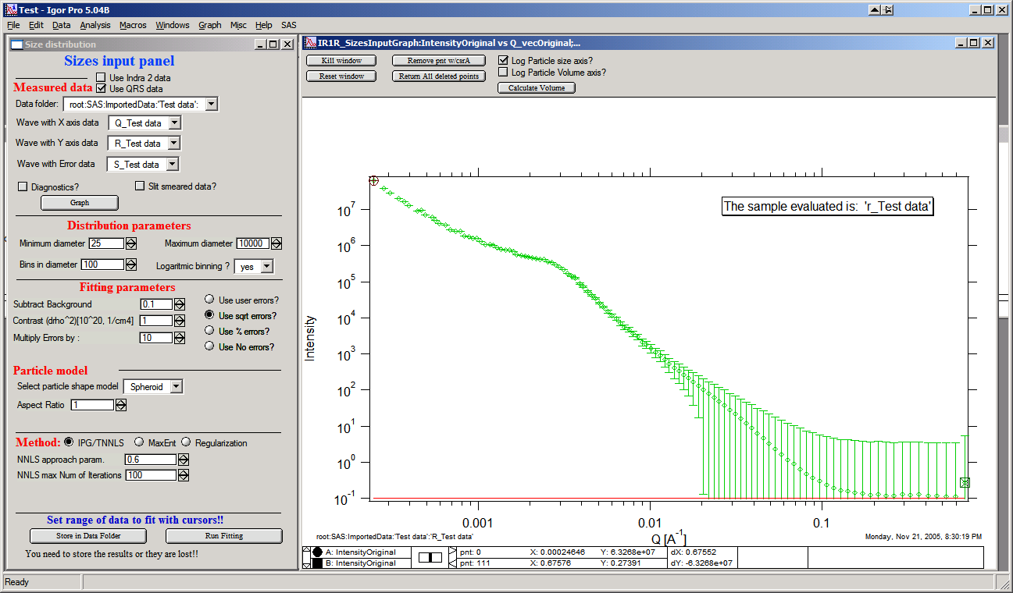

% errors, used 20%:

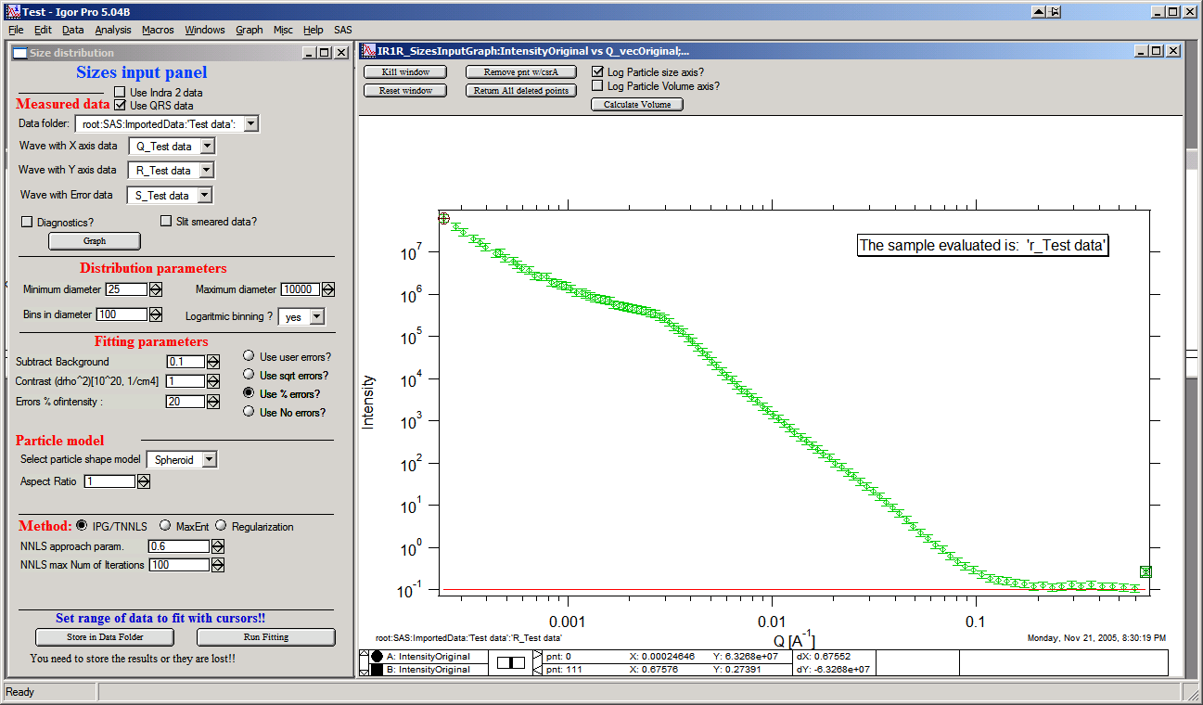

No errors, selected to use I*Q3 vs Q “space” for fitting:

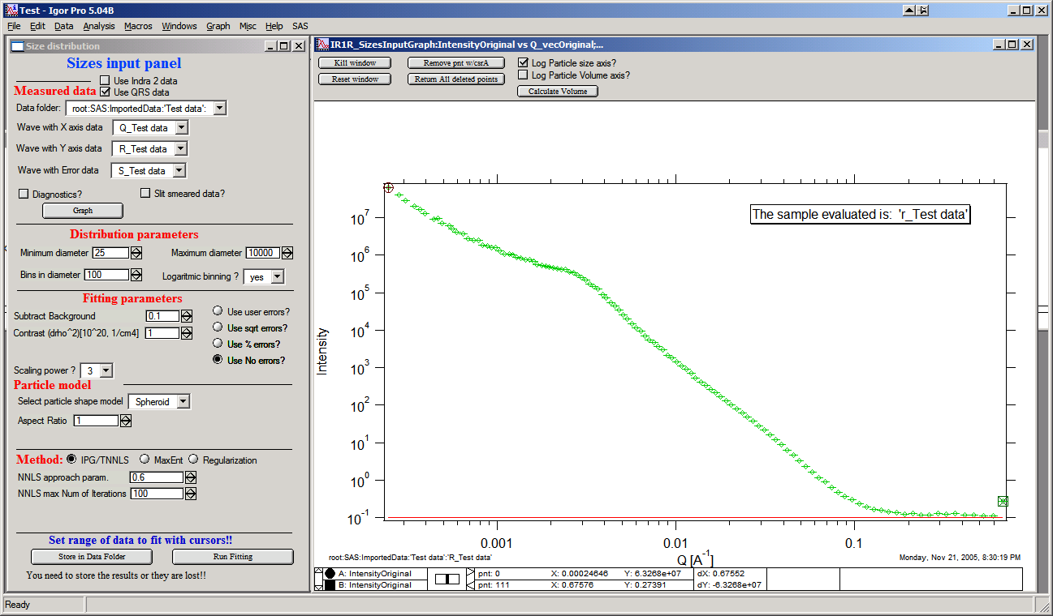

### Particle shape:

Particle shape model – the tool uses the same selection of form factors as Least square fitting. If you feel you really need another shape, I can put it in. Same comments apply WRT speed as mentioned in Least square fitting – “integrated spheroid” is using the most complex way to avoid possible artifacts, but is very slow. Spheroid AR 1 is fastest, others depend on complexity of math and integration. The code has been internally optimized to run as fast as possible.

Aspect ratio – anything, 1 is for sphere.

### Method:

**The default method is Maximum Entropy.**

Size precision parameter is internal number which should not be changed too much. Most users should be happy with default. Smaller the number, more precisely MaxEnt needs to match the chi squared…

MaxEnt max number of iterations – unlike Regularization, which has limit on number of iterations, MaxEnt can go infinitely. Therefore maximum number of iterations need to be enforced.

MaxEnt Sky Background. While this is relatively complicated number internally, note the suggestion next to it. Suggested value is 0.01 of maximum of the resulting volume distribution. The suggested value will be either green or red, depending if the value in the box is reasonable. Accept the suggestion and you will be happy.

**IPG/TNNLS**

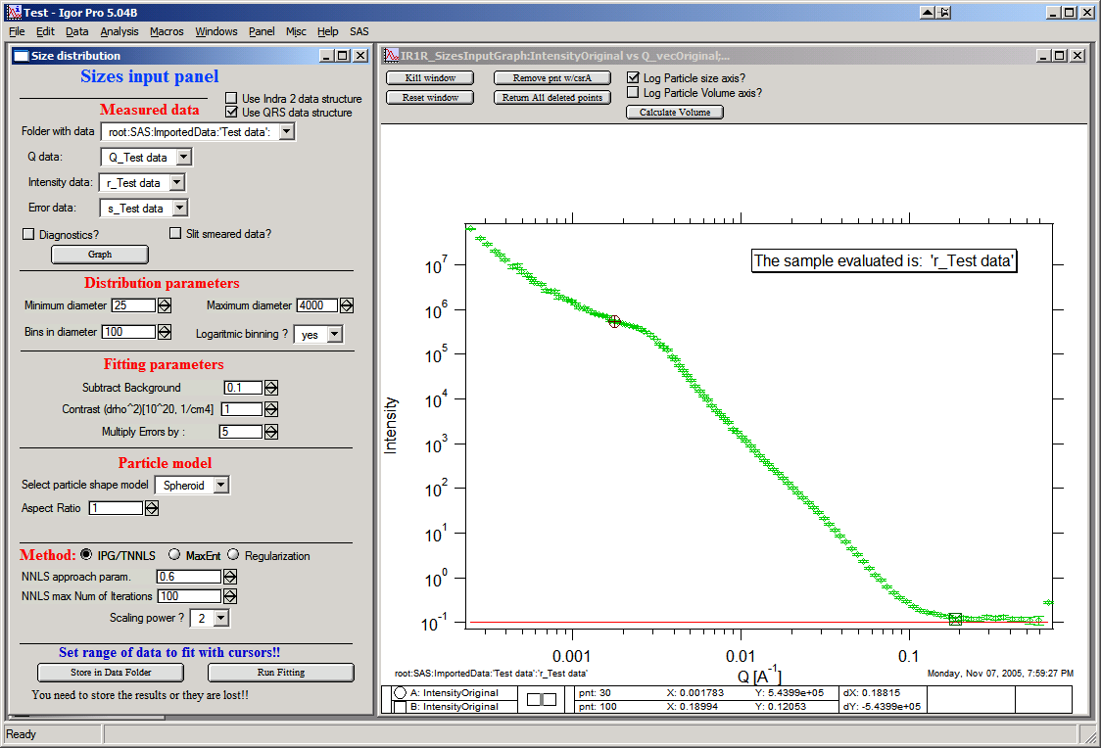

Approach parameter is the step size (from maximum) which will be made in each step towards calculated ideal solution. Basically convergence speed, but too high number will cause some overshooting and oscillations. For most practical purposes seems to work fine around 0.5-0.6.

NNLS max number of iterations – limits number of iterations. Change as needed.

Scaling power – this is how Intensity will be scaled to improve the conditioning of the problem.

**Regularization**

Has no additional controls.

### Buttons part

**“Run fitting”**  runs the above selected method.

SAVE THE RESULTS button – if you do not push this, the data are not copied back into the sample folder and are overwritten with new data.

### Getting fit.

First select range of data using the cursors. Set rounded cursor on point about 30 and squared on point 89 or so. Note, that you can vary the range of fitted data between the fits.

Push button “Run internal MaxEnt”. Solution should be found as in the figure below…

If the parameters are too restrictive you may get error message, that solution was not found. In such case check minimum and maximum diameter settings, check the error multiplication factor etc. Generally I suggest starting with higher range of radii than needed and higher error multiplication factor. Then reduce as needed. Also check the shape.

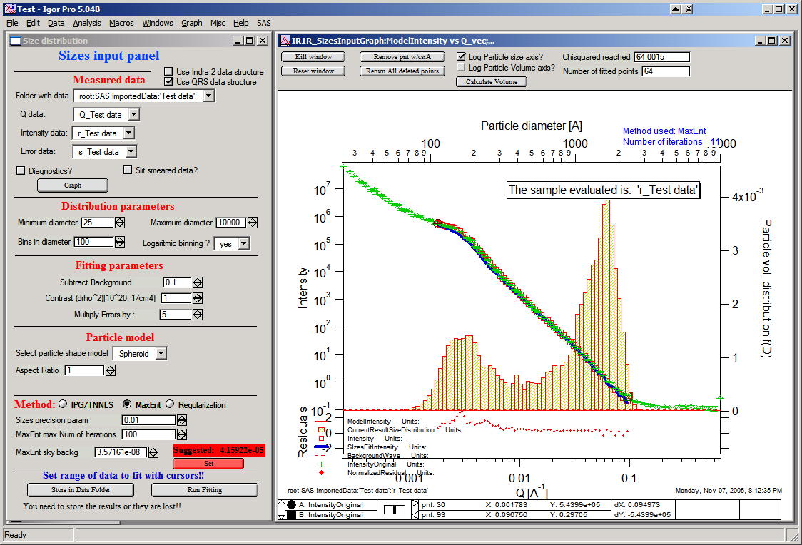

This is rough fit for the data in the graph – and for purpose of description of this graph now.

**Now let's get to explanations**:

The green points are the original data points.

The red points (top part of graph) are points selected for fitting (without background)

The blue line (very difficult to see) is the fit obtained by the fitting routine

The bar graph is the particle volume distribution (use top and right axis)

In the low graph

The red dots are normalized residuals. Ideally these should be random within +1 and –1, this structure suggests some misfits in some areas.

To get better results one now needs to play with the parameters. I suggest reducing maximum diameter to about 4000A, reducing multiply errors by to 3, fixing the MaxENt sky background and the running the same routine again. Following is the result:

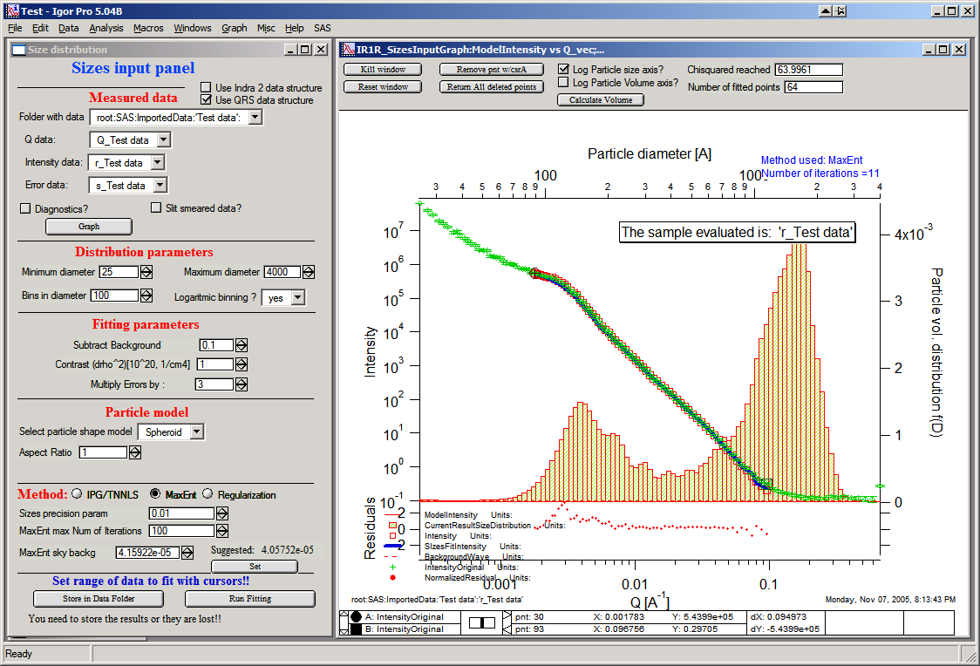

This shows, that we have bimodal distribution of scatterers. By the way, these data are from mixture of two polishing powders.

And now the IPG/TNNLS method:

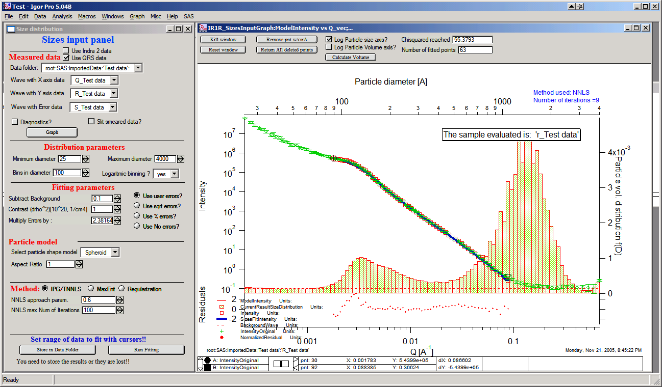

This is solution with user errors. Note, that the solution is basically very similar to MaxEnt.

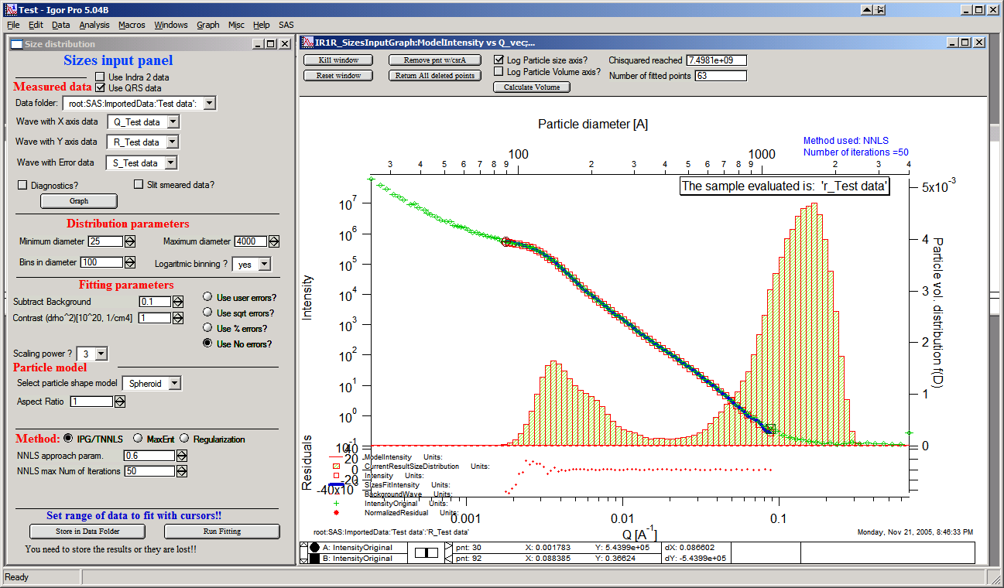

And here is solution with no errors, but scaling by Q3. Less noisy. Note, that in this case the IPG/TNNLS method is stopped by the Maximum number of iterations. Less number of iterations, less noisy solution – but may not be close to measured data…

**NOTE : at this time you cannot use this method (no errors) with MaxEnt or Regularization.**

Saving the data copies waves with results into folder where the measured data originated. Also, it is possible to have various generations of data saved. In order to give user chance to find what each saved result is, following dialog is presented:

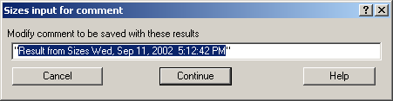

Here user can write ANYTHING, as long as it is bracketed by the QUOTES. The QUOTES are VERY important.

If user tries to start Size distribution macros in folder, where saved solution to this method exists, he/she is presented with dialog, which allows one to recover most of the parameters used for that solution.

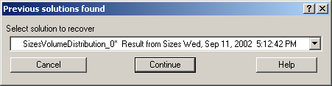

Therefore it is possible to start from where he/she left off. Also it is possible to start fresh - just hit cancel in this dialog - when parameters are left in the state they are left in after last fitting (or in default if this macro was not yet run in this experiment.

### Resulting waves:

Following waves are created in the folder with data, when saved from this macro (_0, _1, _2, etc are different generations of solutions saved by user):

SizesNumberDistribution_0

Contains number distribution data

SizesVolumeDistribution_0

Contains volume distribution data

SizesDistDiameter_0

Contains Diameters for the other waves which need it

SizesFitIntensity_0

Contains Intensity of the model

SizesFitQvector_0

Contains Q vectors for the above Intensity wave

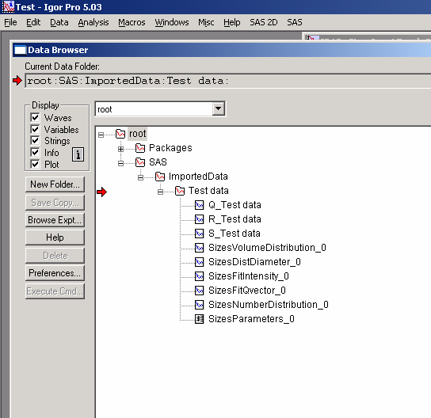

Comment, each of these waves contains WaveNote (see below at the bottom of the figure), which contains most of the details about how the particular results were obtained:

These are the parameters:

SizesDataFrom=root:'Test data':

SizesIntensity=Intensity

SizesQvector=Qvector

SizesError=Error

RegNumPoints=40

RegRmin=12.5

RegRmax=2000

RegErrorsMultiplier=3

RegLogRBinning=yes

RegParticleShape=Spheroid

RegBackground=0.12

RegAspectRatio=1

RegScatteringContrast=1

RegSlitSmearedData=No

StartFitQvalue=0.001783

EndFitQvalue=0.068163

RegIterations=12

RegChiSquared=60.45

RegFinalAparam=1.8853e+07

UsersComment=Result from Sizes Wed, Sep 11, 2002 5:12:42 PM

Wname=SizesDistributionVolumeFD_0

Most of these parameters should have self explanatory names. This is where user can figure out what happened.

Further some parameters are also saved in the string with name “SizesParameters_0” such as MeanSizeOfDistribution.

## 9.3 Uncertainity analysis of Size distribution:

If "Fit (w/uncertainities)" is used, 10 fits with data varied by data modified by Gaussian noise scaled to ORIGINAL uncertainties is run and statistical analysis is done on each bin. Here is example of results:

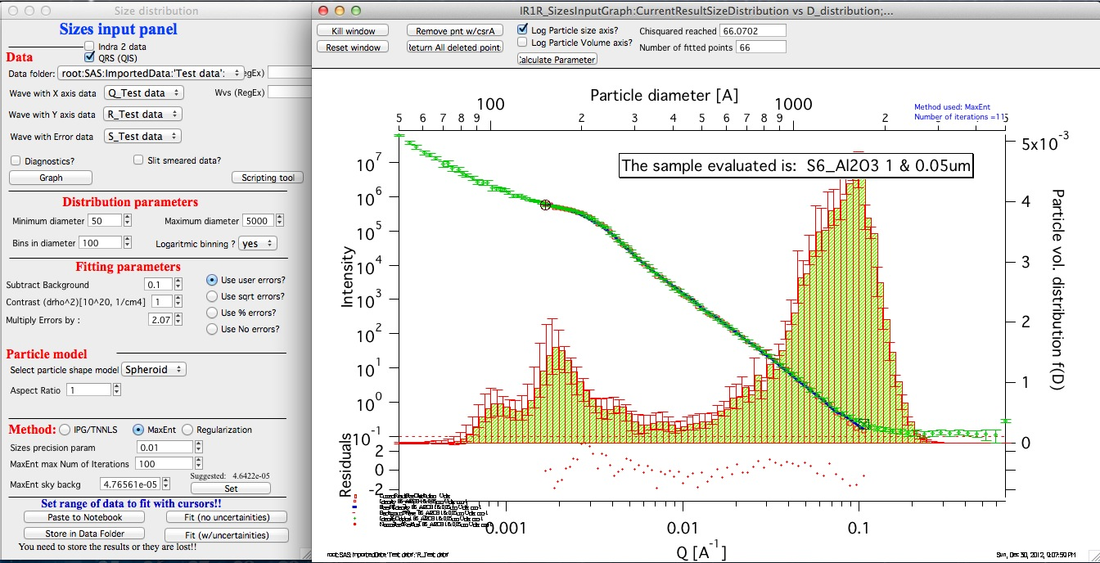

Note, that the tool can provide calculations of volume with uncertainities:

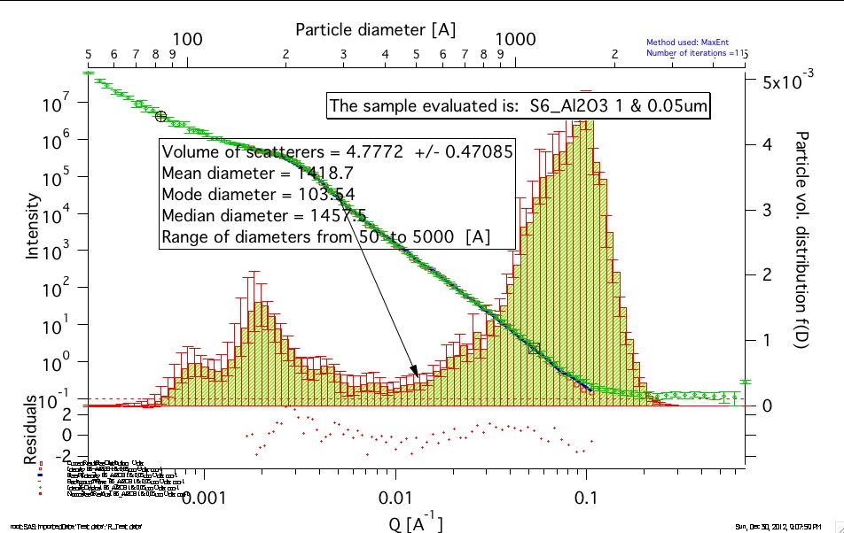

The uncertainties are exported and plotted. More support in Irena needs to be added as needed.

# 10. Pair distance distribution function (PDDF, p(r))

## 10.1 Model description

This tool calculates Pair distance distribution function as generally defined in the small-angle scattering theory (see any basic SAS book, like Glatter/Kratky 1982, page 27, formula 29):



where the is contrast/volume of the scatterers (simply scaling) factor. This one is neglected in this tool and set to 1. This is how GNOM does it also.



The PDDF is and r is the distance (in A).



This tool uses two different methods to achieve its goal – Regularization (by Pete Jemian) and Moore’s method (Moore, P. B. (1980). J. Appl. Cryst. 13, 168–175.). Both seem to have some advantages and disadvantages. The tool was tested against generally accepted GNOM by D. I. Svergun (EMBL). Test cases available to me yield same results and GNOM.

From version 2.41 the tool also generate Gamma function: gamma = pddf/(4*pi*r^2). Per user request. I am not sure what else to do with this, so if you want to get more functionality, let me know.

NOTE: I have observed significant changes on the calculated PDDF with changes with maximum dimension assumed and with errors scaling. My observations are noted in text further below.

Comment on graph formatting… This tool uses same default font and font size setting as other tools. You can change font sizes and used font for legend, text boxes and tags in “SAS” - “Other tools”-“Configure common items”.

## 10.2 Use of the tool

Test data for this tool are included in the Irena folder distributed in the zip file and should be in your Igor Pro folder/User procedures/Irena

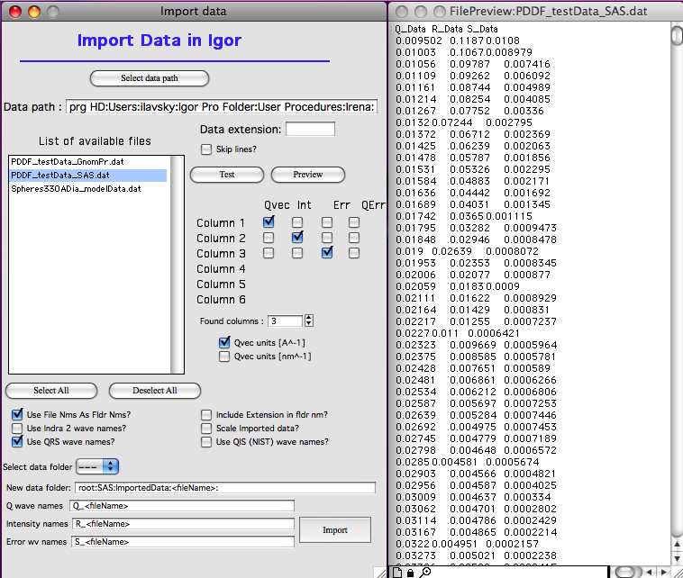

These data contain Q/Int/error and included is also GNOM generated PDDF in the similarly named file (see figure). These can be used to compare the results.

Load data in Igor as seen in the above figure and the follow next steps.

Following GUI is available from SAS menu (under Pair Distance dist. Fnct.)

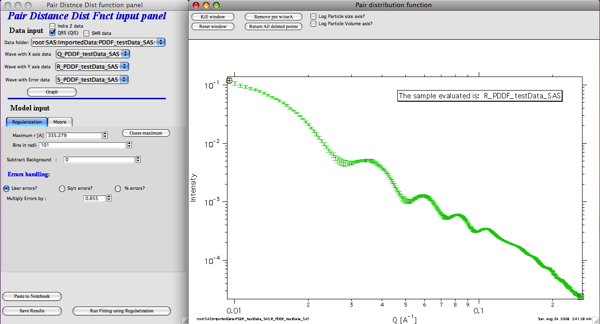

In this GUI I have already selected the test data and pushed button “Graph”. This created the input graph on the right hand side.

Model Input selection:

PDDF modeling requires few right choices… Here are some suggestions how to get the right values for analysis…

1. Maximum r. Generally this is maximum distance for p(r) (=PDDF) function. For relatively spherical particles it is close to 2*Rg, for less spherical particles can get larger, may be up to 4* Rg. It is important to guess large enough number, but not too large. To help, you can try using the button “Guess maximum”. In this case the code will attempt to fit one-level Unified fit to the data and provide guess for Rg. Maximum r is set to 2.5*Rg. Here is result in this case:

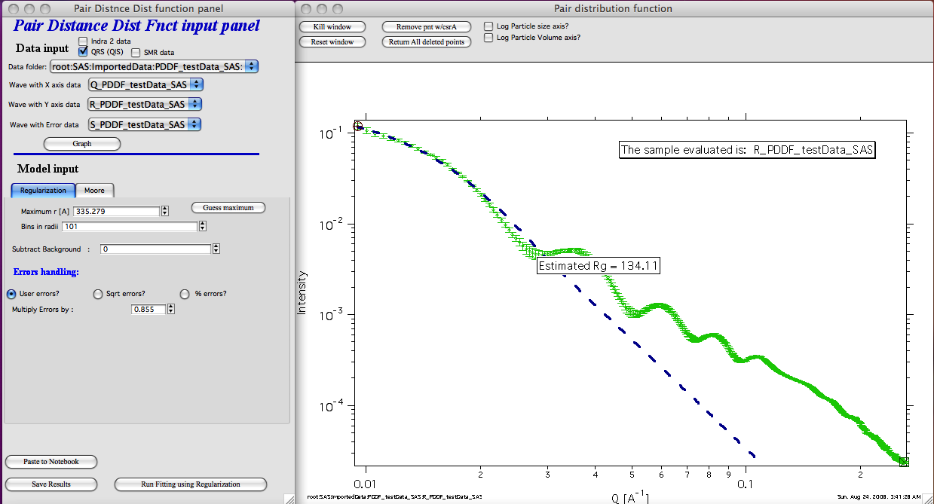

Note, this fit is not exciting, but the Rg is actually quite good, as you will see later…

2. Next one needs to choose number of bins. Too large number slows down calculations. I am not sure if higher numbers are of much use.

3. Subtract background – if there is some flat background in the data still left, one can subtract it here. Moore’s technique can fit the background. Test data really do not have any background left.

4. Errors handling. There is no perfect selection here. One needs to play and get the right errors handling here. Many SAXS data reduction tools do not produce meaningful errors and each technique required somehow different error handling. “sqrt errors” are meaningful ONLY if the data are still in “counting” statistics. Rare case… However, there are some ideas about the right approach here:

Regularization

Start with higher error multiplier (for User errors of sqrt errors) and then try fitting with decreasing error multiplier. At some point the fit will look good – and when multiplier is decreased even more, the fit will start failing. Lowest multiplier when you can still get fit is probably close to right…

Moore technique

Uses least square fitting. I had better success with using fractional errors. Again, reduce errors to force good with within reasonable number of iterations.

**Regularization**

There is nothing more needed, just select range of data to fit (probably whole range, but can be limited using cursors) and push fit button:

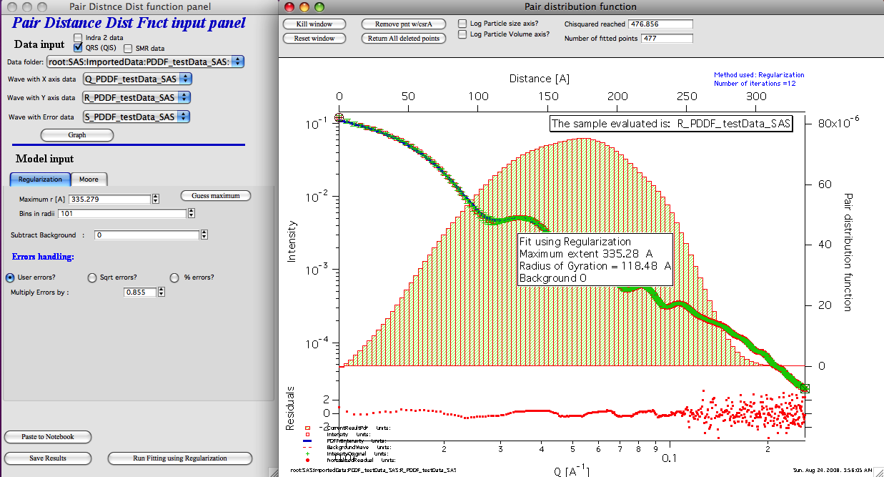

And here is result… One can see the PDDF, below graph are normalized residuals, provided is Rg and fit int eh graph.

**Moore technique (indirect Fourier Transformation)**

Select the tab with “Moore” and then see below:

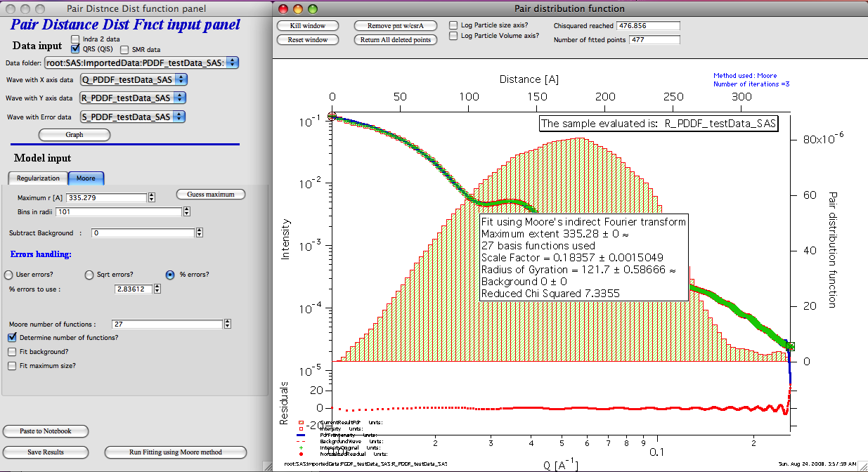

Note, that one has more controls:

“Determine number of functions” – that is useful to make sure reasonable number of function is chosen… I suggest using it, unless you have reason not to.

“Fit background” – if there is flat background left in the data, you can try.

“Fit maximum size” – you can try, but in my experience resulting maximum size seems too low.

## 10.3 Semi-GNOM file and other output data methods

There are three buttons to use with three different methods to output data.

New in version 2.31 is output of Semi-GNOM ASCII file for use in other ATSAS packages. ATSAS is well known package of programs from Dmitri Svergun,  
 <http://www.embl-hamburg.de/ExternalInfo/Research/Sax/software.html> . GNOM is program which performs regularization method of PDDF analysis, same as PDDF in Irena package. Its output file is being used by all other ATSAS programs, such as DAMMIN etc. A user has requested that I provide method of outputting output file compatible with GNOM to use with results from Irena PDDF tool.

The GNOM file format does not seem to be publicly described and therefore, I had to reverse engineer which parts of the GNOM file are actually important for other programs and formatting of all different fields, as the formatting seems to be really unusual and obsolete.

The provided data format has been tested on DAMMIN PC version 5.3 and attempts to follow the GNOM file version 4.4 included as example with DAMMIN. I cannot guarantee any functionality. If you find case when it does not work, send me the Igor experiment and all other related details and I will try tooimprove the compatibility, if I can.

Note, not all parameters printed in the output file are meaningful for Irena PDDF tool. Some of them are there because they just seem to have to be there.

Here is snippet of the GNOM output file, red are my comments

*****************************

#### G N O M --- Version 4.4 #### Header, must be here

Thu Sep 25 08:44:00 2008 Date, meaningful

=== Run No 1 === meaningless

Run title: root:SAS:ImportedData:lyzexp:R_lyzexp Your data name, meaningful

******* Input file(s) : R_lyzexp meaningful

Condition P(rmin) = 0 is used. meaningless

Condition P(rmax) = 0 is used. meaningless

Highest ALPHA is found to be 1 meaningless

#### Final results #### meaningless

Angular range : from 0.0414 to 0.4984 meaningful

Real space range : from 0.00 to 50.00 meaningful

Current ALPHA : 0.10E+01 Rg : 0.153E+02 I(0) : 0.655E+01 Alpha is meaningless, else is meaningful

Real space range : from 0.00 to 50.00 meaningful

S J EXP ERROR J REG I REG meaningful

0.0000E+01 0.6555E+01 meaningful

0.2299E-02 0.6552E+01

0.4598E-02 0.6544E+01

0.6897E-02 0.6530E+01

0.9197E-02 0.6512E+01

0.1150E-01 0.6488E+01

0.1379E-01 0.6459E+01

0.1609E-01 0.6424E+01

0.1839E-01 0.6385E+01

0.2069E-01 0.6341E+01

0.2299E-01 0.6291E+01

0.2529E-01 0.6237E+01

0.2759E-01 0.6179E+01

0.2989E-01 0.6116E+01

0.3219E-01 0.6048E+01

0.3449E-01 0.5977E+01

0.3679E-01 0.5901E+01

0.3909E-01 0.5822E+01

0.4138E-01 0.5904E+01 0.7150E-01 0.5739E+01 0.5739E+01 meaningful

0.4372E-01 0.5652E+01 0.7020E-01 0.5651E+01 0.5651E+01

0.4605E-01 0.5533E+01 0.6995E-01 0.5560E+01 0.5560E+01

….

Distance distribution function of particle meaningful

R P(R) ERROR meaningful

0.0000E+01 -0.5838E-03 0.5818E-04 meaningful

0.5000E+00 0.6171E-04 0.4782E-04

….

Reciprocal space: Rg = 15.252 , I(0) = 0.6555E+01 meaningful

Real space: Rg = 15.252 +- 0.000-00 I(0) = 0.6555E+01 +- 0.000E+00 meaningful, except for errors.

**Other methods of saving data…**

“Save results” copies wave with results into originating data folder. Copied are both model intensity and Q vector, as well as normalized residual. Also copied is PDDF and associated size wave. All of these waves have wave notes with all parameters and are recognized as results by Plotting tool, Data export tool and other Irena tools.

“Paste to Notebook” copies graph and somehow formatted summary of result into speciual notebook (created if necessary) for printing and future review.

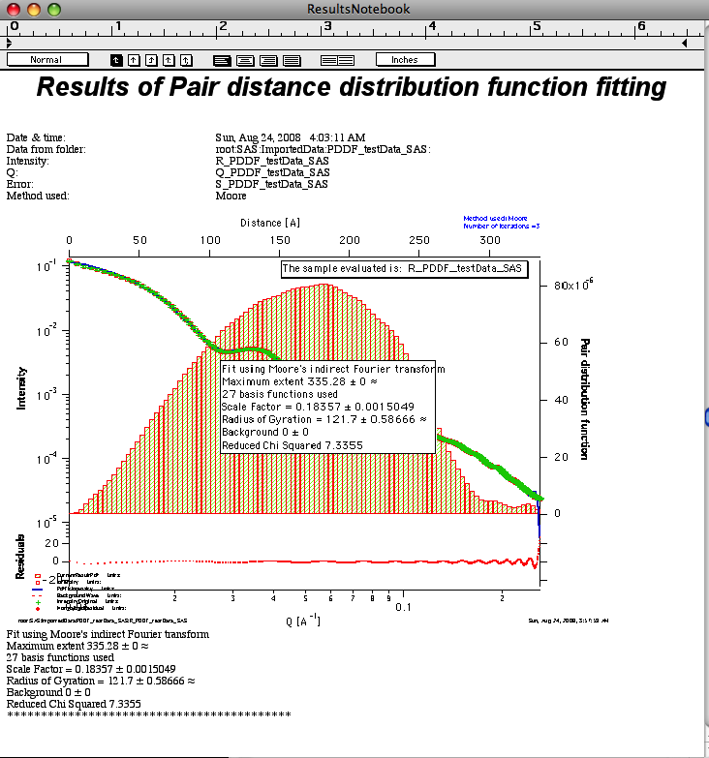

You can access this notebook (if exists) from “SAS”-“Other tools”-“Show Results notebook” menu. You can save the notebook as RFT file, which then can be edited in any Word processor.

# 11. Fractal model

This model has been developed by Andrew J. Allen from NIST ([Andrew.allen@nist.gov](mailto:Andrew.allen@nist.gov)). The model allows to combine two volume and two mass fractals in much similar way as the Unified model does. The parameters from this model have advantage of being more “fractal-related” than the values from Unified. There is short pdf file included in the distribution which served as basis for my design of this tool. Note, that this tool is actually port of Andrews original Fortran code into Igor, my code was verified to give same results as this Fortran code.

Note, that this write up was written for studies of cement and therefore some of the terms are material-specifically called.

## 11.1 Model description

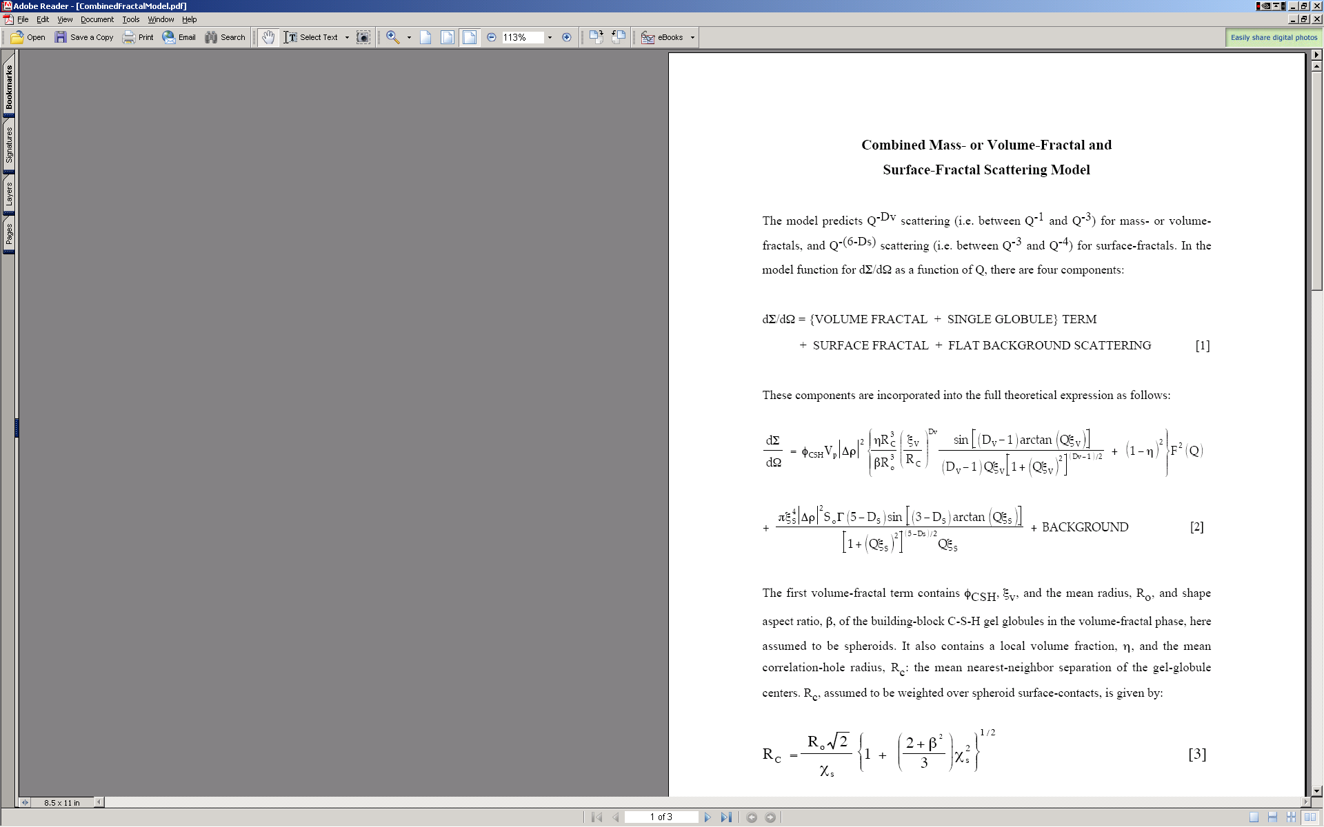

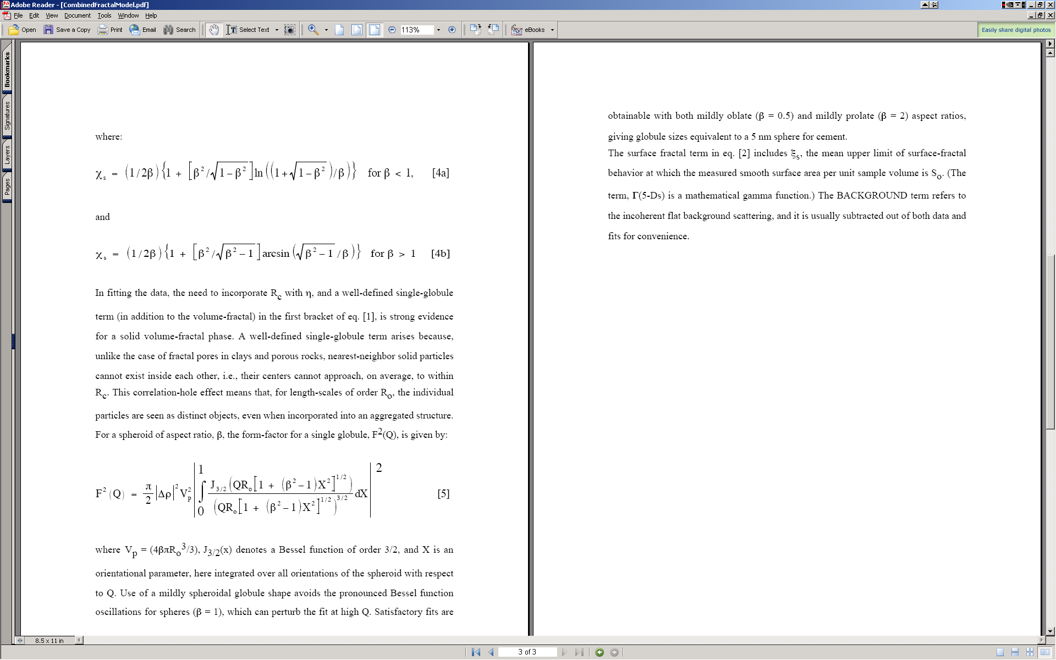

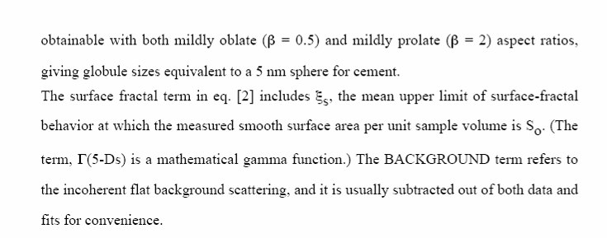

## 11.2 Use

I do not have included real fractal data, but for purpose of GUI description and function description, the included data should be sufficient.

Start the tool from SAS menu under “Fractal model”. GUI panel similar to all other tools appears, select “Use QRS data structure” and pick the data set available. The push “Graph” button to create graphs.

Note, that the “Subtract background” variable next to data selection allows to subtract known FIXED large background. The “SAS Background” at the bottom is similar term, but this one can be fitted during the fitting routine.

**Select “Use mass fractal 1” for starters and other checkboxes as in figure below:**

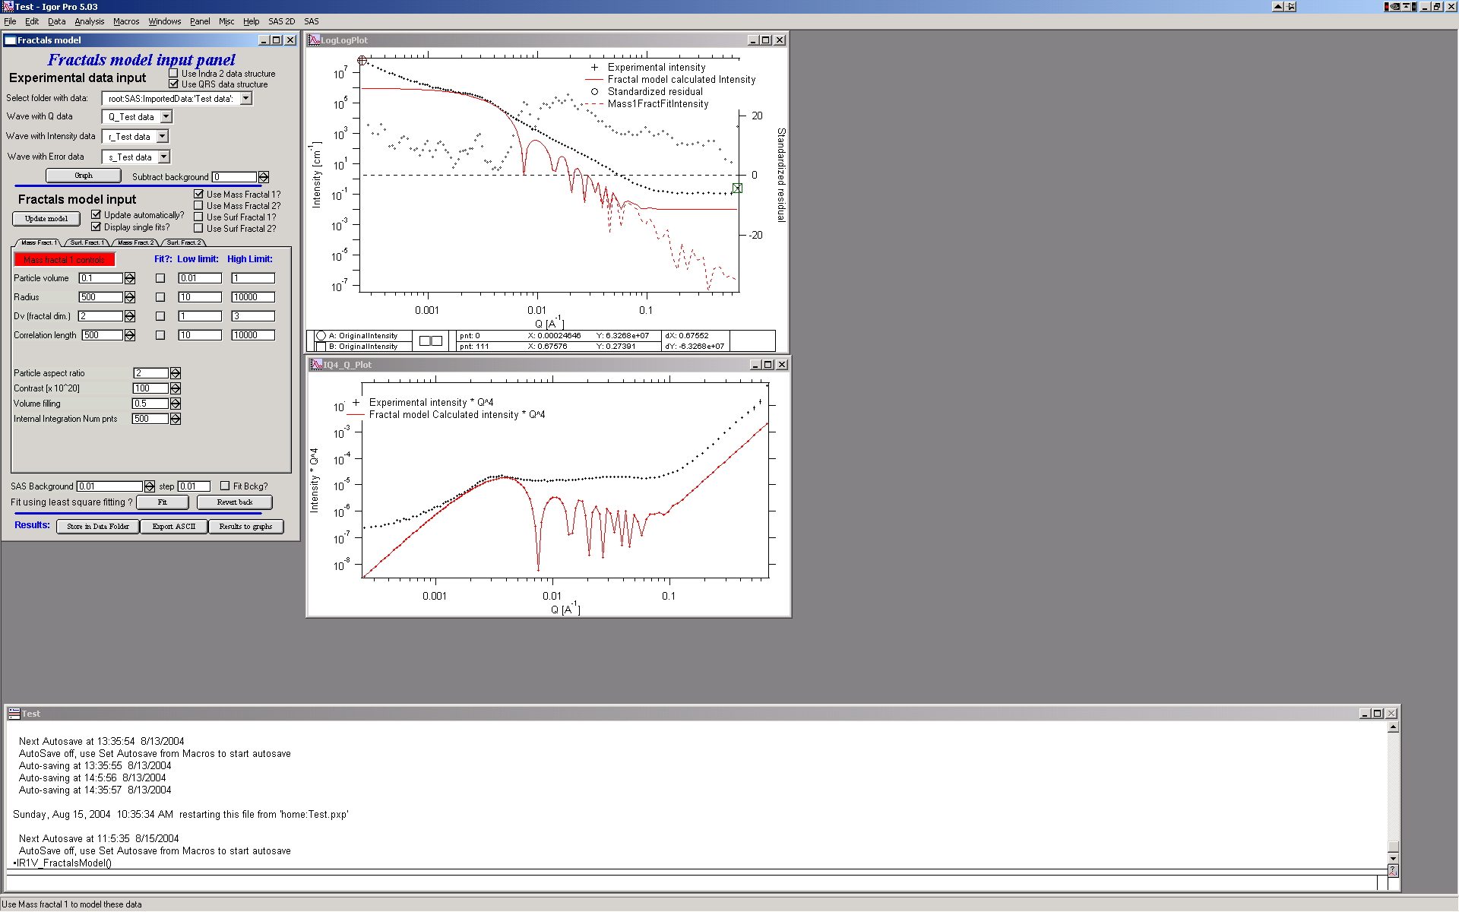

Note, that you can combine ANY combination of the two mass fractals and two surface fractals.

Comments on Mass fractal parameters:

Most parameters should be closely related to the ones mentioned above in description of the method.

**Particle volume** – volume of particles

**Particle radius** – size of the particle

**Dv**  - fractal dimension

**Correlation length** – distance between the particles

**Particle aspect ratio** – 1 if particles are basically spheres, larger than 1 – elongated particles, lower than 1 prolated particles. Particles are always spheroids.

**Contrast** – contrast…

**Volume filling** – see above

**Internal integration Num pnts** – internal parameter. Number of point in the numerical integral which I use to calculate orientational average of the particle form factor. Small number of points (especially at high aspect ratios) can cause artifacts. Large number of points increases significantly calculation time. My suggestion is to lower the number of points to find a good starting conditions and for final fitting may be increase, or to recalculate for testing results with higher (double) number of points at the end – if no change is observed, the number of points is selected correctly.

Suggestions: check solution for particle aspect ratio 2 and 0.5, keep integral integration num of point reasonably high (over 100 for sure, likely around 500) and change it only if you seem to see artifacts. Keep volume filling between about 0.4 and 0.6.

**Now select “Use Surf Fractal 1” and deselect the mass fractal:**

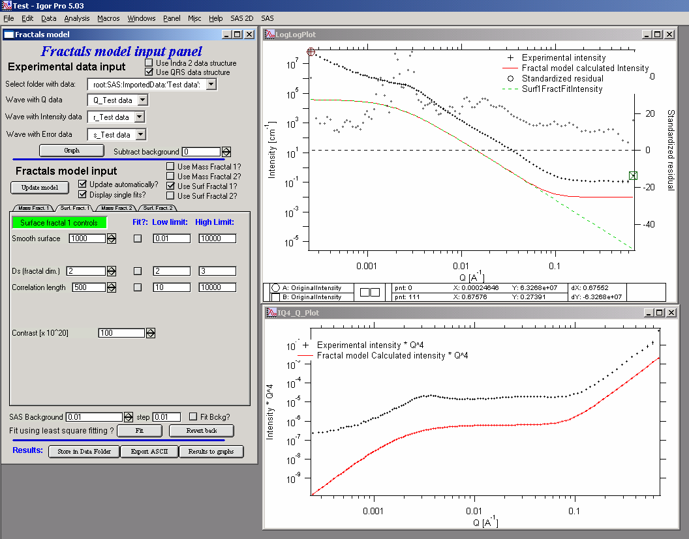

Comments on surface fractal parameters:

Again, for meaning check the description above.

**Smooth surface** – limits of smooth surface as described above

**Ds** – fractal dimension

**Correlation length** – correlation length as described in the theory

**Contrast**  - contrast…

Method of finding the solution is same as with Unified fit – first manually find good starting conditions and then select appropriate range of data with cursors and use fitting (select appropriate parameters to fit) to optimize data using least square fitting…

# 12. Analytical models

**This tool provides GUI for different models: Debye-Bueche, Treubner-Strey, Ciccariello-Benedetti**

Debye-Bueche model for modeling structural in homogeneities in the gels.

Treubner-Strey model for modeling of small-angle diffraction

Ciccariello-Benedetti for coated smooth surfaces

All models can be combined with low-Q Single Unified level. The controls have now four tabs – one for Unified level, one for Bebye-Bueche, one for Treubner-Strey, and one for Ciccariello-Benedetti. It is possible to combine them together, but it is not likely physically meaningful.

For explanation of the Unified level control, please see Unified fit.

## 12.1 Debye-Bueche model for gels

The theory is implemented in following form:

I(q) = (4KcorrL3)/(1+q2corrL2)2

where K = 8-4

Parameters of the gel are then the corrL – correlation length and . The model also allows low-q power law to be fitted and subtracted from data as well as flat SAS background. The low-q power law slope has 2 parameters (slope and prefactor) and background has one. All can be fitted.

**NOTE: August 2012 user identified typo in the formula, which was used:**

**I(q) = (4KcorrL2)/(1+q2corrL2)2**

Based on provided citations, this formula needed corrL3 not corrL2 as was used in original implementation. As of now I am looking in the source of this error (which dates to about 2003). Currently there are not really clear, refereed publications I could base the decision on here. Actually, the one referred publication (my own) I have cites the "wrong" formulas. If you have any citation or opinion here, let me know.

***The best I can is get at this time is following citation from Hammouda, NIST, web presentation:***

Quoting: The Debye-Bueche model is used to describe scattering from phase-separated (two- phase) systems. Here also correlations are characterized by an e-folding length ξ. The pair correlation function is give by (Debye-Bueche, 1949):

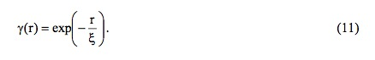

The scattering cross section is obtained by taking the Fourier transform to obtain:

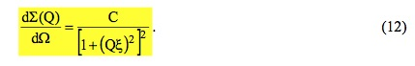

The prefactor can be expressed in terms of the volume fraction φ and contrast factor Δρ2 as:



The Debye-Bueche model is obtained as a special case of the Teubner-Strey model for

very large d-spacing (d>>ξ).

******

This is the main screen:

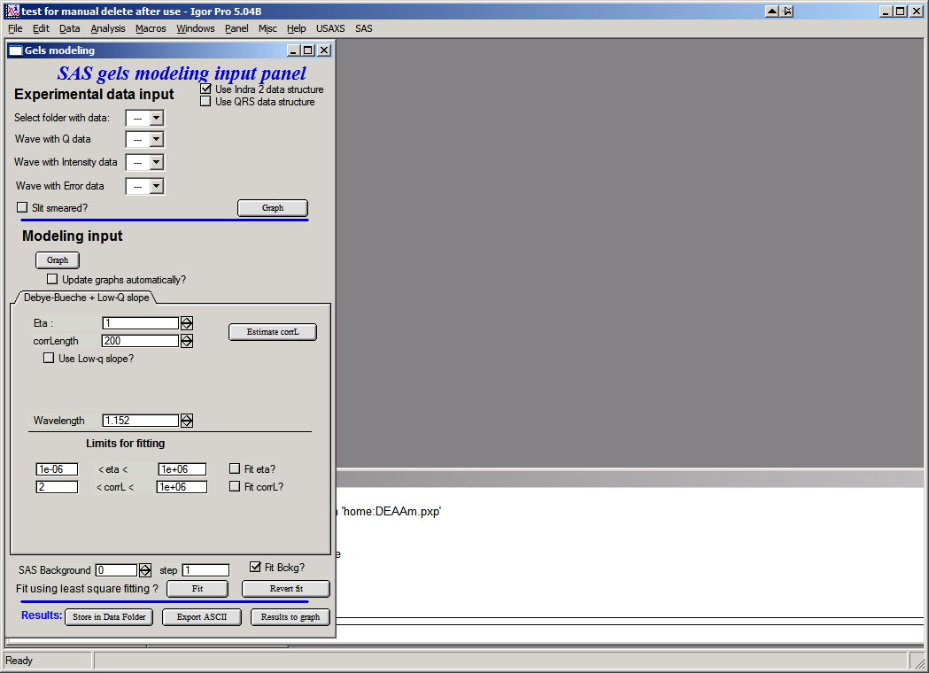

Data can be selected at the top part – as usually, one can use either pin-hole type data (desmeared for USAXS instrument) or slit smeared data. Results are the same, the model is slit smeared with slit length if slit smeared data are used.

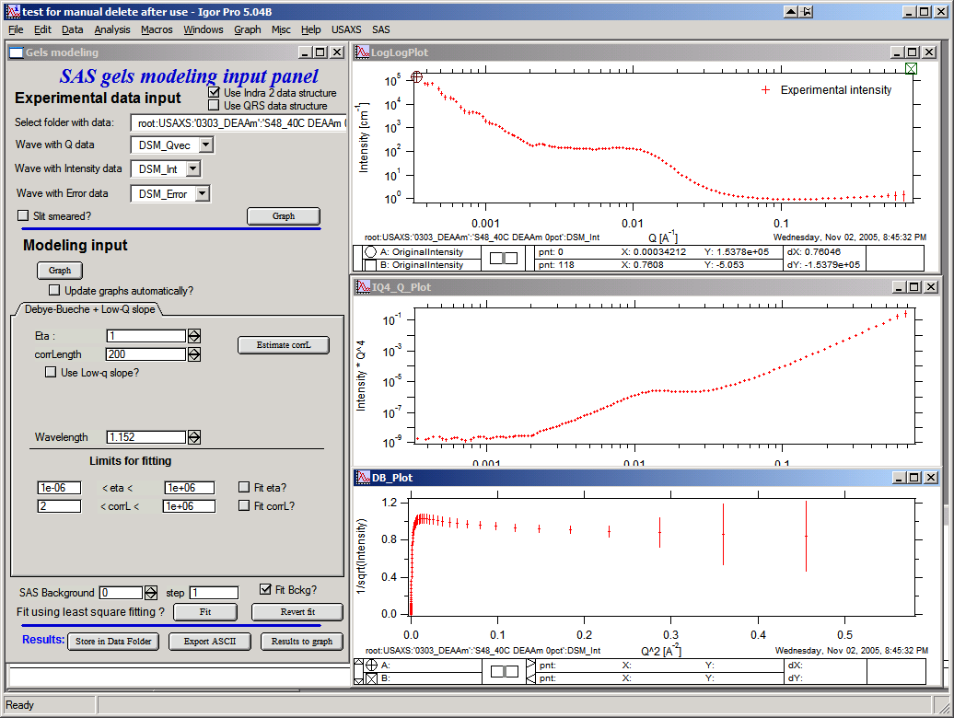

This is how the screen looks like with data selected. Note three graphs:

Top is log-log, middle is I * q4 vs q, and bottom is 1/sqrt(Intensity) vs q2. Data selection for fitting purposes is in the top graph…The other two are only for informational purposes.

Controls:

Top button “***Graph***” loads data into the tool and creates the graphs.

Lower Button “***Graph***” will calculate model and place result in the graphs.

“***Update graphs automatically***” will recalculate model after every change of any parameter in this tool. Useful on fast machines.

***Eta*** and ***corrLength*** – model parameters. Can be estimated using the button “Estimate” if the knee area is selected first in the top graph:

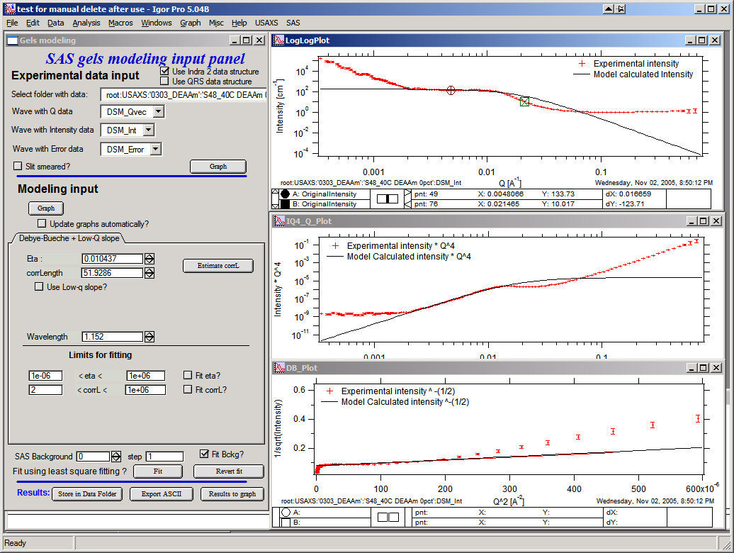

Checkbox “***Use low-q slope***” will enable controls for low-q power law slope. One can again select range of data where the power law dominates and Estimate slope with the button.

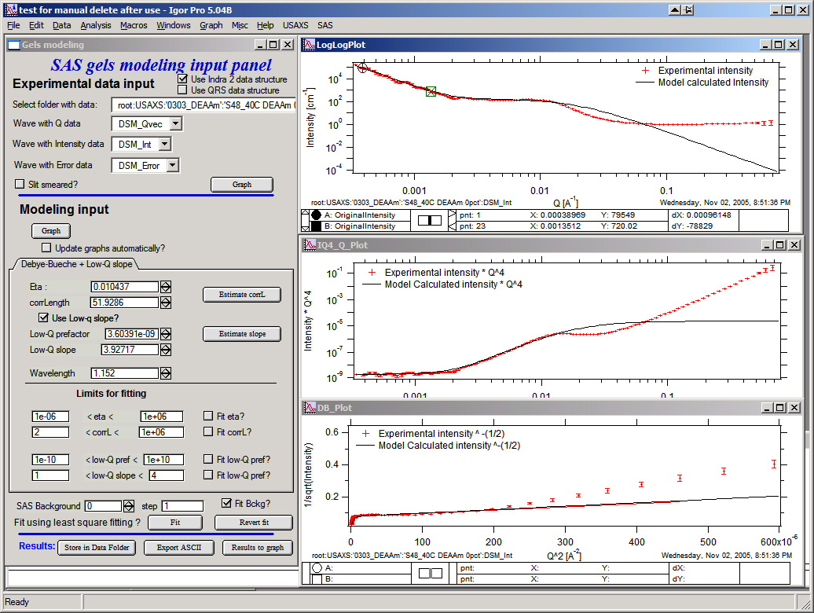

**Limits for fitting** should be set, if needed, to sensible numbers. The checkboxes with “***Fit*** …” allow selection of parameters which are going to be fitted using standard Igor least-squares fit.

Last item is “***Background***”, which should be reasonably guessed and then fitted as one of the parameters:

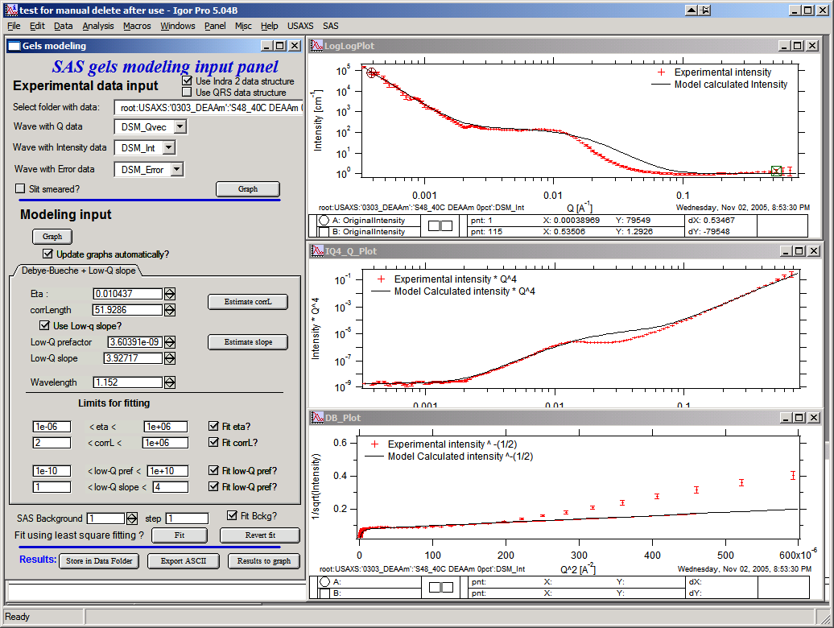

Now with good starting guesses one can fit the model – using the “Fit button”

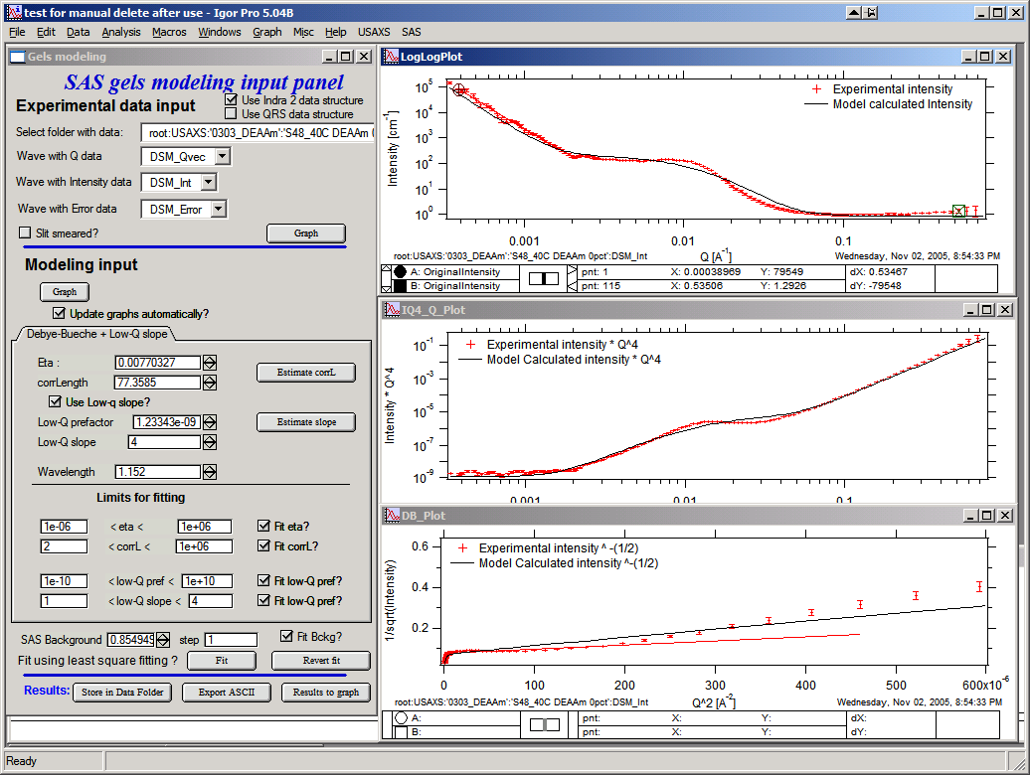

This is the best fit this model does to these data (note the misfit, this is not probably the best model…).

Buttons:

***Revert fit*** – use to reset the last set of parameters after bad fit which “lost it’s way”…

***Store in Data folder*** will save model data (waves with wave notes) for further use. It copies them into folder, where the data came from. Can be plotted, exported, reloaded in this tool, and mined for numbers later.

***Export ASCII*** will export model as ASCII from Igor.

***Results to Graph*** will paste results into graph for better view:

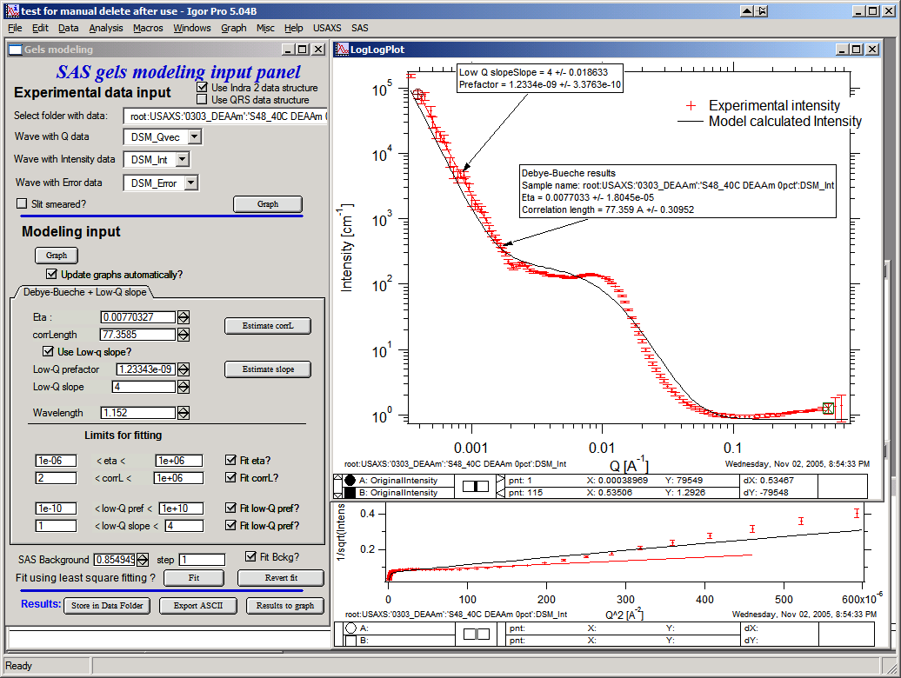

## 12.2 Treubner-Strey for small-angle diffraction

Treubner-Strey model follows the publications : Teubner, M; Strey, R. J. Chem. Phys., 1987, 87, 3195 and Schubert, K-V.; Strey, R.; Kline, S. R.; and E. W. Kaler J. Chem. Phys., 1994, 101, 5343.

The code is adopted form NIST SANS package. The formulas are:



Where A, C1 and C2 are parameters from the theory and TS is scaling factor.

Correlation length °ξ and repeat distance (d) are:



Example of the GUI with results:

Note, that only the parameters TS, A, C1, and C2 are user controlled. Parameter TS is added scaling factor, as there does not seem to be other way to scale the model to data.

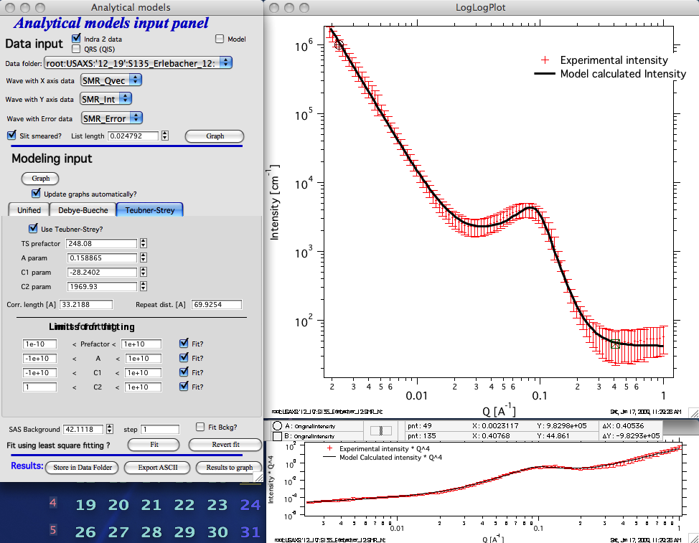

This is fitting to slit-smeared data for which Treubner-Strey model is the appropriate model to use.

## 12.3 Ciccariello – Benedetti model for coated smooth surfaces

This tools was coded using following manuscripts:

A. Benedetti, S. Ciccariello, Coated Silicas and Small-angle X-ray intensity behavior, J. Appl. Cryst (1994) **27**, 249-256.

S. Pikus, E. Kobylas, and S. Ciccariello, Small-angle scattering characterization of n-aliphatic alcohol films adsorbed on hydroxylated porous silicas, J. APpl. Cryst. (2003) **36**, 744-748.

And tested on experimental data provided by S. Ciccariello. Note, that the experimental data were only slit smeared and that I have found some interesting discrepancies between using finite slit length (an dusing internal smearing routines of Irena for slit smearing the model) and running provided specific code for slit smeared data (assuming infinite slit length). Simply put, the results vary depending on slit length and one needs to be careful on this. Please, read further…

In summary, this model assumes that on surfaces of porous media is present constant thickness and constant scattering length density layer. The surface of the film is assume to be always parallel with the surface of the solid. Basically, it is coated porous surface with very specific layer – since this is modification of Porod’s law, it is clear that the interfaces must be sharp. In this case the Porod’s Q-4 power law is modified by oscillatory behavior from which one can extract the thickness and scattering contrast of the film. For more details, please read the manuscripts.

Ciccariello-benedetti GUI:

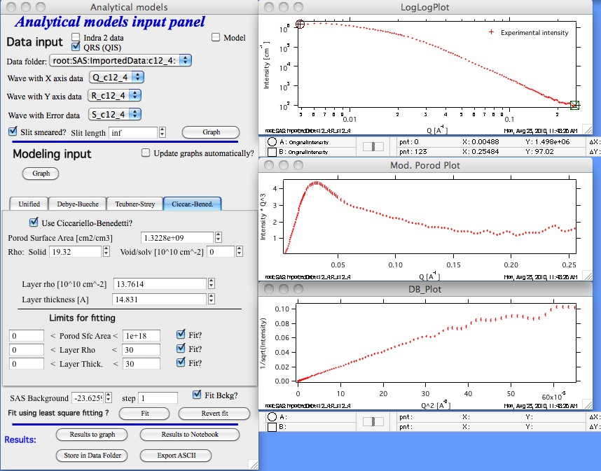

This is the control panel and loaded data for this method…

AT the top of the main panel is regular “Load data” selection. In this specific case ONLY (no other Irena tool supports infinite slit length) you have a choice of finite slit length and “inf” as infinite slit length. Also you can run this on data in pinhole configuration.

If you want to use this tool, select “Use Ciccariello-Benedetti” checkbox. Controls will appear.

The model has three main parameters, which can be fitted:

Porod specific surface area (area of the solid/void (solvant) interface. This is area of the interface without the layer on.

Layer rho (scattering length density)

Layer thickness

And the model has two parameters which area assumed to be known:

Scattering length density of the solid (rho) and scattering length density of the void/solvent (material which is inside the voids). If this is air, it is likely 0.

Note, that one needs to select also SAS background and set fitting limites and “Fit?” checkboxes as in other tools.

When user pushed “Graph” button next to data selection, three graphs get created.

Intensity vs Q graph. **PLEASE NOTE, this is still the ONLY graph you can use to select the range fo data to be fitted.**

Intensity * Q4 (or for slit smeared data as in the figure above: Intensity * Q3). This is probably the best graph for this tool. Unluckily, making this one the “input” graph would make it cumbersome and complicated to use with other tools.

1/sqrt(Intensity) vs Q2

Rest of the controls works the same as usually.

Finally, one may want to know how would “ideal” case of the system described by Ciccariello-Benedetti model looks like. You can do it easily by using the Modeling capabilities of this tool:

Here is slit smeared data set using the parameters from above, just with “Modeling” data only (no input data)

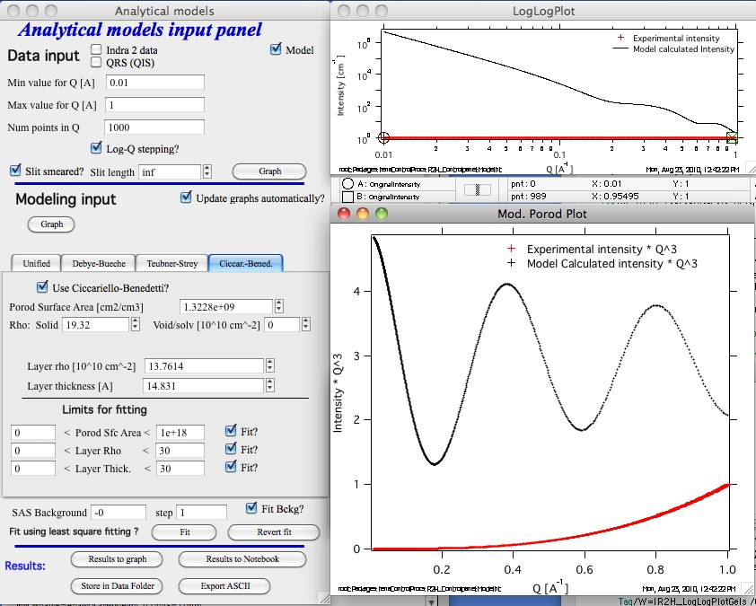

and here is the same set of parameters, just with pihole-colimated data input:

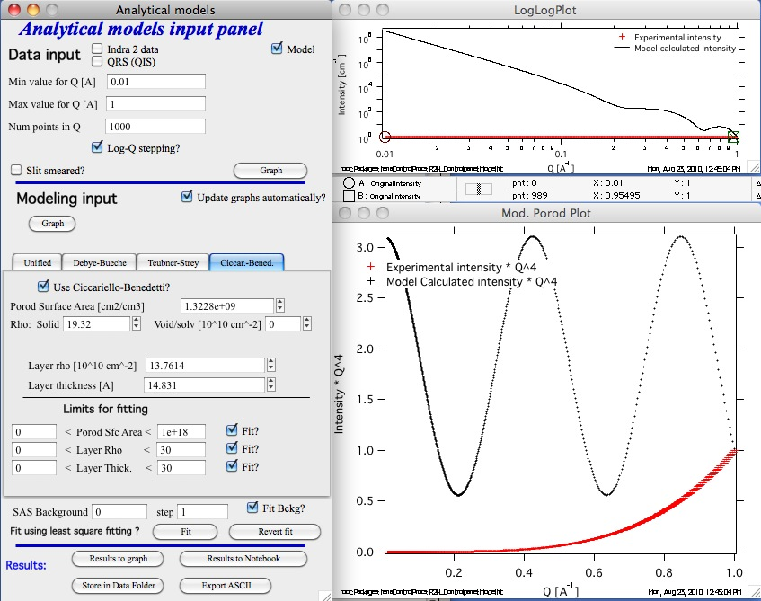

Note, that for these pinhole data the lower graph is set to be Intensity * Q-4.

# 13. Small-angle diffraction tool

**Small-angle diffraction tool models data using :**

**Flat background**

**Power law scatter (I = G * QP)**

**Up to 6 peaks**

Each peak can have one of many different shapes – Gauss, Lorenz, Pseudo-Voigt, Gumbel, Pearson-VII, modified Gauss, Lorenz-Squared, or Skewed Normal. Peaks can also represent Percus-Yevick S(q) structure factor and Percus-Yevic S(*q*) multiplied by Sphere F(*q*). Please note, that you should use ***only*** the shapes which are meaningful for your problem and you can justify. For example the S(q) and S(q)F(q) may be real challenge to justify inmost cases. I needed them for *very* specific case.

Some first have 3 parameters – prefactor (~intensity), position (NOTE: using Q units) and width (in Q units). Some have one more parameter which controls the tail height or some other shape features. Note, that for Pseudo-Voigt when eta = 0 the shape is Gauss and eta=1 the shape is Lorenzian.

The tool will manage slit-smeared data (USAXS data). There are few more details *very* important for slit-smeared data:

It is very useful to use experimental data which extend significantly beyond to slit length. If the data to less than slit length are used, it is important to model peaks which extend to Q positions smaller than slit length. If you see ripples (caused by slit smearing very narrow peaks), you can use “Oversample” checkbox – but that will increase the calculation time by about 5x.

Use of the tool:

Select “Small-angle diffraction” from the menu

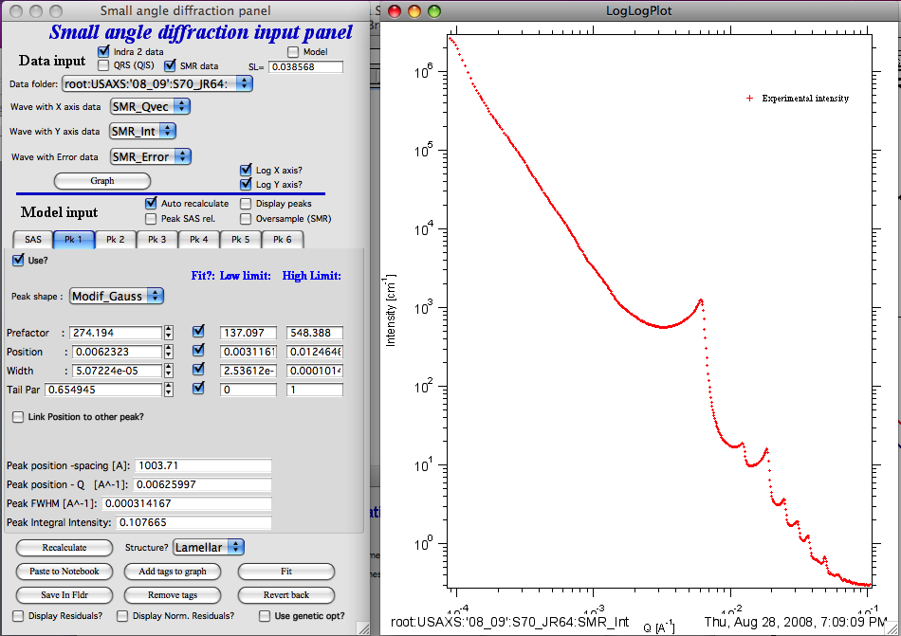

Select Data in the data selection controls and click graph button… Data are graphed.

### Function of controls:

“auto recalculate” will cause data to be recalculated after most parameter changes. If calculations take long time, you may want to uncheck this and recalculate data using button “Recalculate”.

**VERY IMPORTANT**

“Peak SAS rel.” – this is very important checkbox. In case this checkbox is NOT selected, the following is the formula to calculate intensity:



While when it is checked, then the formula is:



Where Ki is scaling factor for each diffraction peak.

Where (Q) is function of the three or four peak parameters – scaling factor, peak position, width, and for some also “tail” parameter. The exact formulas vary depending on peak profile selected.

**What does this mean? If the checkbox is NOT selected, the calculation is based on assumption, that the SAS scattering and diffraction peaks are from one population and loosely one can see it as F(Q)*S(Q) assumption in small-angle scattering.**

**If the checkbox IS selected, the assumption is loosely that the peaks are independent of small-angle scattering and are produced by some other features than what produces the SAS itself.**

I suspect, that right selection is based on experience and what really fits right. Note, that the parameters are always evaluated for (Q) only… This is *VERY* important to understand and if you see cases, when these assumptions are wrong, please, let me know…

Following are formulas for peak profiles Ψx used for the peak profiles:

1. Gaussian Function



where is the Gaussian width, and is the center of the peak, and M is scaling factor.



1. Modified Gaussian Function



where d is the exponent that decides the falloff rate.



1. Lorentz Function, Lorenz-squared (is just the same function squared)



where *a* is the Lorentzian width.

1. Pseudo-Voigt Function



where , x0 is the peak center, w is the FWHM, and is a weight parameter.



1. Pearson type VII Function



where a is proportional to the FWHM, and m decides the rate at which the tail of the peak profile falls.

1. Gumbel Function



where  is the width and  is the center of the peak.

1. Skew normal function

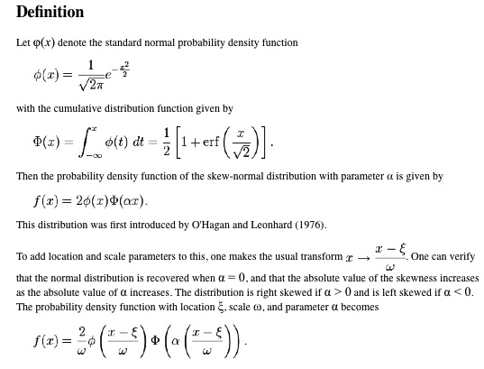

1. Percus-Yevick S(q) and Percus-Yevick S(q) multipled by Sphere F(q) are described in some detail in Form factor and Structure factor description (pdf file which you can open from SAS menu in Igor Pro). The code for P-Y S(q) is NIST code from NIST SANS data analysis macros.

“Display peaks” will display individual peaks. Note, data for individual peaks are never smeared.

“Oversample” – for sit smeared data only. Will oversample Q range with 5x as many point to reduce artifacts caused by slit smearing very narrow peaks.

Tab SAS:

G – prefactor for power law slope

P – power law slope

Bckg – flat backgroud

Tabs for Peaks:

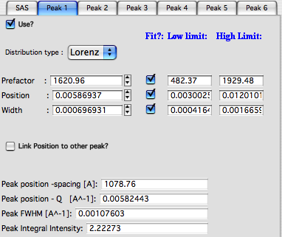

“Use” – use the peak. No need to use peaks in order, can be mixed-and-matched

“Distribution type” – peak shape

“Prefactor” – scaling factor for the peaks (~hight)

“Position” – peak position in Q units

“width” – peak width in Q units

“Link Position to other peak?” – you can link peak position to position of another peak with scaling constant.

Lower set of parameters are peak parameters calculated numerically, so they may be slightly different than the numbers above.

Final controls:

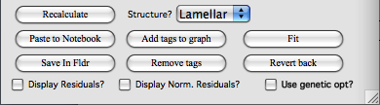

“Use genetic optimization?” – uses genetic optimization… Very slow fitting routine unlikely needed for this application. If needed, read explanation of the method in previous chapters.

“Fit” – fits

“Revert back” – reloads stored parameters from before fitting.

“Add tags to graph” – adds tags with parameters into the graph…

“Remove tags” – removes tags from the graph.

“Structure?” – sets ratios of positions for some known structures. Peak positions will be fixed with respect to Peak1. Note, user must set correct widths and prefactors for each peak manually…

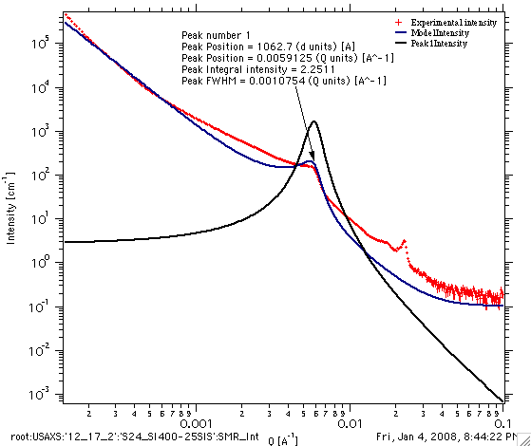

“Save in Fldr.” Saves results (including peak profiles if selected) back into data folder.

“Paste to Notebook” – opens notebook for results and pastes in there graph and summary of results.

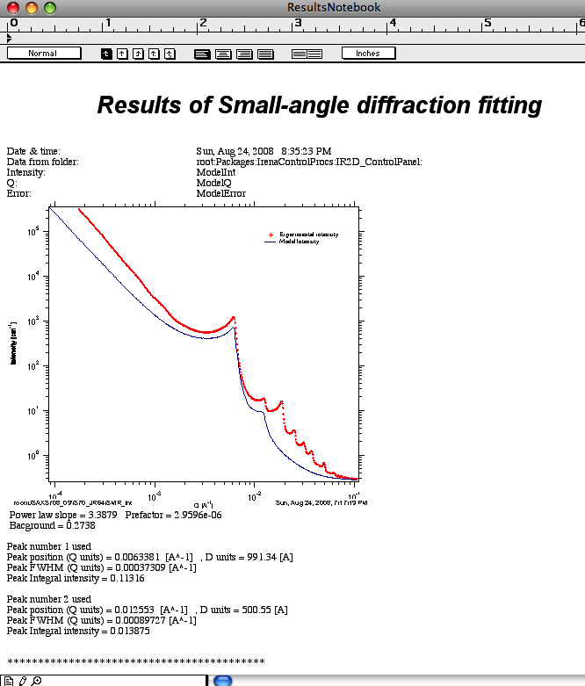

“Recalculate” – forces model recalculation if user needs to do it.

You can attach also residuals or normalized residuals into the graph, see example below.

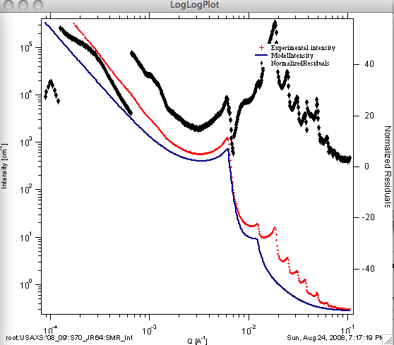

Useful comments:

Make sure the fitting parameters ranges are set appropriately. This is IMPORTANT and not obvious problem in fitting (experience speaks)… Results of fitting are also automatically recorded to into usual “SAS logbook” these tools keep… All is recorded there in more or less useful form. Your notes I keep for you....

# 14. Reflectivity

This is relatively simple tool to model and fit X-ray and neutron reflectivity for up to 8 layers using recursive Parratt’s code (L. G. Parratt, *Phys Rev*, **95**(2), 359-369, 1954), as implemented for example in older code called “Parratt”. The code itself was provided by Andrew Nelson ([Andrew_Nelson@users.sourceforge.net](mailto:Andrew_Nelson@users.sourceforge.net) ). I have implemented only the GUI in manner similar to the rest of the Irena code. I will provide basic support for this package. Please note, that Andy has made more complex and capable version of his package “Mottofit” available for free download to other Igor users through <http://motofit.sourceforge.net/> under GNU license. If you need more complex fitting, than my code allows, please use Andy’s powerful code. You may, however, have to learn little bit more of Igor.

**Use of xop to speedup the calculations**

Starting from version 2.20 (note: this version is ONLY 6.0 compatible) the code supports optional abeles.xop and GenCurveFit.xop. These are both optional – but the increase in speed (especially abeles.xop) is major (factor of 5-10x). These xops can be downloaded from Andrew Nelson’s web site (listed above).

Note: If you have version 2.16 (last Igor 5 compatible version) note, that these xops will not be used. The code to use them was removed to make this release Igor 5.0 compatible.

## 14.1 Running the reflectivity

For testing purposes, I have included 3 column reflectivity data in Irena folder (…Wavemetrics/Igor Pro/User procedures/Irena) in the file called reflectivity.txt. Please load the data through Data loading tool as qrs data.

The select “Reflectivity” from the SAS menu:

Following are the parts of the panel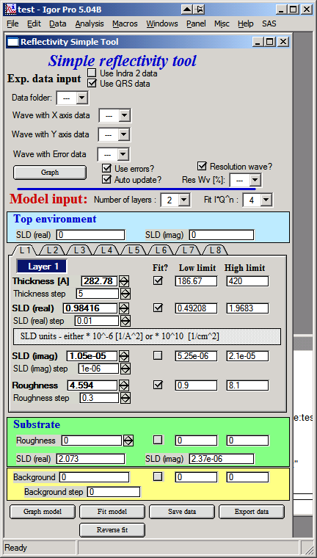:

1. The top part – data selection part is similar to the other tools in Irena – select type of data, data folder with the data, and wave names containing q, reflectivity and error. Push Graph to generate graphs. If you have resolution as single value, uncheck the “Resolution wave” checkbox and insert value in the field, if you have resolution wave (q resolution), select it’s wave name here. NOTE: for now this wave must be in the same folder as the data are. I will fix this in the future. Also, for now there are no checks on wave length, so make sure this wave has same number of points as data waves have.
2. Select number of layers, input scattering length density (SLD) for the top environment (usually air, so 0 is fine, but if this experiment was done for example under water, than this would be different).  
   The tabs contain controls for each layer – thickness in A, SLD (real and imaginary) in units as displayed on the panel and roughness.
3. Substrate values – roughness and SLD
4. Measurement (aka flat) background.
5. Control buttons

When data are selected, following graphs appear:

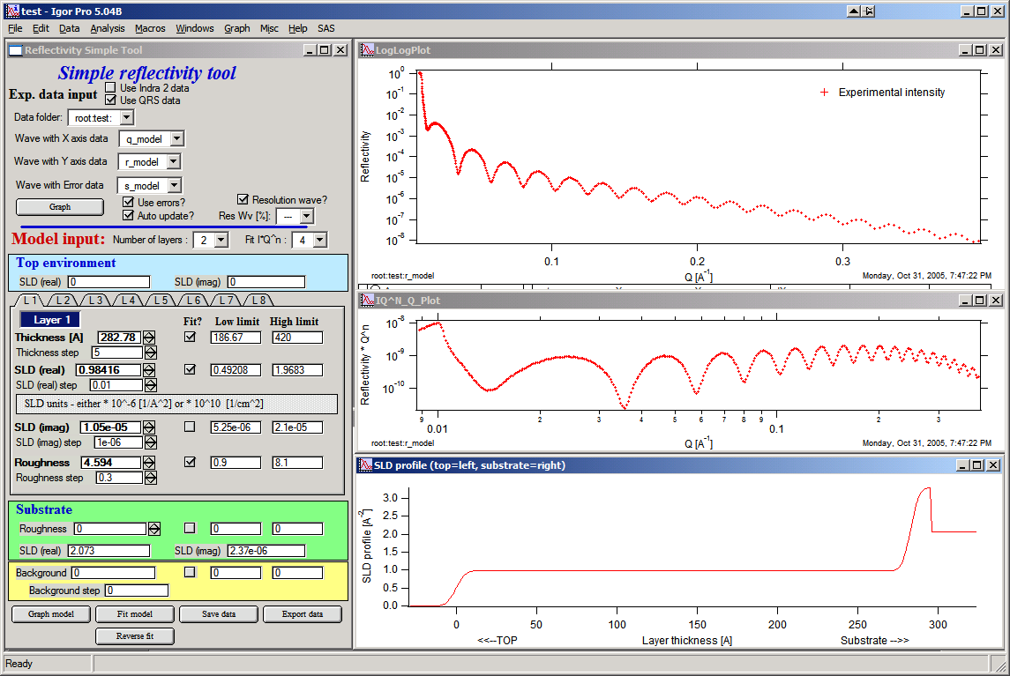

Note, that the top graph is log-log plot of reflectivity vs Q, medium is reflectivity * Q^n (n=0 to 4 as selected in the panel) and bottom is reflectivity profile. The fitting (see later) is done in the space reflectivity * Q^n to improve mathematical stability and convergence of the problem. The controls (selection of data range) however, MUST be done in the top graph (the log-log plot).

Now, I have very good values for these particular data (thanks to Dale Schaefer for providing the data and solution!!), see the tabs below:

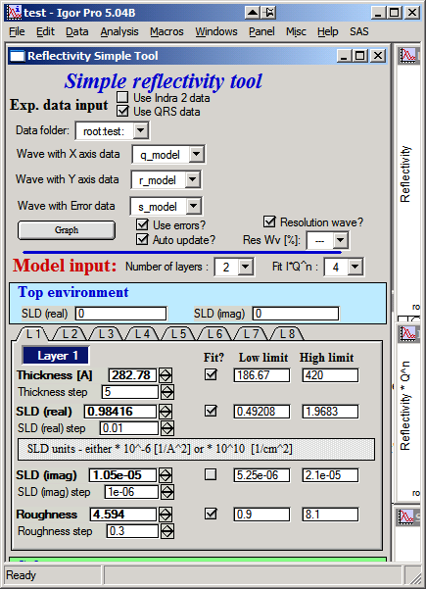 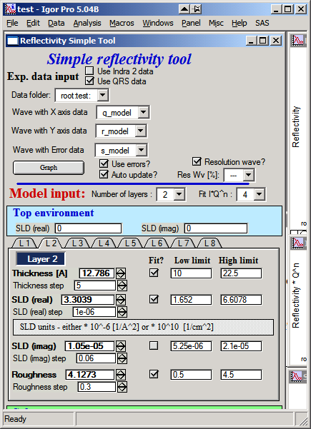

Input these values and SLD for substrate of (real part) 2.073 and imaginary part 2.37e-6. The resolution is 1%, so uncheck the “resolution wave (if checked)” and input 1%.

Then push button “Graph model” you should get really good match to data:

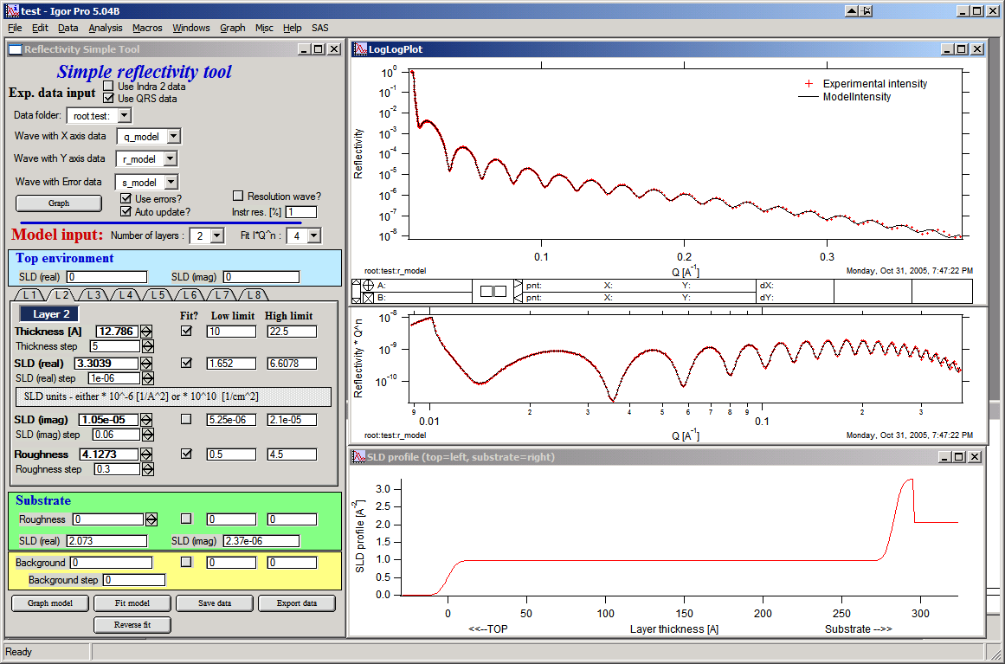

I suggest you play now with parameters to find out, how sensitive the problem is.

### Important comments

Resolution wave for now must contain % resolution for each point.

Fit model/reverse fit: Select range of data to fit in the top graph and push the Fit model button. Fitting is done in the Intensity * Q^n as selected in the panel. Use power of 4 is suggested, if lower values are used, the fitting tends to neglect the high-q data. If fit fails but reaches some solution, you can recover to previous data by pushing “reverse fit” button. Very handy…

Save data – copies model data into data folder so they can be used in the future. If you try to load data from folder containing already reflectivity data, you will have option to reload previous solution into the tool. This allows very quick regraphing of the stored solution.

Export data saves ASCII file outside Igor for use in other packages. 15. Data mining tool

This tool allows finding and tabulating various data from folders within Igor. At this moment it is just about functional and will be developed further.

The data can be stored in either variables, strings, wave notes or they can be waves with data themselves. Depending on input type, the data can be output into graphs or notebook (for waves), or in notebook or in new waves (for strings, variables and data from wave notes).

## 14.2 Use

There are few peculiarities, this tool behaves little bit different than the others… See below:

In the top part you need to select data type to be searched and example folder, in which are data types you want to “mine”. Therefore, you need to be able to find at least one folder with data you are looking for.

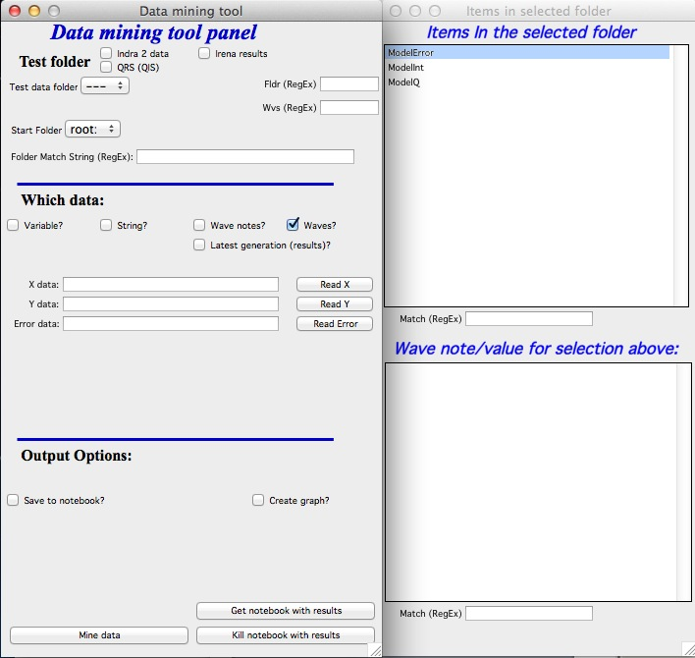

When you select such folder, new panel with list of particular items from this folder appears. The top lists waves/strings/variables as appropriate; bottom lists the wave note (for waves) or the value of the string or variable.

**Mining the waves:**

You can select (or input manually) wave names – one, two or three – in the fields. To select highlight the wave in the panel and then push button “Read X” (Y or Error). You can also use * as wildcard. Then you can either output into notebook (and print which folders contain – or do not contain these waves) or you can plot the waves into graph (plots X against Y) with few controls (colors, axis type).

**Mining the strings/variables/wave notes**

Select string or variable name in the list in the right panel and push button “add to list”. The item will be added.

To select wave note, select both wave and item in the wave note and pus button “add to list”. Item will be added. At this time you have to Clear the whole list, if you want to remove something.

Output can be done to notebook (can be messy very fast…) or to new waves. Create new folder for the waves. After search, these waves will be created, if possible converted to number waves and new table will be created.

# 15. Data export tool

Irena produces large number of data sets, which can sometimes be exported when created, but more often not. While the most convenient use of the data is within Igor experiment by ploting or processing further, many users may want to use another programs. And then it is imperative to export them as ASCII files. This is the tool for that…

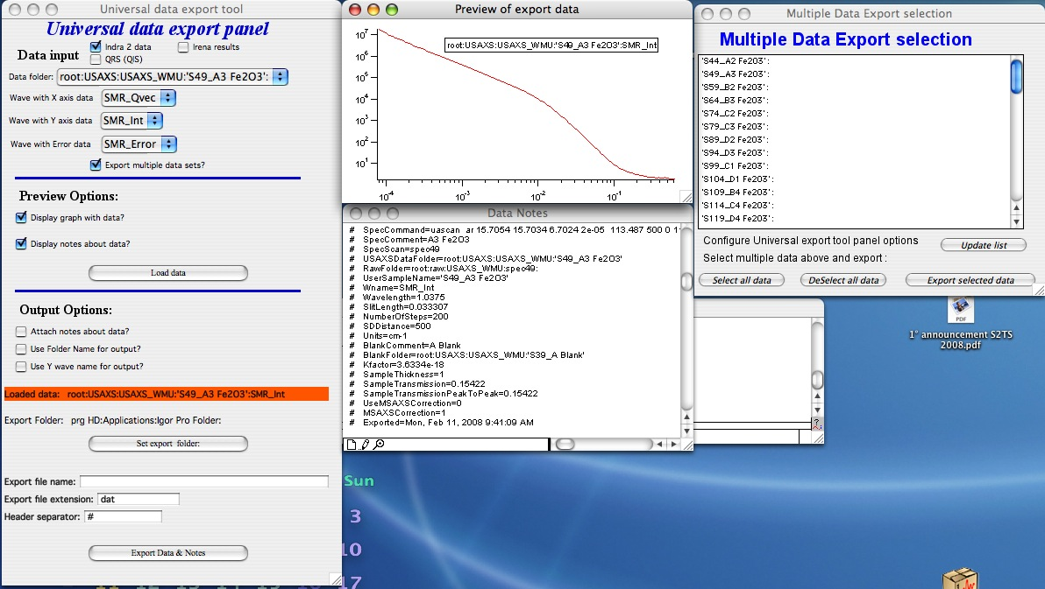

Above are standard set of controls. Select data in the top part of the panel. Than decide – do you want to see graph of the data? Do you want to see any associated notes (Irena writes a lot of stuff in the wave notes)?

Push button “Load data”

Note the “Export multiple data sets?” checkbox. It opens the Multiple Data Export selection panel. This panel enables exporting of many data sets at once. The correct use of this option is to export one data set manually (sets all parameters and export paths), test one data set and then use the Multiple Data set option…. See comments later.

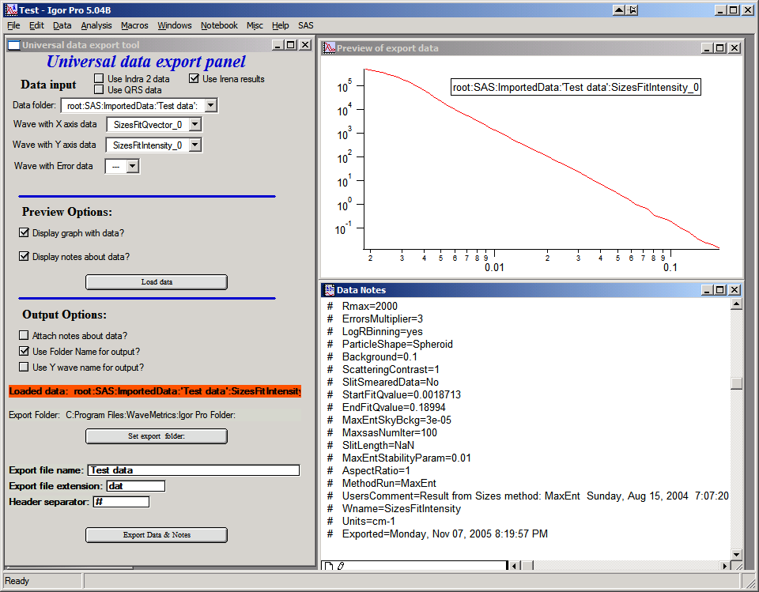

Now we have graph and list of notes. Note, that no attempt is made to create sensible graph. You may have to modify the graph manually if needed.

Next select Output options:

Attach notes about data will attach the wave note into the ASCII file. Note, at the bottom of the panel is field where one can insert the separator character (including spaces) if different than default is desired.

Use folder names for output if you are using folder names as anmes for samples, this is sensible…

Use Y wave name for output if your Y wvae name is sample name (e.g., qrs data this type)

“Set export folder” set where to store data. Cannot create folder, create first, then set here. The folder is displayed din red box above the button.

Export file name modify, if default is not good enough

Export file extension set to whatever needed

Header separator change, if different isdesired. Include spaces, if these are desired!!!

“Export Data & Notes” button does the job. If the data exist, you will be asked if you want to overwrite them.

Multiple data set export option:

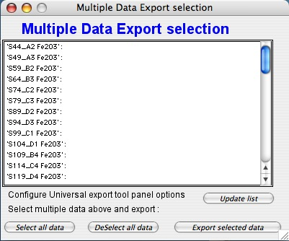

There are few items one needs to know about this tool.

1. If you make changes to the main panel, the list of folders in this panel may get stale. Use button “Update list” to update it.

2. There is logic in listing the data which is actually quite complicated… Here are some comments:

a. The tool started to search for data from parent folder of data selected in the main panel. In the current selection :

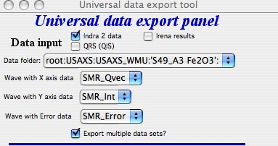

The tool start searching from root:USAXS:USAXS_WMU: - if you cannot find your data, select different starting folder in the main panel and update the list. This is to reduce clutter and help users with giant experiments…

b. For results… The tool will search for not only the same data tyupe as selected in the main panel, but also same generation! Therefore, if you have in some folders saved multiple results from same tool (you have waves with results like: SizesVolumeDistribution_0, but in some also SizesVolumeDistribution_1, SizesVolumeDistribution_2, etc…) the tool will search only for generation (“_0”, “_1”,…) selected in the main panel. It just gets really messy to create different logic.

# 16. Evaluate size distributions tool

This is tool to obtain various details about size distributions – such as results from Size distribution, Modeling I and Modeling II tools. User can obtain mean/mode/median size in range selected by cursors, volume, surface and number of particles (per cm3) and generate cumulative distributions and even mercury intrusion (MIP) curve (intruded volume with respect to pressure in Psi).

Number of size distributions can be included at one time in the graph, but the graph will become crowded very soon…

## 16.1 Description

Select “Evaluate size distributions” from the SAS menu.

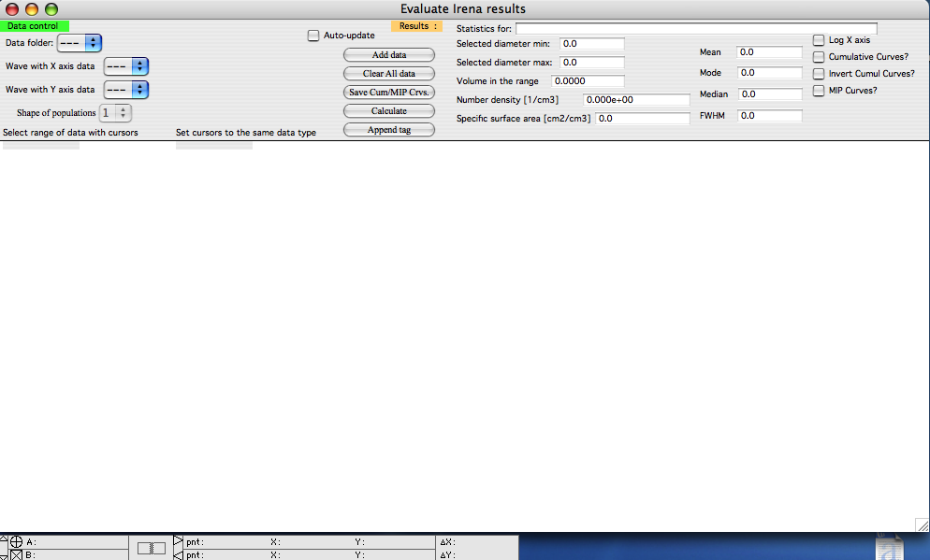

This tool has all controls in the Control bar at the top of the graph window. For MIP data a new window will be opened. It is also important to follow the history area, as this tool prints important information into there so the user is informed about specific needs or events…

Data selection controls are top left corner. This tool should know all results data from Irena for which it makes sense to be used. If any data type is missing, please let me know and I will add it.

Select data folder and if more than one of useable data types is in that folder, select appropriate data types. You will see only folders, which contain at least one useable data type. You may have to select both X axis data and Y axis data. Very little checking is done on sensibility of the selection here, so be careful.

The usually grayed popup “*Shape of populations*” will be explained below…

Next are buttons with following functions:

“*Auto-update*” checkbox – if selected all data are recalculated when cursors are moved. Note, that cursors have to be on the same data set , or the results all will be NaNs.

“*Add data*” – when data set is selected this button adds the data set into the graph

“*Clear all data*” – will remove all data from graph and clear it.

“*Save Cumul/MIP curves*” – will save new data into the data folder with the original data. Saves the new curves, which exist at that time. Both cumulative size distributions and/or MIP curves. These data can be exported by using the Data export tool.

“*Calculate*” – if the “*Auto-update*” checkbox is not selected, this forces recalculations. Again – if the cursors are not in the graph or not on the same wave, no numbers are calculated!

”*Append tag*” – appends descriptive tag to the graph, so more different data sets can be compared together.

Now the results part:

“*Statistics for*:” … is string with the name of data on which the cursors are and for which the data are calculated.

“*Selected diameter min*” and “*max*” – diameters of current cursor positions so you know where the data are calculated

“*Volume in the range*” – fractional volume of scatterers in the range between cursors. Calculated with correct formula for volume of give form factor used.

NOTE: for distributions from Modeling I and II it is impossible to decide for the code, where which formula for volume should be used. So if one combines different shapes, there is practically now way one can correctly calculate all of these numbers. Therefore the code will make available the popup “Shape of distributions:” and one can select which shape should be used for the calculations. This is meaningful if the populations are reasonably separate and one knows where which shape dominates. This is problem when one is converting between distributions – so if one is using volume distribution, the volume is correct at all times as there is not conversion needed, but the number of particles may be wrong. If one is using number distribution then number of particles is right but the volume may be wrong. Specific surface area is likely affected all the time, unless one has the right shape. Simply – be careful when using Modeling results with more than one shape of scatterers.

User is informed about need to select right shape by printout in the history area:

***“These data may contain mixture of shapes for different populations. Please select the right population number to evaluate”***

This is not problem when individual distributions are saved together with the total distribution and evaluated. In such case the code will select correct shape for volume calculations and conversions…

“*Number density*” is number of particles per cm3 for data between cursors.

“*Specific surfaced area*” is specific surface area between the cursors.

“*Mean*”, “*mode*”, “*median*” are values evaluated for GIVEN DISTRIBUTION between cursors – evaluated numerically. Note, that of course these will be different for number and volume distributions.

“*FWHM*” is full width at half-maximum value evaluated numerically. This is ONLY meaningful, if the data resemble one single peak. There will always be number there, but it may be not useful if the data are not one single peak.

Last column of checkboxes:

“*Log X*” sets diameter axis (x axis) to log scale.

“*Cumulative curves*” forces calculation of cumulative curves

“*Invert Cumul. Curves*” forces the 0 to be at large sizes. There are some cases when this is useful…

“*MIP curves?”* – if selected MIP curves are calculated and new window with them opens. Few other controls appear also:

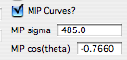

These are two parameters used for MIP calculations. These are generally used values, user can change them if he/she wishes. Sigma is in dynes/cm and cos (theta) is unit less, theta is wetting angle between the material and the mercury…

## 16.2 Example

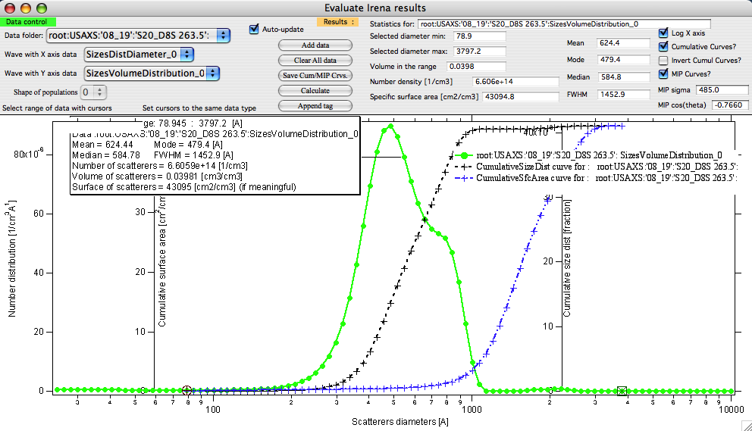

The green data are original data, cursors select the range, which is being evaluated, black curve is Cumulative size distribution volume (it has its own axis on right) and blue is cumulative specific surfaced area (has axis mid left). Tag contains summary of results. Since the MIP curves checkbox was selected, MIP graph was created:

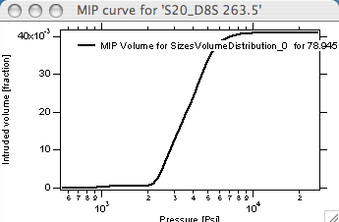

If user chooses to save the new data now, both Cumulative curves as well as MIP curves are going to be saved in the original data folder for export or future use.

Example of comparison of two data sets and use of tags to display results for both:

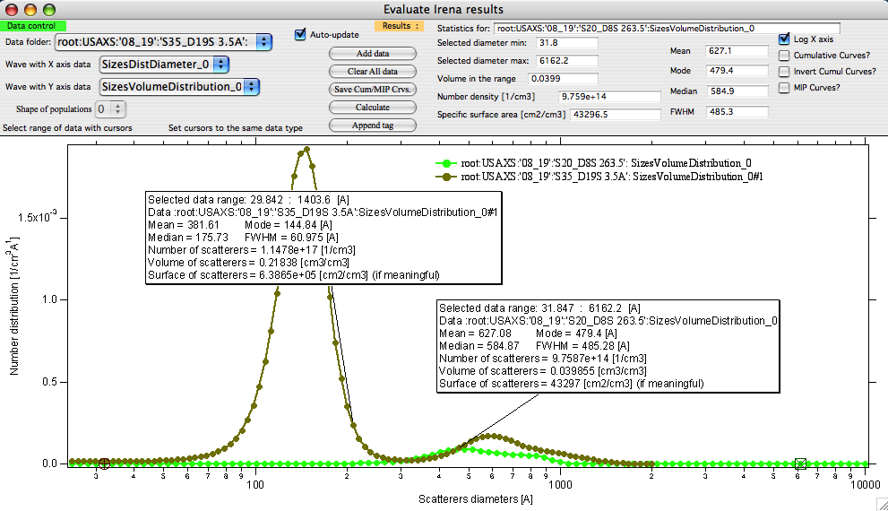

## 16.3 New data created

If the user chooses to save the cumulative and/or MIP curves, new data are created in the folder with original size distributions from which these were created. These are named:

MIPVolume_XX

MIPPressure_XX

CumulativeSizeDist_XX

CumulativeSfcArea_Dist_XX

CumulativeDistDiametersDist_XX

With XX being index to guarantee uniqueness.

The index choice is quite complicated and may result in confusion… So here is explanation:

* + - 1. First the index of the original data is tested – if Original Data were “SizesVolumeDistribution_2”, then the code will test of the index 2 is available. If yes, it will save the data and print result in the history area.
      2. If this index is not available, Message is displayed for user and index is increased. User needs to make sure he/she makes note of the right index and keeps notes on this… I have not found more sensible system yet.

When saving data user is informed by printout in the history are what data were created and what generation they were saved in.

Example:

Saved Cumulative data to CumulativeSizeDist_02 / CumulativeSfcArea_Dist_02 / CumulativeDistDiametersDist_02 in folder root:USAXS:'08_19':'S20_D8S 263.5':

Saved MIP data to MIPVolume_01 / MIPPressure_01 in folder root:USAXS:'08_19':'S20_D8S 263.5':

Note, the waves contain descriptive wave notes which can be exported with the ASCII data as header or searched through the Data miner tool.

# 17 Scripting tool

This tool enables scripting of (for now) four packages – ***Unified fit, Size Distribution, Modeling II and Plotting tool I*** – to enable automatic processing of large data sets. During the automatic processing the error messages and most of the user dialogs generated by these packages are suppressed.

## 17.1 What this tool does:

For Data analysis tools for each of selected data folders it does following:

Select the data folder and load the data in, create graph (pushes “Graph” button)

Sets cursors to the same Q value as previously set

Pushes “Fit” button

Saves data per selection in the control panel

Limitations: The data selection must be unique for every data set. This requires one data set per folder for qrs data structure. For USAXS data (“Indra2”) the data used will be type selected during testing – for example SMR_* or DSM_*, or M_SMR_* etc. These data must exist in all folders. If needed, I can try to update the system and make more options. Send me e-mail if you need more functionality.

For Plotting tool I :

1. Reset or no reset the tool
2. Add data sets into the Plotting tool in order listed in the panel (can be controlled by order choices)
3. Push button "Plot"

## 17.2 Use of the Scripting tool

Open the tool, which you want to script and make a fit on representative data set. Make sure the data range selection (if any) using cursors is correct for all data sets in consideration. Use appropriate data type.

Open the main window:

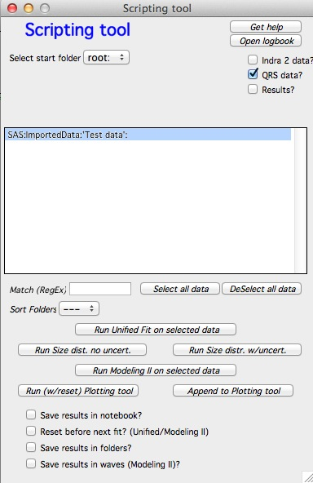 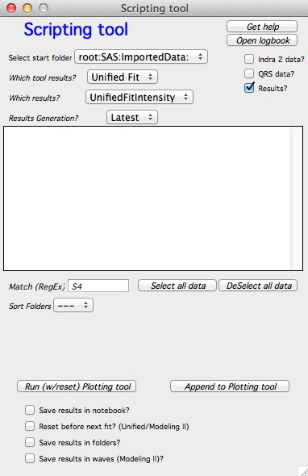

Select starting folder and from the list of folders here select the ones you want to process. Select type of data to be processed… Note, that if you select "Results" you can use only Plotting tool I. The controls hopefully make sense - which tool results, which type of results (e.g., volume or number size distribution?) and which generation. remember, each tool can create multiple "generations" of results - each push of "save" button creates new one (_1, _2,...). Latest picks highest number found.

Note, that the order here will be from top to bottom. Change the order by using "Sort Folders" popup. Let me know if more ordering should be done.

The buttons at the top:  
“Get help” creates panel with short help for this tool.

“Open logbook” opens one of two logbooks… If this tool was used to create its own notebook for results, this one will open. This notebook contains selected results and also graphs. If this notebook does not exist, standard internal logbook will be opened. This one contains similar data, but no graphs.

**Select options:**

1. *Save results in notebook* – will create notebook in which graph and summary of results for each data sets will be printed.

2. *Reset before next run* – valid for Unified. Will reset to original values from test case after each fit. This is useful when the changes are not progressive but more or less random and previous result could be worse starting point that the test case. If not selected, the last result is used as starting model for next sample.

3. *Save results in folders* – will copy usual results waves in the original data folders so they can be plotted or looked at again.

Note:

Without “Save results in notebook” and/or “Save results in folders” there will be no output from the procedure and you will not learn anything…

**To run:**

Select representative case example (and test extreme cases) and run the tool on this example data. Make sure all parameters are set correctly. This includes:

Proper selection of fit checkboxes and limits on Unified…

Proper error weighing and background value in Size distribution.

Proper range of data selection with cursors (if applicable) for both tools.

When ready push button “Run …. on selected data”

# 18. Desmearing

Desmearing routine built in this package is using Lake method (reference), which has been originally programmed by Pete Jemian and then coded in Igor by me. There were some minor improvements over the years, but generally this method has proven itself many times to be robust and reliable. We have verified the function of this method by collecting data from the same sample using both slit-smeared and 2D collimated USAXS. We have verified this method repeatedly and every time the desmearing was blamed for artifacts and unexpected results, we have found another reason for problems. That said, desmearing is always going to increase noise on the data… Note, that the routine will correctly handle data with absolute intensity calibration.

3/10/09 Change in desmearing tool. Per request the tool now allows both slit length (in direction perpendicular to the q direction) and slit width (in direction parallel with q direction). Further, the slit can now have shape of trapezoid, similar to what GNOM allows for instrument geometry. PLEASE NOTE: for historical reasons the parameters for Irena desmearing are ½ of the GNOM parameters.

This is the graph:

2* slit length – 2*slitLengthL

^^^^^^^^^^^^^^^^^^^^^^^^^^^^^

^^ ^^

^^ ^^

^^ ^^

^^^^^^^^^^^^^^^^^^^^^^^^^^^^^^^^^^^^^^^^^^^^^^^^^

2* slit length + 2 * slitLengthL

same geometry applies for slit width.

Once more, if you have parameters used for GNOM, you have to divide the numbers by ½.

The GUI changes should be easy. Please note, that :

* + - 1. If you set slit length or slit width to 0, you assume infinitely high resolution in that direction.
      2. If you set “L” parameter to 0, you assume the shape is rectangular in that direction, not trapezoidal.

## 18.1 Theory behind the Desmearing Procedure

See the Lake paper.

## 18.2 Example of the Desmearing Procedure

I have included a file with an example data set with slit smeared data (smeared data.dat) where the slit length SlitLength=0.05113. You can include this in your experiment using Data import tool…

## 18.3 Final comment

One major comment – if you need to go back in the routine, anytime you can click on previous tab and return to that place… All from tabs to the right is forgotten and routine restarts on the tab, where you click. It is also possible to skip the smoothing tabs without any penalty – note, that if the smoothing parameters are set (the checkboxes are checked) the data WILL BE smoothed, even when you do not click on the tab…

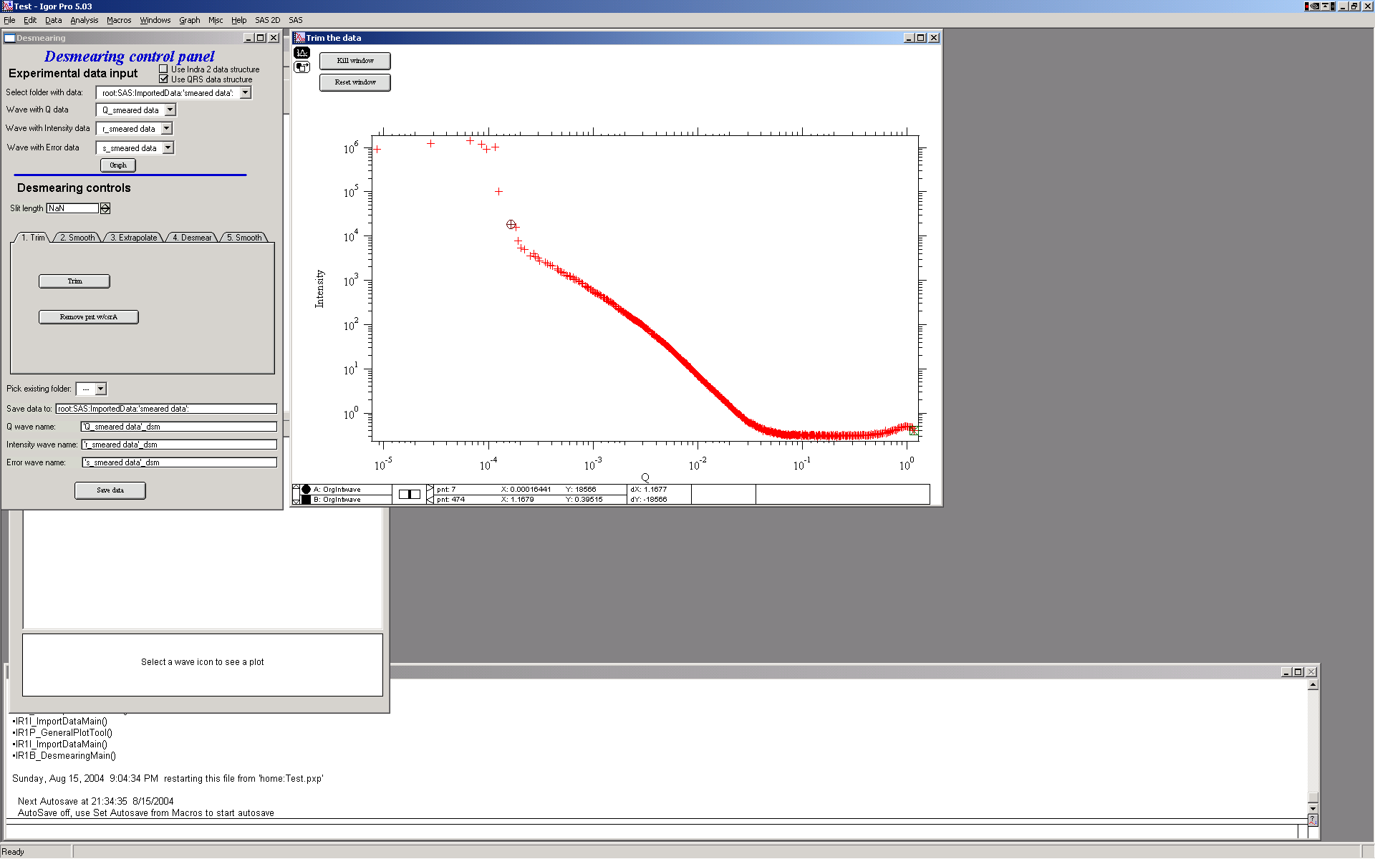

This is GUI and graph after loading data. Only thing needed is to fill in the slit length.

The tool is controlled by the tabs. The order which needs to be followed is the tabs from left to right. For each data set to be desmeared, this procedure must be followed, selecting in sequence the tabs from left to right.

1. First step – trim useable data – small and high Q data… Use cursors to select data range. And then push button “Trim”. You can also remove any spurious point with the other button and cursor A (the rounded one)

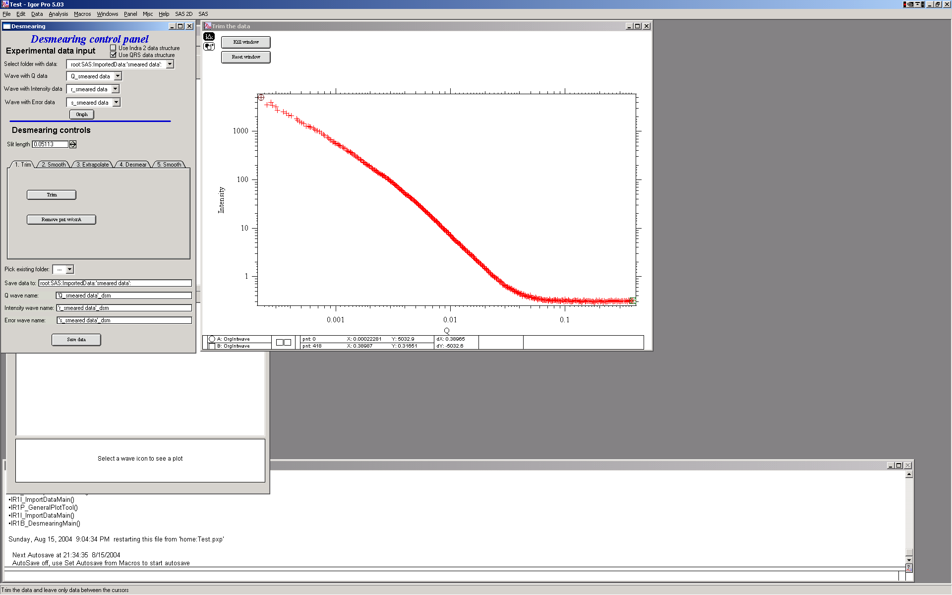

2. Next step – it is possible to smooth data using spline smoothing, but only if necessary. I strongly discourage this… However, the screen is next:

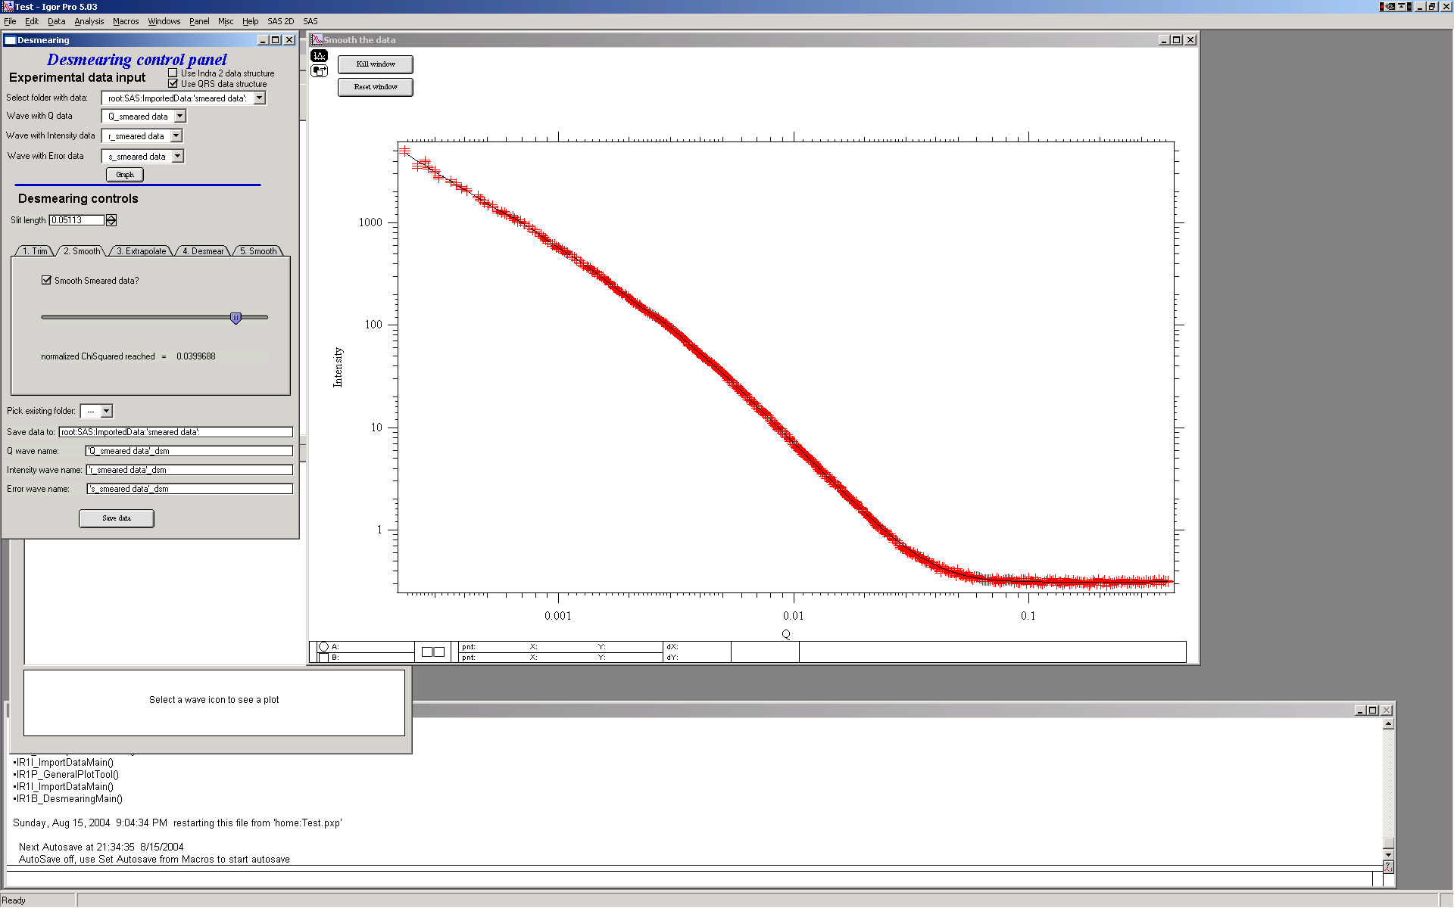

Note the slider and checkbox – the checkbox switches on the smoothing, in that case the slider appears. The slider controls the internal smoothing parameter - more to the right, more smoothing…

As I said, I discourage this, so let’s remove this in next step.

3. Extrapolating.

In order to properly desmear, I need to smear and that means I need data for at least 1 slit length BEYOND the last point. Therefore we need to extrapolate the data using one of selection of mathematical functions. Most useable one is “Power law with flat” and “powerlaw” or “flat”. These data suits best the Powerlaw with flat…

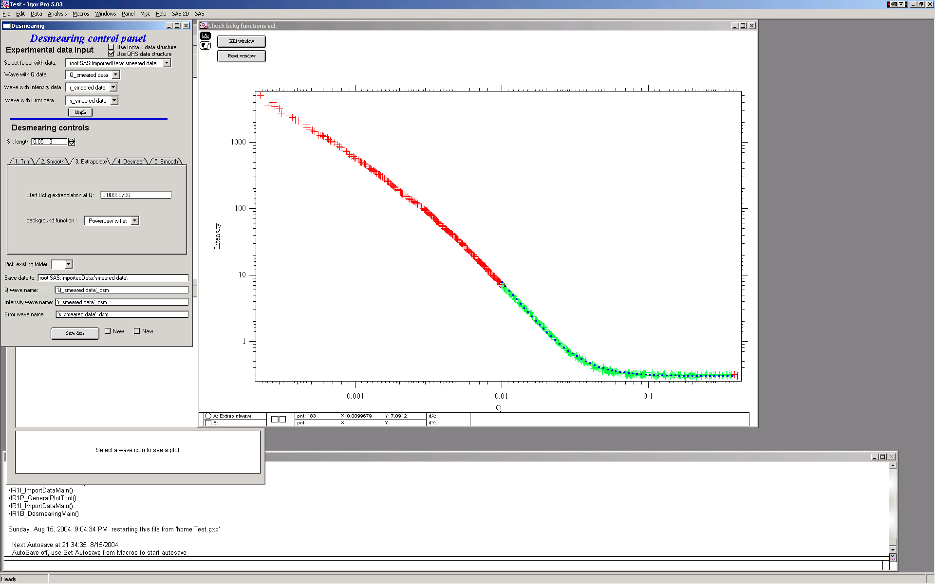

Note the colors: red are the original data, green are the original data used for evaluation of extrapolation parameters and the dotted blue line is the extrapolated data.

4. Desmearing

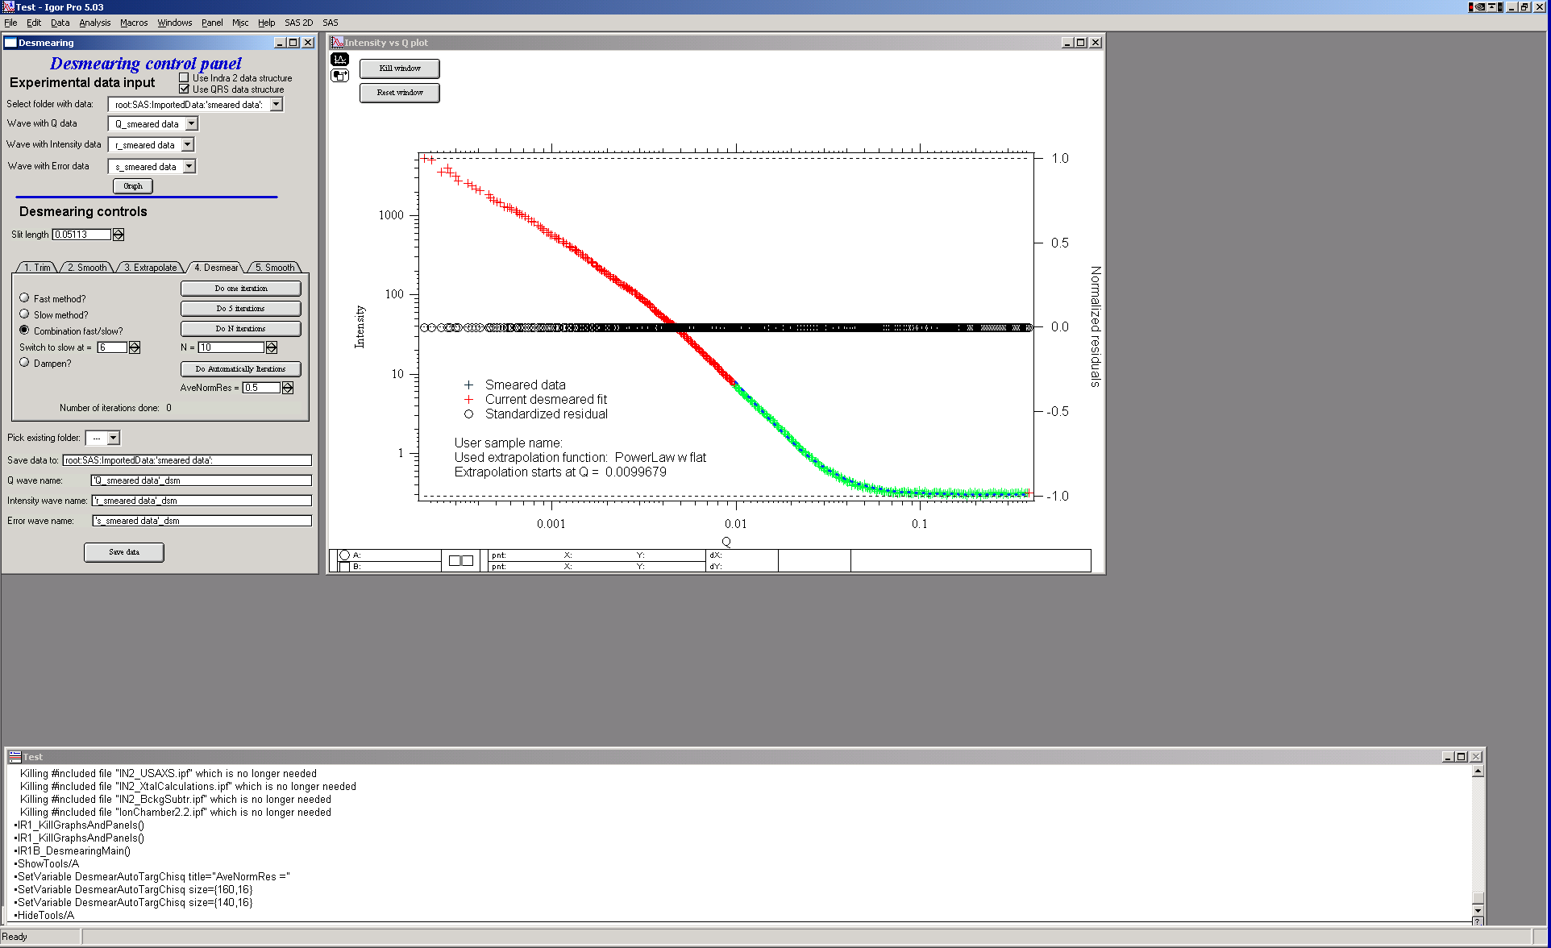

The desmearing can be done in steps – one at a time, 5 at a time, selected number of iterations at once (when you already know how many iterations are going to be needed), automatically (iterates until average normalized residual < preset value) or any combination. Also, there are two modes of conversion for Lake method: aka “slow” and “fast”. The fast method is overall the best method to use, the “slow” method iterates much slower and can result in negative number for intensity.. Combination methods – “Combination”, and “Dampen” attempt to use “fast” method (as main) and reduce formation of noise characteristic for this method. In both cases normalized residual for each data point is during each iteration compared. For combination method, if the data point is already estimated to within the user selected precision of input data (normalized residual < User input value) the point is further dersmeared by “slow” method. For dampened method, if the point is estimated to normalized residual < 0.5 it is not desmeared anymore at all…

This should reduce some of the noise created at high-q data during larger number of iterations while keeping the fast convergence of the “fast” method.

Let’s select the “Fast nethod” here, for simplicity.

Do one iteration:

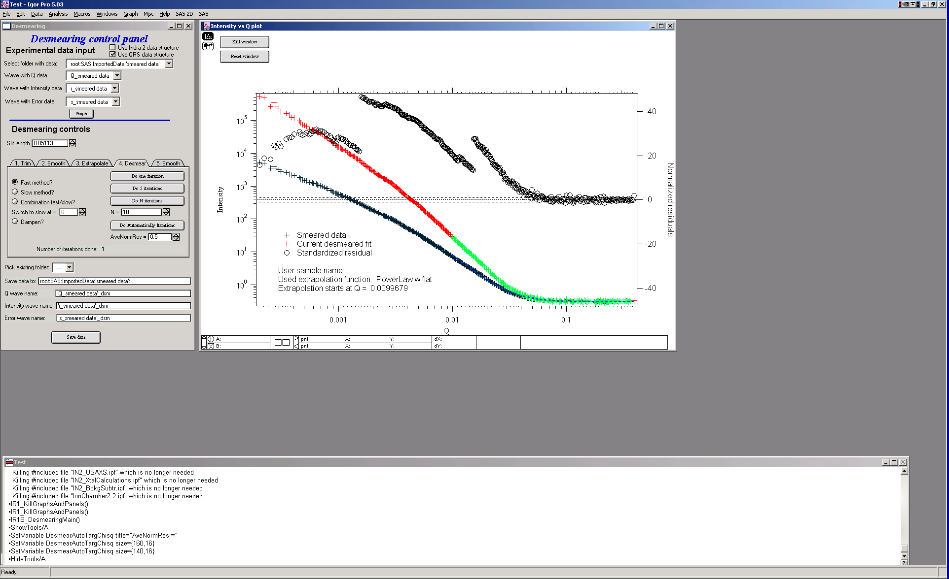

Explanation: Red/green data are current desmeared data (see above about extrapolation). Crosses are original data and circles are normalized residuals.

Desmearing should continue until the plot of the residuals becomes featureless with scatter distributed randomly about z=0 (where z is the standardized residual). Convergence is achieved when the residuals do not readjust to a significant extent between consecutive desmearing iterations. Acceptable convergence is always at the judgement of the person doing the desmearing.

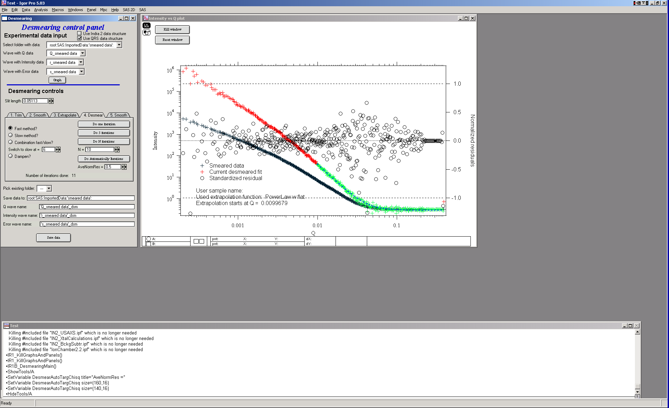

For many data sets, 10-20 iterations are sufficient. Other data sets (those with more structure in the scattering curve) may require as many as 50 iterations or more to satisfy the convergence criteria of the user. For this example data set, this is about where one may end – 10 iterations and most of the circles are within +/- 1. There are some points at low Q which may need more iterations, due to the use of the combination method. (The fast method would have resolved this with fewer iterations.)

5. Final smoothing

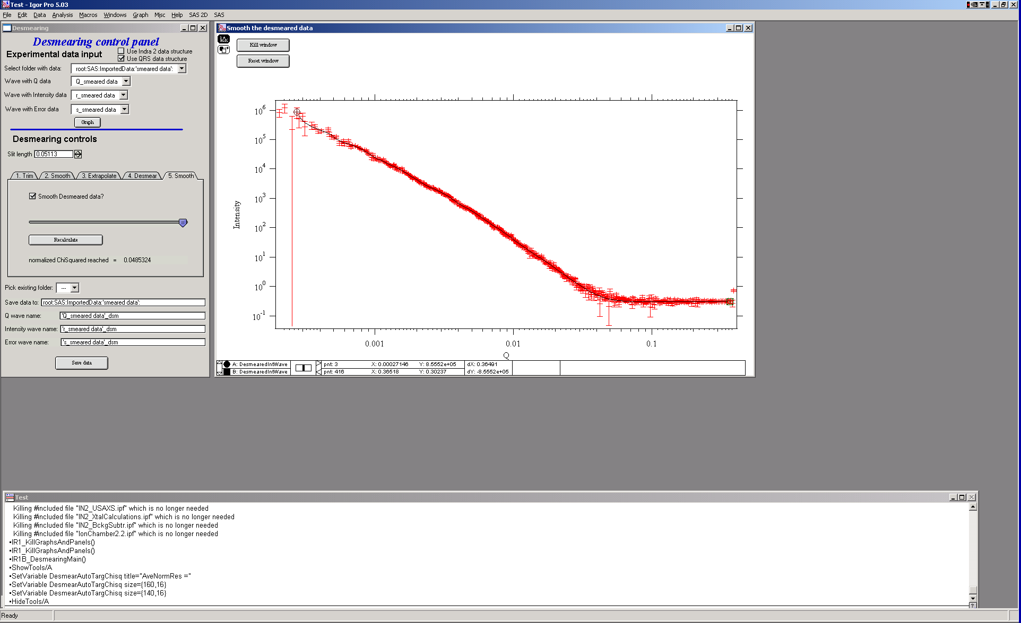

Here one can smooth data… This is probably a better place to smooth, if necessary at all.

6. Save data

Use the bottom part of the GUI panel to save data in folder of your choice. The folder, if it does not exist will be created.

# 

# 19. Modeling I (standard models)

- note, this tool is deprecated and will not be maintained or improved. It has been moved to "Support and Older tools" menu item.

This program allows user to create up to 5 populations of scatterers and combine small-angle scattering from them to compare with measured data. Fitting and optimization: Parameters can be least square fitted to measured data. From version 2.15 second optimization method is available – “Genetic optimization”. See comments on Genetic optimization in the introduction.

Each population have it’s own shape, distribution type, size, contrast, etc. Common selections only are which type of distribution probability is modeled – number distribution of volume distribution.

## 19.1 Details on Standard models mathematics:

What the macros do:

The macros model small angle scattering (SAS) using basic SAS formula:

,

where  is contrast, F(Q,r) is scattering form factor, V(r) is the particle volume, N is the total number of scattering particles, (r) is the probability of occurrence of scatterer at size of r. This formula is, of course, replaced by summation formula with limited number of bins in radii. Therefore the formula coded in is following:



This formula has been coded very many times… Following are comments, which address specific parts of this formula.

Summary of features:

1. Use of SAS data from Indra 2 data structure, QRS data structure – or any other data structure (need Q vector, intensity, error).
2. Allows creation of “model” only – does not require input data anymore (creates q values in user defined range)
3. Up to 5 customizable distributions of scatterers, each with it’s own scattering contrast, particle shape, size distribution model, etc.
4. Three different distribution models available – Gauss (Normal), Log-Normal, and LSW (Lifshitz-Slyozov-Wagner used in precipitation theory involving Ostwald Ripening).
5. Automatic selection of radius distributions – ranges needed, bin widths etc. – with user selectable precision and number of steps.
6. Easy control of all parameters in one panel
7. Immediate comparison with the measured data in one graph in Intensity-vs-Q (log-log) plot and in Intensity*Q4-vs-Q plot.
8. Independent graph for distributions of scatterers.
9. Fitting routine for parameters…
10. Automatic recording routine for parameters before and after fitting
11. Number of available form factors. Note, that it is relatively easy to add other shapes in the code, so if anyone needs (really needs) another shape, let me know… Note, that calculation speed of different form factors varies significantly depending on calculations needed to calculate involved integrals.

## 19.2 Interference

This code includes simple and very crude interaction calculation, which can be independently switched on or off for each population of the scatterers. **User should be aware of the crudeness of these calculations.**

The code used for calculations involves correcting intensity from a population of scatterers using this formula:

Intensitywith interfernce(Q, R) =Intensitywithout interference * (1+*pack*\* SphereAmplitude(Q, *Eta*))

Where the *pack* and *Eta* are the two parameters of this model.

Note, that this is supposed to be valid for spheres. I am working on adding other methods for other arrangements of particles.

**Remember**: this method accounts in very crude way ONLY for interaction for particles in the particular population. If there are interactions among particles from different populations – which is very likely – these calculations have NO WAY to account for it.

## 19.3 Important Information

The code uses for all size related parameters Angstroems (10-10 m) or for Q vector (A-1). In the case of scattering contrast, number distribution and any other volume contents centimeters (10-2 m).

This code uses everywhere Radius for scatterer size.

### Distribution Ψ(r) and V(r)* Ψ(r) and distribution of r.

The code can work with distribution defined as for number distribution N*Ψ(r), where integral over Ψ(r) for all r is 1 and N is total number of scatterers or for volume distribution Vtot*Ψ(r), where integral over this term is equal total volume of scatterers. Internally, the code actually always works with number distributions (N*Ψ(r)), which, in the second case is calculated from the total volume of scatterers.

There are currently 3 different distributions built in the code, which can be used independently for any of up to 5 scatterers populations: Gauss (normal), Log-Normal, LSW.

Gauss and Log-Normal distribution definitions were adopted from NIST engineering statistics handbook, [www.itl.nist.gov/div898/handbook/eda](http://www.itl.nist.gov/div898/handbook/eda) . See <http://www.itl.nist.gov/div898/handbook/eda/section3/eda366.htm>

Standard complicated log-normal distribution is defined as follows (Allen, A.J., Krueger, S., Skandan, G., Long, G.G., Hahn, H., Kerch, H.M., Parker, J.C. and Ali, M.N. (1996). *J. Am. Ceram. Soc.* **79**, 1201-1212., Filliben, J.J. (2006). *Exploratory Data Analysis*, in *NIST/SEMATECH e-Handbook of Statistical Methods*, edited by C. Croarkin and P. Tobias, p. 1.3.6.6.9, available online at *http://www.itl.nist.gov/div898/handbook/*. Gaithersburg, MD: NIST.):

The NIST definition is modified to be more elegant and parameters used by Irena package are as follows:

"Min" = Dmin

"Mean" = (Dmed - Dmin)

"Sdev" = sigma = ln((Dmed-Dmin)/(Dmode-Dmin))

The LSW distribution has been accepted from a source by J. Nasser, A. K. Kuruvilla, and J. E. Smith Jr. These authors in their manuscript on the web (www.space.gc.ca/science/space_science/paper_reports/spacebound97/materials_sciece/….) refer to distribution by Lifshitz, Slyozlov, and Wagner:



This is the particle size distribution predicted by LSW in their theory of Ostwald Ripening.

Each distribution in this type of problems needs an appropriate selection of radial bins. Appropriate selection is actually problem – too many bins cause too long calculation times, narrow range of radii causes some significant volume of scatterers to be neglected, etc. In this code I take a different approach, which is important to explain properly:

For each distribution I create cumulative distribution (if exists using formula, if not numerically). Using user input value I select range of radii in which the value for cumulative distribution is between this value and (1-this value). This causes, that only the tails, for which the cumulative probability is below the user selected value are neglected, giving user full control of the precision in which we/she wants to model the data. Then radial bins are calculated, so their spacing for cumulative probability is the same. This causes that the bins have varying width – are narrowest around the areas, where probability function changes fast and wider in the tails. This should provide the best possible method for using the binning method, I hope…

All of the code handles bins of varying width…

### F(Q,r) problem – applicable ONLY to integrated spheroid

For the case of **integrated spheroids ONLY** - *rarely addressed problem is related to usual method of calculation of F(Q,r), independent of selected particle shape. In usual method of modeling – using bins this problem is usually neglected. Standard method is to take for radius the center point of the bin, and calculate F(Q,r) for this point. However, this may be very incorrect - the F(Q,r) is a strong function of Q*r (with period of pi). Through the Q range and size range studied, the number of periods in pi within the bin width * Q varies strongly. Taking just center of the bin for calculating F(Q,r) results in nearly random selection of the r for this calculation and can result in significant error. Calculated value may be very far from average F(Q,r) value, which we should properly used.*

*In case of data from USAXS instrument we at least have no problem with definition of Q – the Q resolution is very high, otherwise we would have to worry about the Q variation within the Q point - smearing…*

*Anyway, to avoid problems with the oscillatory behavior of the F(Qr) the code takes at least 3 – and maximum 61 F(Qr) values within the bin in radius (at least start, middle and end of the radius bin point), linearly distributed in the bin, multiply them by appropriate V(r) and then average the result. The number of points within the bin is obtained as floor(3+abs((10*(QRMax-QRMin)/pi))), with maximum being 61.*

*This causes significant increase in the calculation time… Keep this in mind*.

--- end of part valid ONLY for spheroids

The above does not apply for other shapes – globs by definition do not exhibit this problem and I have not included this complication for other shapes. The standard spheroid also do not have this included – if you want to use this integration method, use even for spheres “integrated spheroid” and aspect ratio 1.Select “Modeling I” from “SAS” menu. This brings up control panel. Select available data set, “Graph”, and select 1 distribution as number of distributions. Also check “Update graphs automatically”:

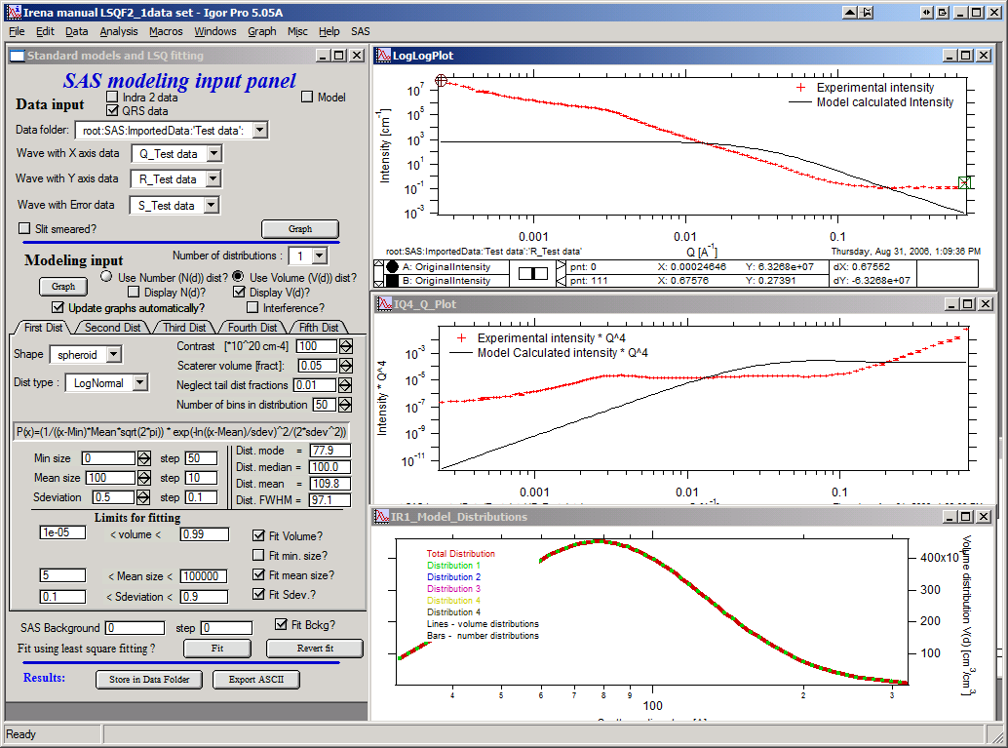

Top graph is log-log plot of Intensity vs Q, lower plot is Intensity * Q^4 vs Qvector (=S(Q) as known from scattering theory).

This is default distribution for distribution 1. Shape is spheres (spheroid with aspect ratio 1).

Distribution type is Log-normal (other options: Gaussien and LSW).

If the distribution parameters seem unusual, the formula used is posted above the parameters. Values for contrast, volume fraction of scatterers (0.05 = 5%) and number of bins in distribution are quite clear in their meaning.

**Parameter “Neglect tail dist fraction”** is more complex… When I create the distribution according to parameters user provides, firs I find the middle of the distribution (maximum). To create cumulative distribution and use that to distribute bins so the change in cumulative distribution in each bin is the same. However, there is need to terminate the binning at some minimum and maximum size. To do so I need to know, what amount of cumulative distribution user is willing to neglect. So if this parameter is set to 0.1, then binning in radii (diameters) is done so there is less than 1% probability for radii (diameters) smaller than smallest bin size and less than 1% probability that it is larger than largest bin size. This is necessary, since the Gaussian and Log-Normal distributions used here are unlimited.

Parameters Dist mode, median, mean and FWHM (full width at half max) are calculated numerically for user to provide some sensible information on the probability distributions. They cannot be changed.

Parameters used in the distribution formula can be modified and fitted. Modify them to fit the Guinier area of the smaller particles. Note solution below, which is not bad starting point. Note input range by selecting data with cursors in the TOP graph (log intensity vs log Q). Now select area between points 69 and 100 (only top graph can be used for input!!!) and check Fit Volume, Fit min. size, Fit Mean size, Fit Background checkboxes (Fit Sdeviation causes significant instabilities, so use sparingly). Check limits (FitVolume lower limit may need to be decreased, for example).

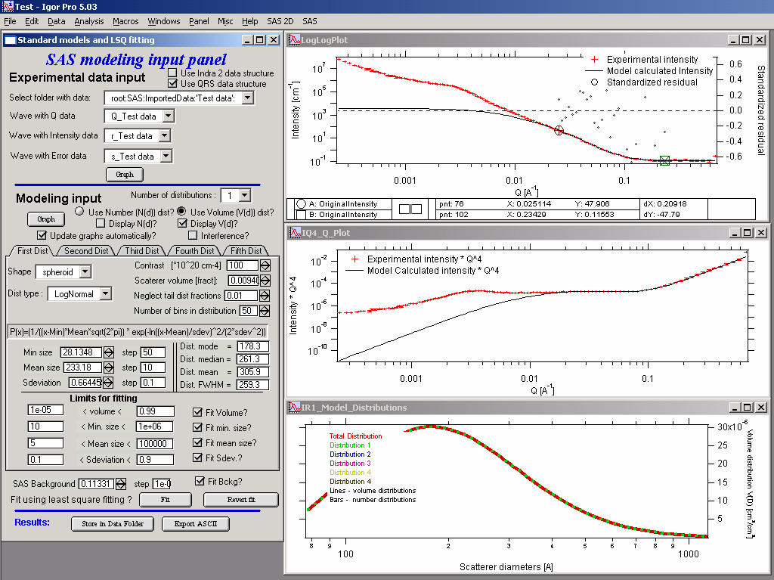

Now, let’s add second population of particles. Select number of distributions 2, and click on the tab with “Second Dist” name. Increase the Mean size for this population to 2000A and possibly modify other parameters according to following parameters.

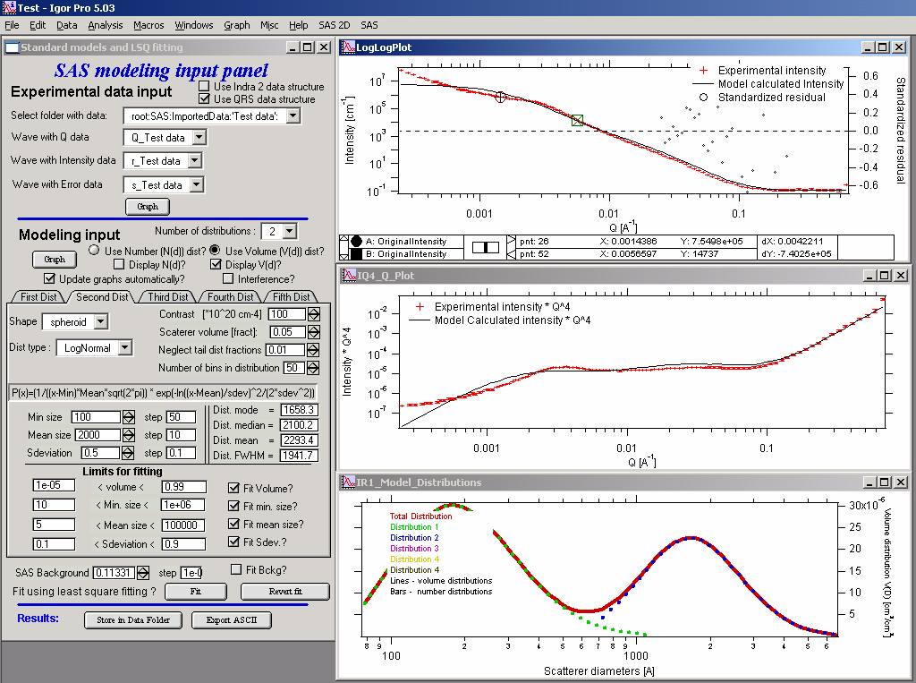

This is not bad guess. Note, that as the second population became larger, if you display number distribution the distribution line nearly disappears from the bottom graph. There are only few of large particles there. Therefore in this case is better to display volume distribution, which will show the second population. However, choice of user if to model volume or number distribution needs to be made based more on physical basis…

Select point 29 to 62 in the top graph using cursors. In the Tab of the First distribution uncheck all fitting boxes, uncheck Fit Background checkbox and in the tab for second distribution check Fit Volume, Fit Location, Fit Scale checkboxes… The fit.

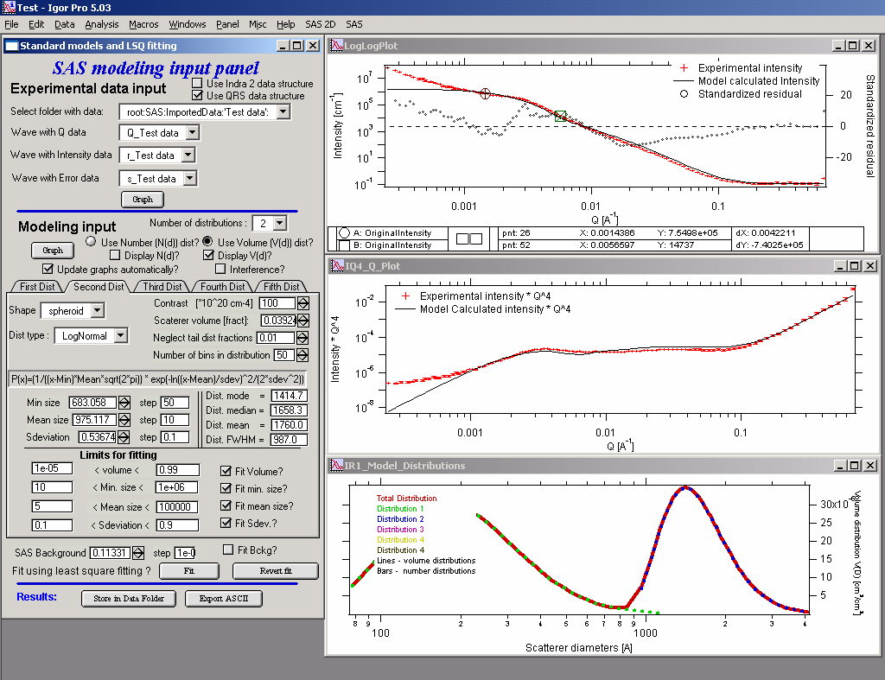

This is reasonably good local fit for second population. Note the straight line between the distribution for the first population and second population – this is where there are no datapoints, since first population already ended and second did not start. This area will get smaller if the “Neglect tail dist fraction” is set smaller. However, if this number is very small, or distributions are close to small sizes, problem with bins with negative diameters appears. The code just truncates the binning at 2A or so, so there can be artifacts for distributions which have significant volume at smaller scatterers…

Now we can optimize all parameters at the same time. Select point about 29 to 102 using cursors. Check major parameters from First distribution and fit all together.

Final fit may look like:

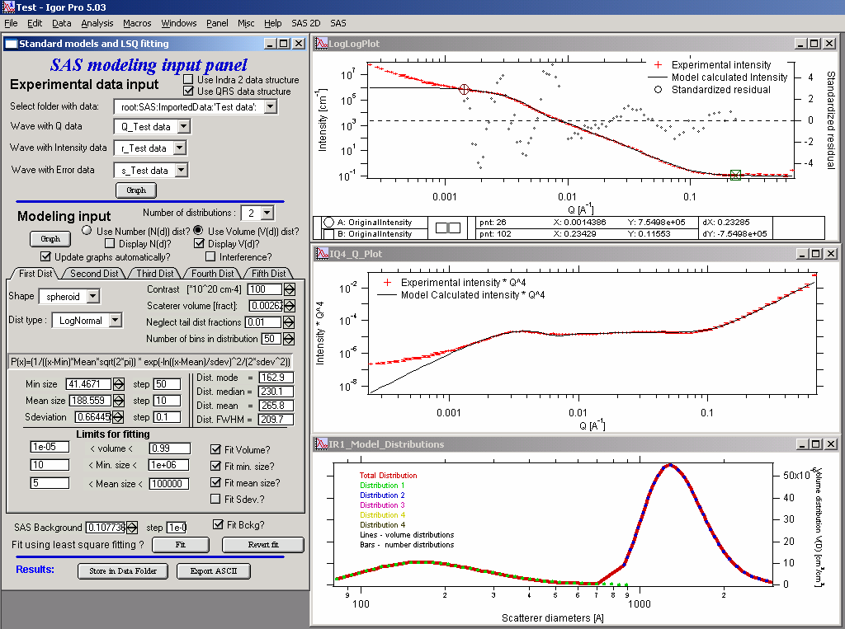

Note, that fitting the small-Q powerlaw with this model is not easy, since there is no real size information about those scatterers. Therefore I will not attempt to do it at this time.

#### Adding interactions

Check the checkbox “Interactions” on the control panel. New panel pop-ups with Interference control tabs for each population

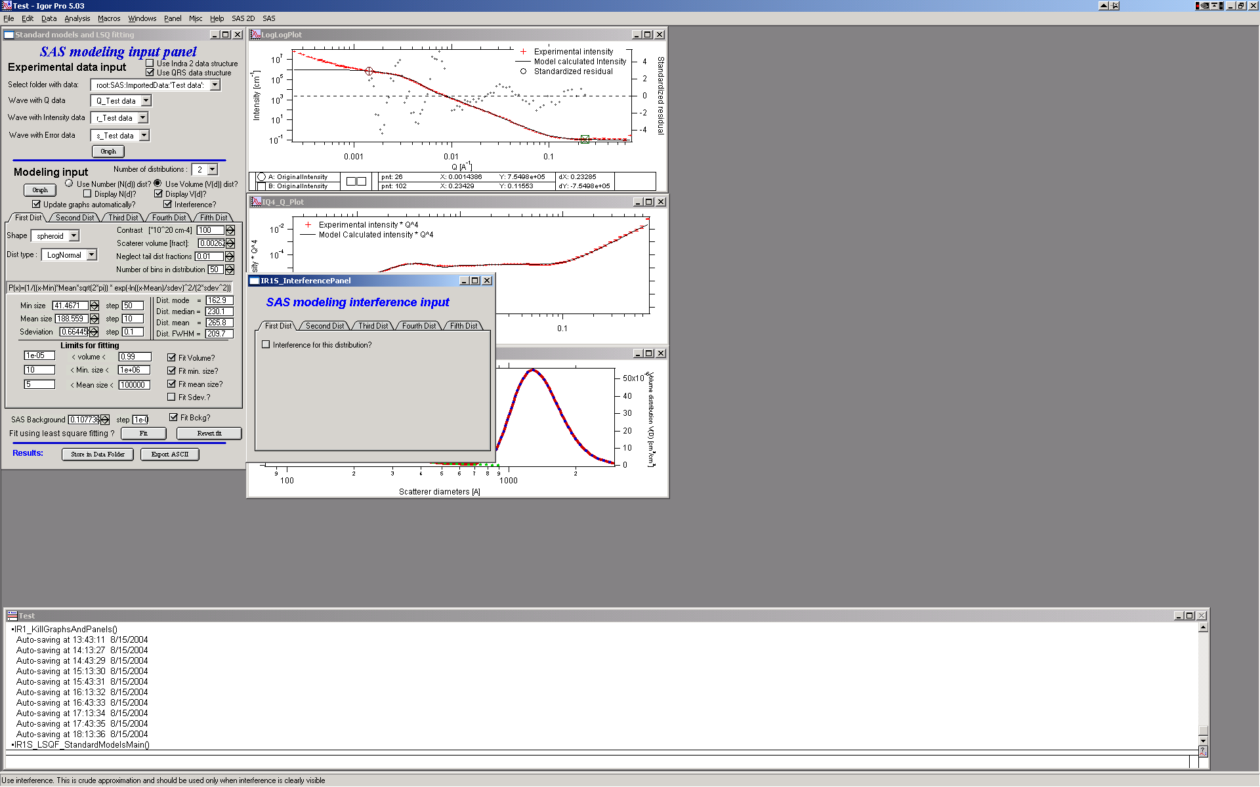

Check the checkbox “Interference for this population” for population, you want to include interference calculations for and two parameters show up.

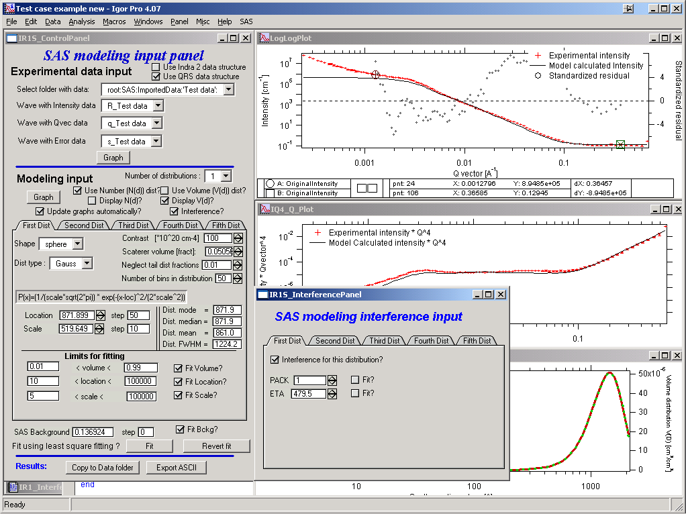

These parameters can be fitted by checking “Fit?” checkbox, when other necessary fields appear. Note, that in my experience the fits are not very stable. Need to have really good estimates for these parameters. For more on these parameters, look into the Unified fit section, since this is the same code used here as in Unified.

### Saving results

It is now possible to save data back to data folder where the measured data came from or export ASCII file.

#### Copy to data folder

User can copy Igor waves (as in above methods) with comments, which can be recovered in the future or used for users plotting of data. In the dialog

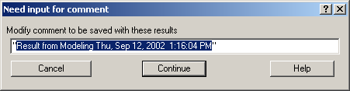

user can fill in any text description (in the quotes).

Following waves are created in the data folder. _0 is index of users solution saved in the folder, so user can have multiple solutions. These solution can be recovered in the future as in previous cases…

ModelingDiameters_0 diameters for the distributions

ModelingNumberDistribution_0 number distribution

ModelingVolumeDistribution_0 volume distribution

ModelingIntensity_0 intensity from the model

ModelingQvector_0 Q vector for the model

Note, that each of these waves has again wave note with all parameters from this model.

#### Export to ASCII

Exports ASCII file with all parameters (wavenote from solution waves above) and columns of data with the distributions and intensity-Qvector.

### Modeling only

In order to facilitate modeling only of SAS from population(s) of scatterers, user does not need any input data. These data will be created – in Q range user selects, with number of points user defines and spread either logarithmically or linearly. Just select “model” checkbox at the top of the Data Input part of main tool panel.

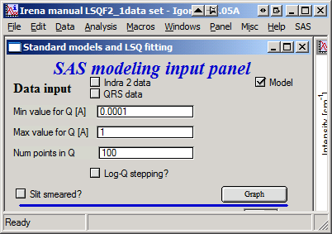

Select proper values and log-Q stepping, then push “graph”. Tool will function with no input data now…

## 19.4 Fitting

### General comments

This code uses either Igor built in least-squares fitting routine or Genetic optimization.

Least square fitting: The SAS data (intensity, Q and error) always extend over large ranges – often many decades – this routine is not the best one for parameters optimization. Therefore it is imperative to have a good starting guess for the parameters, properly select range of values, the fit is allowed to look for solution and fit limited number of parameters at a time.

Genetic optimization: very good for cases when number of local minima can make least square fitting unusable.

Note change on the panel: Lower left corner – the two checkboxes switch between least squares and genetic optimization. Least squares is default.

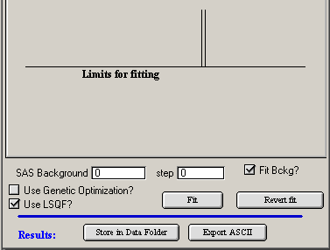

For genetic optimization user is presented with review of parameters which will be fitted and review of range which will be probed. It is imperative to have limited and sensible range of parameters to be fitted!!!

# 

# 20 Logging feature

This feature is not finished and works only for standard models. It is planned update for future to make sure these records are useful…

User can see the notebook by selecting second item in the SAS menu “Show SAS logbook”. This area is at this time under development, but this is current status of what is written in this logbook:

This is log results of SAS fitting with modeling macros Irena.

1/5/02, 5:47 PM

***********************************************

***********************************************

***********************************************

Parameters before starting Fitting on the data from: root:USAXS:'S5_Al2O3 1um':

Number of modelled distributions: 1

SAS background = 0.15, was fitted? = 0 (yes=1/no=0)

*********** Distribution 1

Particle shape: sphere

Distribution type: LogNormal

Contrast 120

Volume 0.09 , fitted? = 0

Location 250 , fitted? = 1

Scale 300.1 , fitted? = 1

Shape 0.5 , fitted? = 0

Mean 575.21

Median 550.12

Mode 483.83

FWHM 291.36

***********************************************

Results of the Fitting on the data from: root:USAXS:'S5_Al2O3 1um':

Number of fitted distributions: 1

Fitting results:

SAS background = 0.15, was fitted? = 0 (yes=1/no=0)

*********** Distribution 1

Particle shape: sphere

Distribution type: LogNormal

Contrast 120

Volume 0.09 , fitted? = 0

Location 278.88 , fitted? = 1

Scale 278.32 , fitted? = 1

Shape 0.5 , fitted? = 0

Mean 575.21

Median 550.12

Mode 483.83

FWHM 291.36

Fit has been reached with following parameters

Chi-Squared 910.31

Points selected for fitting 28 to 109

The record will get significantly more complex in the future and, if using more populations of scatterers, also longer…

# 21. Final Comments

This manual is apparently never ever finished… Real apologies to everyone for this, but it seems to be impossible to keep up with changes and modifications.